**2014**

**JP Morgan Chase & Co.**

**Technology Training**

**Spring Framework: Participant Guide**

Contents

Module 1: An Overview of Spring Framework 8

Lesson 1: Basics of Spring Framework 9

Topic 1: History of Spring Framework 9

Topic 2: Uses of Spring Framework 10

Lesson 2: Benefits of Spring Framework 14

Topic 1: Advantages of Spring Framework 14

Topic 2: Best Practices for Using Spring Framework 17

Module Summary 22

References 23

Module 2: DI Wiring Collection and Objects 24

Lesson 1: DI and XML Configurations 25

Topic 1: Spring Implementation of IOC with DI 25

Topic 2: Using XML for Configuration of Spring Beans 31

Topic 3: Injecting Different Values 37

Lesson 2: DI with Annotations 44

Topic 1: Purpose of Annotations 44

Topic 2: Spring Configuration using Annotations 49

Module Summary 56

References 57

Module 3: Autowiring 58

Lesson 1: Understanding Fundamentals of Wiring Beans 59

Topic 1: Wiring Spring Beans 59

Topic 2: Types of Autowiring 62

Lesson 2: Configuring Autowiring Using XML and Annotations 66

Topic 1: Configuration of Autowiring Using XML 66

Topic 2: Configuration of Autowiring Using Annotations 66

Module Summary 72

References 73

Module 4: Spring MVC 74

Lesson 1: Spring MVC Support 75

Topic 1: Introduction to MVC 75

Topic 2: Spring MVC Architecture 81

Lesson 2: Building Web Applications Using Spring Framework 88

Topic 1: Employing Controllers, Handlers, and View Resolvers 88

Topic 2: Using Spring Annotations 106

Module Summary 114

References 115

Module 5: Aspect-Oriented Programming (AOP) 116

Lesson 1: Introduction to AOP 117

[Topic 1: Purpose of AOP 118](#_Toc385970252)

[Topic 2: Spring Framework AOP Support 123](#_Toc385970253)

[Lesson 2: Implementation of AOP in Spring Framework 125](#_Toc385970255)

[Topic 1: Implementation and Configuration of Spring Framework AOP using XML Spring Framework AOP 128](#_Toc385970257)

[Topic 2: Spring Framework AOP Annotations and Usage 134](#_Toc385970258)

Module Summary 146

[References 147](#_Toc385970261)

Module 6: Data Access 148

Lesson 1: Spring JDBC Support 149

Topic 1: Introduction to JDBC 149

Topic 2: Implementing Spring JDBC 155

Lesson 2: Advanced Spring JDBC 162

Topic 1: Spring jdbcTemplate 162

Topic 2: Stored Procedure Exception Handling 173

Topic 3: Implementing Caching Using Annotations 176

Module Summary 179

[References 180](#_Toc385970261)

Module 7: ORM Integration 181

Lesson 1: Introduction to ORM and Hibernate 182

Topic 1: Introduction to ORM 182

Topic 2: Introduction to Hibernate 185

Lesson 2: Spring ORM 201

Topic 1: Introduction to Spring ORM 201

Topic 2: Integration of Spring and Hibernate 203

Module Summary 216

References 217

Module 8: Transaction Management 218

Lesson 1: Introduction to Transaction Management 219

Topic 1: Understanding Transactions 219

Topic 2: Purpose of Transaction Management 225

Lesson 2: Spring Transaction Management 227

Topic 1: Integration of Different Transaction Managers 227

Topic 2: Declarative and Programmatic Transaction Management 232

Topic 3: Transaction Management with Annotations 236

Topic 4: JNDI 239

Module Summary 243

References 244

Module 9: Spring Security Framework 245

Lesson 1: Spring Security Framework Support 246

Topic 1: Introduction to Spring Security Framework 246

Topic 2: Securing Web Requests 252

Lesson 2: Advanced Spring Security 259

Topic 1: Using Spring Tag-Lib for Security 259

Topic 2: Method Level Security 273

Topic 3: Customizing Filter Chain 280

Module Summary 287

References 288

Glossary 289

Additional Study: Difference between AOP and AspectJ 294

**Spring Framework**

**Course Overview**

As an open source framework for Java applications, Spring Framework was introduced in 2003 by Rod Johnson as an alternative to Enterprise JavaBeans (EJB) to increase productivity during project development and improve run-time performance.

Spring Framework is a tool in which the code is used to selectively change Java programs to make them application oriented. Spring Framework offers many beneficial services, such as Inversion of Control (IoC), for working with Java applications. The IoC container uses Dependency Injection (DI) to configure application components and manage project build life cycles, simplifying component configuration and build management tasks. Spring Framework containers can autowire relationships between components to cut down coding and manage DI. Another important service is the Spring model-view-controller (MVC) web application framework, which makes it easier for you to use Servlet APIs for cleaner front-end coding. This course describes how to configure Spring Framework and what is the specific purpose that it meets.

Spring Framework can be used to implement Aspect-Oriented Programming (AOP) that manages sections of code that cannot be completely separated from the rest of the system. AOP is also used to resolve the resulting code duplication and creation of significant dependencies. Another desirable component of Spring Framework is the Transaction Management framework that helps you to manage transactions performed on Java Database Connectivity (JDBC) connections and Object-Relational Mapping (ORM) tasks, making it easier to manage remote handling of your application code.

Spring autowiring is a service performed by the Spring container, where it autowires (automatically builds) relationships between components called Java beans to cut down the amount of XML configuration code you need to write in large projects. The course describes each of the services provided by Spring Framework, the configurations needed to use these services, and integration of these services with third-party vendors to suit your development needs.

The course also explains how to deploy Spring Framework security to provide authentication and authorization to Java-based applications. This security framework can be easily extended to meet custom requirements to provide optimum security to your applications. You will learn about the benefits of using Spring Framework and its service modules in creating a well-designed, user-friendly, and efficient enterprise application using the Java Programming Language.

**Course Objectives:**

By the end of this course, you will be able to:

* Explain the purpose of Spring Framework.
* Configure Spring Framework using XML and annotation.
* Demonstrate Spring Autowiring.
* Implement Aspect-Oriented Programming in Spring Framework.
* Provide Spring Framework support for JDBC.
* Illustrate Spring transactional management.
* Explain the fundamentals of hibernation.
* Integrate Spring ORM with Hibernate.
* Implement Spring MVC.
* Deploy Spring Framework security.

# Module 1: An Overview of Spring Framework

**Module Overview:**

Spring Framework is used to develop Java-based enterprise applications. By using Spring Framework, you can make application code well-factored and ensure it contains well-defined components. It makes your application easily readable, scalable, and maintainable and better performing in terms of implementing business logic. When you use Spring Framework, your applications are able to run smoothly, with or without containers, and are easy to test with minimum interference to the source code. This module introduces you to the basic concepts of Spring Framework and benefits of and the best practices for implementing Spring Framework.

**Module Objectives:**

By the end of this module, you will be able to:

* Describe Spring Framework.
* Explain the basic concepts of Spring Framework.
* Explain the advantages of and best practices for using Spring Framework.

## Lesson 1: Basics of Spring Framework

Since the first version of Spring Framework was introduced by Rod Johnson in October 2003, the framework has undergone several developments and improvements to attain its present state of a nonintrusive framework. Spring Framework now enables you to develop applications efficiently, in an object-oriented manner. This lesson outlines the history of Spring Framework and its uses in Java-based application development.

### Topic 1: History of Spring Framework

Rod Johnson’s book “Expert One-on-One J2EE Design and Development,” released in October 2002, introduced J2EE development features such as IoC, AOP, transaction management, and MVC API, all of which were later integrated into Spring Framework. Spring Framework was first released in June 2003 under the Apache 2.0 license, which was followed by the first milestone release in March 2004. Let us look at a brief history of the development of Spring Framework.

Spring Framework is a leading open source framework that has multiple versions released since its inception. The major versions of Spring Framework are listed in Table 1.1.

|  |  |  |
| --- | --- | --- |
| **Version** | **Release Date** | **Description** |
| **Spring Framework 1.0** (Stable release version: Spring Framework 1.0.5) | March 2004 | The first release of Spring Framework was called Spring Framework 1.0 RC4. |
| **Spring Framework 2.0** (Final version: Spring Framework 2.0.8) | October 2006 | This version introduced the Beans Configuration Dialects that simplified the common configuration tasks. |
| **Spring Framework 2.5**  (Current version:Spring Framework 2.5.6.SEC03) | November 2007 | This version reduced the amount of XML-based configurations needed by introducing XML Schema support and custom namespaces. |
| **Spring Framework 3.0 GA**  (Current version:Spring Framework 3.0.6) | December 2009 | In this version, annotations are used to support task scheduling and asynchronous methods. This version also supports REST web applications and Expression Language support. It also includes an aspects bundle that can be used to declare dependencies and fixed HTML Utilities. |
| **Spring Framework 3.1 GA**  (Bug fixing release version:Spring Framework 3.1.2) | February 2011 | The final release for this version in February of 2011 was the Spring Framework 3.1 GA, which supports JUnit 4.9 and load-time weaving. The version also introduced ForkJoinPoolFactoryBean and WritableResourceInterface.  Spring Framework 3.1.2 released in July 2012 is a bug-fixing release that fixed key issues such as those related to content notification and currency. |

**Table 1.1: Spring Framework Versions**

Over time, Spring Framework has become more user friendly and lightweight compared to its first release. The use of annotations has reduced the volume of code needed to perform autowiring and configuration tasks. Spring Framework’s support for third-party tools such as Hibernate and JUnit allow you to develop applications that are more portable and flexible for enterprise requirements.

### Topic 2: Uses of Spring Framework

Spring Framework enables you to create high-performing and easily testable and reusable code. This is made possible because Spring Framework was designed as a platform for developing Java-based, enterprise applications. Let’s now understand the concepts on which the framework was designed.

#### Concepts of Spring Framework

To use Spring Framework, it is important to know the concepts that govern its design. These concepts will provide you a better understanding of its use in developing Java-based enterprise applications:

#### Spring is a noninvasive framework: Traditional frameworks used for Java development have the disadvantage that these frameworks make your application code dependent. This is because framework-specific interfaces are implemented. As a noninvasive framework, Spring Framework minimizes the dependence of the code on the framework, thus enabling it to configure even those objects that do not import Spring APIs. It can also configure the classes that were written by users who do not have any knowledge of Spring Framework. This feature offers advantages such as:

* The application code developed using Spring Framework can run without the framework, which makes it more portable and flexible.
* You can easily migrate to another lightweight container, or your application can reuse objects in the EJB container, which supports a subset of Spring Framework’s DI.
* Migrating or upgrading your application to future versions of Spring Framework is simple and easy as there is greater decoupling between your code and the framework. Therefore, any changes in the framework will not break your code, thus guaranteeing its safety.
* **Spring Framework provides a consistent programming model**: Using Spring Framework to create your application makes your code less dependent on runtime context by providing a programming model that makes your code independent of environment details, such as the Java Naming and Directory Interface (JNDI). As a result, most web applications you create do not need expensive, high-end application servers. In addition, not all applications are server-side applications and can easily run simple containers such as Tomcat or Jetty. This is made possible by Spring Framework.
* **Spring Framework promotes code reuse**: Spring Framework’s abstraction lets you deploy your code in any environment, which means you do not have to worry about making decisions regarding configuring your application to Java Transaction API (JTA) or JNDI. Therefore, you get to decide which environment to choose, on the basis of business requirements, and test your code for scalability and effectiveness.
* **Spring Framework promotes good programming practices**: Spring Framework encourages good programming practices, such as programming to interfaces rather than classes. This practice ensures that your code need not include application implementation, which is decided by the interface signature. Using IoC reduces code complexity significantly by concealing the specifications of implementation classes from the methods’ calls to objects. Therefore, you can change or upgrade your implementation as the code development progresses.
* **Spring Framework promotes plug-ability**: In Spring Framework, your application objects are like named services and the dependencies between them are expressed in terms of interfaces. Therefore, you can exchange one service for another without impacting the rest of your application. In other words, you can replace an existing service by plugging in a new one based on your requirements. Spring Framework achieves this by concealing from the client’s view the manner in which each service is configured.
* **Extracting configuration values from Java code:** Spring Framework allows you to extract configuration values from Java code into an XML or properties file. Externalizing the configuration values eliminates the need for your application to manage configurations of all vital application components and keeps your code maintainable and reusable.
* **Applications become easy to test**: Applications that are developed using Spring Framework contain Plain Old Java Objects (POJOs), which are easy to test. Dependencies are in the form of interfaces, which are easy to stub, mock, and test.
* **Spring Framework is consistent:** Using Spring Framework lets you adopt a consistent approach, in different run-time environments and different parts of the framework. This means that once you learn one part of the framework, you'll find that the knowledge can be applied to the other parts as well.
* **Spring Framework promotes architectural choice**: While providing an architectural support system for your application’s design, Spring Framework enables you to make each layer replaceable. This allows for switching from one Object-Relational Mapping (ORM) framework to another with minimal impact on your code logic.
* **Spring Framework does not reinvent the wheel**: Even though it has a very broad scope in application development, Spring Framework does not invent a new alternative to the existing solutions, such as replacing ORM frameworks or employing its own logging abstraction, connection pool, distributed transaction coordinator, remote protocols, or other system services that are satisfactory in other products or application servers. This makes it easier to use the existing solutions effectively by placing them in a consistent architectural approach.

#### Purpose of Spring Framework

The traditional approach to developing J2EE application presented certain challenges such as:

* Large volumes of code needed to be written.
* The EJB component model becomes complicated and thus difficult to maintain.
* Design patterns use complex APIs that are difficult to configure.

Using out-of-the-box J2EE solutions for these problems is difficult as they involve more coding to customize every feature needed to meet your business requirements (such as managing transactions and applying security features). Spring Framework allows you to use J2EE solutions for your business application while minimizing any difficulty that your application may face. Therefore, Spring Framework’s purpose is to provide enterprise services to your application in a Java environment, keeping your application reusable in a variety of run-time environments.

In fact, Spring Framework makes J2EE development easier and is needed even when there are well-known frameworks such as Struts and Hibernate. This is because:

* Unlike Struts and Hibernate, Spring Framework is a multitier framework that supports application development in a consistent, productive, and coherent manner.
* It is used to minimize complications in application code.
* It makes dependencies explicit by providing self-documenting application classes.
* It is needed to simplify JDBS.
* It is used to perform configurations without breaking your application code.

### Key Features

Spring Framework is lightweight when it comes to size and transparency. This means that you need less code to achieve more and there are no hidden parts that cannot be accessed for making changes or modifications. Its core features such as transaction management, AOP, and IoC using DI are used in developing any Java application. It also contains extensions for building web applications on a Java platform. Let us look at some of the key features that make it such a popular tool among developers.

* + **ORM**: The ORM module provides integration layers for popular object-relational mapping APIs, including JPA, JDO, Hibernate, and iBatis. Using the ORM package, you can use all of these O/R-mapping frameworks in combination with all of the other features Spring Framework offers, such as Spring’s transaction management support for each of these ORM frameworks.
  + **Model-view-controller (MVC) framework**: Spring Framework has its own MVC framework, which defines the strategy interfaces (interfaces whose behavior is specified only at run time) for all tasks to be handled by a request-based framework. The interface’s goals are kept simple and clear to enable you to write your own implementation based on business requirements. Spring MVC Framework accommodates multiple technologies view such as Java Server Packages (JSP), Velocity, Tiles, and iText.
  + **Inversion of control (IOC):** An important feature of Spring Framework is its IoC container that consistently configures and manages Java objects by using software reflection. An application that examines and changes the structure and behavior of its components at run time demonstrates reflection. The IoC container manages object life cycles by DI. DI is a software design pattern, which involves decoupling of components by reversing the dependency relationships established from high-level components to low-level components. As a result, the high level components remain independent and their reusability is not limited.
  + **Aspect-Oriented Programming (AOP)**: Spring’s AOP Framework helps you to manage concerns about cross-cutting aspects. An application’s aspects are its components that are linked to many other parts of the application. Cross-cutting aspects cannot be completely disconnected or isolated from the rest of the code; trying to do so will result in breaking the code. An AOP framework allows you access to the basic AOP features without any complicated design, implementation, or configuration. Any object created and configured by the Spring IoC container can be enriched using Spring AOP, leading to better code quality.
  + **Beans**: The Spring container holds and manages the life cycle of application objects. This involves creating these objects, calling their initialization methods, and configuring them by wiring them together. The objects created by this container are called managed objects (or beans).
  + **Transaction Management**: The Spring transaction management framework provides an abstraction layer to manage local and global transactions, nested transactions, and support transactions in all environments of the Java platform. It also allows you to use pluggable transaction managers in your application to customize it to the business requirements.
  + **JDBC exception handling**: Spring Framework offers a JDBC abstraction layer that implements logical exception hierarchy. This simplifies error handling.

## 

## Lesson 2: Benefits of Spring Framework

The previous lesson introduced you to the concepts that govern Spring Framework and to the key features and advantages of this framework. This lesson describes the benefits of using Spring Framework for building Java-based enterprise applications. It also describes the best practices for using Spring Framework.

### Topic 1: Advantages of Spring Framework

Spring Framework has several features such as IoC, AOP, and transaction management, and each of these features provides specific advantages in using Spring Framework. There are also certain benefits associated with using Spring Framework as a whole and in using Spring Framework as a development platform for developing business-oriented enterprise applications.

The key benefits of using Spring Framework are:

* You can develop enterprise applications with POJOs using Spring Framework. The use of POJOs eliminates the need to use an EJB container such as an application server. You can use any commercial Servlet container such as Tomcat without having to create your own, thus saving time and money.
* Spring Framework is organized into modules. This means that even though it contains a large number of packages and classes, you can choose the ones your application needs and ignore the others.
* Spring Framework does not perform unnecessary tasks by creating solutions to replace the existing ones. It uses several existing technologies such as ORM frameworks, logging frameworks, JEE, and JDK timer and provides integration with these for better use and faster application development.
* You can easily test an application written using Spring Framework as the code is environment independent.
* Spring has a well-designed MVC framework that is an alternative to the existing frameworks such as Struts, as it provides a way to use the MVC framework and still keeps your code independent of the framework for portability and flexibility.
* Spring provides a convenient API to translate exceptions that are technology-specific (thrown by JDBC, Hibernate, and others) into consistent, unchecked exceptions for ease in locating code errors and fixing them.
* When compared to EJB, Spring Framework’s IoC is lightweight. This is helpful when working with limited memory and CPU resources for deploying your application.
* The transaction management interface is consistent and can be scaled down to local transactions or scaled up for global transactions, which provide your project added scope and coverage.
* Spring Framework has high-level data access features when compared to other frameworks that enable you to implement platform-independent data access objects (DAO) interfaces with a choice of multiple technologies, such as Hibernate, JDBC, TopLink, and JDO.
* Spring also has its own robust JDBC abstraction layer, which simplifies JDBC access and reduces the potential for errors. For example, Spring's Hibernate integration will considerably reduce the amount of code you need to write to use Hibernate and improve your productivity.

**Architectural Benefits of Spring Framework**

You can use Spring Framework to effectively organize the middle tier objects of your application. Spring Framework takes care of coding that you would have to do if you use Struts or other frameworks geared to J2EE APIs. When used for designing an application, Spring Framework provides several key architectural benefits:

* Configuration management services can be used in any architectural layer, in any run-time environment.
* Spring Framework can eliminate the proliferation of Singletons, which reduces testability and object orientation.
* By handling configuration in a consistent way throughout applications, you do not need to use a variety of file formats for custom properties.
* The use of IoC and DI enables you to look at the class’s JavaBeans properties or constructor arguments, which makes your code easy to read.
* Since the applications are less dependent on APIs, you can adopt good programming practices and reduce your project’s development costs by using interfaces instead of classes.
* Your business objects do not have any dependency on the framework, which makes your application easy to test.
* You can choose to implement business interfaces such as POJOs or local EJBs, without affecting calling code. Spring Framework helps you solve many problems without using EJB and can provide an appropriate alternative to EJB.
* You can provide a consistent framework for data access, whether using JDBC or ORM product such as TopLink, Hibernate, or a JDO implementation.

There are other IoC containers (such as PicoContainer and Google Guice) available to you for DI. While these are lightweight and simpler in DI when compared to Spring Framework, they are not as intuitive or extensive. Spring Framework keeps your code independent of the framework and third-party vendors, which makes the application more portable, maintainable, and reusable when compared to PicoContainer and Guice. Let us analyze how Spring Framework compares with PicoContainer and Guice DI Framework.

### Spring Framework Vs. PicoContainer

PicoContainer is a Java-based IoC container for components that utilize the DI pattern. It is used as a lightweight alternative to Sun’s J2EE patterns for web applications or general solutions. A comparison of the features of Spring Framework and those of PicoContainer is presented in Table 1.2.

| **PicoContainer** | **Spring Framework** |
| --- | --- |
| It is lightweight when compared to Spring Framework. | Although Spring Framework is lightweight, its components are heavier than those of PicoContainer. |
| It is just an IoC container. | It is an IoC container and a web framework. |
| When coupling with the framework, Pico does not provide complete support. It tends to discourage setter injection. In addition, your application classes are not aware of PicoContainer; only the wiring is aware of it. | When coupling or interconnecting with the framework, Spring Framework ensures that your entire application is independent of the framework, giving it more portability. |
| PicoContainer is faster than Spring Framework; however it does not suit configuration use cases. You may need to write many of the features inherently to meet your application requirements. | Spring Framework is usually slow; however, you can improve its speed by using the JavaConfig library. You need not write features inherently as they are provided by the framework. |
| PicoContainer is easy to configure but it takes on autowiring decisions from you. It does not allow for user-defined autowiring. | Spring Framework is relatively easy to configure but its XML files can grow very large and complex over time. This can be solved using handwritten dependency injections. |
| PicoContainer is not a widely used framework. | Spring Framework has a large following and is used to make other frameworks more dependency injection friendly. |

**Table 1.2: PicoContainer Vs. Spring Framework**

### Spring Framework Vs. Guice

Google Guice is an open source IoC framework that supports DI using annotations to configure Java beans. Guice binds implementation classes to an interface and then injects these classes to constructors, methods, or fields using the @inject annotation. You can also create custom annotations when you need multiple implementations of the same interface. The differences between Spring Framework and Guice are summarized in Table 1.3.

| **Guice Framework** | **Spring Framework** |
| --- | --- |
| Guice focuses only on DI. | Spring Framework offers much more that just DI, such as transaction management, AOP and code security. |
| Wiring objects and testing them is easier in Guice as it supports annotations and generics. | Spring Framework uses string identifiers, which is more error prone. |
| Objects are recognised based on their type in Guice, so you can have multiple objects with the same name as long as their types are unique. | Objects are recognised based on their names in Spring Framework, so you cannot have multiple objects with the same name. |
| Guice is faster while performing DI. | Spring Framework is usually slow as it contains more code such as references to classes, properties, and beans. |
| Guice does not help in life cycle management of Java beans. | Spring Framework supports a rich set of life cycle events around the creation of beans in the Spring container. |
| Guice is not a widely used framework. | Spring Framework has a large following and is used to make other frameworks more dependency injection friendly. |
| Using third-party vendors with Guice needs customization which adds complexity to application configuration. | Spring Framework keeps your application independent of third-party vendors so configuring your application remains simple. |
| AOP is not as effective as it nonintuitive when compared to Spring Framework’s AOP. | Spring Framework has an AOP that is intuitive and powerful when it comes to managing aspects in your application. |

**Table 1.3: Guice Vs. Spring Framework**

### Topic 2: Best Practices for Using Spring Framework

While using Spring Framework to develop Java-based enterprise applications, there are a few guidelines you can follow as best practices to improve your code quality and efficiency.

As a versatile Java framework used in a wide range of configuration settings, the best feature of Spring Framework is that it provides enterprise services to POJOs called beans. The dependencies and services needed by these beans are specified in XML configuration files or annotations. Using XML files is easier and less complicated. If you plan and write XML files appropriately, they are easy to manage even in large projects, such as enterprise applications.

Note: Other factors, such as application design, impact the XML configuration. However, this module focuses only on the XML configuration’s readability and manageability.

### Let us look at some of the best practices you can employ while configuring Spring Framework.

### Header comment to each file: Each configuration file can have a header comment attached to its code, which summarizes the beans and properties defined in the file. These comments can be XML comments or description elements. Description element tags have the advantage that they can be easily recognized and picked up by search tools if you need to reuse them in a different place in your application code. An example of a header comment is shown in Code Segment 1.1.

**Code Segment 1.1: Example of Header Comments**

<beans>

<description> This configuration file will have all beans which may be used for controlling transactions.

</description>

... </beans>

### Consistent naming conventions: Using the same naming convention across all configuration files increases their readability. These names should be clear and descriptive so that other developers accessing them will not misuse them. For example, to identify a bean, you can use the same convention as Java class field names. Suppose there is a class EmployeeUpdateDAO. Its bean ID will be employeeUpdateDAO, and you can prefix the package name for large projects with multiple packages finance.employeeUpdateDao.

* **Schema references**: Do not include version numbers in schema references in bean configuration files. Spring Framework automatically picks the latest version available from the project dependencies. As the project progresses, the versions are updated and there is no need to maintain all the XML configuration files to access new features. Code Segment 1.2 is an example of schema reference without version numbers.

### Code Segment 1.2: Schema References without Version Numbers

<?xml version="1.0" encoding="UTF-8"?> <beans xmlns="http://www.springframework.org/schema/beans" xmlns:xsi="http://www.w3.org/2001/XMLSchema-instance" xmlns:context="http://www.springframework.org/schema/context" xsi:schemaLocation="http://www.springframework.org/schema/beans http://www.springframework.org/schema/beans/spring-beans.xsd http://www.springframework.org/schema/context http://www.springframework.org/schema/context/spring-context.xsd">

<!-- Other bean definitions-->

</beans>

* **Setter injection over constructor injection**: Spring Framework provides three types of dependency injection—constructor, setter, and method. Of these, constructor and setter injection are the most commonly used. Setter injection is a better choice as it provides code flexibility and maintainability. By using setter injection, creating and maintaining long lists of parameters to set in a bean can be avoided. An example of setter injection is shown in Code Segment 1.3.

<!-- Setter injection --> <bean id="employeeDAO" class="com.howtodoinjava.dao.EmployeeDAO">

<property name="datasource" ref="datasource">

</bean>

### Code Segment 1.3: Example of Setter Injection

Constructor injection can make thread safety possible where there are immutable objects. Thread safety guarantees that such objects will not be handed over to other beans without complete initialization. Nevertheless, the advantages of using setter injection are more desirable.

* **Use type over index for argument matching in constructor injection:** It is better to use setter injection for dependency injections. However, if you ever have to use constructor injection, then the parameters passed to the contractor should be matched based on their type rather than the index. A type-based argument is more readable and less likely to err. You can resort to index-based argument matching only when there is some kind of ambiguity in type-based matching. Code Segment 1.4 shows an example of type-based argument matching in constructor injection.

<!-- Index based constructor injection --> <bean id="employeeDAO" class="com.howtodoinjava.EmployeeDAO"> <constructor-arg index="0" value="rest"/> <constructor-arg index="1" value="8080"/> </bean> <!-- Type based constructor injection --> <bean id="employeeDAO" class="com.howtodoinjava.EmployeeDAO"> <constructor-arg type="java.lang.String" value="rest"/> <constructor-arg type="int" value="8080"/> </bean>

### Code Segment 1.4: Type-Based Argument Matching in Constructor Injection

* **Use shortcut forms over expanded forms:** In Spring Framework, beans configuration, it is possible to specify property values in two forms:
  + Expanded form
  + Short form

The short form is preferred to reduce code length. Code Segment 1.5 shows the expanded form and the short form of specifying property values in beans configuration.

### Code Segment 1.5: Expanded and Short Forms for Property Value Specification

<!-- Expanded version --> <bean id="employeeDAO" class="com.howtodoinjava.dao.EmployeeDAO"> <property name="datasource">

<ref bean="datasource"></ref>

<value>datasource</value> </property> </bean>

<!-- Shorter/shortcut version --> <bean id="employeeDAO" class="com.howtodoinjava.dao.EmployeeDAO">

<property name="datasource" ref="datasource" value="datasource">

</bean>

### Reuse bean definitions as much as possible: The bean definition reusability feature provided by Spring Framework is useful and should be applied extensively in your application code to reduce the actual amount of new code you have to write. This can be done especially when constructing new beans for your application. An example of reusing bean definitions is shown in Code Segment 1.6.

### 

### Code Segment 1.6: Bean Definition Reuse Example

<bean id="abstractDataSource" class="org.apache.commons.dbcp.BasicDataSource" destroy-method="close" p:driverClassName="${jdbc.driverClassName}" p:username="${jdbc.username}" p:password="${jdbc.password}" />

<bean id="concreteDataSourceOne" parent="abstractDataSource" p:url="${jdbc.databaseurlOne}"/>

<bean id="concreteDataSourceTwo" parent="abstractDataSource" p:url="${jdbc.databaseurlTwo}"/>

### Always use ids as bean identifiers: There are two types of bean identifiers in Spring Framework. You can identify a bean by using its:

### ID attribute

### Name attribute

### Worldwide, the attribute id is preferable over the name attribute. This is because the attribute id is unique to each bean as it is user defined for a particular situation in a business application.

### Try to avoid autowiring: Autowiring is an advantage if you are able to manage it in the long term. However, it is convenient if you have as little beans as possible and remember them. When your project grows, autowiring may cause problems in identifying the correct dependencies to use. Here, Spring Configuration files are more suitable as they can present your system to a new developer quickly and easily. Autowiring also makes debugging difficult as the dependencies are all mixed up.

### Always use classpath prefix: To have a clear idea about the new location where you are reusing components, it is better to use the classpath or classpath\* prefix while importing resources, XML configurations, or properties. The classpath is determined by the build tool and IDE as follows:

### src/main/java for java code,

### src/main/resources for non-java dependencies

### src/test/java for java test code and

### src/test/resources for non-java resources.

### Code Segment 1.7 shows an example of using the classpath to import resources.

**Code Segment 1.7: Classpath Used to Import Resources**

<!-- Always use classpath: prefix--> <import resource="classpath:/META-INF/spring/applicationContext-security.xml"/>

### Always externalize properties: Often the run time of an application needs multiple configuration parameters (such as run-time conditions and environment) that are passed to bean definitions in the configuration file context. These should not be hard coded in the configuration file, but externalized to some properties file. These can be grouped in separate files based on their use or module. For example, all JDBC data source properties are held in the jdbc.properties file. An example of using an external JDBC properties file instead of hard coding it in the configuration file is shown in Code Segment 1.8.

**Code Segment 1.8: Passing Multiple Parameters to Bean Definitions**

<bean id="abstractDataSource"class="org.apache.commons.dbcp.BasicDataSource" destroy-method="close" p:driverClassName="${jdbc.driverClassName}" p:username="${jdbc.username}"p:password="${jdbc.password}" />

/\* file://jdbc.properties \*/ jdbc.driverClassName=com.mysql.jdbc.Driver jdbc.username=root jdbc.password=password

### Use dependency-check at the development phase: Set the dependency check attribute to all objects so that your container can perform validation. This is useful when the properties of a bean must be explicitly set. Code Segment 1.9 shows an example of using the dependency check attribute.

**Code Segment 1.9: Dependency Check Attribute**

<bean id="abstractDataSource" class="org.apache.commons.dbcp.BasicDataSource" destroy-method="close" p:driverClassName="${jdbc.driverClassName}" p:username="${jdbc.username}" p:password="${jdbc.password}" dependency-check="all" />

### Do not abuse/overuse DI: Java provides you the “new” keyword to create a new object. Use this where DI is not necessary.

**Module Summary**

This module introduced you to the ideas and concepts behind Spring Framework’s creation and use. You are now aware of the brief history of the framework and how it has evolved since its inception in 2003. As an open source and highly versatile framework, it enables you to create enterprise applications easily.

Spring Framework’s key features such as IoC using DI allows you to decouple objects and behaviors so that they can function and be tested independently. Spring Framework also provides you with many services such as the MVC framework, AOP, ORM, and transaction management and security features that help you to create your enterprise Java-based applications end-to-end and efficiently.

This module introduced you to the benefits of using Spring Framework as a developer and as an application architect. The flexible integration with third-party services, code that is independent of its environment, easy to set security, and the automatic update of Spring Framework helps you create code that is maintainable, portable, flexible, and easily readable.

### References

* Web references:
* http://en.wikipedia.org/wiki/Spring\_Framework (Accessed 5 Apr 2014)
* http://www.tutorialspoint.com/spring/ (Accessed 5 Apr 2014)
* http://www.theserverside.com/news/1364527/Introduction-to-the-Spring-Framework (Accessed 5 Apr 2014)
* Book references:
* Johnson, Rod; Hoeller, Juergen; Arendsen, Alef; Risberg, Thomas; Sampaleanu, Colin. (2005). *Professional Java Development with the Spring Framework.* In: Wiley Publishing, Inc.
* Walls, Craig. (2011). *Spring in Action, 3rd edition.* Manning Publication Company.

# Module 2: DI Wiring Collection and Objects

**Module Overview**

Any Java application, from simple applets to n-tier server-side enterprise applications, consists of objects that work together and hence have dependencies on each other. While the Java platform provides excellent application development functionality for creating these objects, it cannot be used to organize these basic building blocks of an application into a comprehensive aggregate. This organizing infrastructure needed for application development is provided by Spring Framework.

Spring Framework’s Inversion of Control (IoC) container and Dependency Injection (DI) enable you to organize the disparate objects of an application into a working application that is ready for use. Spring Framework implements IoC using DI to create high-performing, easily testable, and reusable code. The task of organizing or loosely coupling Java objects or beans is important because it keeps the application beans grouped logically and, at the same time, independent of each other. This organization helps in unit testing and mock testing the beans without affecting their dependencies.

In this module, you will learn how to implement IoC using DI in Spring Framework to develop flexible and reusable code. You will also learn how to configure your application beans to execute the application as per the required specifications.

**Module Objectives:**

By the end of this module, you will be able to:

* Perform Spring Framework’s implementation of IOC and DI.
* Configure Spring Framework beans with XML and annotations.

## Lesson 1: DI and XML Configurations

In today’s changing environment, flexible software solutions can help businesses align with the changing market trends and discover new opportunities for growth. Implementing IoC through DI and XML configurations help to meet business requirements with as little coding as possible and keep your application secure and flexible. To do this, Spring Framework allows third-party vendors to extend your code for greater reach, without impacting the source code. In this lesson, you will learn to implement IoC in Spring Framework and discover how DI and XML configurations bring in code flexibility and simplicity.

### Topic 1: Spring Implementation of IoC with DI

In order to understand Spring Framework’s implementation of IoC with DI, let’s first find out more about IoC and DI.

**IoC**

As a developer, you would prefer to use a minimum amount of coding to develop an application that meets the business requirements. Also, the interfaces in your application design determine which implementation to use on the basis of the types of beans they handle and the version of your application. Some of these decisions are not made until the run time of your application. Achieving your project objectives with minimum coding and supporting interfaces for the necessary implementation-related decisions are handled by the IoC container of Spring Framework.

IoC is a programming method that couples two objects that are logically related to each other at run time. Compared to the traditional methods of programming, where business logic is governed by objects statically bound to each other, in IoC, the logic flow depends on the object dependency graph built at run time. IoC’s abstract definition of object relationships keeps the application logic dynamic and flowing easily. In other words, IoC can be defined as the process where reusable control code is used to implement problem-specific code. The control code and problem-specific code work together even though they are developed independently.

By deploying IoC in Spring Framework, you keep the application independent of decisions that can be made at a later date or at run time. Binding objects at run time means that Java beans that have a logical relationship to each other are brought together at run time to produce a desirable result. For example, in an application that controls amounts and calculations for an ATM machine, the beans for amount and calculations are kept separate until you need to perform a calculation.

DI is the process of binding compatible objects at run time using an object graph. Here, the bound objects should have compatible abstractions. Abstractions refer to the separation of certain code (which includes common tasks) from the main code such that the separated code can be accessed using references to the main code for future changes and bug fixes.

**Key Features of IoC**

IoC has several features; the key among them are listed:

* **Loose coupling**:IoC ensures loose coupling of modules by ensuring less or no changes to the source code and facilitates addition, replacement, or removal of components. For example, as shown in Code Segment 2.1 of the class createAccount, there are three property components:
* AccountInterface
* AddressInterface
* DaoInterface

These components can be modified, added, or removed without any changes to the class createAccount.

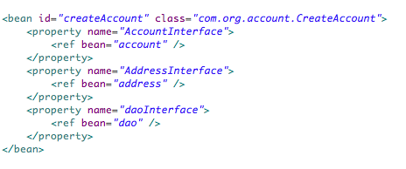**Code Segment 2.1: Property Components**

Suppose you do not want to implement the property component AddressInterface, then, you simply remove the xml configuration, as shown in Code Segment 2.2. The addition or deletion of a component does not affect the main class createAccount.

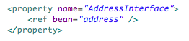

**Code Segment 2.2: Property Component AddressInterface**

* **Lazy initialization of objects:** In an application, you will need to initialize objects. The default initialization in Spring Framework is to pre-instantiate all Singleton beans defined in the ApplicationContext of the application. If this default initialization of the bean is not desired, then you can define the beans with a “lazy initialization”. Here, object creation happens upon the first reference to it by another object. Lazy initialization means that the object is not called upon until it is actually needed during application execution. This initialization is usually done using the properties file and extra coding. However, IoC features eliminate the need to read from a properties file.

For example, as shown in Code Segment 2.3, the first bean, which is defined with the “lazy-init=true”, is initialized only when Spring Framework comes across its first reference in the code. The bean that is defined as “not.lazy” is pre-initialized in the ApplicationContext of the application.

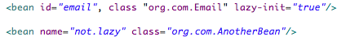

**Code Segment 2.3: Lazy Initialization of Objects**

You can also set the default initialization of all the beans in an application to lazy. This means that none of the beans are pre-initialized in the ApplicationContext, but only when they are referred to. This saves compilation time and memory space, keeping the application efficient. Code Segment 2.4 shows the setting of all bean initialization to “lazy”.

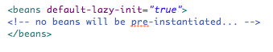

**Code Segment 2.4: Lazy Initialization of Objects**

* **No application server dependency**: IoC supports the creation and use of proxy objects, which act as codeless interfaces to access other objects. A proxy object functions as an interface to another object. The proxy is designed to interface all types of objects, such as a network connection, a large object in memory, a file, or another resource, which is costly or difficult to duplicate. Proxy objects avoid unnecessary code such as Java Naming and Directory Interface (JNDI) calls that allow applications to look up for objects on local or remote servers. Proxy objects are configured inside the Spring Framework container; they do not require additional coding to locate objects.

Therefore, IoC is a method of using control code to call on program code to perform a task. There are distinct advantages of using IoC in Spring Framework:

* IoC enables an appropriate method to focus on the task that it is meant for.
* IoC supports designing of a module with less dependency on the main code.
* Modules can be replaced without any side effects to the main code. Some of the side effects may be ripple effects of changes or more assembly or testing time due to the increased inter-module dependency. In IoC, it does not matter what happens within a code module as long as the user interface (UI) definition of the module remains constant, which means that the user should only see the result of an action and not how the action was performed.
* Modules are flexible with the implementation. For example, say a module of code is used to perform multiplication and addition on certain amounts. The module can first perform multiplication or addition based on the methods called. This is irrelevant to the outside world as long as the result obtained is accurate and in the right format.

**IoC Implementation in an Object-Oriented Language**

IoC is a process that reverses dependencies in an application to keep objects loosely coupled so that they do not lose their identity in the code. As object-oriented programming also focuses on the application objects rather than the code, it is feasible to integrate the two concepts to benefit from the advantages of IoC and OO programming. Let’s look at the techniques used in IoC implementation in an object-oriented programming language:

* **Service locator pattern:** The service locator pattern is a design pattern used in application development to bring together the methods used to obtain service with a strong abstraction layer. This pattern uses the "service locator" registry, which returns the necessary data to perform a certain task. This is an efficient mechanism to locate various services stored on a server. The first time a service is required; a service locator looks up the service in JNDI and caches the service object. Further lookup for the same service is done by the service locator in its cache. This enhances the performance of the application considerably as it prevents dependencies from being hidden and provides a global access to them so that you can manipulate dependencies based on the objective of your code.
* **Factory pattern:** This is used for creating loosely coupled objects or a class. The Factory pattern compresses object creation logic, which makes future modifications of applications easy. Every factory method is responsible for the dependencies it creates. Therefore, it becomes easy to track and change dependencies when they are implemented using the Factory pattern.
* **Dependency injection through setter injection:** This is used to implement user-defined DI. Here, you need to provide the setter method for each bean dependency. The advantage is that you can use the name, the type, or both for a dependency as an argument while defining the DI relationship between objects.
* **Dependency injection through constructor injection:** Here, the DI is implemented by defining the dependency in a constructor method of the object. This ensures that the object is always in a valid state. The advantage of using constructor injections is that for each class, you can create as many instances of dependencies as needed, using arguments.

**IoC Implementation in Spring Framework**

In Spring Framework, a bean is an object that is instantiated, assembled, and managed by a Spring IoC container. Let’s find out how IoC implementation is achieved using Spring Framework. Spring Framework’s IoC container is supported by the two following packages:

* **org.springFramework.beans**: This package provides basic functionality for managing and manipulating beans, usually used in a programmatic way.
* **org.springFramework.context**: This package adds the ApplicationContext interface, which extends the BeanFactory interface, in addition to extending other interfaces that support methods and behaviors that are more compatible with the framework being used. Table 2.1 lists the interfaces and their uses while implementing IoC in Spring Framework. These interfaces are used in the configuration mechanism to achieve basic and enterprise-specific functionality.

|  |  |
| --- | --- |
| **Method/Interface** | **Use** |
| **BeanFactory** | * Provides advanced configuration mechanism for managing objects of all types |
| **ApplicationContext** | * Helps in message resource handling * Enables event propagation * Provides application-layer specific contexts such as the WebApplicationContext for use in web applications |

**Table 2.1: Methods/Interfaces Supporting IoC implementation**

The org.springFramework.beans.factory.BeanFactory interface is the actual representation of the Spring IoC container and is responsible for containing and managing the beans of the Spring Container. In BeanFactory, commonly used method implementations are the **XmlBeanFactory** and **XmlWebApplicationContext** classes.

Depending on the definition of a bean, the factory will give either of the following:

* An independent instance of a contained object through the Prototype design pattern
* A single shared instance of the contained object, which supports multiple instances of the same class or, in other words, code reuse is supported. This is preferred to a Singleton instance of the bean, which limits the number of instances of a given class to exactly one.

The type of instance returned depends on the bean factory configuration and, in either case, the Application Programming Interface (API) will be the same.

Now that you have been introduced to beans, their dependencies specified in the configuration metadata, and how Spring container manages their life cycles, let us move on to understand how dependencies are established between objects. This will help you to understand how IoC is implemented in Spring Framework through DI.

**Dependency Injection**

A coherent application, small or big, comprises objects that work in a coordinated manner to achieve the intended purpose. It is important that objects maintain their individuality while collaborating together to achieve the application’s goal.

DI is the method used to implement IoC in Spring Framework. DI is a process that objects use to define their dependencies using one of the following procedures:

* Using constructor arguments
* Passing arguments to a factory method
* Injecting properties of an object instance

After the dependencies are established using any one of the listed methods, the Spring Framework’s container injects the dependencies to create a bean. Once the application beans are created, it is important to name them in a way that lets your application and developers recognize them clearly. This ensures that Spring Framework injects the right dependencies to the right beans when your application is executed.

**Naming Beans**

Every bean must have a unique identity so that it is easily recognized by the code for the purpose of DI. The custom is to use the standard Java convention for instance field names when naming the beans. As per this convention, bean names start with a lowercase letter and are then camel-cased. Instances of such names are accountManager, accountService, userDao, and loginController.

Beans are associated with one or more ids known as identifiers. An id is unique within a container where the bean is hosted. A bean having more than one id is said to have aliases.

In XML-based configuration of metadata, the bean identifiers are specified using the id or name attributes. The XML parser will allow only one id attribute. If there are many, they can be specified using commas (,), semicolons (;), or whitespace in the name attribute. A bean need not be named explicitly; the container generates a unique name implicitly.

**Aliasing Beans**

While defining a bean, you can provide multiple names for it based on its id attribute, and all these names are considered equal aliases. These are useful in situations where each alias can be used to define dependencies of the same bean to multiple components. To give a bean an alias, you need to write XML-based configuration metadata for the bean with aliases. This is done by using the <alias> element and then specifying the bean’s aliases within this section of bean definition. For example, <alias name=”fromName” alias=”toName”/> is a sample for aliasing beans. Code Segment 2.5 shows an example of naming and aliasing beans.

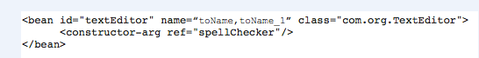

**Code Segment 2.5: Example of Naming and Aliasing Beans**

In Code Segment 2.6, the id=textEditor must be unique as per Java convention. To name an attribute with multiple values, you must separate it with a comma (,). The comma-separated values function as alias beans. In this example, the object is inserted as a constructor argument, since the constructor type of injection is used.

### Topic 2: Using XML for Configuration of Spring Beans

When a bean is configured, dependencies defined for it are also injected so that it performs its function when the application is executed. This can be done using XML-based configuration and injecting references to implement DI. Let us look at how this is done in Spring Framework.

**Injecting Bean References**

For a bean to play its role accurately, it needs to be injected with dependencies. DI is done using the constructor and setter methods and by referring a new bean as a property to the original bean. You can define bean properties and constructor arguments by defining references to other beans managed by Spring Framework using the XML property element’s ref attribute and constructor attributes. For defining such references, a number of sub element types are available in Spring Framework’s XML-based configuration metadata such as within its <property/> and <constructor-arg /> elements.

Key sub elements of the ref attribute are:

**The idref Element**

The idref element is an easy and precise method used to set a property to the ‘String id’ or ‘name’ of another bean in a Spring container to inject dependencies while configuring the bean.

Use the idref element to pass the id of a particular bean in the container to a <constructor-arg/> or <property/> element. Code Segment 2.6 shows where the ‘id’ of the target bean is passed to the <property/> element.

#### MAC HD:Users:sravankumar:Desktop:idref.png

**Code Segment 2.6: Using the idref Element for Bean Configuration**

Now, at run time, Code Segment 2.6 is exactly the same as Code Segment 2.7.

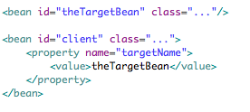

**Code Segment 2.7: Configuring Bean without the idref Element**

Let’s now consider the difference between Code Segments 2.5 and 2.6. In Code Segment 2.5, when the <idref/> tag is used, the container validates at run time that the referenced, named bean actually exists. However, in Code Segment 2.7, the container performs no validation on the value that is passed to the targetName property of the client bean. If any error, such as a typo, occurs, it will be discovered only when the client bean is instantiated.

Additionally, if the referenced bean is in the same XML unit, the local attribute is used, as shown in Code Segment 2.8. This allows validation of the bean id at XML document parse time and ensures that errors are caught early.

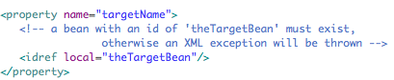

**Code Segment 2.8: Local Attribute**

**The ref Element**

Use the ref element to assign the value of a specified property within the <constructor-arg/> or <property/>definition element. This assignment sets the value of the specified property as a reference to another bean that is managed by the container or the collaborator. The referred-to bean is considered a dependent bean, whose property is being set, and it will be initialized as and when needed before its property is set.

**References**

References are calls from one object to another. The referencing method determines how scoping and validation of the object is done. There are three ways in which the id and name of the referenced object can be specified. The three ways include:

* **Using the bean attribute of the <ref/> tag:** The target bean is specified using the bean attribute of the <ref/> tag. This method is most commonly used and it helps in creating a reference to any bean in the same container or in the parent container.

<ref bean = someBean />

The value of the bean attribute can be the name or id attribute of the target bean.

* **Using the local attribute of the <ref/> tag:** The target bean is specified using the local attribute of the <ref/> tag.

<ref local = someBean />

The value of the local attribute should be the value of the id attribute of the target bean. If the values do not match, the XML parser will throw an error. Using the local attribute is considered the best method for referencing because if the target bean is in the same XML file, errors are caught early, by the parser itself.

* **Using the “parent” attributes:** The target bean is specified using the parent attribute, which allows referencing a bean located in the parent container of the current container. This method is useful when you have a hierarchy of containers and there is a need to wrap the present bean in the parent container with a proxy whose name is the same as that of the parent bean. The value of the parent attribute can be the id attribute or one of the name attributes of the target bean. Code Segment 2.9 shows the syntax for referencing a parent bean and Code Segment 2.10 shows the use of the syntax in a child bean context.

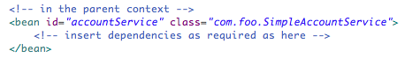

**Code Segment 2.9: Using the “parent” Attribute for Referencing a Bean**

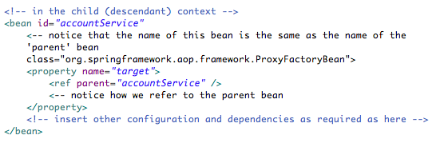

**Code Segment 2.10: Method 3 - Child Context**

**Inner Beans**

Intermittently, when a bean is just used as a property of another bean, it can be declared as an inner bean, and it may be useful to define the bean value inline rather than referring to a bean that is resident in another location in the BeanFactory.

Inner beans are defined by using the <bean/> element within the <property /> or <constructor-arg /> elements. An inner bean is defined, as shown in Code Segment 2.11.

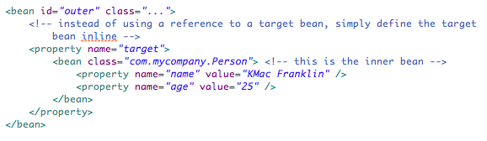

**Code Segment 2.11: Inner Beans**

It can be observed in Code Segment 2.11 that the id or name attribute and the scope flag are not mandatory. Inner beans are always anonymous and scoped as [prototypes](http://docs.spring.io/spring/docs/2.0.8/reference/beans.html#beans-factory-scopes-prototype) as they will not be reused anywhere else.

**Loading Multiple Spring Bean Configuration Files**

As modular programs are easy to build and maintain, it is a good idea to develop large projects as modular programs. In continuation with this idea, Spring Framework’s bean configuration files, which also contain configuration information for injecting beans, are placed in various folders for modularity and ease of maintenance. Table 2.2 lists a few examples of bean configuration files and the corresponding folders where they are located.

|  |  |
| --- | --- |
| **File Name** | **Folder** |
| Spring-Common.xml | Common |
| Spring-Connection.xml | Connection |
| Spring-Address.xml | Application |

**Table 2.2: Location of Bean Configuration Files**

Code Segment 2.12 shows the process for loading multiple Spring Framework bean configuration files.

ApplicationConext context = new

ClassPathXmlApplicationContext(new String[] {“Spring-Common.xml”,”Spring-Connection.xml”,”Spring-Address.xml”});

**Code Segment 2.12: Loading Multiple Spring Bean Configuration Files**

All Spring XML files should be under the project classpath, as shown in Code Segment 2.13.

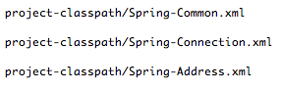

**Code Segment 2.13: Location of Spring XML Files**

However, placing Spring Framework’s bean configuration files in various folders means lack of organization of the files, which could lead to errors. The solution is to add all multiple bean configuration files into a single XML file. For example, you can first create the Spring-All-Application.xml file and then import all the bean files into it, as shown in Code Segment 2.14.

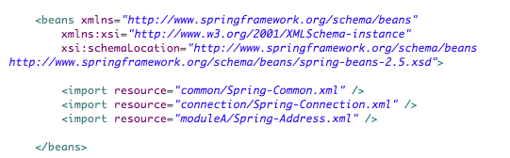

**Code Segment 2.14: Spring-All-Module.xml**

Next, a single xml file is loaded using the following code:

ApplicationContext context = new ClassPathXmlApplicationContext(Spring-All-Application.xml);

Finally, the file is placed under the project classpath.

Project-classpath/Spring-All-Application.xml

In this manner way, you loaded multiple Spring Framework bean configuration files under the project classpath while retaining the modularity of the application.

**Using External Properties in the Spring Configuration File**

Although the feature of loading multiple Spring Framework configuration files has the advantage of modular programming, it also has a drawback. Consider a situation where you want to change some value such as update the name in the address field. In such a situation, you will need to refer to the bean definition file that also contains all the bean definitions, possibly for several applications. This situation can be overcome by externalizing the properties in the Spring Framework configuration file. For any changes, you will need to modify the external file. To externalize the properties:

1. Consider the file Spring-Address.xml, which contains all the name values. All these values are moved to a property file called namesaddress.properties.

myAddress.name = XYZ

1. In the Spring-Address.xml file, define the PropertyPlaceholderConfigurer bean. This definition replaces the name value with their keys, as shown in Code Segment 2.15.

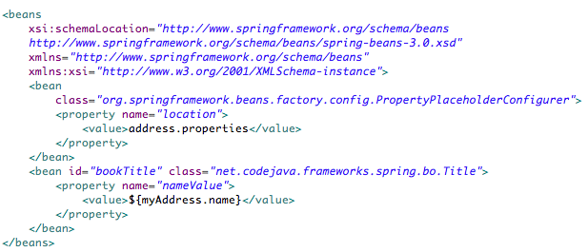

**Code Segment 2.15: Definition of PropertyPlaceholderConfigurer Bean**

In Spring Framework, you can combine the Spring bean configuration files with (XML) configuration files of the user or system administrator. For example, suppose there is an application with various beans and the Spring beans configuration is distributed in the WAR. This application contains settings that are user specific, such as SMTP server address. You can also have a Spring Framework configuration file defining some constants and include or import them in bean configuration files that uses these constants to configure the beans. This is shown in Code Segment 2.16.

**Code Segment 2.16: Defining Constant Values to Properties**

application context:  
<bean id="dataSource" class="org.springframework.jdbc.datasource.DriverM anagerDataSource">  
<property name="driverClassName"><value>${jdbc.driver}</value></property>  
<property name="url"><value>jdbc:${jdbc.dbname}</value></property>  
</bean>  
<bean id="dataSource" class="org.springframework.jdbc.datasource.DriverM anagerDataSource">  
<property name="driverClassName"><value>${jdbc.driver}</value></property>  
<property name="url"><value>jdbc:${jdbc.dbname}</value></property>  
</bean>  
<bean id="mail" class="examples.Mail">  
<property name="smtp"><value>{mail.smtp}</value></property>  
<property name="from"><value>${mail.from}</value></property>  
</bean>  
  
properties.xml:  
<properties>  
<jdbc>  
<driver>com.mysql.jdbc.Driver</driver>  
<dbname>mysql://localhost:3306/mydb</dbname>  
</jdbc>  
<mail>  
<smtp>localhost</smtp>  
<from>name@domain.com</from>  
</mail>  
</properties>

### Topic 3: Injecting Different Values

Now that you have learned how bean properties and constructor arguments are defined, let’s look at how the Spring Framework container injects different values.

**Using the <value> Element and the “value” Attribute**

Spring Framework converts primitive data types into java.utilities.Properties instances. Therefore, it is important to look at how primitive data types, such as String, are configured in Spring Framework. In Java, every variable has a type declared in the source code and primitive types contain values. There are eight primitive types:

* byte
* short
* int
* long
* char
* float
* double
* boolean

Using the <value/> element, you can define a property or a constructor argument as a decipherable string. JavaBeans PropertEditors converts these string values from a string to the actual type needed for the property or argument. Code Segment 2.17 shows the use of the <value/> element.

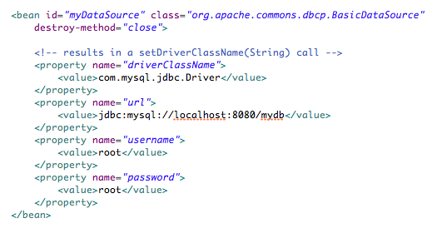

**Code Segment 2.17: Usage of the <value/> Element**

To enable structured configuration better than what the <value/> element achieves, you can use the value attribute supported by the <property/> and <constructor-arg/> elements. Code Segment 2.18 shows how Code Segment 2.17 can be rewritten using the value attribute.

**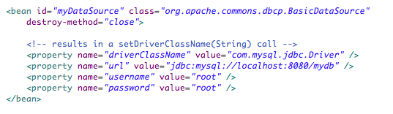**

**Code Segment 2.18: Use of the Value Attribute**

Generally, because it enables better configuration, which is easy to write, the value attribute shown in Code Segment 2.18 is preferred over the nested <value /> element shown in Code Segment 2.17.

However, there can be situations where the nested <value /> element may be preferred over the value attribute. Observe the configuration of an instance of the java.util.Properties class (a class that represents a static set of properties) in Code Segment 2.19.

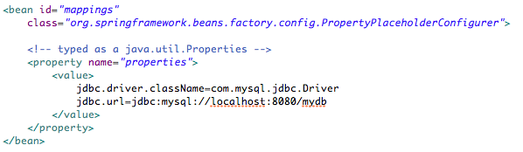

**Code Segment 2.19: Configuration of the java.util.Properties Instance**

In Code Segment 2.17, it can be seen that the Spring container converts the text inside the <value/> element to a java.util.Properties instance. This is done using the JavaBeans PropertyEditor mechanism. As this provides a shorter way for achieving bean configuration, the nested <value /> element is preferred over the value attribute style.

**Injecting Collections**

You have seen how to configure primitive data types in Spring Framework. However, in Spring Framework, collections are preferred over primitive data types for managing objects as they can pass multiple objects or a bundle of data such as lists, sets, or maps. This is useful when your application depends on a set of data objects such as lists and maps instead of single data objects such as numeric and string values.

The elements that allow multiple data collections to be transferred by initiating collections in XML configuration are:

* <list>: Enables injecting a list of objects, and allows proxy objects
* <map>: Enables injecting a bundled object as a collection of name-value pairs, in which the name and value can be of any type
* <set>: Enables injecting objects stored as a set of values, and does not allow duplication of objects
* <props>: Enables the injection of collections of objects as name-value pairs where the name and value are both of the type String

To add a value that belongs to one of the Spring-supported collections, you can use the <list/>, <set/>, <map/>, and <props/> elements inside the <property/> element. Code Segment 2.20 shows the use of collections in Spring Framework.

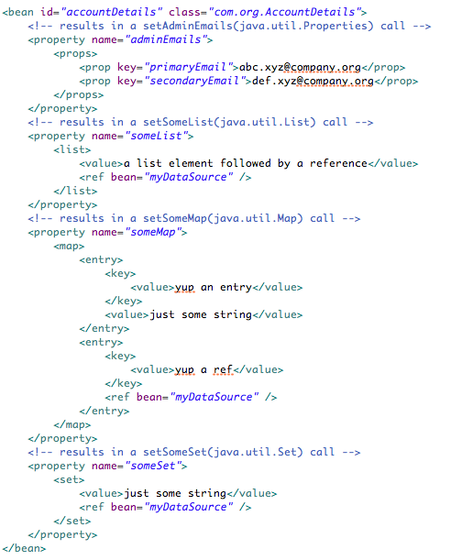

**Code Segment 2.20: Use of Collections**

**Collection Merging**

There are situations when the values of collections need to be combined. For example, a university database holding student information may contain multiple tables of information (such as personal details, medical records, course details, and financial records) related to each student. Each table contains data of many types such as string values for names, numeric values for tuition-related data, and so on. Collection merging enables an application developer to define the following parent-style elements to merge values.

* <list/>
* <map/>
* <set/>
* <props/>

The resultant child’s collection value is the merged value of the parent and child elements. This includes the overriding of the child’s collection elements in the parent collection. An example of the collection merging feature is shown in Code Segment 2.21.

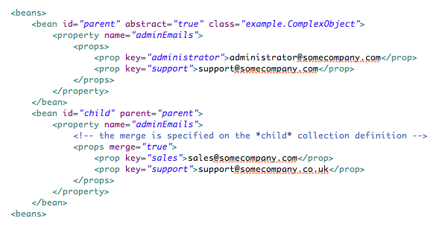

**Code Segment 2.21: Collection Merging**

The merge=true attribute is used on the <props/> element of the child bean’s adminEmailsproperty. When the child is instantiated, the instance will contain the adminEmails Properties collection, which is the result of merging of the child's adminEmails collection and the parent's adminEmails collection. This merged result is seen in Code Segment 2.22.



**Code Segment 2.22: The Merged Result of Code Segment 2.19**

In the result in Code Segment 2.22, the value set of the child Properties collection is inherited from the parent <props/>. This merging behavior is common to the <list/>, <map/>, and <set/> collection types. In the <list/> element, the semantics of the List collection type, which is the ordered collection of values, is maintained. In the case of the Map, Set, and Properties collection types, there is no organizing of the values.

**Note**: Different collection types, such as a map and a list cannot be merged, as it results in exceptions.

**Strongly Typed Collection**

As a Java user, you know that Java is a strongly typed language, which means, a variable, say of type int will always hold only int values. Therefore, you can declare a Collection type such that it can contain only String elements.

You can use Spring Framework to inject a strongly typed collection into a bean. To achieve this, Spring Framework has a type-conversion feature that helps in converting the strongly typed collection to the required type before being added to the collection. Let’s consider an example. Code Segment 2.23 and 2.24 demonstrate how the type-conversion feature is used to convert String type values to the Float type.

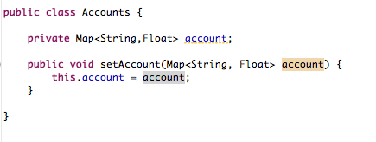

**Code Segment 2.23: Strongly Typed Collection Definition**

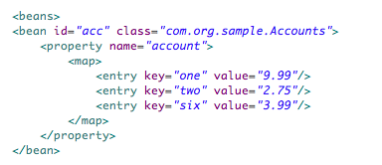

**Code Segment 2.24: Strongly Typed Collection Configuration**

In Code Segment 2.24, the account property of the acc bean is used for injection. The element type of the strongly typed Map <String, Float> is available via reflection. Now, Spring Framework’s type conversion infrastructure will recognize the various value elements of the Map element as being of the type Float and so its string values 9.99, 2.75, and 3.99 will be converted into the Float type.

In any application, classes are used to hold collections of objects and these are usually under the generic object interface. If objects are not grouped logically based on their type, you can face the following problems:

* The collection name or the class name does not specify the object’s use within the application
* Incorrect object types may be inserted in methods, leading to error and code failure.
* When object types have to be added later, it increases code volume and compilation time.

Therefore, when you use collection of objects here, all the elements must belong to the same type, and must be defined as a StrongyTypedCollection class. This helps you to clearly identify objects not only by index, but also by type, to ensure your application’s methods perform accurately.

**The Null Element**

The <null> element is used to manage null values. In Spring Framework, empty arguments for properties are treated as empty strings. In the example shown in Code Segment 2.25, the email property is being set to the empty String value (“ ”).

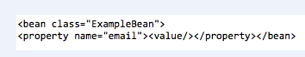

**Code Segment 2.25: Using the Null Element**

You may also use the <null> element to indicate a null value. For example, in Code Segment 2.26, the email property is being set to a “null” value.

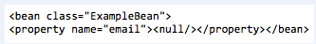

**Code Segment 2.26: Setting a Null Value**

These code segments demonstrate how to set an empty string value and a null value.

## Lesson 2: DI with Annotations

One way to implement Spring Framework object configuration is to write XML code to define the DI. However, this is time consuming and effort intensive. Therefore, a simpler and faster way to inject dependencies is to use annotations. Spring annotations are tags that can be added to classes or methods to define a specific configuration condition for those classes and methods. In this lesson, you will learn how to build an application using annotations and specify object configuration details using annotations.

### Topic 1: Purpose of Annotations

The most important task while using Spring Framework is to write configuration files to execute an application. A well-written configuration automatically updates any changes made in the code using autowiring and object mapping. These changes are then reflected automatically in the object and do not need manual intervention.

Spring configuration files can be written in two ways:

* Spring Framework 2.0: This version introduced the use of XML schema to write configuration files
* Spring Framework 3.0: This version introduced the use of annotations to write configuration files

Using XML schema made it difficult to navigate through complex configuration definitions written for each Java bean in an application. An example of an XML-based configuration is shown in Code Segment 2.27.

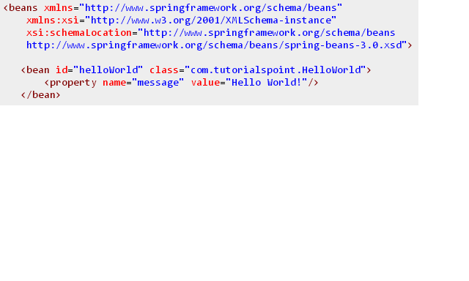

### Code Segment 2.27: Example of XML Configuration for Java Beans

As seen in Code Segment 2.27, each definition written between “<>” angle brackets is long and difficult to understand. This problem was solved using annotations.

### Spring Annotations

Spring annotations are simple tags that can be added for creating and injecting beans with their dependency definitions. Annotations are used during application bean configuration or object configuration to inject dependencies to Java beans and are written before XML injection. Key annotations in Spring Framework are listed in Table 2.3.

| **Annotation** | **Use** | **Description** |
| --- | --- | --- |
| @Autowired | Used as a constructor or a field or to annotate a method | Declares that an object (Constructor, field, or method) needs to be autowired by type |
| @Configurable | Type specification | Declares the component types whose properties are to be injected into Java beans.  Used to inject properties of domain objects |
| @Order | Type, method, field | Defined the order of interfaces and is used instead of the org.springframework.core.ordered interface |
| @Qualifier | Field, parameter type, annotation type | Declares that specified autowiring should be done by means other than type-based matching |
| @Required | Method | Specifies those properties that, when not injected, will result in configuration failure |
| @Scope | Type specification | Specifies the scope of a bean, whether it is Singleton, prototype, request, or session bean |

**Table 2.3: Spring Framework Annotations**

**Building an Application Using Annotations**

Let’s take up an example that shows how to build an application using annotations in Spring Framework. In this example, you are writing an application that acquires customer information for a bank account for validating the account information.

1. **Add dependencies to your pom.xml**: Adding Spring and JUnit Maven dependencies to the application’s POM. This is shown in Code Segment 2.28.

**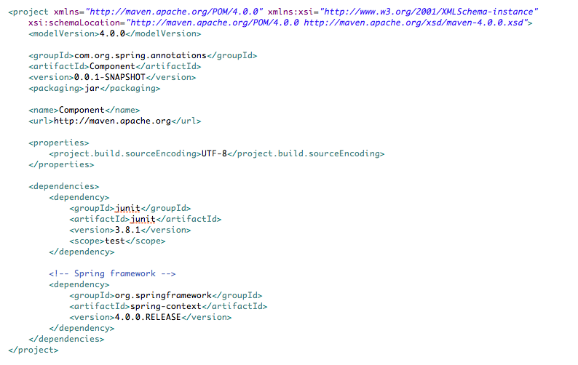Code Segment 2.28: Adding Dependencies to pom.xml**

1. **Create the service class**: For injecting dependencies, you need to have a service class to provide DI service. The AccountService interface class is created with a single method that validates the user account. This is shown in Code Segment 2.29.

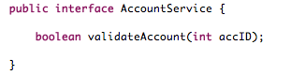

**Code Segment 2.29: The AccountServices Class**

1. **Create a use class or an implementation class**: The class AccountDetails.java is created to validate an account. This is shown in Code Segment 2.30.

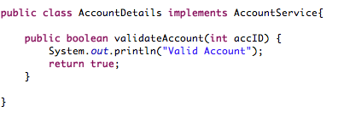

**Code Segment 2.30: AcoountDetails.java Class**

1. **Create component classes**: Now that the services and methods are ready, create a component class that holds account holder information. Here, annotations are used for autowiring DI. Code Segment 2.31 shows the MyApplication.java class, which is a component class.

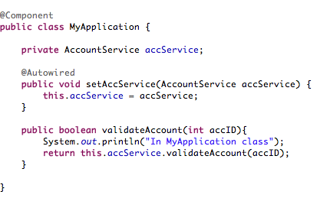

**Code Segment 2.31: MyApplication.java Class**

In the MyApplication.java class, you are using:

* The @Component annotation to declare the class MyApplication as a component.
* The @Autowired annotation to let Spring Framework know that autowiring is needed for the method setAccService.

In the above two instances, you are using method-based annotations in Spring Framework.

1. **Use Spring configuration with annotations**: To use an annotation-based configuration, you need to first create a configuration class that is used to inject the Java bean with the component property. This class is named DIConfiguration.java and is shown in Code Segment 2.32.

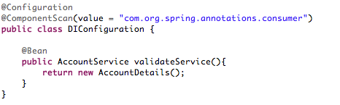

**Code Segment 2.32: The DIConfiguration.java Class**

Note:

* The @Configuration annotation used here declares this class as a configuration class.
* The @ComponentScan annotation used here specifies the application to look for the component class created earlier in Code Segment 2.32.

1. **Test the annotation-based DI**: Write a simple JUnit test case called App.java. In this test method, you:

* Use AnnotationConfigApplicationContext as the implementation of the abstract class AbstractApplicationContext. This autowires services to the components when annotations are used.
* Use the AnnotationConfigApplicationContext constructor. To do this, you pass the DIConfiguration class as an argument to get the bean implementation to inject in component classes.

1. **Run the application**: Using the getBean(class name) method, you can retrieve component objects and use the DIConfiguration class for autowiring the objects. Code Segment 2.33 shows the test case App.java.

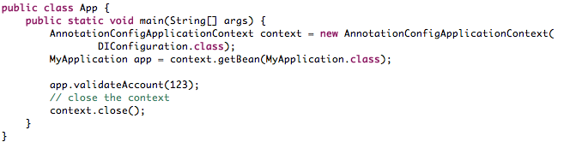

**Code Segment 2.33: Test Case App.java**

When the application App.java is run, you get the result shown in Figure 2.1.

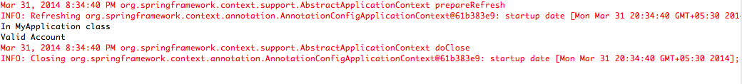

**Figure 2.1: Result for Running the Test Case App.java**

### Using Annotations in Multitier Applications

A multitier application holds one service in each tier for clarity and simplification of application management. There are different layers in a multitier application:

* Presentation layer
* Business layer
* Service layer
* Persistence layer
* Data access layer

Each tier or layer has its own specific annotations that are used to annotate classes so that Spring Framework can detect them automatically for configuration. This helps developers as each annotation performs work in a manner suitable to a particular layer. Hence, developers need not write separate code to locate configuration files. Some of the key annotations and the layers to which they belong are listed in Table 2.4.

|  |  |
| --- | --- |
| **Annotation** | **Corresponding Layer** |
| @Component | Is generic and can be used across layers |
| @Service | Annotates classes in the Service layer |
| @Controller | Annotates classes in the Presentation layer and is mostly used in Spring MVC |
| @Repository | Annotates classes in the Persistence layer and can be used as a database repository |

**Table 2.4: Layer-Specific Annotations**

**Topic 2: Spring Configuration Using Annotations**

Using annotations is a way of configuring your application without writing a lot of configuration code. You can set up transaction management, Spring MVC, or timers for your tasks by annotating your configuration classes. These concepts are covered in the later modules of the course.

Using annotations is possible because of the @Enable\* annotations in Spring Framework. In the following session, you will learn about the @Enable\* annotations and how they simplify a developer’s tasks by eliminating the need for lengthy configuration code. Let us look at how using annotations makes Spring Framework configuration processes quicker and simpler.

### @Enable Annotations

### The @Enable\* annotations have one design goal—to let you set up complicated functionality with as little coding as possible. These annotations also help in hiding code complexity to make your application readable. In other words, you can create and set up a lot of beans for your application and configure them without detailed knowledge of the beans. The Java BeanFactory is unaware of the @Enable annotations, and there are no dependencies defined between the core functionalities and annotations or the jars these annotations are stored in.

### Let us look at the different @Enable\* annotations.

* @EnableScheduling
* @EnableTransactionManagement
* @EnableAspectJAutoProxy

**@EnableScheduling**

This annotation lets you perform a specified method at a given time or repeat a method at a specified time interval. For example, in an application that manages payment from bank accounts, you can use @EnableScheduling to send the bill payment amount to a service automatically. Code Segment 2.34 shows the syntax for the @EnableScheduling annotation.

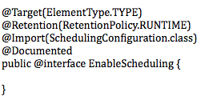

**Code Segment 2.34: @EnableScheduling Annotation**

Code Segment 2.35 shows another Spring Framework-specific annotation, @Import, which is used to import the class passed as its argument (which in this case, is the SchedulingConfiguration class). Code Segment 2.35 shows the main configuration code that calls upon the @EnableScheduling annotation.

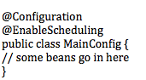

**Code Segment 2.35: MainConfig Code**

Since the MainConfig is annotated as @EnableScheduling, when the BeanFactory is parsing the file, it will also find the @Import(SchedulingConfiguration.class) annotation and import the class defined in the value. Here, the SchedulingConfiguration class is considered as an additional Java Spring bean.

SchedulingConfiguration is annotated as @Configuration, so that BeanFactory considers it like a configuration class and all the beans defined in that class get drawn into your application. Some beans that are defined in the SchedulingConfiguration class, which you treat as any regular bean during configuration, use an event to identify these beans. This is shown in Code Segment 2.36, where the method ScheduledAnnotationBeanPostProcessor uses a standard application event to find out when the application context is refreshed. It then checks to see whether any beans belong to the SchedulingConfiguration class, and if so, uses those beans to be configured.

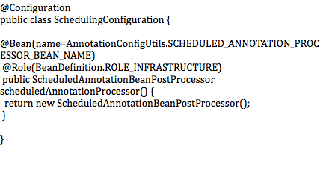

**Code Segment 2.36: Configuring Beans of the SchedulingConfiguration Class**

This code shows how the @Enable annotation uses @Import to draw in another @Configuration class and make all the beans in this class available for your application.

**@EnableTransactionManagement to Handle Inheritance-Based Proxies**

Suppose you want to load a new set of beans on the basis of certain configuration needed for your application. You can use @EnableTransactionManagement for this with a MainConfig class, as shown in Code Segment 2.37.

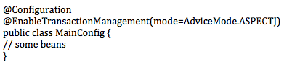

**Code Segment 2.37: MainConfig Class for the @EnableTransactionManagement Annotation**

You can also use @EnableTransactionManagement with an argument pass that shows which class is to be used for the method. Code Segment 2.38 shows a parameter being added to the @EnableTransactionManagement annotation.

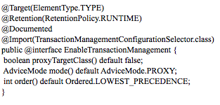

**Code Segment 2.38: @EnableTransactionManagement Annotation**

In this instance (Code Segment 2.38), the @Import annotation is importing the class TransactionManagementConfigurationSelector. This class implements the ImportSelector class, which in turn, allows your code to choose the configuration classes to load at run time. The TransactionManagementConfigurationSelector scans the mode and returns some classes based on the mode, as shown in Code Segment 2.39.

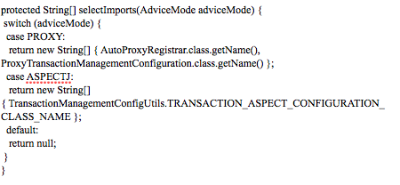

**Code Segment 2.39: Classes returned by TransactionManagementConfigurationSelector**

The @Configuration classes returned are loaded and configured to your application. You now know how to load a set of beans, which have been identified at run time, using the @ImportSelector and @EnabledTransactionManagement annotations. The next topic deals with the @EnableAspectJAutoProxy annotation.

**@EnableAspectJAutoProxy**

Suppose your application wants to deal with a Bean Registry (Factory) directly. To manipulate BeanFactory or work with beans at the Bean Definition level, you can use the @EnableAspectJAutoProxy with the MainConfig, as shown in Code Segment 2.40.

**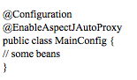**

**Code Segment 2.40: MainConfig for @EnableAspectJAutoProxy**

The syntax for using @EnableAspectJAutoProxy is shown in Code Segment 2.41.

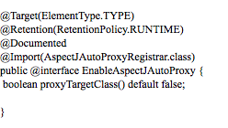

**Code Segment 2.41: @EnableAspectJAutoProxy**

Here, the @Import annotation is used to tag AspectJAutoProxyRegistrar, which neither is a @Configuration class nor does it implement ImportSelector. Instead, it implements the ImportBeanDefinitionRegistrar interface, which provides access to the BeanRegistry and annotation metadata so that you can manipulate the registry at run time, depending on the parameters specified. In this manner, you can use @Import to pull beans from the BeanRegistry into your application when using @Configuration classes is not enough.

### Best Practices for Using Annotations in Spring Framework

You can follow certain best practices while using annotations to inject dependencies in Spring Framework.

* **Discovery directive**: A discovery directive is a must for all annotations. You need to know which XML directives can discover annotations. You can ensure this by:
  + Registering individual Bean Post-Processors that can identify specific annotation categories as listed in Table 2.5.

|  |  |
| --- | --- |
| **Bean Post Processors** | **Annotations They Can Identify** |
| RequiredAnnotationBeanPostProcessor | @Required |
| CommonAnnotationBeanPostProcessor | @PostConstruct, @PreDestroy, @Resource |
| AutowiredAnnotationBeanPostProcessor | @Autowired, @Value, @Inject |
| PersistenceAnnotationBeanPostProcessor | @PersistenceUnit, @PersistenceContext |

**Table 2.5: List of Bean Post-Processors**

* + Using the annotation-config directive, which automatically registers the Bean Post-Processors listed in Table 2.5. This is a better way to use annotations than without the use of Bean Post-Processor registration as it allows you to initiate the use of more annotations in your application.
  + Using the component-scan directive that not only registers Bean Post-Processors but also scans for component annotations such as @Component, @Repository, and @Service.
* **Application component scanning**: Configuration elements that are not a part of your application should be excluded to avoid prolonged run time. This can be done using controllers that are a part of the application and deal with the UI but are not relevant to web services. An example of a controller is shown in Code Segment 2.42 within your applicationContext-bootstrap.xml file.

<context:component-scan

base-package="com.gordondickens.enterprisespring">

<context:exclude-filter

expression="org.springframework.stereotype.Controller"

type="annotation"/>

</context:component-scan>

**Code Segment 2.42: Controllers Used for Component Scanning**

* **MVC component scanning**: If your application serves a UI client and web service clients, then only the most suitable components must be discovered in the main application configuration. All the other components that are unnecessary must be removed. Code Segment 2.43 shows the use of controllers to remove unwanted components within your applicationContext-webmvc.xml.

**Code Segment 2.43: Controllers That Scan MVC Components**

<context:component-scan

base-package="com.gordondickens.enterprisespring"

use-default-filters="false"/>

<context:include-filter

expression="org.springframework.stereotype.Controller"

type="annotation"/>

</context:component-scan>

* **Component scanning** 
  + When an application context is created in Spring Framework, all the configuration files are collected into a single context, no matter how many there are.
  + Component scanning should be configured only in the bootstrap config file.
  + Be specific while specifying the packages that are to be scanned. Do not use “com” or “org” as this will scan all the existing packages and will take a long time.
  + Do not cross application boundaries while scanning for components.
* **Element references**: Use the scanning references listed in Table 2.6 by importing them to the applicatioContext-bootstrap.xml.

|  |  |
| --- | --- |
| **Scanning Reference** | **Elements** |
| applicationContext-services.xml | Used for scanning services |
| applicationContext-persistence.xml and applicationContext-webmvc.xml | Used for scanning persistence and entity beans |
| applicationContext-webservice.xml | Used for scanning web service beans |

**Table 2.6: Scanning References for Different Elements**

Using separate discovery files for different layers while configuring them will allow:

* Easier unit testing as the discovery of beans is more specific
* Separating the project into multiple jars/WARS
* Reducing the risk of discoveries that are not specific, over scanning, and multiple discoveries of the same beans, saving you time and debugging tasks

**Module Summary:**

In this module, you learned that IoC and DI are at the core of the Spring Framework design. IOC reverses the responsibility of managing the life cycle of Java beans, which makes writing your application code easier. DI is a method that supports IoC in Spring Framework and can be used to decouple objects for maintaining the portability and flexibility of your code.

You also learned about the annotations available in Spring Framework and how they can be used to implement DI. Using these annotations helps you to achieve complex goals by using simple coding syntaxes.

### References

Web references:

* [http://www.tutorialspoint.com/spring/spring\_injecting\_collection.htm](http://www.tutorialspoint.com/spring/spring_injecting_collection.htm" \t "_blank) (Last accessed 12 Apr 2014)
* [http://www.tutorialspoint.com/spring/spring\_injecting\_inner\_beans.htm](http://www.tutorialspoint.com/spring/spring_injecting_inner_beans.htm" \t "_blank) (Last accessed 12 Apr 2014)
* http://javarevisited.blogspot.com/2012/12/inversion-of-control-dependency-injection-design-pattern-spring-example-tutorial.html (Last accessed 8 Apr 2014)
* http://www.tutorialspoint.com/spring/index.htm (Last accessed 8 Apr 2014)
* http://docs.spring.io/spring/docs/3.0.0.M3/reference/html/ch04s11.html (Last accessed 8 Apr 2014)

Book references:

* Johnson, Rod; Hoeller, Juergen; Arendsen, Alef; Risberg, Thomas; Sampaleanu, Colin. (2005). *Professional Java Development with the Spring Framework.* In: Wiley Publishing, Inc.
* Walls, Craig. (2011). *Spring in Action-3rd edition.* Manning Publication Company.

# Module 3: Autowiring

**Module Overview:**

Java beans wiring is essential for implementing Dependency Injection (DI) while executing an application. The ApplicationContext container holds and manages all Spring Framework beans. It is in this container that all beans are autowired. By autowiring beans, you create an instance of one bean within a specific field of another, thus building a relationship between the two beans to inject a dependency. Autowiring beans can help you cut down on the amount of XML configuration you need to write for a Spring-based application.

In this module, you will learn about automatically wiring beans with each other and configuring the relationship formed because of this autowiring. You will also be introduced to the types of autowiring possible in Spring Framework and configuring autowiring when an application is executed. Additionally, you will learn how autowiring helps developers perform Inversion of Control (IoC) using DI to keep their applications portable and easy to manage.

**Module Objectives:**

By the end of this module, you will be able to:

* Use Spring autowiring.
* Perform autowiring configuration using XML and annotations.

## Lesson 1: Understanding Fundamentals of Wiring Beans

Using Spring Framework, you can refer one bean from another. This lets you to loosely couple application beans by injecting a dependency. This process is called wiring and when performed automatically by Spring Framework, it is called autowiring.

Let’s begin by exploring the concept of wiring and its purpose in a Java-based application developed using Spring Framework. Next, the concepts of autowiring dependencies into beans and autowiring beans in a Spring Framework-based application are covered.

### Topic 1: Wiring Spring Beans

The term “wiring” means connecting two application beans using DI in the Spring container. Your application code communicates to the container regarding the beans to be loosely coupled and wiring them using DI. The main purpose of wiring is to bring beans together logically and, at the same time, keep them independent of each other. Keeping beans independent is important in a Java-based application as it supports code reuse and allows for better unit testing of an application. Unit testing is a method of evaluating units, pieces, or modules of code to check whether they work the way they are supposed to.

Wiring beans in Java using Spring Framework serves a specific purpose. They define the logical relationship between beans that belong to the same domain. The steps to be performed while implementing autowiring are:

1. Declare beans that are to be wired.
2. Configure the beans that are to be wired.
3. Write the main class that calls the beans.
4. Wire the beans.

Let’s find out more about implementation of autowiring using an example. AB Bank, a multinational banking and financial services company based in Texas, United States, provides a range of banking services through its website. The applications that AB Bank uses run on Java and are built using Spring Framework.

One of these applications contains classes that hold account information and methods to retrieve and update account information for every customer. Suppose there are two classes named AccountDetails and AccountType, which you declare as beans in Spring Framework to manage them easily. Then, you can connect the AccountType class to the AccountDetails class as each account’s details also convey what type of an account it is, such as a savings account or a check-in account. To wire together the AccountDetails bean with the AccountType bean:

1. **Declare the beans**: Beans are declared using a specific format in the configuration files of your Spring Framework application. Code Segment 3.1 shows the bean declaration for the AccountDetails.java class.

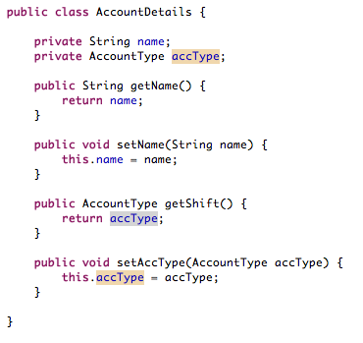

**Coded Segment 3.1: Declaring the AccountDetails.java Class**

Code Segment 3.2 shows the bean declaration for the AccountType.java class.

**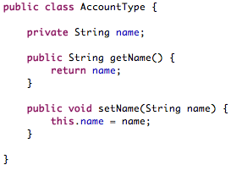**

**Code Segment 3.2: Declaring AccounType.java Class**

1. **Configure the bean using annotation.xml**: Configure the beans by defining all the parameters and methods for the bean that enable you to manage beans programmatically. Code Segment 3.3 shows how to set the configuration in the Spring-config.xml file.

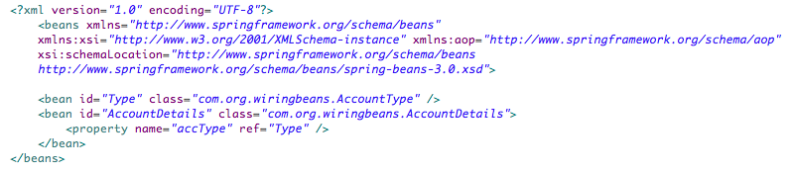

**Code Segment 3.3: Setting Configuration in Spring-config.xml**

1. **Write the main class**: Once the beans are configured, you need to call on the application to implement them. In other words, you execute the application by writing a Main class. Code Segment 3.4 shows the AccountDetailsTypeMain.java class.

**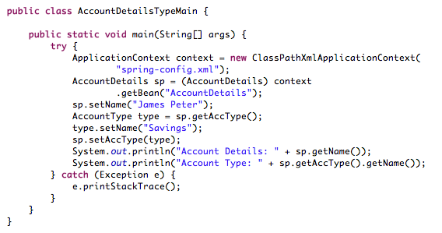**

**Code Segment 3.4: AccountDetailsTypeMain.java Class**

### Wire the beans: Wiring beans is done at run time. You wire beans by defining the DI between them in the code of the Main class. Here, you use inner beans to wire properties to the beans AccountDetails and AccountType. Inner beans are used when there is exactly one property to be wired to the beans, since inner beans are supported both in the setter injection property and the constructor injection constructor-arg.

### Using inner beans: Here, you declare one bean inside another to nest them instead of wiring them with an independent declaration. This is similar to nesting classes in an application where the classes have a logical relationship. To define an inner bean, you define the <bean> element of one bean in the <property> or <constructor> element of another bean.

1. **Configure the beans**: You configure the application using the innerBean.xml file, as shown in Code Segment 3.5.

### CS_3.8.png

### Code Segment 3.5: Configuring Using innBerbean.xml

1. **Wire using inner beans**: You nest the beans by writing the class InnerBean and declaring one bean inside the other. Here, you are defining the AccountType bean within the AccountDetails bean. This is shown in Code Segment 3.6.

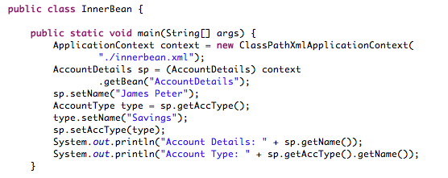

### Code Segment 3.6: InnerBean Class

### 

### Topic 2: Types of Autowiring

In Spring Framework, the Spring Container can autowire logical relationships between appropriate beans, as defined by a developer. Each bean has autowiring defined specifically for it. This means that autowiring can be enabled for some beans in your application but not for others. You can specify the type or method by which autowiring can be applied to your beans by specifying the mode in which autowiring must be done. Spring Framework then matches the specified bean by its type, name, or constructor and uses autowiring to inject dependencies to the bean. When defining beans, you can specify the mode for autowiring in the <bean id> element.

There are five modes in which the autowiring functionality can be implemented in Spring Framework, as listed in Table 3.1.

|  |  |
| --- | --- |
| **Autowiring Mode** | **Description** |
| No | Is the default mode set manually and it means that there is no autowiring to be performed. |
| byName | Looks for the bean that has the same name as the property to be autowired and is passed as an argument to byName. |
| byType | Looks at the bean type as specified by the argument passed to byType in the XML configuration file. Autowiring is performed if there is exactly one bean with the specified type in the container; otherwise, a fatal exception is thrown. |
| constructor | Is similar to the byType mode and is applied only to constructor arguments. Autowiring is performed if there is exactly one bean that matches the constructor argument type; otherwise, a fatal exception is thrown. |

### Table 3.1: Modes of Autowiring in Spring Framework

Let’s take up an example that illustrates the use of these modes. To specify the autowiring mode, begin by declaring beans for wiring.

* In this example, let’s declare beans named AccountWithoutAnnotations and AddressWithoutAnnotations. Code Segment 3.7 declares the bean AccountWithoutAnnotations.

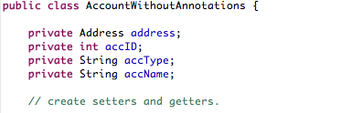

### Code Segment 3.7: AccountWithoutAnnotations

Code Segment 3.8 declares the bean AddressWithoutAnnotations.

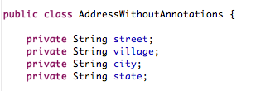

### Code Segment 3.8: AddressWithoutAnnotations

Next, let’s set autowiring for the beans declared in Code Segments 3.10 and 3.11 in different modes:

* **Autowiring using no**: By using the no mode, you can exclude a bean from being wired so that this bean remains independent throughout your application. Code Segment 3.9 demonstrates autowiring in the no mode, which is done using the ref attribute.

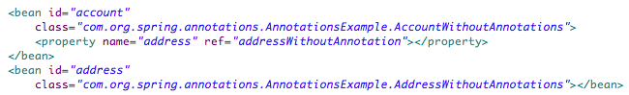

### Code Segment 3.9: Autowiring in the no Mode

* **Autowiring byName**: Code Segment 3.10 demonstrates autowiring using the byName mode, which is used when you want to specify the bean to be wired by its name. In this situation, the name of the address bean is the same as the name of the account bean’s property (address). Therefore, Spring autowires it using the setter method—setAddress(AddressWithoutAnnotation address).

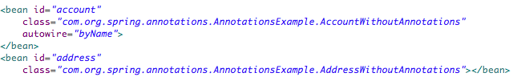

### Code Segment 3.10: Autowiring byName

* **Autowiring byType**: You use the byType mode to specify the bean to be wired by its type, as shown in Code Segment 3.11. Here, the data type of the address bean is the same as the data type of the account bean’s property (AddressWithoutAnnotation object). Therefore, Spring autowired it via the setter method—setAddress(AddressWithoutAnnotation address).

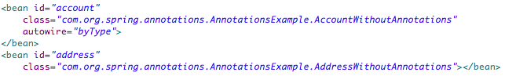

### Code Segment 3.11: Autowiring byType

* **Autowiring using constructor**: When you want to specify the bean to be wired by using the constructor it was created with, you use the constructor mode of autowiring, as shown in Code Segment 3.12. Here, the data type of the address bean is the same as the constructor argument data type in the account bean’s property (AddressWithoutAnnotation object). Therefore, Spring autowired it via the constructor method—public AccountWithoutAnnotation(AddressWithoutAnnotation address).

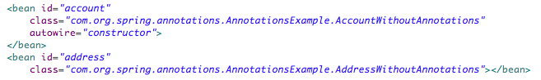

### Code Segment 3.12: Autowiring Using constructor

### Invoking Autowiring

Autowiring byType or byName are not default processes and can function only if they can find suitable properties to inject into the target beans. However, they can be instantiated in two ways:

* By using the @Required annotation in the setter method for XML-based configuration
* By setting the @Autowired annotation’s required attribute to true for annotation-based configuration

When using the constructor mode of autowiring, Spring Framework attempts to identify a bean to call its constructor and throws NoSuchBeanDefinitionException if it cannot find the target bean. In addition, it does not inject a Null value. A setter-based injection simply ignores the dependency, unlike the autowire constructor.

When a class has a constructor with arguments and another constructor without arguments, Spring Framework calls the no-argument constructor by default and no dependencies are injected.

### Limitations of Autowiring

Autowiring is at its best when used consistently across a project as wiring only a few beans may cause confusion. Implementing autowiring in Spring Framework speeds up development, but also has a few limitations associated with it, such as:

* Autowiring adds complexity to the bean configuration file as it is not easy to identify which bean is wired to which bean. This is because once the autowiring dependencies and properties have been configured, they are not easily accessible. To make any changes, you need to manually parse through the code to locate the dependencies and properties.
* Primitive data types such as strings and classes cannot be autowired.
* It is easy to override autowiring when writing dependencies in your code by tags such as <constructor-arg> and <property>. This means that if you have the <property> tag in your application, any autowiring you have initiated may be useless and is overridden.

It is in fact preferable not to use autowiring as it is not as explicit as user-defined wiring. User-defined wiring helps you to customize wiring through the use of qualifiers. As the name suggests, a qualifier checks whether a bean or a property qualifies for the specified wiring task. This can be done using the @Qualifier annotation, which is discussed in the subsequent topics.

## Lesson 2: Configuring Autowiring Using XML and Annotations

### To execute a component, a property, or a method, it is important to first configure it to desirable run-time conditions. Configuring autowiring allows you to set the conditions for DI during run time so that the beans can be kept independent of each other until it is the right time to execute them in your application code. In this manner, you can manage how the dependencies are being injected into the beans in your application. While configuring autowiring, the metadata needed for it is supplied in a simple XML format, which can be used during execution.

### Autowiring in Spring Framework can be configured using any of these two methods:

* XML-based configuration
* Annotation-based configuration

Let’s find out more about each of these two methods.

### Topic 1: Configuration of Autowiring Using XML

When using XML-based configuration for autowiring, your application beans are configured as <bean/> elements inside a top-level <beans/> element. In addition, autowire mode for the bean definition is specified by using the autowire attribute of the <bean/> element.

You can also exclude a bean from being available for autowiring using an XML-configuration format. To do this, when defining the bean, set the autowire attribute “autowire-candidate” of the bean to “false.” Code Segment 3.13 shows an example of autowiring using XML in Spring Framework.

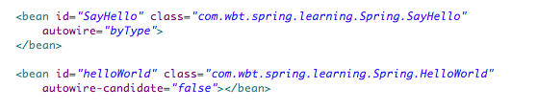

**Code Segment 3.13: Example of XML-Based Autowiring Configuration**

### Topic 2: Configuration of Autowiring Using Annotations

From Spring Framework 2.5, it has become possible to use annotations for autowiring through annotation-based DI. Annotations help move bean configuration into the component class. Using annotations for configuring DI reduces the amount of code you need to write for the configuration files when compared to XML-based configuration and is therefore considered a better method.

Annotations can be used to configure the autowiring of properties for your application beans to achieve DI and IoC. Annotations are easier to read and write and quicker to execute compared to XML-based configurations. However, annotation-based autowiring is not available by default in the Spring container. To get annotation-based configuration, you need to include the configuration files shown in Code Segment 3.14 in your Spring Framework application.

**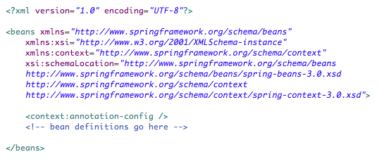**

**Code Segment 3.14: Files Necessary to Enable Annotation-Based Configuration**

You can use annotations in your code to indicate that the Spring container should automatically wire values into your beans once the <context:annotation-config/> files are configured. The annotations that you can use to configure autowiring are listed in Table 3.2.

|  |  |
| --- | --- |
| **Annotations** | **Description** |
| @Required | Is applicable to only bean property setter methods |
| @Autowired | Is applicable to bean property setter methods, nonsetter methods, constructors, and properties |
| @Qualifier | Is used to specify the exact bean to be wired |

**Table 3.2: Annotations for Autowiring Configuration**

Let’s take up an example that illustrates how annotation-based autowiring configuration works. Suppose there is a class Account bean, which has been declared in the bean configuration file of your application. This Account class holds the fields, account name, id, type, and address of the account holder. The address field of the Account class is being autowired using annotations—let’s sees how.

**@Autowired**

In the first instance, you use the @Autowired annotation to configure the Address bean wiring. To enable your application to use the @Autowired annotation, you need to first register AutowiredAvvotationBeanPostProcessor in one of these two ways:

* Include <context:annotation-config /> in the bean configuration file.
* Include AutowiredAnnotationBeanPostProcessor directly in the bean configuration file.

The configuration file for using the @Autowired annotation is shown in Code Segment 3.15.

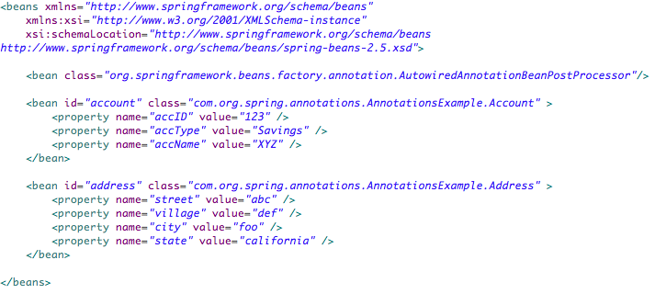

**Code Segment 3.15: Configuration File for Using the @Autowired Annotation**

In Code Segment 3.15, the class Address is the component being autowired. This class is shown in Code Segment 3.16.

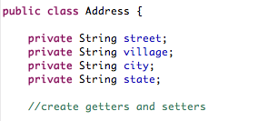

**Code Segment 3.16: Address Class**

The Address class bean shown in Code Segment 3.19 can be autowired using @Autowired applied to a setter method, a constructor, or a field.

* Using @Autowired applied to a setter method is shown in Code Segment 3.17.

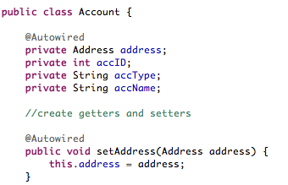

**Code Segment 3.17: @Autowired Using the Setter Method**

* @Autowired applied to a bean constructor object or class is shown in Code Segment 3.18.

**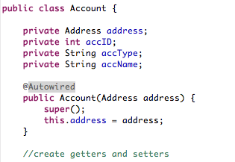**

**Code Segment 3.18: @Autowired Applied to a Constructor**

* @Autowired applied to a field is shown in Code Segment 3.19.

**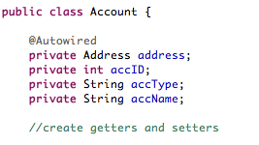**

**Code Segment 3.19: @Autowired Applied to a Field**

By default, the @Autowired annotation injects dependencies using the byType mode of autowiring.

**@Qualifier**

The @Qualifier annotation helps you to control the bean being wired when there are several similar beans. For example, suppose there are two similar Address beans, address and address1, with the configuration file, as shown in Code Segment 3.20.

**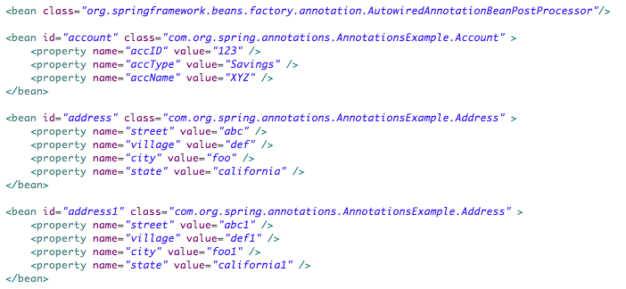**

**Code Segment 3.20: Configuration of Two Similar Address Beans**

In this situation, your application needs multiple beans of the same type as there can be multiple account holders, each having a unique address field. However, you need to wire only one particular address with a property to target a particular account holder. Here, using the @Qualifier annotation along with the @Autowired annotation resolves confusion regarding the address to choose for wiring. The @Qualifier annotation is used by applying it to a particular field or a parameter to filter out the bean to be wired with a property.

Code Segment 3.21 shows how to use the @Qualifier annotation to autowire the bean address1 to the Account’s address property.

**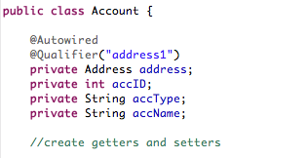**

**Code Segment 3.21: Using @Qualifier**

By using @Qualifier and @Autowired together, you can inject dependencies byType and byName.

**@Required**

To specify that a particular bean property must be included during configuration, you use the @Required annotation. The @Required annotation specifies a property through an explicit property value in the bean definition or by using autowiring. The Spring Framework container will throw an exception if the affected bean property has not been included in the configuration list. The @Required annotation is used to debug large applications where it is difficult to pinpoint NullPointerExceptions caused due to improper injection of dependencies. Code Segment 3.22 is an example showing the use of the @Required annotation while autowiring beans.

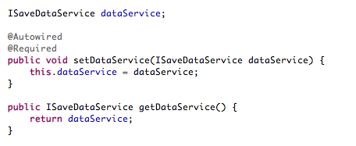

**Code Segment 3.22: @Required Annotation**

**Module Summary**

This module introduced you to the concept of autowiring, which is wiring Java beans to each other to implement DI while executing an application. The process of autowiring is performed by Spring Framework in different modes, which determine how dependencies are injected into components included in a bean’s definition.

You also learned how to configure autowired dependencies using XML-based and annotations-based configurations. Annotations-based configurations enable you to perform the same task as XML configurations, but with less coding and are therefore preferred over XML-based configurations. Therefore, using annotations keeps your code easy to read, write, and manage.

### References

* Web references:
* http://docs.spring.io/spring/docs/3.0.0.M3/reference/html/ch04s03.html#beans-factory-autowire (Accessed 14 Apr 2014)
* http://www.tutorialspoint.com/spring/ (Accessed 14 Apr 2014)
* Book references:
* Johnson, Rod; Hoeller, Juergen; Arendsen, Alef; Risberg, Thomas; Sampaleanu, Colin. (2005). *Professional Java Development with the Spring Framework.* In: Wiley Publishing, Inc.
* Walls, Craig. (2011). *Spring in Action, 3rd Edition.* Manning Publication Company.

# Module 4: Spring MVC

**Module Overview:**

Trygve Reenskaug first described the Model View Controller (MVC) design pattern in 1979 and it was initially aimed at desktop computing. Since then, the MVC design pattern has evolved as architecture for web applications in the Java Programming Language and is also commonly used in object-oriented programming. The purpose of the MVC design pattern is to separate the components of a web application so that they are easier to manage.

Spring MVC is the web component of Spring Framework, which enables you to build dynamic and flexible web applications, by implementing the MVC design pattern. Using the MVC framework, you can ensure rich functionality such as usability, efficiency, and speed in development for your web applications and create objects that are loosely coupled, which helps in unit testing. Spring MVC also offers many built-in classes that simplify development of web applications and require fewer configurations for development. Also, it is easy to integrate Spring MVC with other web frameworks such as Struts and Java Server Faces (JSF).

This module introduces you to the MVC design pattern and Spring MVC and its architecture. You will learn how to build web applications using the built-in classes of Spring MVC, in addition to the annotations that support these classes to provide MVC design pattern implementation.

**Module Objectives:**

By the end of this module, you will be able to:

* Describe the architecture of Spring MVC.
* Develop web applications using Spring MVC.
* Identify annotations supporting Spring MVC.

## Lesson 1: Spring MVC Support

Spring Framework supports the model-view-controller (MVC) architecture with ready-made components such as handlers and controllers that are used to create web applications. The Spring MVC separates the components of a web application such as input logic (model), business logic (controller), and UI logic (view) to keep them independent of each other. This design pattern, therefore, simplifies unit testing of the application and helps in maintaining the integrity of the code. Another advantage of using this design pattern in your web application is that project-related information is presented using formats that are easy to read and comprehend.

This lesson introduces you to the MVC design pattern, which helps in building a flexible and reusable web application. You will also learn about the components and features of this design pattern so that you can implement it in Spring Framework.

### Topic 1: Introduction to MVC

The MVC design pattern separates the concerns in the presentation layer of an application into various components, with each component having its own functions. This is an advantage as the loose coupling between the three main components helps you to work on all three components simultaneously, enabling parallel development.

### Components of MVC

The MVC design pattern separates the components of an application into three main types—model, view, and controller—and defines the relationship between them. Let’s find out more about each of these types.

* **Model**: Implements the logic required for application data and is responsible for managing and maintaining data, which is usually Plain Old Java Objects (POJOs).
* **View**: Represents an application’s user interface. It generates an output for you on the basis of the information passed on by the controller and data changes gathered from the model.
* **Controller**: Controls the interaction between the model and the view, that is, the interactions between the application data and how the data is perceived by you. The controller handles user interaction, works along with the model, and selects a view that displays the user interface. The controller passes on commands:
* To the model to update the data state
* To the view to update the presentation of the view on the basis of the changed state of the model

To summarize, the model passes on information about changes in the data state to the views and controllers. As a result, the views update their presentation and controllers change the available set of commands. At times, instead of waiting for information, the other MVC components poll the model to get updates.

Figure 4.1 shows the interactions among the three components of the MVC design pattern.

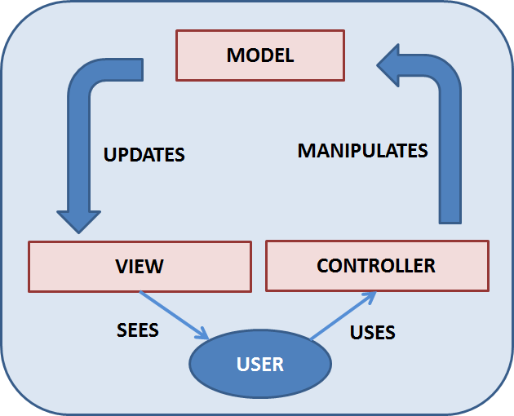

**Figure 4.1: Three Components of the MVC Design Pattern**

Figure 4.1 shows the flow of tasks and data in the MVC design pattern implementation using a model, a view, and a controller. You can trigger an event, which causes the controller to manipulate the data in the model. The model is updated and the changes are sent back to the view, which then updates itself with the latest data from the model.

In a web application, you can trigger an event by raising a request. The application then updates and renders the view that is returned to the user. Therefore, rather than pushing the changes to the view, here the need is to pull the changes from the server. However, in a web environment, the flow of tasks as seen in MVC design pattern, does not work due to the nature of the Hypertext Transfer Protocol (HTTP). The web does not have a data state (the web server does not retain data about user requests), so pulling changes using a model is not easy, as the model works on the states of data it controls.

The solution is to implement the MVC design pattern for the web as Model 2 architecture. This means that instead of directly sending your requests to the controller, you use a front controller, also called a Servlet engine. The front controller communicates the incoming requests to other controllers in the MVC design pattern, which in turn, handles the incoming request, returns it to the model, and finally selects a view. Figure 4.2 shows the front controller implementation.

**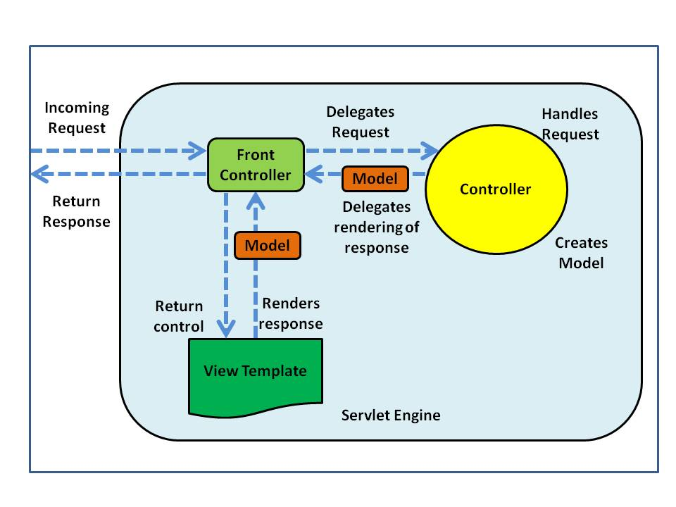**

**Figure 4.2: Model 2 Architecture**

In Figure 4.2, the Servlet engine (or the front controller) is the component that handles incoming requests. To start with, the request is delegated to an appropriate controller. The controller processes and updates the model. When this activity is completed, the front controller determines which view to render based on the response from the controller. Usually, this front controller is implemented as the javax.servlet.Servlet Servlet.

### Benefits of the MVC Design Pattern

The main benefits of using the MVC design pattern include:

* **Separation of concerns**: The separation of the model, view, and controller within your web application allows the reuse of business logic across the application. For example, when a view is separated from the controller, it enables the controller to call on multiple views rendered to reflect every change in the data model. Similarly, a separate controller can handle requests from different presentation layer views. As a result, a single application can present multiple views to multiple users in a format that can be unique to each user.
* **Loose coupling between layers**: Loose coupling of the different layers of the application reduces the dependency between them, and as a result, any change in one layer will not affect the other layers (such as the service, persistence, data access, and UI layers). For example, if you need to change the technical stack used in the database layer from SQL to NOSQL, then you can change the code only in the database layer. Loosely coupled components in an application also simplify testing of the code, especially unit testing.
* **Easy code maintenance:** The separation of concerns allowed by the MVC design pattern enables you to separately develop multiple user interfaces without accessing the business logic code bases. By separating concerns, you can reuse methods and objects in multiple components, which reduces the work needed to maintain a project. In addition, when you separate the web-based code from the main business logic, you can protect the integrity of the application.

### MVC Design Pattern Application Layers

In Spring Framework, its own MVC design pattern is available to you for developing Java-based enterprise applications. In this design pattern, the application is physically separated into different layers. These are:

* **The domain layer**: Contains the business rules for the application’s domain and is therefore the most important layer in any application. The business rules included in the domain layer consist of domain entities, value objects, and domain services and events.
* **The user interface layer**: Presents the application to the user, by displaying server responses in the format and design requested by the user client. The user interface is usually dependent on the domain layer to retrieve data to be presented to the user in the view of the application.
* **The web layer**: Performs two key functions—guides the user through the web application and integrates the service layer and HTTP. A simple example of guiding the user through a web application or a website is mapping a URL to views. This navigation function occurs only in the web layer. The navigation logic is not found in the domain or service layer, and the web layer does not contain any business logic.

The web layer is too thin to carry out functions between services such as managing HTTP requests and returning server responses to the UI. The thin web layer converts the incoming HTTP request to a form that can be handled by the service layer, which then transforms the server response into a user interface response. The web layer contains cookies, HTTP headers, and HTTP sessions and is responsible for managing these consistently and efficiently. Topics like views, mapping, and more details about the web layer are discussed in Lesson 2 of this module.

* **The service layer**: This layer is at the heart of any application as it is used to define and implement the service interface, which contains all the code related to services offered by the application (such as a form-filling service or a search engine) and have been developed using the Spring Framework. The service layer makes the functions of the application available through the use of APIs. The service layer acts as a single point of entry for the whole system or business logic. This layer is usually kept stateless, thus making it thread safe, which means that the service layer is not affected in any way if multiple tasks are run on it by the application.
* **The data access layer**: This layer is the part of a web application that provides simplified methods to access the data held in a persistent storage object like a relational database. Having a separate data access layer in your application is useful as it helps you mock or stub data objects when running unit tests for your application. Spring Framework supports many data access frameworks such as Java Database Connectivity (JDBC), Java Persistence API (JPA), Hibernate, and Java Data Object (JDO), thus enabling transaction management, resource handling, and exception translation for your application, making it easier to use and keep free of errors.

Figure 4.3 shows the different application layers in the Spring MVC.

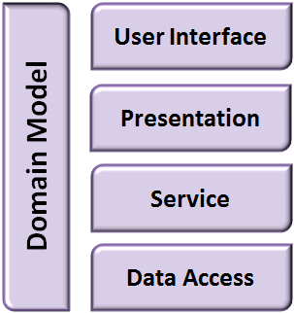

**Figure 4.3: Spring MVC Application Layers**

You are aware of the different layers in which the MVC design pattern divides an application. Next, let’s find out how all the layers in an application interact with each other. Figure 4.4 shows commonly used web application design, which explains the interactions between the layers of a web application.

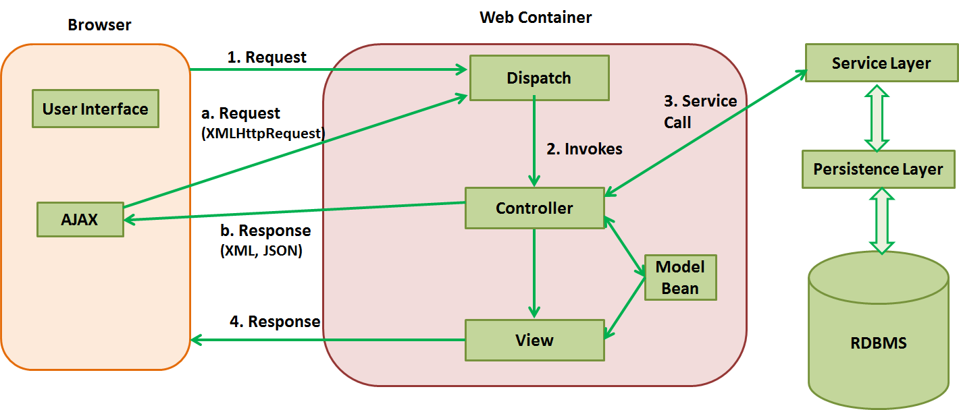

**Figure 4.4: Web Application Design Pattern**

As shown in Figure 4.4, the steps performed while handling a normal view request from a web application are:

1. A submission of the request is made to the web server. On the server side, a dispatcher, which is usually a Servlet, handles such requests.
2. Based on how the web application is configured and the HTTP request information, the dispatcher forwards this request to the appropriate controller.
3. The controller interacts with the service layer during the service call.
4. Based on the response generated, the controller updates the model and returns the corresponding view to the user. Inside a view, Asynchronous JavaScript and XML (AJAX [Web development techniques]) calls occur continuously. For example, when a user browses data on a website and clicks to go to the next page, Asynchronous Java Script and XML (AJAX) enables partial page upload by generating a request and a response.

* **Request**: An XMLHttpRequest is generated by the UI in the web browser and submitted to the server from where the dispatcher forwards it to the corresponding controller.

**Response**: The controller interacts with the service layer and the response received is formatted and sent to the browser, which performs a partial update of the existing view

You learned that in Spring Framework, the MVC module provides extensive support for web applications, simplifying the implementation of the presentation layer. Next, you will learn about the Spring MVC architecture.

### Topic 2: Spring MVC Architecture

An MVC framework such as Spring MVC or Struts works around a central Dispatcher Servlet that acts as a middle man between the users and the MVC framework-based application. Any Dispatcher Servlet accepts the web request from a UI and redirects it to the correct handler or container to process the request and provide the appropriate response.

The DispatcherServlet in Spring MVC sends requests to controllers and is fully integrated with the Spring IoC container. The DispatcherServlet is also equipped with the following features:

* **Controller mappings**: The controller component of a web application accepts requests from the UI or a web browser and returns the server response to the request back to the UI. Controller mapping is the process where the requests are matched with their corresponding views and request handlers to ensure that the user requests are handled correctly. Your application’s default controller is a simple Controller interface, which offers the ModelAndView handleRequest(request,response) method.
* **View resolution**: The representation of user information by a web application is seen in the view. It can be resolved, which means that it is created in the format specified in the web request by the controller.
* **Locale and theme resolution**: The DispatcherServlet binds request locale and theme resolvers to a request sent to it. In other words, when a request comes in, the DispatcherServlet collects data regarding the location of the request such as the date format, currency, and language. By doing this, the DispatcherServlet initiates elements that provide locale-related data and themes for rendering the response view, ensuring that the view is well presented in the UI.
* **Support for uploaded files**: You can customize Spring Framework’s DispatcherServlet by using parameters in the initialization of the DispatcherServlet. This helps you to initialize the request handling process, indicate where in the application you can find the appropriate context for the request, and set a namespace for the Servlet to identify it as a component unique to your application.

### Differences Between Spring MVC and Other Frameworks

Spring MVC differs from other frameworks such as Struts or WebWork; these differences are listed in Table 4.1.

|  |  |
| --- | --- |
| **Spring MVC** | **Struts Frameworks** |
| Controllers are a subclass of the framework itself, so you do not need to implement and configure multiple interfaces. | Controllers are a subclass of a base controller class and must be implemented and configured every time a new controller is used. |
| Any object can be treated as a command or a form object and does not need framework-specific interfaces. Therefore, you can reuse objects as necessary. | Objects used here are framework-specific and cannot be used as command or form objects, unless they extend specified base classes. |
| Data binding is flexible and there is no need for duplicating data beans as they can be reused. | Objects are built around base classes. Therefore, when the objects are bound to properties, it is necessary to bind the interfaces too, and this requires extensive coding. |
| IoC simplifies unit testing of applications. | Unit testing is not possible as IoC is not extensive. |
| It integrates with many view options such as JavaServer Pages (JSP), Tiles, and Velocity, to help you provide a UI view that is best suited to the user’s request. | The facility of integrating with view options is not provided. |

**Table 4.1: Differences Between Spring MVC and Struts Frameworks**

### 

### Features of Spring MVC

Some of the notable features of Spring MVC are:

* There is a clear separation of roles with a dedicated object for each role— controller, validator, command object, model object, form object, DispatcherServlet, view resolver, handler mapping, and others.
* You can configure both the framework and the application classes as JavaBeans. This configuration enables easy referencing across contexts.
* Instead of a single controller, any existing controller subclass such as command, form, wizard, multi-action, or a custom controller can be used.
* To extend a particular framework base class, the existing business code or business objects can be reused as commands or objects instead of duplicating them.
* Binding and validation of beans can be customized. For example, type mismatches can be customized as application-level validation errors.
* Handler mapping and view resolution can be customized. The strategies of handler mapping and view resolution include simple URL-based configuration and complex purpose-built resolutions.
* Locale and theme resolution can be customized.
* The flexibility of model transfer through a name or a value Map enables easy integration with any view technology.
* A JSP tag library called the Spring Framework’s tag library supports data binding and themes. Custom tags allow maximum manipulation in the markup code.
* A JSP form tag library simplifies writing forms in JSP pages.

Spring MVC uses the DispatcherServlet as a front controller in order to manage the tasks of receiving requests, processing them, and sending responses to the user. Let us explore how the features of Spring MVC are implemented using the DispatcherServlet.

### The DispatcherServlet

In Topic 1, you learned about the role of a front controller. The DispatcherServlet is an implementation of a front controller; it receives requests and maps the requests to appropriate resources such as models and views to send a response back to the user. Figure 4.5 shows the DispatcherServlet.

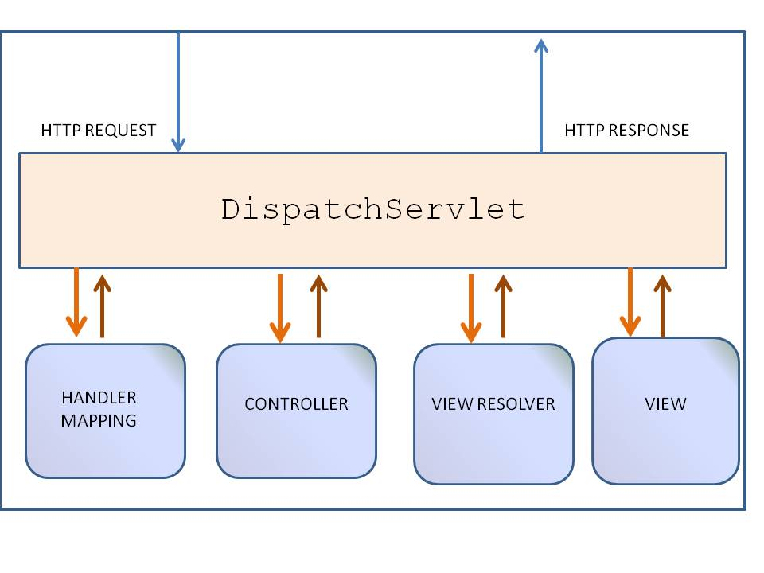

**Figure 4.5: The DispatcherServlet**

The DispatcherServlet is a Servlet inherited from the HttpServlet base class and is declared in the web.xml of the web application. The requests to be handled by the DispatcherServlet are also mapped using URL mapping in the same web.xml where the DispatcherServlet is declared. This is the standard J2EE Servlet configuration. Code Segment 4.1 shows an example of such a DispatcherServlet declaration and mapping.

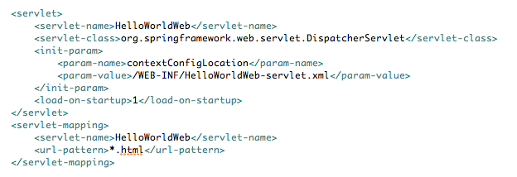

**Code Segment 4.1: Example Showing a DispatcherServlet Declaration and Mapping**

In Code Segment 4.1, all requests that end with .form are handled by the example DispatcherServlet.

Each DispatcherServlet has a unique WebApplicationContext that extends the root WebApplicationContext class inheriting all the beans defined in it. Such beans are overridden in the Servlet-specific scope, and new scope-specific beans are defined. This feature of the DispatcherServlet is shown in Figure 4.6.

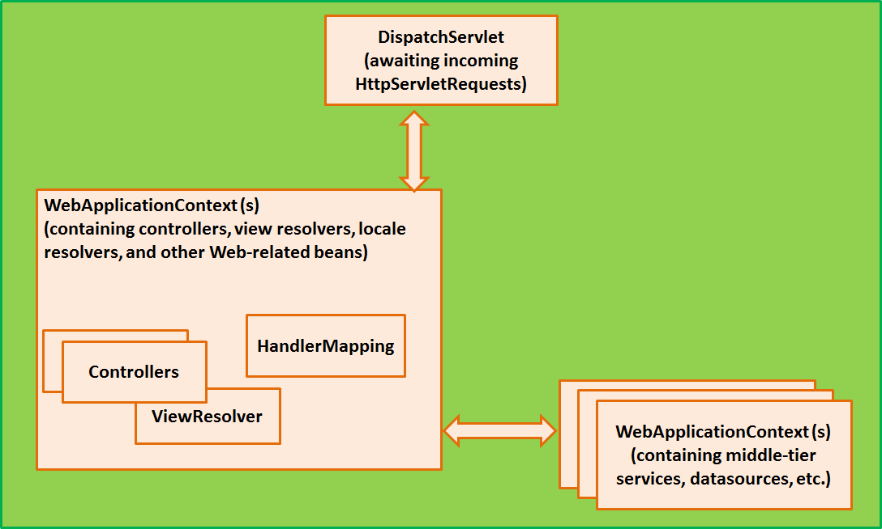

**Figure 4.6: DispatcherServlet Containing WebApplicationContext**

When a DispatcherServlet is implemented, the framework scans it for a file named *[Servlet-name]-servlet.xml* in the WEB-INF directory of the web application. It then creates the beans defined there and overrides the definitions of any beans defined with the same name in the global scope.

Consider the DispatcherServlet configuration (in the web.xml file.) shown in Code Segment 4.2.

**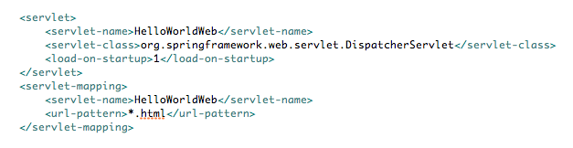**

**Code Segment 4.2: DispatcherServlet Servlet Configuration**

To the above configuration, add a file called /WEB-INF/HelloWorldWeb-servlet.xml, which contains all the required Spring MVC-specific components to receive requests and return responses using the web application. The WebApplicationContext interface invoked here is an extension of the plain ApplicationContext containing the necessary features required for web applications.

When a request comes in from the UI, DispatcherServlet will search the bean configuration and find the suitable handler for this request. To process requests and render suitable views, the DispatcherServlet uses beans configured in the WebApplicationContext. When a DispatcherServlet receives a request, it starts processing the request by performing the following steps:

1. It locates the WebApplicationContext and includes it in the request as an attribute in order to implement the controllers and view generators. WebApplicationContext is bound by default under the key DispatcherServlet.WEB\_APPLICATION\_CONTEXT\_ATTRIBUTE.
2. It binds the locale resolver to the request so that the application can decide which locale-specific data is to be used when processing the request.
3. It binds the theme resolver to the request to let elements such as views determine the theme to be used.
4. For multipart resolver specifications, it examines the request for the multipart. If multiparts are found, the request is wrapped in a MultipartHttpServletRequest for further processing.
5. It searches for a suitable request handler. If a handler is found, the preprocessors, postprocessors, and controllers associated with the handler are implemented, which helps to prepare a model (for rendering).
6. If a model is returned, it renders the view. If no model is returned because the request was to be intercepted by a preprocessor or postprocessor (for security reasons), a view is not generated. This could be probably because the request was already fulfilled.

If an exception is thrown when the request is being processed, it is picked up by the handler exception resolvers declared in the WebApplicationContext. Using these exceptions, you can define custom behaviors such as if an exception is thrown, display a specified message or call a specific method.

**Spring MVC Request Life Cycle**

The process of handling a request by Spring MVC involves many components, each with a specific purpose. Figure 4.7 shows the Spring MVC request life cycle.

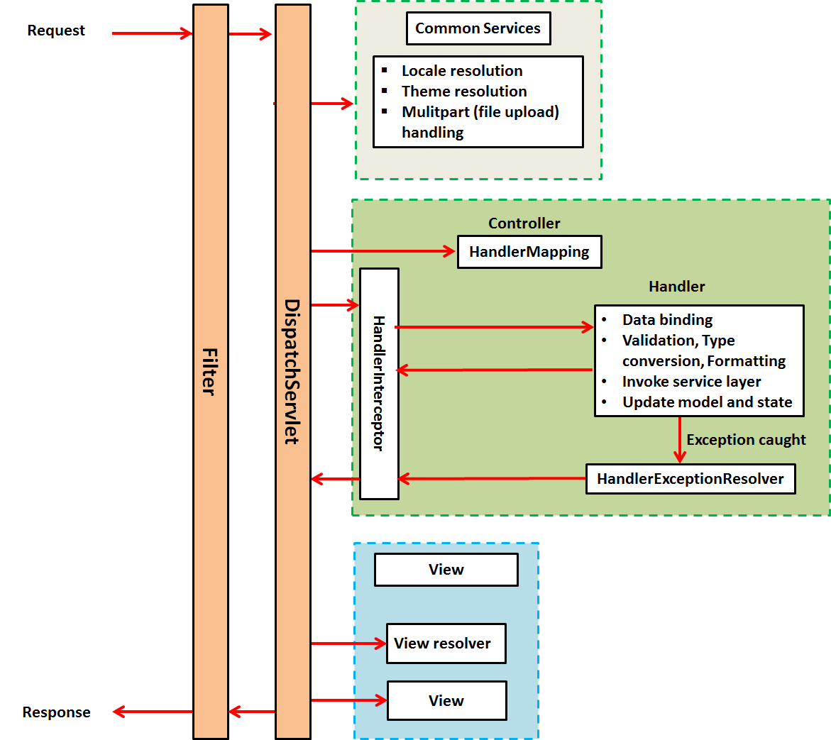

**Figure 4.7: Spring MVC Request Life Cycle**

The processes and components involved in a Spring MVC request life cycle are:

* **Filter**: This is a request filter that is applied to every request to direct it to the correct DispatcherServlet.
* **Dispatcher Servlet**: This is a servlet that evaluates incoming requests and redirects them to a suitable controller for processing.
* **Common services**: These services are applied to every request in a web application to support i18n, themes, views, and uploaded files. These services are configured in the DispatcherServlet’s WebApplicationContext.
* **Handler mapping**: Here, the request is mapped to the handler. From Spring Framework version 2.5, handler configuration is not required because Spring MVC automatically registers the org.springframework.web.servlet.mvc.annotation.DefaultAnnotationHandler mapping class that maps handlers based on HTTP paths.
* **Handler interceptor**: Handler interceptors enable handlers to implement common checking or logic. For example, a handler interceptor can check and ensure that the handlers are invoked only during office hours.
* **Handler exception resolver**: The HandlerExceptionResolverinterface is designed to deal with unexpected exceptions thrown during request processing by handlers.
* **View resolver**: This interface provides support for view resolution based on a logical name that is provided by the controller. Views can be dynamically resolved based on the media types supported by the client’s system and this feature is supported by the ContentNegotiatingViewResolver class. The media types on the client’s system could be XML, Portable Document Format (PDF), and JavaScript Object Notation (JSON).

The next lesson covers components such as controllers and view resolvers in detail. In addition, you will learn how to develop a simple web application using Spring Framework’s MVC design pattern.

## Lesson 2: Building Web Applications Using Spring Framework

In most enterprise application strategies, web applications play a crucial role as they help in connecting remote participants with each other. Web applications are the best way for a customer to access a software product and in today’s world, web applications can also be extended to mobile devices.

Java-based web applications are used most commonly and are simple to develop using Java enterprise development tools, such as Spring Framework. As a developer, you can use Spring Framework to develop simple, portable, fast, and flexible Java-based systems and applications without any dependency on vendors.

This lesson introduces you to the process of developing web applications using Spring Framework. You will learn about the following components of Spring MVC:

* **Controllers**: A class or an interface that acts as a gateway between the user and the MVC-based application.
* **View resolvers**: Are components that define an application’s view and identify them by name.
* **Handler mappings**: Are objects that handle predetermined tasks implemented before, after, or during a method implementation in the application’s business logic.
* **Property editors**: Are custom editors that can convert the properties of an object, such as the date and time, into human readable forms.

You will also learn how to implement these components using annotations. In addition, you will use these components in your application’s code to implement the MVC design pattern through Spring MVC.

### Topic 1: Employing Controllers, Handlers, and View Resolvers

Controllers, handlers, and view resolvers are components involved in developing a web application using Spring MVC. By using controllers in Spring MVC, you ensure that the requests are handled by the right components in your application.

**Controllers**

Controllers provide access to the behavior of an application, which is defined by a service interface. The main purpose of controllers is to translate user requests to application recognizable code. They also convert the application’s response to a form that is understandable by users and display this in the appropriate view. Spring Framework supports different types of controllers, categorized on the basis of the type of requests they handle. For example, if the UI holds a simple form on the web page, then you can define a SimpleFormController to handle incoming requests. These are discussed in detail later in this lesson.

Controllers in Spring Framework are held in the org.springframework.web.servlet.mvc.controller interface. The source code for accessing controllers is shown in Code Segment 4.3.

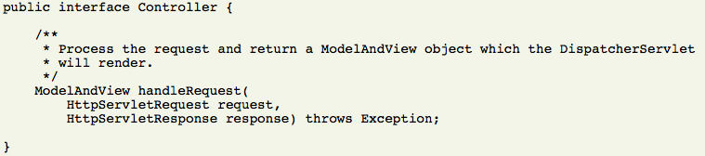

**Code Segment 4.3: Source Code for Accessing Controllers in Spring Framework**

The Controller interface defines a single method to handle a particular request and return the correct model and view. Therefore, the controller implements the basic concept of the MVC design pattern in an application developed using Spring Framework. You can also create custom controllers in Spring Framework to define any custom functionality in your application. Custom functionality could be methods that are initiated only by certain types of requests, data object methods that return error messages after a comparison, or any user-defined method that meets your business requirements.

When a request reaches the DispatcherServlet, it redirects the request to a controller by declaring a controller object. The controller object returns org.springframework.web.servlet.ModelAndView (which is a container class holding the model and view for your application) back to the DispatcherServlet. The model object represents the data that can be used by the view to display responses to the user. The model object is maintained as a map for storing application data. By using the org.springframework.web.servlet.View class, you can plug in any kind of view technology such as Excel, Jasper Reports, PDF, Hyper Text Markup Language (HTML), and Velocity. Code Segment 4.4 shows the ways to construct the model and view objects in Spring Framework.

//View Object

View pdfView = ….;

//Model object

Map modelData = newHashMap();

Or

ModelAndView mv1 = new ModelAndView (pdfView, modelData);

**Code Segment 4.4: Creating Model and View Objects**

If you specify the view by using the new ModelAndView('myView', someData) method, the view is called a Logical view. This means that myView can point to a .jsp, or .pdf, or an .xml format of the response in the user interface (UI). In the configuration file, you can configure the physical location of the corresponding Logical view to specify the format in which the view is to be generated.

**Controller Types**

The following are the types of abstract controllers available in Spring Framework that can be designed to perform a specified task in the application.

* **Abstract Collector:** To provide basic infrastructure, all of Spring Framework’s Controller classes inherit from AbstractController, a class which supports caching of information needed for your application. This class allows you to implement your logic by overriding the handleRequestInterval() method and then returning a ModelAndView object. Code Segment 4.5 is an example that shows a class declared in the webapplicationcontext file.

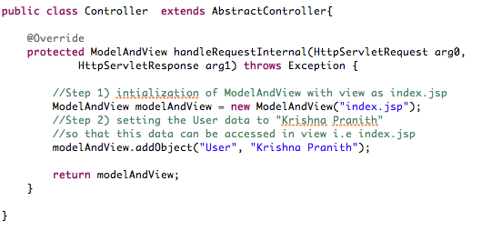

**Code Segment 4.5: Example for Using a Controller Class that Inherits from AbstractController and Returns a ModelAndView Object**

Code Segment 4.6 shows the bean definition needed for the Controller class in the example.



**Code Segment 4.6: Bean Definition for the Controller Class**

Once you have defined a class that inherits from the AbstractController class, you need to set up a handler mapping to get this simple controller working and return a hard coded view to the UI. Some of the controller parameters supported by the AbstractController class are listed in Table 4.2.

|  |  |
| --- | --- |
| **Controllers** | **Description** |
| supportedMethods | Indicates the methods that AbstractController should accept when processing a web request. By default, this method is set to both GET and POST, but can be modified to reflect the method you want to support. If a method not supported by the AbstractController class brings in a request from a user, a ServletException is thrown and the user is notified. |
| requiresSession | Indicates whether AbstractController requires an HTTP session. If a session the controller requires is not present, the controller informs the user by throwing a ServletException. |
| synchronizeSession | Synchronizes controller handling to the user’s HTTP session. |
| cacheSeconds | Specifies a positive integer when the controller must generate a caching directive (that controls the behavior of browser caches) in a HTTP response. By default, this value is set at -1 so that no caching directives are included unless specified. |

**Table 4.2: Methods of the AbstractController Class**

* **MultiActionController:** Multiple actions can be logically grouped into one controller using the MultiActionController class. This class is held in the org.springframework.web.servlet.nvs.multiaction package. The MultiActionController class can map requests to method names and then invoke the correct method in your web application. Mapping requests to method names is useful when you have common methods in one controller but need to have multiple entry points to change or modify the code behavior. This class supports an optional argument that you can use to define exception handlers to handle exceptions thrown by methods contained in the MultiActionController class. This exception argument can be an exception that is a subclass of the java.lang.Exception class. A few examples of MultiActionController methods are shown.

Code Segment 4.7 shows the MultiActionController method that mirrors the controller interface method.



**Code Segment 4.7: Method That Mirrors the Collector Interface Method**

Code Segment 4.8 shows a method that accepts a user name and password as arguments that are specified as parameters in the user request.

****

**Code Segment 4.8: Method That Accepts Arguments and Populates Them According to User Request**

Code Segment 4.9 shows a method for exception handling.



**Code Segment 4.9: Exception Handling Method**

* **CommandController:** The CommandController class is an important part of Spring Framework’s MVC package as it provides a way to interact with the application’s data objects and allows parameters to be bound to a specified data object. As the CommandController class does not need to implement a framework-specific interface, it helps Spring Framework in keeping your application independent of the framework for code portability and flexibility. The methods of the CommandController class that are available to you are listed in Table 4.3.

|  |  |
| --- | --- |
| **CommandController** | **Description** |
| AbstractCommandController | This method is used to create a custom command controller capable of binding request parameters to a data object you specify. This class enables validation so that you can specify command object tasks in the controller itself. |
| AbstractFormController | This method is used to model request submission forms and populate them using a command object retrieved from the controller. After a user has completed the form, the AbstractFormController method binds the fields, validates the command object, and hands it back to the controller to take the appropriate action. |
| SimpleFormController | This method is used to provide support when creating a form with a corresponding command object. With SimpleFormController, you can specify a command object and view names for a form and the page displayed to the user when a form is successfully submitted. |
| AbstractWizardFormController | This is an abstract class for extending the application’s wizard controller. To achieve the extension, you need to implement the validatePage(), processFinish(), and processCancel() methods. |

**Table 4.3: Methods of the** CommandController **Class**

**Handler Mapping**

Handler mappings are used to map incoming web requests to the correct handlers. SimpleUrlHandlerMapping or BeanNameUrlHandlerMapping can be used out-of-the-box and are available in Spring Framework. The basic function of any handler mapping is to deliver a HandlerExecutionChain which contains information such as:

* Which handler is to be contacted for a particular request
* Which of the handler interceptors are to be applied to the request

When an application receives a web request, it is redirected by the DispatcherServlet to the handler mapping. The handler mapping reviews the request and comes up with a suitable HandlerExecutionChain. The DispatcherServlet then executes the handlers and interceptors defined in the chain. This helps you to include supporting functionalities for the sequence of events that follow a request submission in your application. For example, assume there is a custom handler mapping that chooses a handler based on a particular state of the session that the request belongs to, in addition to the URL of the request coming in.

Two of Spring Framework's most commonly used handler mappings are:

* **BeanNameUrlHandlerMapping**: This interface maps the names of incoming HTTP requests to names of beans defined in the webapplicationcontext. In the ReachoutWorld example, you can use a BeanNameUrlHandlerMapping when you need to map the HTTP request to any URL provided in the web application. An example of this is shown in Code Segment 4.10, where a form that allows users to create an account is to be submitted through an URL.

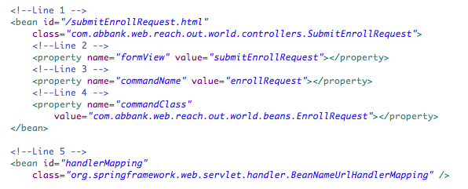

**Code Segment 4.10: Using BeanNameUrlHanlderMapping**

* **SimpleUrlHandlerMapping**: This mapping is configurable in the applicationcontext of the application. It is used to match handlers based on properties you define and request the controller to invoke. Both BeanNameUrlHanlderMapping and SimpleUrlHanlderMaping extend AbstractHandlerMapping and share properties such as handler interceptors and the order of handler mapping available. Handler interceptors are interfaces that intercept a request when specified:
* Just before the controller: Using the preHandle() method initiates the handler execution if set to true and stops it if set to false.
* Just after a controller: Using the postHandler() method allows manipulation of the ModelAndView object before rendering the view.
* Just before the response is sent to view: Using the afterCompletion() method after the view is rendered ensures cleanup of the resources used.

These handler interceptions are done to apply specific functionalities to certain requests and can be configured at run time. Code Segment 4.11 shows how to configure handler interceptors using Spring Framework’s configuration files for the ReachoutWorld example.

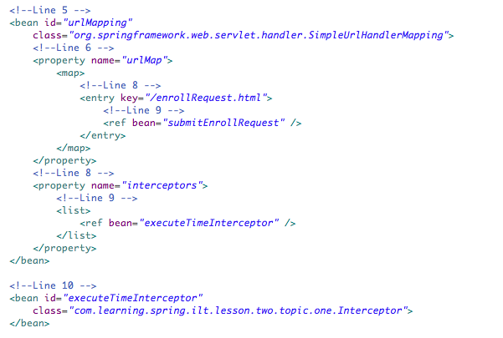

**Code Segment 4.11: Configuring Handler Interceptor**

After you develop your application and define handler interceptors, you need to define and configure a URL handler for the application. This is shown in Code Segment 4.12, which calls a URL handler for your ReachoutWorld application.

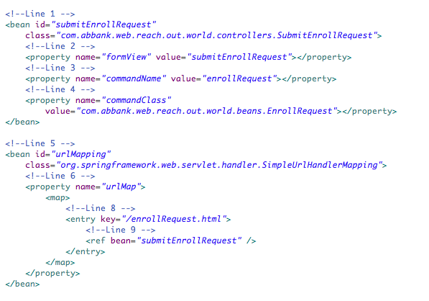

**Code Segment 4.12: Defining the URL Handler for the ReachoutWorld Application**

Next, the request made to the URL enrollRequest.html will invoke the controller. However, in this implementation of the controller, you initialized the view of the ModelAndView as “success” for the successful form submission state and “error” for a failed form submission. Next, let’s look at generating and resolving a view for your application.

**Views and Resolving a View for an Application**

Spring Framework provides you with view resolvers that help in rendering views to a specific template according to a user’s requests. Two important interfaces that are needed to handle views in Spring Framework are:

* ViewResolver: Provides mapping between view names and actual views
* View: Prepares the request and hands it over to one of the view technologies such as JSP or Velocity to generate a view.

All the controllers in the Spring Framework’s MVC module return a ModelAndView object. Views in Spring Framework are identified by a view name and are resolved by a view resolver. Some of the view resolvers available in Spring Framework are listed in Table 4.4.

|  |  |
| --- | --- |
| **View Resolver** | **Description** |
| AbstractCachingViewResolver | Performs the task of caching views. Often, views need preparation before being used; extending this view resolver provides caching of views. |
| ResourceBundleViewResolver | Uses the bean definitions specified in a ResourceBundle. The beans are specified in the bundle’s base name, and the bundle is defined in a properties file located in the classpath. |
| UrlBasedViewResolver | Is used to resolve view names to URLs without using an explicit mapping definition. This is useful if your symbolic name directly matches the name of your view resources. |
| InternalResourceViewResolver | Supports InternalResourceView (that is, Servlet and JSPs), and subclasses such as JstlView and TilesView. |
| VelocityViewResolver / FreeMarkerViewResolver | Supports VelocityView (that is, Velocity templates) or FreeMarkerView, respectively, and their custom subclasses. |

**Table 4.4: View Resolvers Available in Spring Framework**

Let us look at a simple web application and how you can develop it using Spring Framework. In this example, the application called “ReachoutWorld” allows users to fill out a form and submit it to a server. The server then returns a message to the user regarding whether the form submission was successful. To develop this application:

1. **Configure Spring Framework**: To develop the web application using Spring MVC, first set up the development environment. This means that you have to configure the DispatcherServlet in the web.xml file, as shown in Code Segment 4.13.

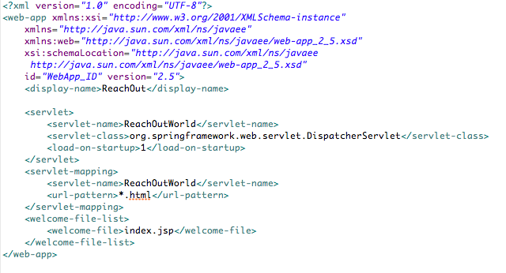

**Code Segment 4.13: Configuring DispatcherServlet in web.xml**

1. **Create an xml file named ReachoutWorld-servlet.xml:** The file named ReachoutWorld-servlet.xml holds all the bean definitions needed for the application to run, as shown in Code Segment 4.14.

**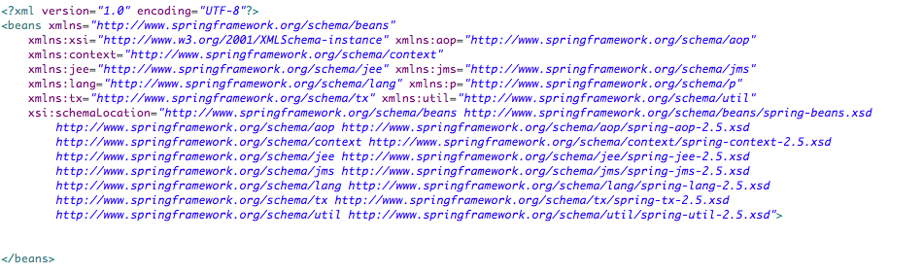**

**Code Segment 4.14: Creating the ReachoutWorld-servlet.xml File**

1. **Add controllers**: To add controllers, you need to write a class that performs a method on the application data. Here, the EnrollRequest class in used to map the UI form field and is a command class, as shown in Code Segment 4.15.

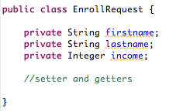

**Code Segment 4.15: Creating the Command Class EnrollRequest**

Now, you can write a controller for this method class. This class is called SubmitEnrollRequest and extends SimpleFormController as the application handles form submissions. The controller class SubmitEnrollRequest is shown in Code Segment 4.16.

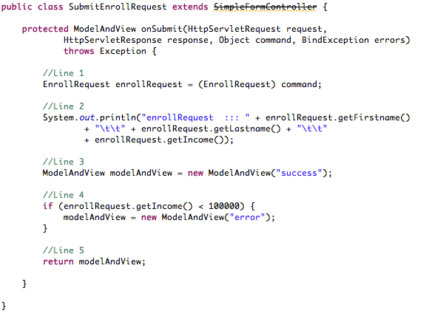

**Code Segment 4.16: Controller Class SubmitEnrollRequest**

In Code Segment 4.16, the onSubmit method’s argument is the command class defined in Code Segment 4.15. This specifies the POJOs to which the form field values are to be mapped directly by Spring Framework. Once the form has been submitted and by the time control reaches the controller, the command class is populated with values of the form fields.

In Code Segment 4.16:

* Line 1: Code is type casting the command object to our command class. This mapping of command class is done in the config file, which will be explained in the next step.
* Line 2: Printing the command objects in the console.
* Line 3: Code is initializing the ModelAndView with “success” as the view.
* Line 4: Application is checking whether income is less than one hundred thousand and then it directs the UI to an error page.
* Line 5: Application is returning the ModelAndView.

1. **Generate a view:** To generate a view, create a new “submitEnrollRequest.jsp” page in the jsp folder. This code is written in the UI and shown in Code Segment 4.17.

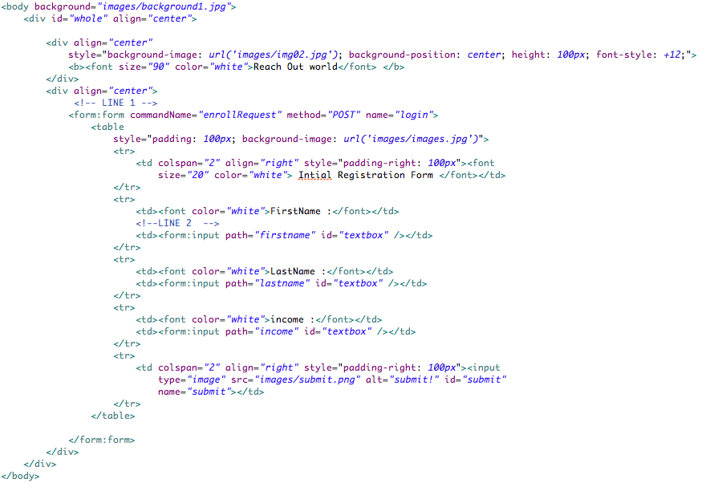

**Code Segment 4.17: Creating a submitEnrollRequest.jsp**

The element <form:form> in the above code segment is the Spring Library Tag used to map form fields with command class parameters.

1. **Configure the application**: To configure the application in Spring Configuration files, you first define the controller SubmitEnrollRequest as a bean with the id submitEnrollRequest. Code Segment 4.18 shows the configuration written for this application.

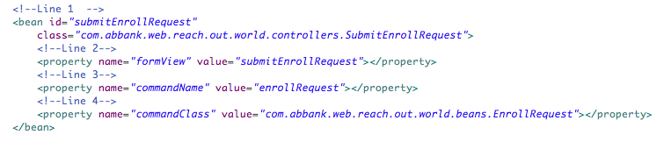

**Code Segment 4.18: Configuring the Application**

1. **Develop one successful and one failed pages:** Code Segment 4.19 shows a successful form submission.

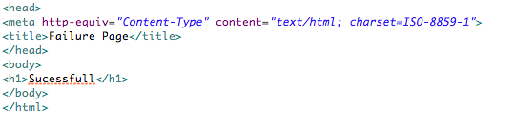

**Code Segment 4.19: Successful Form Submission**

Code Segment 4.20 shows a failed form submission with an error message.

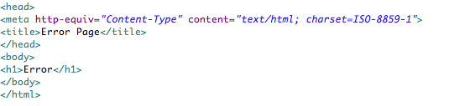

**Code Segment 4.20: Failed Form Submission**

You have developed an application. Next, you learn how to call the application from the DispatcherServlet when a user request is sent to it. This task is performed by handler mapping in Spring Framework.

1. **Define handler mapping**: By declaring a SimpleUrlHandlerMapping, you can match handlers based on properties and request the controller to be invoked. In the ReachoutWorld application, the use of SimpleUrlHanlderMapping is shown in Code Segment 4.21.



**Code Segment 4.21: Example of SimpleUrlHandlerMapping**

1. **Configure handler interceptors**: Configure handler interceptors using Spring Framework’s configuration files for the ReachoutWorld example.
2. **Invoke the controller**: The request made to the URL enrollRequest.html will invoke the controller. Once you have developed the application and defined handler interceptors, you need to define and configure a URL handler for the application. This is shown in Code Segment 4.22, which calls a URL handler for the ReachoutWorld application.



**Code Segment 4.22: Defining the URL Handler for ReachoutWorld Application**

1. **Define the view resolver**: View resolvers help in rendering a view for the UI depending on the request parameters obtained from the user. Code Segment 4.23 shows how to define a view resolver for the application.

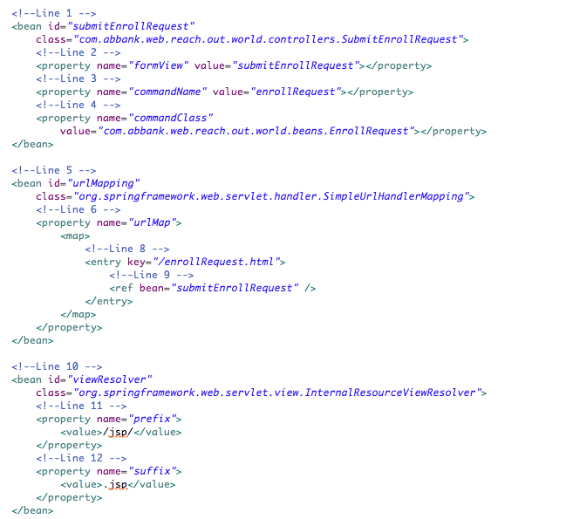

**Code Segment 4.23: Defining a View Resolver**

1. **Perform the final configuration of the application:** In the web.xml configuration files, you defined a welcome file as index.jsp. Now, when the ReachoutWorld application is called from a browser, this field is called first. You need to redirect the user’s form submission request to the URL bean enrollRequest.html. This is shown in Code Segment 4.24.

**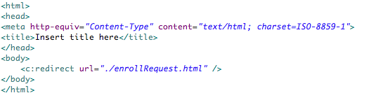**

**Code Segment 4.24: Redirecting the Form Submission Request to a URL**

When you complete this step, your application development is complete. To ensure that the application works, you need to deploy it and check the resulting views generated on the basis of user inputs.

1. **Deploy the application:** Build the application, deploy the WAR files in an application server, and clear server logs.
2. **Access the URL:** Type the URL: <http://localhost:8080/ReachOutPeople> in a web browser. This is shown in Figure 4.8.

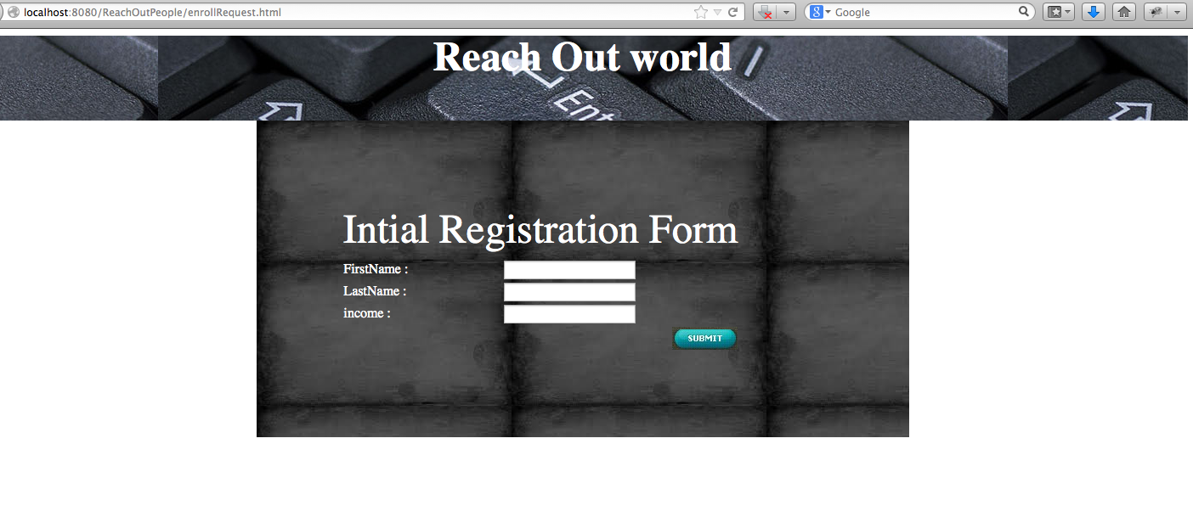

**Figure 4.8: Opening the URL in a Web Browser**

Once the URL is opened, enter the values, click Submit, and check the logs. Figure 4.9 shows the form filled out.

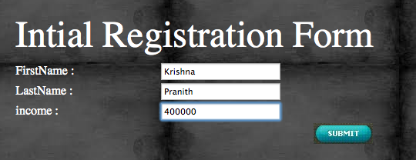

**Figure 4.9: Correct Input to Check Success of the Application**

When the application is run with the income value as 400000, the view displayed is as shown in Figure 4.10.

**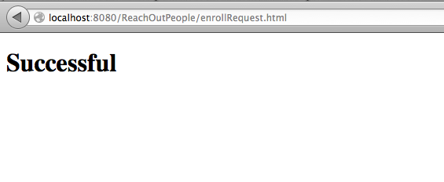**

**Figure 4.10: Correct Input to Check Success of the Application**

If the income values are filled as 99999, as shown in Figure 4.11, then the application is not successful and the view generated is shown Figure 4.12.

**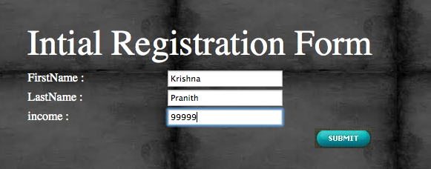**

**Figure 4.11: Incorrect Input to Check Failure of the Application**

**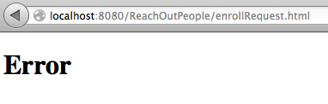**

**Figure 4.12: Failure Output**

The project structure for the ReachoutWorld application in the system directory file will appear as shown in Figure 4.13.

**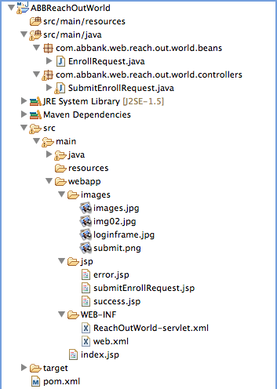**

**Figure 4.13: ReachoutWorld** **Application: Project Structure**

You created a simple web application named ReachoutWorld and added controllers, handlers, and view resolvers to it. Then, you configured the entire application in Spring Framework’s configuration files. Next, you ran the application from a URL and saw a successful run and a failed run that returned an error message.

The steps discussed in this topic can also be performed using Spring Framework’s annotations. You will learn about this in the next topic.

### Topic 2: Using Spring Annotations

### Annotations are syntax-based metadata used to add a behavior or set a condition to classes, methods, variables, or packages. With Spring Framework 2.5, the annotation-based programming model was introduced for developing web applications in Spring MVC.

### You can use annotations to perform all the steps of developing an application (discussed in the previous topic). Using annotations is always an advantage as these:

* Allow you to enhance classes and methods with extra information about their properties or performance
* Are easy and simple to use in large projects such as enterprise applications
* Do not negatively affect the application code or logic in any way

Let us now explore the annotations available in Spring MVC, which are used to implement controllers in a web application.

**Implementing Controllers Using Annotations**

Spring Framework supports annotations for the DispatcherServlet using which you can annotate controllers. When controllers are invoked using annotations, they need not extend base classes or implement any interface, thus reducing the amount of coding needed to implement them. Some of the annotations used while implementing controllers in application development are:

* @Controller
* @RequestMapping

**@Controller Annotation**

When you annotate a class with @Controller, you delegate the role of a controller to that class, without extending any base class or reference to the Servlet API. In other words, the purpose of using the @Controller annotation is to indicate the role of the class it annotates. The DispatcherServlet scans the annotated class for the mapped methods defined in it. You can also define the controller as a bean in the DispatcherServlet’s context using the standard bean definition methods.

In Spring Framework 2.5, your application can autodetect controller classes created using the @Controller annotation and automatically register bean definitions for these controller classes. To enable this auto-detection of annotated controllers, you need to add the component scanning feature to your application configuration. This is done by using the spring-context schema in the XML configuration file, as shown in Code Segment 4.25.

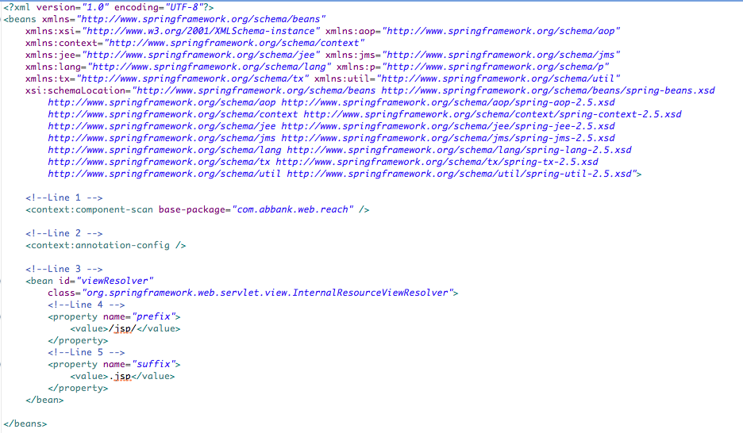

**Code Segment 4.25: Adding Spring-Context Schema to the XML Configuration File**

Once the spring-context schema is added, the DispatcherServlet will scan for beans annotated with @Controller starting from the base packages. The DispatcherServlet then looks for classes annotated with @RequestMapping to start mapping requests to the appropriate handlers. Let us find out how to map requests using annotations to implement the MVC design pattern in application development.

**@RequestMapping Annotation**

Coding request-handling methods poses challenges, such as how to map a method to an incoming request. When writing request handling methods, there are many factors that influence the code, such as:

* The URL from which the request is originating
* The methods used (get() or post() methods)
* Availability of parameters or HTTP headers
* Request content type to be produced

Spring Framework handles requests by using the @RequestMapping annotation on a method used to generate a response to the incoming request. The mapping defined in this annotated method is detected by the org.springframework.web.bing.annotation.RequestMapping interface, which, in turn, maps the incoming URLs to the correct methods.

The @RequestMapping annotation supports certain arguments that you can use for defining precise mapping of incoming requests. A list of these arguments is shown in Table 4.5. Next, you need to specify the specific handler to which the web request must be assigned.

|  |  |
| --- | --- |
| **Argument** | **Description** |
| value | Is used to specify the URL to which a controller is supposed to react when it receives an incoming request |
| method | Is used to specify the HTTP methods to be used in mapping. These methods can be GET, POST, HEAD, OPTIONS, PUT, DELETE, TRACE, and others. |
| params | Is used to specify the parameters of the mapped request. Expressions supported with this argument are:   * param-name=param-value: The specified param must have a certain value * param-name!=param-value: The specified param must not have a certain value. * !param-name: The specified param must be absent from the request. |
| headers | Is used to specify whether HTTP request headers are to be present in the request handler. Expressions supported here are:   * header-name=header-value: The specified header must have a certain value. * header-name!=header-value: The specified header must not have a certain value. * !header-name: The specified header must be absent from the request header. |
| consumes | Is used to determine which of the media types in the request must be mapped |
| produces | Is used to determine the producible media types accepted by the request handler methods |

**Table 4.5: Arguments Used with the @RequestMapping Annotation**

Let’s take up the ReachoutWorld application discussed in the previous topic. Using the @RequestMapping annotation here removes the need to implement any classes or interfaces for mapping. You just need to annotate the method RequestMethod with @Controller and the class will be treated as a controller by the DispatcherServlet. The @RequestMapping annotation will ensure that the method is mapped to the request. This is shown in Code Segment 4.26.

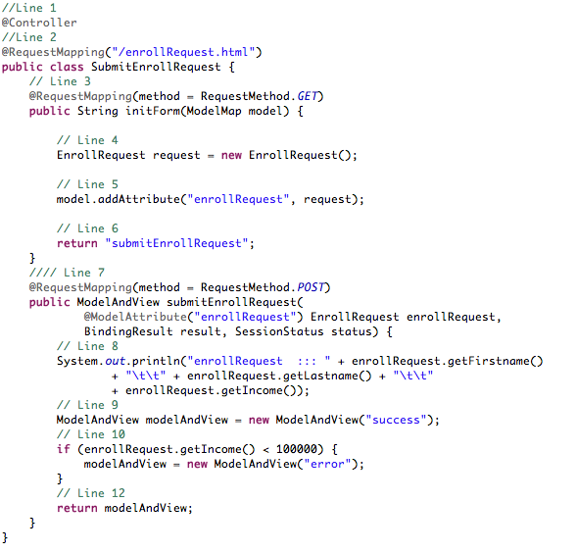

**Code Segment 4.26: Using @RequestMapping to Map Requests to a Method**

**Validation Using Annotations**

Any web application needs to validate user data to prevent user errors and prevent corrupted data from being stored on the databases used by your application. Therefore, any time a user submits data to your system, your application must validate the data. This validation can be achieved using Spring annotations.

To implement validation in a web application, you need to add Hibernate dependencies to your application’s pom.xml file. As Hibernate is a data access framework, it will help you to manage the data that is being validated. Code Segment 4.27 shows how dependencies are added to the pom.xml file.

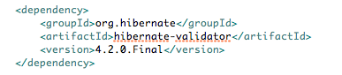

**Code Segment 4.27: Adding Dependencies to pom.xml**

Next, let us look at using annotations used to validate data entries from a URL.

**@Valid Annotation**

The @Valid annotation is used to integrate a Hibernate Framework bean validator in your Spring Framework MVC-based web application. Here, bean validation is done in the HTML format using any one of the following bean annotations:

* **@NotEmpty**: Ensures that the data field is not empty
* **@Range**: Fixes the range for a numeric data field
* **@Email**: Declares the data to be an e-mail address
* **@Size**: Is used to set the size of a string data entry
* **@DateFormat**: Is used to check the date format of a string data entry

Once the beans are validated, you can invoke the controller to validate the form submitted in the request handler method. This is shown in Code Segment 4.28.

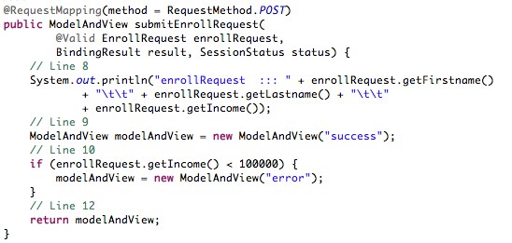

**Code Segment 4.28: Validating Form Submission Using the @Valid Annotation**

The @Valid annotation calls on Spring Framework to validate the EnrollRequest object and to hold the result of this validation in a Java Spring object by using the BindingResult argument of the @Valid annotation. The validation result is added to the application view in the UI.

Suppose the user does not enter the appropriate data in the data fields of the web request form submitted to the application. In such a situation, data validation will fail and an error message will be displayed on the UI. For example:

* The @NotEmpty annotation shows a default error message “This field may not be empty.”
* The @Range annotation will show a default error message that says “This value must be between 1 and 100.”

Error messages can be resolved by overriding them. To do this, create a file in the src/main/resources file in your application directory. This file will hold the default error message overrides. You can also specify custom error messages in the file.

Let us look at an example where an application form has an Age field and a Name field. Both these fields must be filled and the age value must be between 1 and 150. Code Segment 4.29 shows how to set an error message that is displayed when this condition is not met.

Make the following entry in the file: “message.properties.”



**Code Segment 4.29: Setting Custom Error Messages**

Note that validation must not be tied to the web layer of your application and should be easy to localize when required. You should also be able to plug in any validator such as a Hibernate validator. This helps to keep your code flexible and the validation framework independent. To provide the validator plug-in feature, Spring Framework holds the Validator interface that can be included in any layer of your application. The Validator interface performs validation as well as data binding. This keeps the validation-related code separate from your application business logic code to ensure security and clarity for your application.

Another important component of the Spring MVC is the property editor. This is useful in making object properties easy to read by users.

**Property Editors**

Let’s begin by exploring what properties in Java applications are. Important properties are listed in Table 4.6.

|  |  |
| --- | --- |
| **Property Expression** | **Description** |
| name | Indicates the property name corresponding to the methods used such as getName() and setName(). |
| account.name | Indicates the name of the property nested within another property called account. |
| name[2] | Indicates the third element of an indexed property, which can be of array or list type. |
| name[COMPANYNAME] | Indicates the values of the map entry indexed by the key word COMPANYNAME. |

**Table 4.6: Properties in Java Language**

At times, properties in your application may need to be represented in a way that users find easy to understand and these are not viewed just as application objects. This behavior is achieved using property editors that are held in the typejava.beans.PropertyEditor interface. Property editors are used to:

* **Set properties to beans**: When the values of a property are being defined for a bean, Spring Framework uses the ClassEditor to resolve a parameter to a class object.
* **Parse HTTP request parameters**: In Spring Framework, HTTP request parameters are parsed using property editors that are bound to all subclasses of the Controller class.

Custom property editors can be used once they are registered on BeanWrappers or in a specific IoC container. The BeanWrapper interface provides methods to:

* Set and get property values in Spring Framework
* Get property descriptors
* Query properties to find out whether they are readable or writable
* Support nested properties
* Add standard JavaBeans PropertyChangeListeners without writing codes in the target class
* Set indexed properties

The BeanWrapper interface is not directly implemented in the application code but through the DataBinder and BeanFactory interfaces.

Spring Framework offers a number of built-in property editors located in the org.springframework.beans.propertyeditor package. These are listed in Table 4.7.

|  |  |
| --- | --- |
| **Class** | **Description** |
| ByteArrayPropertyEditor | Used to edit byte arrays when strings are converted into their byte representations. |
| ClassEditor | Used to parse strings representing classes to actual classes |
| CustomCollectionEditor | Used to convert any source collection to a specified target Collection type |
| FileEditor | Used to resolve strings to Java.io.File objects |
| InputStreamEditor | Used to convert a text string into InputStream so that InputStream properties can be directly set as strings |
| URLEditor | Used to resolve a string representation of a URL to an actual URL object. |

**Table 4.7: Built-In PropertyEditors**

Spring uses the java.beans.PropertyEditorManager to set the search path for property editors that might be needed for font, color, and all the primitive data types. The JavaBeans infrastructure will detect PropertyEditors automatically if the following two conditions are true:

* They are in the same package as the class they handle
* They have the same name as that class and “Editor” is appended to the name

### Module Summary

In this module, you learned about the use of Spring Framework and its MVC design pattern to develop a web application. Web applications are the most common methods of communicating business requirements and solutions in today’s world. Web applications range from simple form submission applications to enterprise, web layer applications.

You learned that the MVC design pattern divides an application into model, view, and controller components that are loosely coupled to each other and thus enable code reuse, choice of view technologies, clarity, and flexibility in using the web application.

Spring MVC also enables you to customize controller settings to handle any type of user requests. Using the MVC design pattern in Spring Framework for developing web applications is aimed at making developer’s task easy, simple, and efficient.

### References

* Web references:
  + <http://docs.spring.io/spring/docs/3.0.0.M3/reference/html/ch16s02.html> (Accessed 15 April 2014)
  + <http://docs.spring.io/spring/docs/3.2.x/spring-framework-reference/html/mvc.html> (Accessed 15 April 2014)
  + <http://www.tutorialspoint.com/spring/spring_web_mvc_framework.htm> (Accessed 15 April 2014)
* Book references:
  + Deinum, Marten; Serneels, Koen; Yates, Colin; Ladd, Seth; Vanfleteren, Christophe. (2012). *Pro Spring MVC and Web Flow.* New York,NY: APress.
  + Liu, Henry.H. (2012). *Developing Enterprise Java Applications with Spring Framework.* NY: Create Space Independent Publishing Platform.

# Module 5: Aspect-Oriented Programming (AOP)

**Module Overview**

Aspect-Oriented Programming (AOP) is a programming model that aims to increase modularity. This modularity improves code clarity, and as a result, you can fix errors or introduce new functionality in your code as and when your business requirements evolve. In AOP, program logic is broken down into distinct parts called concerns. Concerns are organized areas of functionality that influence several areas of the application and can be used to bring together the multiple tasks of Java-based enterprise architecture, to develop a Java-based enterprise application.

Most programming paradigms support the grouping and encapsulation of concerns into distinct, separate parts by providing abstractions that can be used for composing and implementing these concerns. However, some concerns do not comply with these forms of implementation and cut across multiple abstractions in a program. AOP supports the creation of such concerns that span across the application logic. When used in Spring Framework, AOP helps you to provide declarative services such as transaction management and implement custom program units that support your main business code. This module aims at familiarizing you with AOP concepts, uses and benefits of AOP, and implementation of AOP in Spring Framework.

**Module Objectives:**

By the end of this module, you will be able to:

* Explain AOP and its principles.
* Implement AOP using Spring Framework.

## Lesson 1: Introduction to AOP

In the history of programming, different kinds of programming concepts have evolved and continue to evolve from the need to manage the complexity of software engineering. The software development industry has been consistently developing and adopting different approaches to keep pace with the growth in the size and overall complexity of software projects.

As a new approach to the software development methodology, Object-Oriented Programming (OOP) was developed as a practice in which every concept is treated and used as an object. These objects interact with each other to meet the application requirements. While OOP offered advantages such as code reuse, there were also certain drawbacks such as ill-constructed interfaces that inhibit customized development.

To complement OOP and provide a fresh perspective on the structure of an application, AOP was first proposed by Gregor Kiszales in 1997. This was followed by the release of AspectJ AOP developed by Xerox PARC in 2001. AOP was first introduced in the Spring Framework 2.0 version release in 2003. OOP’s basic unit of code is the class, which holds the objects, and the application focuses on these objects. In AOP, the basic unit of code is an aspect and aspects can be scattered across an application. Combining OOP and AOP in your Java-based application allows you to modularize your code so that you benefit from a well-defined set of methods and objects, code reusability, and clean units of code that can be unit tested easily. This lesson aims at familiarizing you with the concept of AOP and implementing AOP in your Java-based application developed using Spring Framework.

### Topic 1: Purpose of AOP

AOP modularizes cross-cutting concerns into manageable modules called aspects. Unlike OOP, AOP complements the object-oriented features of your application without replacing the OOP part of the application. In AOP, an application is divided into two halves:

* **Base program**: The base program comprises the main functionality of the system and can be implemented using OOP.
* **Aspect program**: The aspect program comprises the cross-cutting functionality that has been modularized away from the base program to keep the two separate, yet loosely coupled. This loosely coupled modularization leads to a more concise structure because the functionality of the cross-cutting concerns is contained within well-defined modules.

Largely, a Java program contains the business application logic along with the code for other services such as transaction management, database access, and networking. The extra code is known as **services** because it serves the main application with different functionalities such as database access, cluster integration, proxy maintenance, logging, and security. All these services are known as concerns and, more precisely, in AOP terms, **cross-cutting concerns**. They are so called because a failure in one concern may cause another service to fail, since the concerns are interdependent.

In OOP, logging and security code cross cut or interweave the actual logic, degrading the readability of the main code. This makes it difficult to maintain the code. AOP provides a solution by separating the code for cross-cutting concerns (such as logging and security) from the core business logic. The cross-cutting concerns are put into special classes called aspects (pieces), which provide key benefits:

* The logic for each concern is in one place, as opposed to being scattered all over the code base.
* The service modules contain code only for their primary concern (or core functionality) and are therefore cleaner. Secondary concerns are moved to service aspects.

Due to such benefits, AOP code is cleaner and easier to understand, has fewer chances of errors, and is easier to design, implement, and maintain when compared to OOP. AOP complements OOP to make Java code robust and improves the productivity of the developer working on Java-based enterprise applications.

Figure 5.1 shows a standard application that is broken down into modules. Each of these modules aims to provide services for its particular domain. Each module also requires similar supplementary functionalities, such as security and transaction management, to function in an appropriate manner.

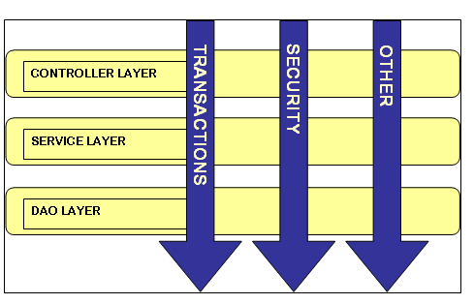

Figure 5.1: Application Broken into Modules

In Figure 5.1, the Controller Layer, the Service Layer, and the DAO Layer are components of the application, which depend on functionalities such as transactions and security. Modularizing the functionalities helps you to call them in every layer of your application as needed.

Modularity is the process in which your application’s components are grouped logically in order to maintain them easily or to add new functionalities to these components. Next, let’s examine the ways in which modularity is approached in OOP and AOP.

**Approach to Modularity in OOP and AOP**

In OOP, the technique for reusing common functionality is by applying inheritance or delegation. However, inheritance can lead to a breakable object hierarchy. If the same base class is utilized throughout an application, delegation can be difficult because complicated calls to the delegate object may be necessary to perform methods related to the base class.

AOP offers an alternative to inheritance and delegation, where instead of calling the base class multiple times, a feature is defined in one place and its implementation alone is called when necessary. In other words, you can use the declarative sections of the code to describe how and where the functionality must be applied. In this way, you are not modifying the class to which you are adding the new feature. This approach is extremely popular, especially in the Java enterprise development. This is because AOP improves code clarity without compromising on the basic objectives that need to be achieved by the application. This means that as a developer, you can focus on the business logic without having to worry about implementing AOP to your application.

In order to work with AOP, you need to be familiar with the common terms used in AOP.

**AOP Terminology**

Similar to other programming languages, AOP has its own set of terms. A complete understanding of these terms will help you grasp the concepts of AOP and use these effectively. The main term used in AOP is aspect.

An aspect can be defined as functionality that implements cross-cutting concerns in an AOP-based application. It is a common feature that can be scattered across your application in methods, classes, object hierarchies, and even entire models. Aspects can be defined in one place and implemented in multiple locations to add new functionalities or methods to your application code. The purpose of an aspect is to encapsulate the cross-cutting functionality away from the base program into independent, well-defined modules. Every aspect has certain functionality such as output or purpose, spanning multiple objects spread across modules.

Some of the elements related to aspects in AOP implementation for your Java-based application are:

* **Cross-cutting concerns**: These can be considered as functions that are used in multiple places in an application and affect many other parts of the application such as dependencies. Cross-cutting concerns do not focus on one clear object and are therefore difficult to define using OOP. Each cross-cutting concern has certain functionality such as error checking or logging. To define such concerns, AOP provides aspects, which enable you to take cross-cutting concerns out of modules and place them in a centralized location. As a result, cross-cutting concerns can be accessed to perform functionalities in any part of the application, without affecting the main code or the aspects themselves. Examples of cross-cutting concerns are authorization, synchronization, transaction management, and error handling.
* **Junctures and join** **points:** Junctures in an application are instances in the execution of code when a task is being performed, such as when a method is invoked or an exception is handled. These junctures are instances or locations in your code where you can insert the necessary aspect code to support the task being executed. The point at which the aspect is plugged in is called the join point. By including the aspect code into the normal flow of your application at these points, you can add new behavior to code.
* **Pointcut**: A pointcut connects aspect and the base code, which are two different entities. A pointcut defines the aspect or a set of aspects should be applied at a specific join point. The pointcut binds a particular aspect to a particular join point. At a single join point, one aspect or a set of aspects can be applied to the methods in an application. For example, in a banking application, the main code handles transactions using methods such as debit() and credit(). Here, the pointcut specifies that the aspects of logging and transaction management should be applied at join points of the debit() and credit() methods.
* **Advice:** Each aspect has a purpose that specifies when and how an aspect should get involved in the main code. The purpose of an aspect is called Advice, which is the action that has to be taken at the join points of a particular pointcut. Advices contain all the functionality of cross-cutting concerns.

Advice defines the job of an aspect as well as answers the question of when to perform the job. Advice can be called before or after or both before and after the target method. It can also be applied if a method throws an exception. Different kinds of Advices are related to method calls, and

Spring Framework aspects can work with five types of Advices:

* **Before Advice**: Is executed prior to a join point. This Advice does not affect the flow of the code before its insertion point unless the code throws an exception.
* **After Returning Advice**: Is executed after a join point completes normally.
* **After Throwing Advice:** Is executed if a method terminates by throwing an exception.
* **After Advice**: Is executed when a join point exits after the attached method returns a normal value or throws an exception.
* **Around Advice**: Surrounds a join point and is the most flexible Advice. Around Advice can perform custom behavior before and after the method is invoked. It also decides whether to proceed to the join point or to stop the advised method execution by returning its own return value or throwing an exception.

It is recommended that the least dominant Advice type be used so that the appropriate behavior can be implemented. For example, if a cache needs to be updated with the return value of a method, it is better to implement an “after returning Advice” than an “around Advice” even though the “around Advice” can achieve the same result. A simpler programming model uses the most specific Advice and has less potential for errors.

* **Introductions**:An introduction is the addition of new methods or attributes to existing classes. This means that you can add new methods or define new behaviors at a future date to classes that already exist in your code. For instance, you can create an Auditable Advice class that contains the state of an object when it was last modified. To do so, use the method setLast-Modified(Date) and an instance variable that can hold this state. You can then present the new method and an instance variable to the existing classes without modifying them, thus giving them new behavior and state.
* **Weaving**:When aspects are applied to a target object to create a new proxy object, it is called weaving. At the specified join points, the aspects are woven into the target object. Weaving executes the relevant Advice at each join point. Weaving can happen at several points during the target object's lifetime:
* **At the time of compilation**: Aspects are woven in when the target class is compiled, using special compilers such as AspectJ compilers.
* **At the time of Classload:**  Aspects are woven in when the target class is loaded into the Java Virtual Machine (JVM). A special ClassLoader, such as AspectJ 5’s Load Time Weaving**,** is required that enhances the target class's byte-code before the class is introduced into the application.
* **At run time**: At times, aspects are woven in during the execution of an application. In such cases, an AOP container dynamically generates a proxy object that delegates methods or behaviors to the target object while weaving in the aspects.

**Benefits of AOP**

The advantages of AOP are:

* **Modular programming**: AOP encapsulates the cross-cutting functionality into well-defined modules. The base program is isolated from the cross-cutting modules, which reduces duplicate code and decreases the probability of errors.
* **Adding newer concerns**: Because of AOP’s loose coupling, new concerns can be developed and added to the existing code. With this facility, additional functionality can be modified with ease or introduced in the base program. This feature is convenient, especially in cases where the source code of the base program is not available. However, the existing functionality must be modified with great care as it can lead to unpredictable side effects.
* **Easy to design and handle**: In AOP, as each concern is a module by itself, it is easy for an architect to design and for a programmer to develop and maintain the code.
* **Aid in Software Testing**: By attaching Advices to method calls, invocation counts and execution time can be measured during software testing. The conditions of methods set (pre-execution and postexecution) can be verified using the around-style Advices that are wrapped around target methods.
* **It’s implemented in pure Java** and there is no need to install any other class loader or tool.
* **It is easy to configure**.

**Drawbacks of AOP**

AOP is a powerful programming technique. Depending on the implementation, method call parameters and return values can be modified, including attribute values of classes in some cases. While this opens new possibilities, it potentially increases the complexity of the system and could therefore lead to problems such as errors in join point or hard-to-track Advice-aspect mismatches. Advice-aspect mismatch means that the wrong functionalities get inserted in your application code or the right functionalities may get inserted at the wrong instances.

Another area for concern is related to the pointcuts that bind the Advices to the join points. Faulty pointcut definitions may cause errant behavior and these can be very hard to point out. Some errors that may occur are:

* Pointcut selects the intended and unintended join points.
* Pointcut selects none of the intended join points.
* Pointcut selects all the intended join points and some unintended ones.
* Pointcut selects some of the intended join points but not all.
* Difficult to debug
* Only method-level advising supported, not field level. Therefore, your pointcut has to be at the method level not at the field level.
* Aspect cannot advice other Aspects.

To use AOP, you implement AOP elements such as aspects, Advices, and join points in Spring Framework. Let’s find out how, in the next section.

### Topic 2: Spring Framework AOP Support

AOP is one of the key features offered by Spring Framework that is used during the development of a Java-based application. The Spring AOP module provides application features, such as extra functionality can be added before or after the method is executed. Examples of aspects that can be inserted into your main code are logging, auditing, declarative transactions, security, and caching. Let us find out more about Spring Framework’s AOP module, also called the Spring AOP Framework.

### Spring AOP Framework

To modularize cross-cutting concerns, Spring Framework has its own AOP that allows you to include basic AOP features into your application, without adding much complexity to the design, implementation, or configuration of the application. Spring AOP Framework is proxy-pattern based and configured at run time. This means that when your application is executed, Spring AOP creates aspects based on proxies of classes in your main code. This helps you to modularize functions without changing the main source code, thus maintaining code integrity.

Spring AOP is designed to enrich any object that is created and configured by the Spring container. This means that beans managed by the Spring container can be made more efficient by adding functionalities to them using AOP. Spring Framework uses Spring AOP for transaction management, security, remote access, and Java Management Extensions ([JMX](http://en.wikipedia.org/wiki/JMX)).

AspectJ is another AOP framework that can be integrated with Spring Framework Version 1.2 onwards. Spring AOP is less complicated but also less effective than AspectJ. You can choose Spring AOP Framework for applying cross-cutting concerns for Spring beans if there are no static methods in a class. On the other hand, you can choose AspectJ to apply cross-cutting concerns over mentioned limitations or over plain Java code. You may choose to combine both, based on business requirements, because Spring Framework supports AspectJ.

**Key Elements of Spring Framework AOP**

Several key elements facilitate implementing AOP within Spring Framework. These key elements are:

* Spring Framework Advices are written in Java
* Spring Framework Advices objects only at run time
* AOP proxies

Let us look at these features in detail.

* **Spring Framework Advice Written in Java**

Advices are written in standard Java classes within Spring Framework. As a Java developer, you can use the same Integrated Development Environment (IDE) that you use for your standard Java development. Furthermore, the pointcuts that define where the Advice should be applied are usually written in XML in your Spring Framework configuration file. Therefore, Java developers are familiar with both the aspect code and the configuration syntax that are needed to write Advices to aspect methods in Spring AOP Framework.

* **Spring Framework Advices Objects at Run Time**

Spring AOP Framework Advices objects only at run time to implement the new behavior being inserted. This means that Advices are used to call aspect methods only at run time. The sequences of events at run time are:

1. At run time, aspects are wrapped within a proxy class and woven into Spring Framework-managed beans.
2. The proxy class poses as the target bean. It intercepts advised method calls and forwards the calls to the target bean.
3. The proxy executes the aspect logic between intercepting the method call and invoking the method of the target bean.
4. Spring Framework does not create a proxied object until the application needs that proxied bean. If you are using an ApplicationContext container, proxied objects are created when it loads all of the beans from the BeanFactory container. Spring Framework creates proxies during run time. Therefore, it does not need a special compiler to weave aspects in Spring Framework's AOP.

* **AOP Proxies**

The Spring AOP Framework is proxy based and the classes in the main code of your application developed using this framework contain references to object proxies. This means that when a method calls on an object, the references in the main code calls on the object proxy. The proxy’s purpose is to delegate all the Advices relevant to the method being executed at run time. The following methods are used by the Spring AOP Framework to implement AOP proxies:

* The Spring AOP Framework uses Standard J2SE dynamic proxies for AOP proxies, by default. This enables any interface (or a set of interfaces) to be proxied.
* Instead of interfaces, Spring AOP Framework can also use Code Generation Library (CGLIB) proxies to proxy classes. CGLIB is typically used if a business object does not implement an interface.
* It is a good practice to program to interfaces rather than classes. It is possible to force the use of CGLIB in different situations:
  + When you need to advice a method that is not declared on an interface
  + When you need to pass a proxied object to a method as a concrete type

## Lesson 2: Implementation of AOP in Spring Framework

You learned about the Spring Framework’s AOP module. Let us now look at implementing AOP within Spring Framework. The Spring AOP Framework supports XML-based and annotation-based configurations. The XML-based approach is used in older versions of Spring Framework (Spring 2.5). Later versions such as Spring 3.x introduced the use of annotations to perform AOP tasks such as defining aspects and introducing Advices. By using the Spring AOP framework, you can modularize your application and add functionalities to your methods using aspect insertions.

Before discussing both the XML-based and annotation-based configuration, let us look at steps common to both. For this purpose, let us build on the ReachoutWorld example application developed in the previous module.

### Service Interface

The service interface in the Service Layer of your application holds all the methods that help your application to meet the business needs. The object that is a target for an aspect should implement the service interface to follow the “program to interface” thumb rule. This ensures the reusability of your code. In the ReachoutWorld example, to instantiate an object in the service interface, perform the following steps:

1. **Create** **a Service Layer package:**

* Create a separate package for Service Layer com.abbank.web.reach.out.world.services.
* Create a new class SaveDataService. This class has a method Save(), which accepts the argument EnrollRequest.
* 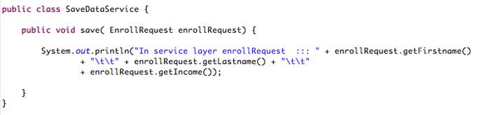EnrollRequest function prints the values in the object. This is shown in Code Segment 5.1.

Code Segment 5.1: Function to Print Values in the EnrollRequest

1. **Define the Bean in ReachOutWorld-servlet.xml**: To implement a method, you have to first define a bean. Here, you are defining the bean aopImpl class that is meant to be an Advice for implementing the aspects. This is shown in Code Segment 5.2

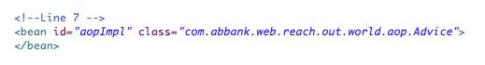Code Segment 5.2: Bean Definition

1. **Create the Advice class**: Create another class "Advice" in a package named com.abbank.web.reach.out.world.aop. This package holds all the classes that are used in AOP of Spring Framework. This is shown in Code Segment 5.3.

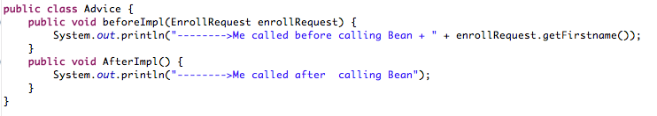

Code Segment 5.3: Creation of the Class Advice

The class Advice has two methods:

* BeforeImpl(),which prints the “Me called before calling Bean” message when it is called
* and AfterImpl(), which prints the “Me called after calling Bean” message when it is called

1. **Call and configure the Service Layer**:

* Call the Service Layer from the controller.
* Configure the ReachOutWorld-servlet.xml file to inject the bean into the Controller reference.
* In the Controller, add the reference of the service layer an the set and get methods.

Calling and configuring the Service Layer is shown in Code Segment 5.4.

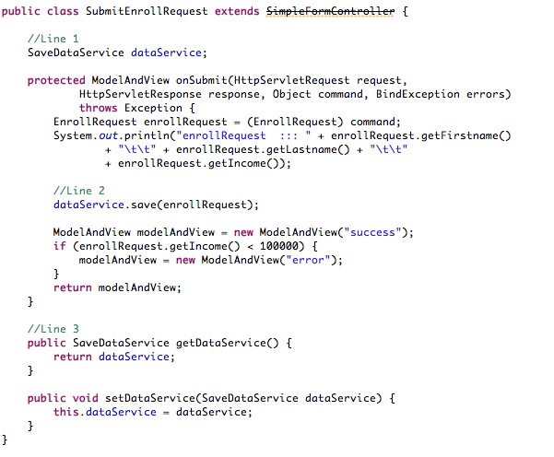

Code Segment 5.4: Calling and Configuring the Service Layer

In Code Segment 5.4:

* At the pointer line 1, a property is defined which is a reference of the service class SavaDataService.
* At Line 2, the service method is called.
* At Line 3, the set and get methods for the property are defined.

1. **Add the dependencies into the POM file**: To configure the entire application, you need to add dependencies to the pom.xml file of the application just as any Java program that is being executed. This is shown in Code Segment 5.5.

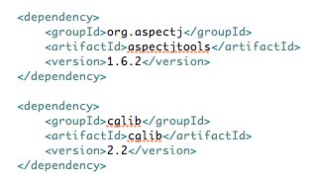

Code Segment 5.5: Dependencies Added

So far, we have done all basic configuration required to make the environment ready for AOP implementation. Now, let us now look at how to implement AOP in a Spring Framework application and also learn how to configure AOP using XML-based configurations and annotation-based configurations.

### 

### Topic 1: Implementation and Configuration of Spring Framework AOP Using XML Spring Framework AOP

Now that the Service Layer has been implemented and Advices created and added to the methods, let us look at configuring the AOP in the ReachoutWorld example. Let’s first take up XML-based configurations.

**XML-Based Configuration of AOP**

To configure AOP, you need to include the aspects and Advices in the XML-based configuration code (ReachOutWorld-servlet.xml in the example), as shown in Code Segment 5.6.

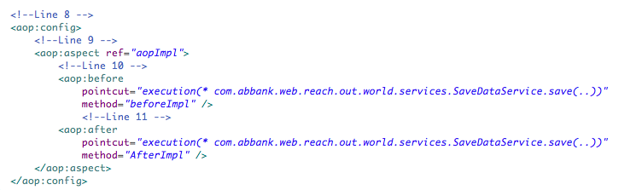

Code Segment 5.6: XML-Based Configuration of AOP

Note that in the Spring Framework AOP XML-based configuration, most of the elements are used within the context of the <aop:config> element. Let us look at declaring some of these elements.

**Declaring an Aspect**

Within <aop:config>, you may declare one or more advisors, aspects, or pointcuts. In Code Segment 5.6:

* A single aspect is declared using the <aop:aspect> element.
* The ref attribute references the POJO bean. The POJO bean supplies the functionality of the aspect.
* The bean that is referenced by the ref attribute supplies the methods called by any Advice in the aspect.

**Declaring Advice**

The aspect has two different bits of Advice:

* The <aop:before> element defines an Advice to call the beforeImpl() method of the Advice bean before any methods matching the pointcut are executed.
* The <aop:after> element defines an after Advice to call the afterImpl() method after the pointcut.

**The Control Flow**

Any application has a control flow that decides the order in which the methods, instructions, or functions of the application are executed. In Spring AOP, when Advice logic is woven into the business logic, the resulting control flow is shown in Figure 5.2:

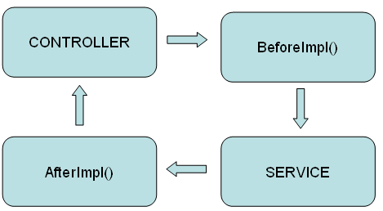

Figure 5.2: Advice Logic Woven into Business Logic

In Figure 5.2:

1. The control first reaches the Controller.
2. It goes to the Advice class and executes method BeforeImpl().
3. The Service class is called and its logic is executed.
4. After leaving the Service class, the Control goes back to the Advice class to execute the AfterImpl() method.
5. The control reaches back to the Controller.

Any of the several types of Advices can be declared during configuration; these are listed in Table 5.1.

|  |  |
| --- | --- |
| **AOP Configuration Advices** | **Description** |
| <aop:advisor> | Defines an AOP advisor. |
| <aop:after> | Defines an AOP after Advice (regardless of whether the advised method returns successfully). |
| <aop:after-returning> | Defines an AOP after-returning Advice. |
| <aop:after-throwing> | Defines an AOP after-throwing Advice. |
| <aop:around> | Defines an AOP around Advice. |
| <aop:aspect> | Defines an aspect. |
| <aop:aspectj-autoproxy> | Enables annotation-driven aspects using @AspectJ. |
| <aop:before> | Defines an AOP before Advice. |
| <aop:config> | The top-level AOP element. Most <aop:\*> elements must be contained within the <aop:config> element. |
| <aop:declare-parents> | Introduces additional interfaces to advised objects that are implemented transparently. |
| <aop:pointcut> | Defines a pointcut. |

**Table 5.2: Configuration Advices**

To control the aspect insertion in your main code, you can fine grain the details of declaring and configuring Advices. Here, you can also define the pointcut and method attributes of an Advice, as shown in Code Segment 5.7.



**Code Segment 5.7: Defining Advices**

In Code Segment 5.7, the two parts of an Advice are:

* **Pointcut**: This pointcut attribute contains the values that specify when the Advice should be executed. It has a special representation called the pointcut representation.
* **Method**: The method in the Advice is executed when the pointcut expression accepts the implementation of the aspect method.

How do you specify pointcuts for a given Advice—let’s find out next.

**Writing a Pointcut Expression**

A pointcut defines one or more join points at which an Advice must be woven. To define pointcuts, use the explicit class and method names or use the regular expressions that specify the matching class and method name patterns. Some AOP frameworks enable you to create dynamic pointcuts. Dynamic pointcuts apply Advice based on run-time decisions, such as the value of method parameters. Pointcuts, therefore, enable Advice to be targeted independent of the object-oriented hierarchy.

The objective of a pointcut is to determine which join points are to be executed with specified Advices in an AOP application. When using XML-based configuration, a pointcut is defined as shown in Code Segment 5.8.



**Code Segment 5.8: Writing Pointcut Expression**

The value passed to pointcut is in the XML expression language. Let us examine each expression sequentially as shown in Figure 5.3.

**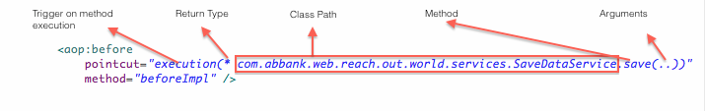**

**Figure 5.3: Writing Pointcut Expressions**

* **Trigger on method execution**: The execution() designator selects the SaveDataService save() method.
* **Return Type**: The method specification starts with an asterisk, indicating that you are not particular about the type the method returns.
* **Class Path**: The fully qualified class name.
* **Method:** The name of the method that should be selected.
* **Arguments**: For the method's parameter list, a double-dot (..) is used to indicate that the pointcut should select any save() method, no matter what the list of arguments is.

Suppose you want to confine the reach of the pointcut to only the com.abbank.game package. In that case, the match can be restricted by taking on a within() designator, as shown in Code Segment 5.9.

****

**Code Segment 5.9: within() Designator in a Pointcut Expression**

While writing arguments, you can use the following characters to set pointcut match conditions as shown below:

* The && operator – used to combine the execution() and within() designators in an "and" relationship (where both designators must match if the pointcut has to match).
* The || operator – used to indicate an "or" relationship.
* The ! operator - used to negate the effect of a designator.

**Using the bean() Designator**

The bean()pointcut is a new designator introduced by Spring Framework 2.5 that lets you identify beans using their IDs in a pointcut expression. The bean() designator takes a bean ID or name as an argument and extends the pointcut to that specific bean alone. Let us look at an example of the bean() designator, as shown in Code Segment 5.10.

****

**Code Segment 5.10: Example bean() Designator**

In Code Segment 5.10, the aspect Advice is to be applied to the method saveDataServicesave() and is limited to the bean with the ID saveContactService. To narrow a pointcut to a specific bean, you can use a negative expression to apply the specified aspect to all the beans except the one with the given ID. This is shown in Code Segment 5.11.

****

**Code Segment 5.11: Example bean() Designator with a Negative Expression**

In this case, the aspect’s Advice will be woven into all beans whose ID is not saveContactService. Now that the basics of writing pointcuts are covered, let’s see how to declare the aspects that use those pointcuts and write the Advice.

**Declaring a Pointcut**

A pointcut can be declared within the <aop:config> element by using its name which allows you to share the pointcut definition across several aspects and advisors. Code Segment 5.12 shows the declaration of a pointcut for the execution of any business service method in the service layer.

#### 

**Code Segment 5.12: Pointcut Declaration**

In Code Segment 5.12, the attribute pointcut ID has the value aop:pointcut and pointcut reference has the value businessService.

**Passing Parameter to Advice**

To pass arguments to the Advice method, you n toeed first configure it in the application’s config.xml files, as shown in Code Segment 5.13.

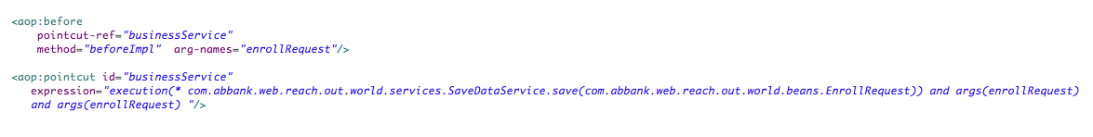

**Code Segment 5.13: Configuring Advice Arguments**

In Code Segment 5.13, the pointcut identifies the Save Advice, which refers to the EnrollRequest and holds an argument that identifies the enrollRequest bean. The <aop:before> Advice declaration refers to the enrollRequest argument, indicating that it should be passed into the saveDataService save method. Now, whenever the save()method is invoked on the saveDataService bean, the beforeImpl will get that data. This is shown in Code Segment 5.14.

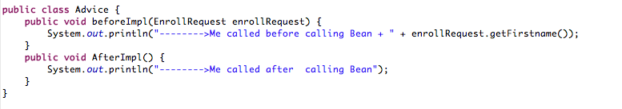

**Code Segment 5.14: Calling the Advice Method**

You learned how to write and declare pointcuts and Advice methods. Next, let us continue with our example ReachoutWorld application. The last step performed was configuring the AOP with all necessary attributes and elements. The next thing to do is to build the project and place it in the WAR to deploy the application. By providing the URL localhost:8080/ReachOutPeople in your web browser, you can see the screen display as shown in Figure 5.4.

### 

**Figure 5.4: ReachoutWorld Screen**

When you click Submit and the form is submitted, you can check the console for the display, as shown in Figure 5.5.



**Figure 5.5: Console Display**

With this, you configured the application in XML method and obtained the result. The project is saved in your directory using the file structure shown in Figure 5.6

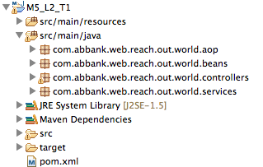

**Figure: 5.6: Project Structure**

### 

### Topic 2: Spring Framework AOP Annotations and Usage

The previous topic described how to configure and implement Spring Framework’s AOP using XML-based configuration. Now, let us look at configuring and implementing AOP in Spring Framework using annotations. As you are aware, annotations are a programming method in Java-based programs that allow you to implement functionalities such as AOP, MVC, Autowiring, and application configuration using simple tag words. Using annotation reduces the volume of code you need to write and is a time-saving method to write applications.

Some of the annotations available in the Spring Framework AOP are:

* @AspectJ
* @Pointcut
* @Before
* @AfterReturning
* @After
* @Around
* @DeclareParents

Next, let’s look at these annotations and find out how to implement these in the ReachoutWorld application.

## @AspectJ Support

AspectJ is an aspect-oriented extension of the Java Programming language and it provides annotated methods to declare aspects as regular Java classes, to enable easier handling of aspects. Spring Framework supports AspectJ annotations using a library that supports pointcut parsing and matching. To enable @AspectJ support in your Spring Framework application, it is necessary to support configuring Spring AOP in your configuration files. It also necessary to autoproxy beans that are advised by AspectJ aspects.

Autoproxying means that if a bean is advised by one or more aspects, a proxy is automatically generated for it to handle introduction methods and to ensure that the Advice is executed as needed. This means that when bean execution is interrupted by adding more than one new functionality as aspects, a bean proxy is generated to handle each new functionality. Enabling @AspectJ support is an advantage to you as a developer as AspectJ helps you to modularize your application easily and is therefore a more powerful AOP tool than the Spring AOP Framework.

To enable @AspectJ, you start by including the <aop:aspectj-autoproxy/> element in your Spring Configuration code. You will also need to include two AspectJ libraries, aspectweaver.jar and aspectjrt.jar, on the classpath of your application. These two libraries are held in the lib directory of an AspectJ installation or the lib/aspectj directory of the projects base pom.xml. You can also include the necessary libraries by adding the following dependencies to your application’s POM, as shown in Code Segment 5.15.

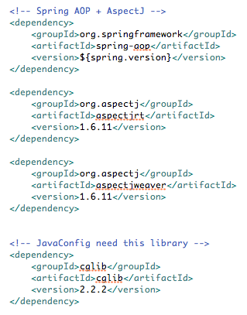

**Code Segmnet 5.15: Including AspectJ Libraries in pom.xml**

This is how you can enable @AspectJ support. Next, let us look at the annotation it supports to help you implement AOP in your application.

**Declaring Aspects**

When you enable @AspectJ support, Spring Framework will automatically detect beans defined with the @Aspect annotation. Code Segment 5.16 shows a regular bean definition in the ApplicationContext to which you are referring an aspect.

****

**Code Segment 5.16: Bean Definition**

Code Segment 5.17 shows the Advice class definition for the same bean defined in Code Segment 5.16. The Advice class is defined using the @Aspect annotation.

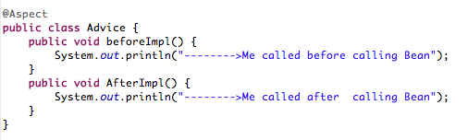

**Code Segment 5.17: Using @Aspect to Define the Advice Class**

You can write methods and fields to an aspect like any other class. You can also write pointcuts, Advices, and introduction declaration when defining the aspect.

**Declaring a Pointcut**

Pointcuts enable you to control Advice execution by determining the join points in your application. A pointcut declaration contains two parts:

* A definition containing the name and parameters, if any
* The pointcut expression that specifies the method executions that are to be advised

Using the @AspectJ style of annotations, you define the pointcut and write the pointcut expression using the @Pointcut annotation. The method serving as the pointcut must have a void return type. There has to be a clear distinction between a pointcut definition and pointcut expression to ensure that these two arguments do not get mixed up when implementing aspect insertions. Code Segment 5.18 is an example of using the @Pointcut annotation.

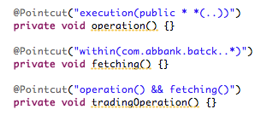

**Code Segmnet 5.18: @Pointcut Annotation**

The Spring Framework AOP supports a list of pointcut designators that can be used to further control conditions for inserting aspects into your application, as listed in Table 5.2.

|  |  |
| --- | --- |
| **Pointcut Designators** | **Description** |
| Execution | Is a primary designator used to match method execution join points |
| Within | Used to limit matching to join points to certain types |
| This | Used to limit join points where the bean reference is an instance of the specified type |
| Target | Used to limit matching to join points when a target object is found |
| Args | Used to limit matching join points where the argument types are specified |
| @target | Used to limit join points where the executing object’s class as a specified annotation |
| @args | Used to limit join points where the run time type of arguments have a specified annotation |
| @within | Used to limit matching join points within types having specified annotations |
| @annotation | Used to limit join points where the join point subject has a specified annotation |

**Table 5.2: Pointcut Designators Supported in Spring AOP**

While declarinf pointcut designators, you can use ‘&&’, ‘||’, and the ‘!’ characters in your pointcut expressions and refer the expression using the name. The example seen in Code Segment 5.18 shows three pointcut expressions:

* operation (which matches if a method execution join point represents the execution of any public method)
* fetching (which matches if a method execution is in the batch module)
* tradingOperation (which matches if a method execution represents any public method in the trading module)

**Declaring Advice**

Pointcut expressions are associated with Advice, which runs before, after, or around the methods matched by the pointcut. Table 5.3 lists the different types of Advice available in the Spring AOP framework and the annotations used to declare them.

|  |  |  |
| --- | --- | --- |
| **Advice Types** | **Annotation** | **Description** |
| Before Advice | @Before | Specifies that the pointcut expression is to run before the method execution |
| After returning Advice | @AfterReturning | Specifies that the pointcut should run after the matched method returns a result |
| After throwing Advice | @AfterThrowing | Specifies that the pointut should run after a matched method throws an exception |
| After (finally) Advice | @After | Specifies that the pointcut should run after the matched method execution is done, no matter the outcome of the method; whether it returns a result or throws an exception |
| Around Advice | @After | Specifies that the pointcut should run around the matched method: before, after returing, or after throwing. |

**Table 5.3: Annotations for Advice Types in Spring AOP**

Code Segment 5.19 shows an example of the before Advice using the @Before annotation**.**

**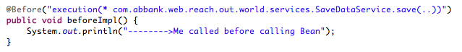**

**Code Segment 5.19: @Before Annotation**

Code Segment 5.20 shows an example of the after returning Advice using the @AfterReturning annotation.

**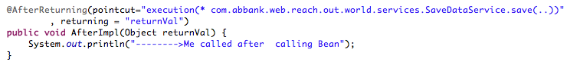**

**Code Segment 5.20: @AfterReturning Annotation**

When you use the @AfterReturning annotation, you must ensure that the name used in the return attribute must correspond to the name of the parameter in the Advice method.

Code Segment 5.21 shows an example of the after throwing Advice using the @AfterThrowing annotation.

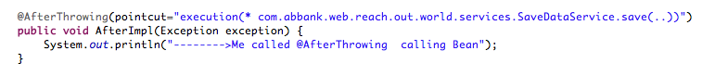

**Code Segment 5.21: @AfterThrowing Annotation**

Suppose you want the Advice to run only when exceptions of a particular type are thrown. In addition, you need access to the thrown exception to correct the error in your main code. In this situation, you can use the @AfterThrowing annotation. Then, you bind the thrown exception to an Advice parameter. This is shown in Code Segment 5.22.

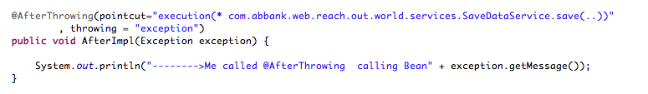

**Code Segment 5.22: @AfterThrowing with Exception Binding**

Code Segment 5.23 shows an example of the after (finally) Advice using the @After annotation.

**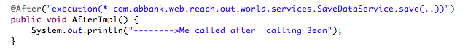**

**Code Segment 5.23: @After Annotation**

Code Segment 5.24 shows an example of the around Advice using the @Around annotation.

**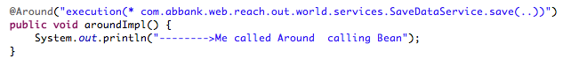**

**Code Segment 5.24: @Around Annotation**

You learned to annotate the different Advice methods, you know that the first parameter of the Advice method must be of the ProceedingJoinPoint type. Calling the Advice on this parameter causes the underlying method to execute. You can declare multiple parameters to the Advice method to make the argument and context values available to the Advice body. Next, you learn to write generic Advices that determine details about the method being Adviced.

**Advice Method Details**

Details specified in the Advice method such as parameters that specify join point access helps you to define aspect insertion in greater detail. This allows you to manage the new behavior being added to your code carefully so as to avoid errors and code failure.

* **Access to current join point**: A parameter belonging to the interface org.aspectj.lang.JoinPoint can be declared as the first parameter for an Advice method. This interface provides methods such as:
  + getArgs(): Returns method arguments
  + getThis(): Returns a proxy object
  + getTarget(): Returns the target object
  + getSignature():Returns the definition of the method being Adviced
  + toString(): Prints a description of the method being Adviced
* **Passing parameters to Advice**: To access the argument values of your Advice method, you can use the binding form of args. If you use a parameter name in the place of a type name in an args expression, the value of the corresponding argument is passed as the parameter value when the Advice is invoked. Code Segment 5.25 shows an example of how parameters can be passed to an Advice using the args.

****

**Code Segment 5.25: Passing Parameters to Advice**

* **Advice ordering:** When you have multiple pieces of Advices that need to run at the same join point, Spring AOP follows the same ordering rules as AspectJ to fix a sequence for Advice execution. The Advice with the highest precedence runs first, followed by others in decreasing order of precedence. When you have two pieces of Advice for different aspects, but both need to run at the same join point, you can specify the order of execution by defining the precedence. Precedence is specified by implementing the org.springframework.core.Ordered interface in the aspect class. You can also use the @Order annotation. The aspect that returns the lower value from the Ordered.getValue() method is given the higher precedence.
* **Introductions:** Introductions enable an aspect to declare that the object being Adviced implements a given interface. Introductions also implement the interface for the objects. You use the @DeclareParents annotation to apply an introduction, which specifies the parent for an object or bean being Adviced. Code Segmnet 5.26 shows an example of using the @DeclareParents annotation, where an aspect declares that all implementations of the service interface must also implement the ISaveDataService interface.

**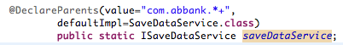**

**Code Segment 5.26: @DeclareParents Annotation**

The type of the annotated field determines the interface to be implemented as a parent interface. The value attribute of the @DeclareParents annotation is an AspectJ type pattern. Therefore, any bean of a matching type will implement the ISaveDataService interface as its parent interface.

You are now aware of the annotations used in Spring AOP along with @AspectJ support. Next, let us find out how to implement Spring AOP configuration using annotations in the ReachoutWorld example. To implement the appliction:

1. **Add the following dependency into POM for AOP support:** Adding dependencies to the application’s base pom.xml is shown in Code Segment 5.27.

**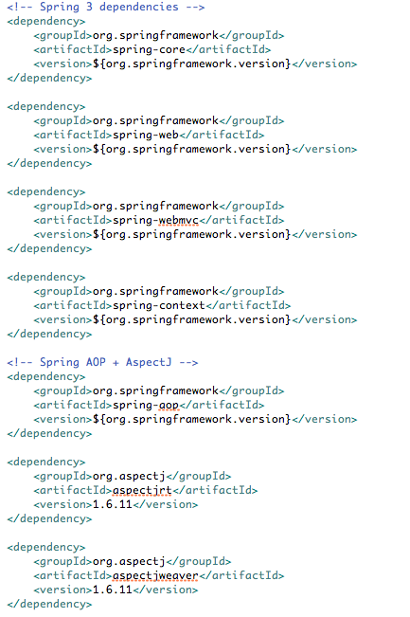**

**Code Segment 5.27: Adding Dependencies to the POM**

1. **Create a new package for Service Layer:** Once you have added the necessary dependencies in your application’s POM, create a interface ISaveDataService with one method save(EnrollRequest ), as shown in Code Segment 5.28.

**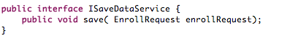**

**Code Segment 5.28: Creating Service Layer**

1. **Create a new class in SaveDataService:** After creating the Service Layer package, create a class that implements the interface ISaveDataService and annotate it with @Component. The @Component is used to declare a class as a component. This is shown in Code Segment 5.29.

**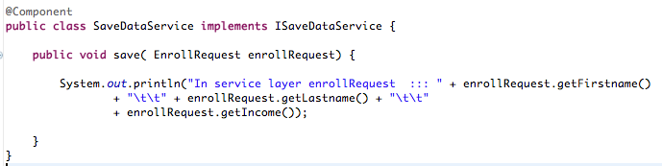**

**Code Segment 5.29: Creating a New Class Using @Component**

1. **Autowire references for form submission:** Once the classes are created, you need to autowire properties to them to indicate which behavior is being inserted as an aspect. In the controller class, create the reference of the interface and annotate it with @Autowire. The controller class autowires the interface with the service class. This is shown in Code Segment 5.30.

**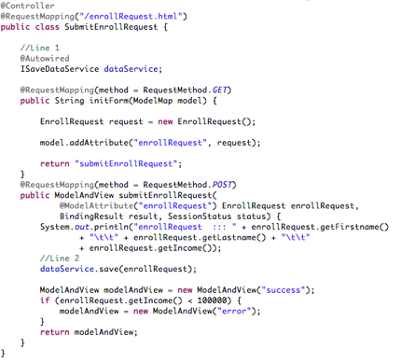**

**Code Segmnet 5.30: Autowiring Interfaces**

1. **Create a package “com.abbank.web.reach.out.world.aop” and create a class Advice:** After referencing the behavior to be inserted, create an Advice for the aspect. In the package com.abbank.web.reach.out.world.aop, create the Advice class. This class has two methods to print the message before and after the method of the service class is called. This is shown in Code Segment 5.31.

**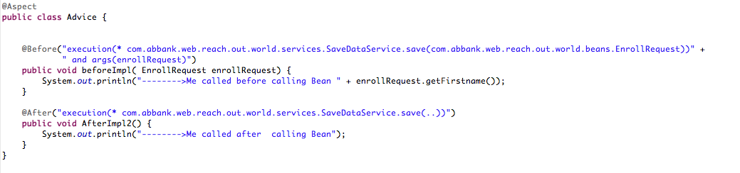Code Segment 5.31: Creating a Package and Defining the Advice Class**

Annotate the class with @Aspect to declare it as an aspect and annotate methods BeforeImpl with @Before. The AfterImpl method with the @After. BeforeImpl method will accept the argument Enrollment request and print it.

1. **Configuration:** After an Advice is defined, you need to declare and configure it. Declare this Advice (as seen in line 4) in the spring-config.xml and configure the Advice as shown in line 3 of the code <aop:aspect-autoproxy>.This is shown in Code Segment 5.32.

**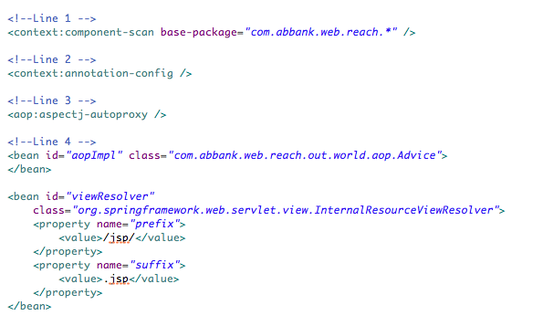**

**Code Segment 5.32: Configuring the Application**

1. Build the project and deploy in the application server.

You learned to implement AOP concepts using Spring Framework annotation-based insertions of aspects. You also learned to configure aspects using annotations. As discussed earlier, AspectJ is another popular tool used to implement AOP. Let us now understand the differences between Spring AOP and AspectJ.

**Module Summary**

This module introduced you to the concept of AOP, which you can use insert aspects into your main application code. These aspects are meant to Advice service methods and enhance them by adding extra functionalities.

By using Spring Framework’s AOP, you can increase the functionality of your Java-based applications while modularizing the components of your application. This modularizing occurs when cross-cutting concerns in your application are separated from the main code.

You have also learned how to implement AOP using XML-based configuration and annotation-based configurations.

### References

* Web references:
  + <http://java.dzone.com/articles/aop-made-easy-aspectj-and> (Last accessed on 21 Apr 2014)
  + <http://docs.spring.io/spring/docs/2.5.4/reference/aop.html> (Last accessed on 21 Apr 2014)
  + <http://www.tutorialspoint.com/spring/aop_with_spring.htm> (Last accessed on 21 Apr 2014)
* Book references:
* Laddad, Ramnivas. (20011). *AspectJ in Action.* Manning Publication Company.
* Walls, Craig. (2011). *Spring in Action-3rd edition.* Manning Publication Company.

# Module 6: Data Access

**Module Overview:**

Enterprise applications that handle a large volume of data every day face the challenge of accessing data stored outside the application. While accessing data from an external database, applications need to protect their code’s logic and at the same time they should not harm the data held in the external database. To access the data held in an external database, Java applications developed using the Spring Framework depend on the data access framework. The Spring Framework provides support for all popular data access frameworks in Java such as Java Database Connectivity (JDBC), Hibernate, iBATIS, Java Data Objects (JDO), and Java Persistence API (JPA). These data access frameworks perform the tasks of communicating with a database from the application and read from and write data to the database depending on the application’s requirements. In this way, an application does not need to include data access code and can focus only on the business logic. In this module, you will learn how to implement JDBC in the Spring data access framework to handle data access tasks and associated features like resource management, exception handling, and transaction participation.

**Module Objectives:**

By the end of this module, you will be able to:

* Support the Spring Framework implementation of JDBC.
* Describe how performing data access operations using JDBC is made easy with the Spring Framework.
* Identify the configuration settings required for using JDBC with the Spring Framework.

## Lesson 1: Spring JDBC Support

Most Java applications use relational databases to implement data related processes such as content management or order provisioning. A secure and easy to access database can support an application’s data requirements keeping the application free of data access code. In the Spring Framework, applications perform database transactions using data sources in JDBC. The Spring Framework’s data access component supports JDBC database transactions by providing the following support:

* **Resource management**: Connecting to databases during application execution and releasing them later
* **Exception handling**: Converting any data access related exceptions to a Spring Framework recognizable format for exception handling
* **Transaction management**: Maintaining transparency in ongoing transactions between an application and a database
* **Resource unwrapping**: Retrieving database objects as needed for the application

All of the above mentioned support is made available to an application by calling the Spring Framework’s data access component within the application’s code. In this way, the Spring Framework’s data access component manages the application’s data access needs without having to write explicit code for accessing data. This reduces the volume of the application’s code significantly and also keeps the business related code free from having to implement data retrieval operations.

Before looking at how the Spring Framework implements JDBC transactions, let us first familiarize you with JDBC Application Programming Interface (API), its implementation, and uses as a data access framework.

### Topic 1: Introduction to JDBC API

JDBC is a Java API that manages the connections between a Java application and any database. Managing database connections are done using the specific APIs that are assigned for database tasks such as:

* Connecting to a database
* Writing SQL commands for transactions
* Executing the SQL queries in the database
* Retrieving data and recording changes to the database

Thus, JDBC provides a set of APIs that perform the tasks listed above and allows an application to access the underlying database and use the data held in it for business purposes. The JDBC API provides two-tier and three-tier processing models, where the client and server components are logically separated. The two main layers in JDBC architecture are:

* **The JDBC API**: This component is responsible for creating a connection between the application and the JDBC Manager, which is a front-end tool. This tool helps applications to connect with a Database Management System (DBMS) that works with JDBC. The JDBC API contains interfaces and classes which you can use to write application tasks such as connecting to a database, using Structured Query Language (SQL) queries to retrieve data, and processing the responses from the database.
* **The JDBC Driver API**: This component is responsible for creating connections between the JDBC Manager and the JDBC Driver. The JDBC Driver is an API that enables an application to access a database and is specific to each database being called in an application.

The JDBC API is similar to core Java interfaces such as java.lang and java.awt in terms of structure and implementation. Figure 6.1 shows the JDBC architecture and the location of the driver manager, JDBC drivers, and the java application.

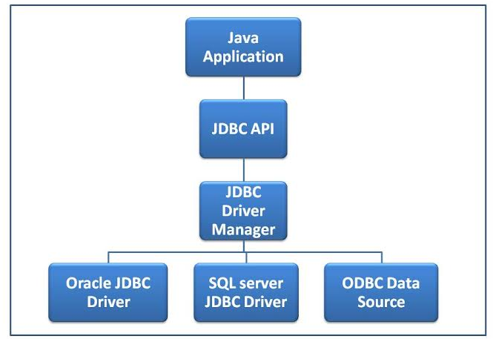

**Figure 6.1: JDBC Architecture**

Now that you are familiar with the JDBC architecture, let us look at the interfaces and classes provided by JDBC to perform data access related tasks.

**JDBC Interfaces and Classes**

Table 6.1 lists the classes provided by JDBC and its descriptions.

|  |  |
| --- | --- |
| **Classes/Interfaces** | **Description** |
| DriverManager (Class) | Manages a list of available database drivers for an application. This class also matches database drivers to establish a connection using connection requests from an application. |
| Driver | Handles database server communications from an application. |
| Connection (Interface) | Contains all methods that implement database communications. Objects of this class represent the communication context. |
| Statement (Interface) | Submits SQL statements to the database using objects. Sun-interfaces of this class also accept message parameters passed to predefined methods. |
| ResultSet (Interface) | Implements objects that contain data retrieved from a database after an SQL query statement is executed. Objects of this class act as iterator that allows an application to parse through the data they contain. |
| SQLException (Class) | Handles exceptions that occur because of database errors and provides the same information for debugging. |

**Table 6.1: Classes and Interface in JDBC API**

Now that you know the interfaces and classes available in the JDBC API, let us look at implementing JDBC in a java-based application.

**Implementing JDBC API**

, Import the java.sql package to implement the JDBC API in a java application.. This package contains the JDBC interfaces and classes needed for programming database communication. To build a JDBC application, the following generic steps needs to be performed:

1. **Register the JDBC driver**: By registering a driver, it is initialized to open a communication channel between the database and an application.
2. **Open a connection**: The actual connection between the database and an application can be represented by an object of Connection class using the DriverManager.getConnection() method.
3. **Execute Queries**: You can build and submit SQL queries to the database from an application by using an object belonging to the Statement interface.
4. **Extract data**: To retrieve data from the ResultSet interface, use the ResultSet.getdataname() method.
5. **Clean up the database environment**: After all necessary communication operations are performed between the application and the database, it is necessary to clean up the database environment and close the database connection. This ensures that only the necessary data is accessed in the database and also secures the integrity of all data stored in the database.

The steps mentioned above can be performed any time an application needs to access the database to add new data, select existing data, or update the database. Code Segment 6.1 shows a simple example of a JDBC application. In this example, a MySQL database of names and salaries is created using a JDBC driver. Upon execution, the application accepts the first name, last name, and salary fields, for each person.

**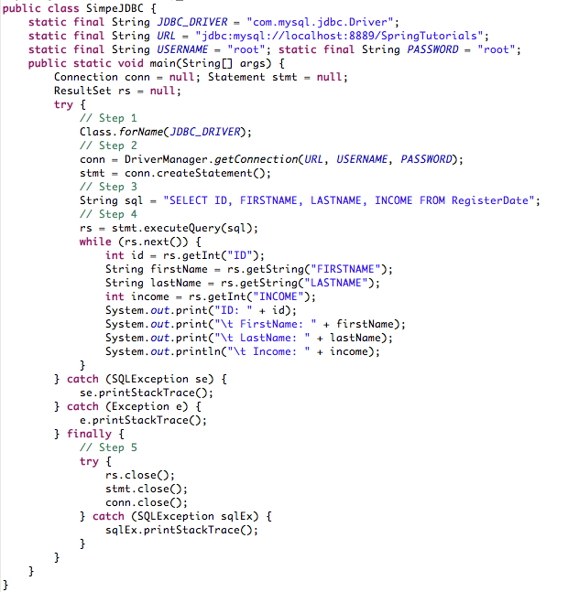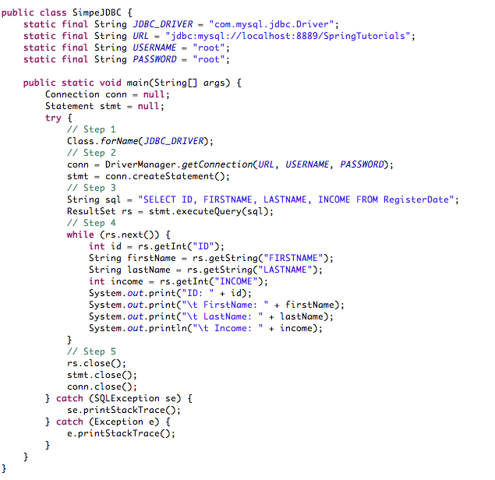**

**Code Segment 6.1: Simple JDBC Application**

Code Segment 6.1 does the following:

* Step 1: Creates a class for handling database transactions
* Step 2: Opens a connection to a database using the JDBC driver
* Step 3: Uses SQL to query data based on ID, FirstName, LastName, and Income from a table called RegisterDate
* Step 4: Prints the data retrieved
* Step 5: Closes connection to the database

Code Segment 6.2 shows the SQL statements that query the database for the above application. These statements are used to insert data into the database tables.

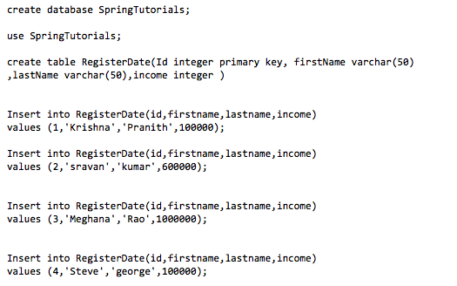

**Code Segment 6.2: SQL Statements to Query the MySQL database**

Code Segment 6.2 provides SQL statements to create a database named SpringTutorials and a table named RegisterDate. It also provides statements to insert four rows of data under the columns named Id, FirstName, LastName, and Income. Figure 6.2 shows the output for the example application once the database table has been filled.

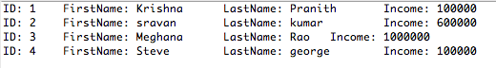

**Figure 6.2: Output for JDBC Example Showing MySQL Table**

The code in this example shows the implementation of a simple Spring Framework application that:

* Accesses a database
* Reads the values in a table called RegisterDate
* Displayed the table

So far you have been introduced to the basic concepts of JDBC, now let us take you through the implementation of JDBC in a Spring Framework based Java application.

**Topic 2: Implementing Spring JDBC**

You can implement JDBC API directly in any Java-based application. However doing so may cause some problems. Let us look at these issues and see how using the Spring Framework can solve them.

**Issues with Implementing JDBC Directly**

In a Java-based application that needs to access data, you can implement JDBC without calling it from the Spring Framework.

The issues developers face while directly implementing the JDBC API in a Java application are:

* **Open database connections**: After the results of a SQL query sent to the database are obtained, the connection between the application and the database needs to be closed. This is done in order to release the database and prevent overloading of the application. But while closing the connection you have to ensure that the implementation of ResultSet, Statement, and Connection interfaces are also closed in the final code block. The close() method used for each interface can throw exceptions which keeps the process incomplete. So the database connection remains open even after the application is executed which is dangerous to the integrity of the data stored within.
* **Handling SQLExceptions**: If an application encounters a problem when accessing the database, all subsequent JDBC implementations throw a SQLException. This is the only exception available in the JDBC API and it is not easy to manage across multiple database vendors. For example, to identify the error in code that throws exception, you may end up having to write a lot of new code in the try-catch blocks (the code block that catches exceptions). The exception itself is not very informative, so it is tough to navigate through the source code to locate and fix errors.
* **Resource look up:** To interact with a database, the javax.sql.DataSource interface provides a lookup method to identify a particular database. This method can be used without having to specify database details such as driver name or the connection URL. These details are configured outside the application configuration. While this serves the purpose of keeping the application code separated from the transaction code, developers end up having to maintain multiple sets of configuration code depending on the number of databases the application is accessing. Each time a connection needs to be established, an application has to look up the specific database details in the DataSource interface using a naming service such as Java Naming and Directory Interface (JNDI). This again adds to the volume of code to be created and maintained, slowing down the application’s execution and increasing chances of error.

**Benefits of Using the Spring Framework in Data Accessing**

Implementing JDBC directly creates problems in an application. To overcome these issues, developers can use the Spring Framework with JDBC. The benefits of using the Spring Framework with JDBC are:

* **Inversion of Control (IoC) through Dependency Injection (DI)**: The configuration of database details such as driver name and connection URL can be defined in the Spring Framework as beans. Once these database details are defined as Java beans, they can be used as properties and injected into the application using DI to implement IoC. As a result, configuration of database is accomplished without writing extra configuration code. Thus, the Spring Framework solves the configuration code problem created by using the DataSource interface in JDBC.
* **Handling database connections**: The Spring JDBC Framework handles all the low-level details related to handling exceptions. These details include:
  + Opening database connections
  + Exception processing and handling
  + Preparing and executing the SQL statement
  + Transaction handling
  + Closing the database connection

To handle database connections, all you have to do is define the connection parameters, specify which of the SQL statements have to be executed, and do the necessary iteration to retrieve data from the database. This means that an application code can focus only on what data to access and where to access the data while, the Spring Framework takes care of everything else.

* **Implementing Object Oriented Programming (OOP) to data access:** The Spring Framework supports the development of applications based on OOP principles. This is achieved using Data Access Objects (DAOs) which are used to read data from and write data to a database. The DAOs are contained in an interface so that the rest of the application is able to access these objects and use them to communicate with the database. The advantages of using DAOs are:
  + Service layer objects are decoupled from data access implementation and so they can be easily tested by using stubs and mocks.
  + The data persistence is limited to the data access framework and only relevant data access methods are available to the rest of the application. This keeps the code flexible and allows you to choose a persistence framework that will have minimum impact on the rest of the application.

Figure 6.3 shows the implementation of the Spring Framework’s DAO to support the data access component.

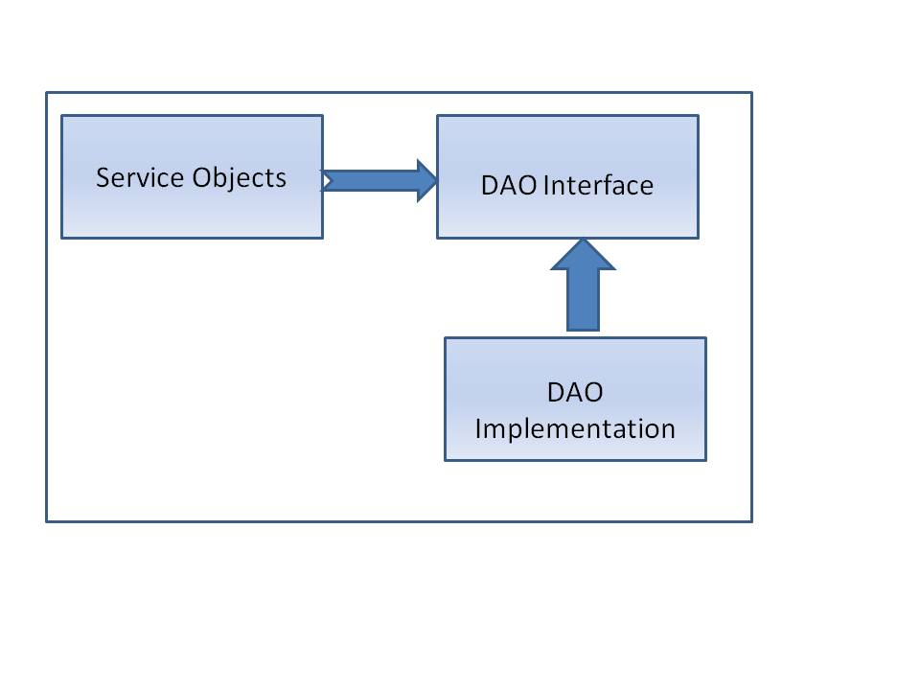

**Figure 6.3: Spring Framework’s DAO Implementation**

* **Consistent exception hierarchy**: The Spring Framework is able to translate technology-specific exceptions to its own exception class that extends the DataAccessException class. This means that all JDBC exceptions are converted to Spring Exceptions and are processed so that the application does not lose any information about why the exception occurred in the first place. Similarly, the Spring Framework’s exception handling also converts Hibernate exceptions to a set of run time exceptions that are easily managed. This consistency in handling exceptions allows an application to manage the exceptions within their own code block. developers also do not have to write the exception declaration in DAO interface. The exceptions are contained in the org.springframework.dao exception hierarchy, as shown in Figure 6.4.

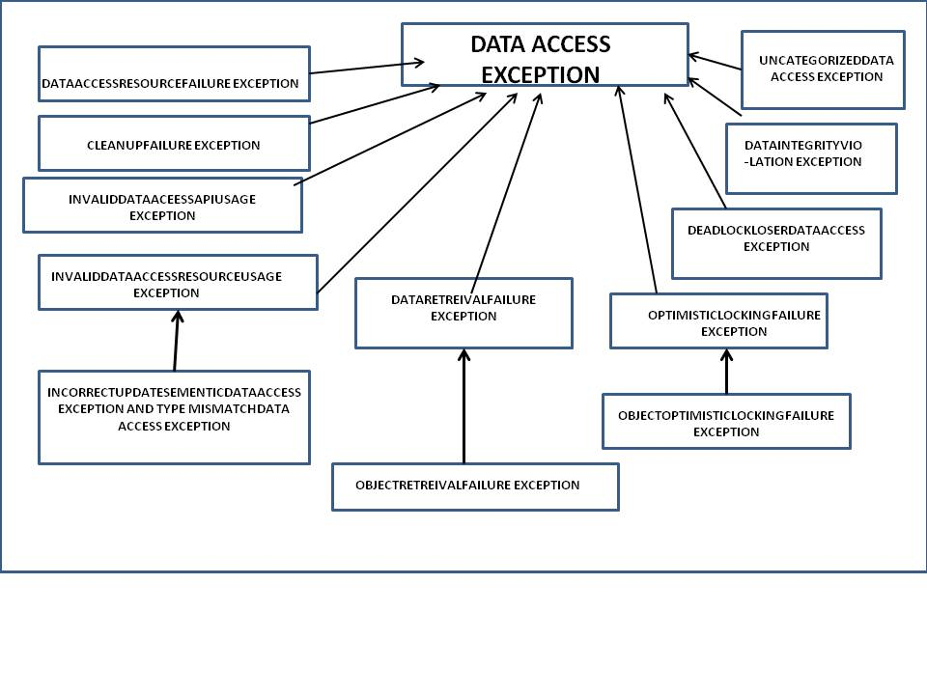

**Figure 6.4: Exception Hierarchy in Spring Framework**

* **Data access templates**: A template is a method that defines the outline of a process, such as delegating responsibility of repetitive tasks to sub classes, filling implementation specific details, and so on. The Spring Framework applies the concept of a template to its data access framework to manage database transactions. Irrespective of the database being queried for transactions, data access application implements certain fixed steps such as controlling transactions, managing resources, and handling exceptions. These fixed steps in data access are managed by the data access templates.

The variable steps in a data access application are user-defined such as, creating SQL statements and binding parameters to methods. These variable steps are handled using callbacks in the Spring Framework. While using JDBC, the Spring Framework provides the jdbcTemplate interface which handles basic data access functions so that the application code focuses only on the data being transacted. This reduces the volume of code needed for accessing data and the time taken for developing applications.

The Spring Framework handles most of the tasks involved during data access when implementing JDBC through it. This reduces the number of tasks performed by the developer, therefore reducing the probability of error and development time needed. These tasks are listed in Table 6.1 along with the person/system responsible for the task.

|  |  |  |
| --- | --- | --- |
| **Data Access Task Description** | **Who Performs the Task** | |
| **Spring Framework** | **You (Developer)** |
| Defining the connection parameters |  | **X** |
| Opening connections to database | **X** |  |
| Specifying the SQL statements that are to be queried |  | **X** |
| Declaring parameters by providing their values |  | **X** |
| Preparing and executing statements | **X** |  |
| Setting up iteration loops | **X** |  |
| Performing each iteration |  | **X** |
| Processing and handling exceptions | **X** |  |
| Closing ResultSet, Statement and Connection interface | **X** |  |
| Closing connection to the database | **X** |  |

**Table 6.1: Task Handling in Spring Framework’s Data Access Component**

You can now conclude that, by implementing JDBC as a data access component of the Spring Framework can significantly reduce the amount of application management needed to implement database related operations. Let us now look at how to approach data accessing through JDBC in Spring Framework.

**Choosing an Approach for JDBC Data Accessing**

There are many approaches to choose from, based on the business requirements, while implementing JDBC for data accessing in a Spring Framework application. These approaches are based on the type of the Spring Framework data access templates being used in an application and are decided when writing code related to data access operations. Business requirements also help you identify the best-suited approach. These approaches are listed in Table 6.2:

|  |  |
| --- | --- |
| **Approach for JDBC Data Access** | **Description** |
| jdbcTemplate approach | This is the lowest level basic Spring JDBC approach possible in an application, and supports all of the Java 5.0 updates such as generics and varargs. |
| NamedParameterjdbcTemplate approach | In this approach, a jdbcTemplate implementation is wrapped to provide a named parameter for connection operations. This is used to provide documentation and support the use of multiple parameters in an SQL statement. |
| SimplejdbcTemplate approach | This approach combines the most frequently used operations in jdbcTemplate and NamedParameterjdbcTemplate implementations. |
| SimpleJdbcInsert and SimplejdbcCall approach | This approach is used to optimize the amount of metadata contained in a database in order to reduce the amount of configuration needed while accessing data. In this approach, coding is simple as developers have to only provide the name of the database table to be accessed and write parameters that match the column names in the table. If the metadata is not provided by the database, then explicit configuration for the parameters has to be written. |
| RDBMS object approach | In this approach, while initializing the data access layer, it is important to create reusable and thread-safe objects similar to those in Java Data Object (JDO) query. Here, developers define the query, declare parameters, compile the query, and then implement the query by calling the RDBMS execute method as many times as needed. |

**Table 6.2: Choosing Approach for JDBC Data Accessing**

**Using Spring JDBC**

JDBC can be implemented using the Spring Framework’s jdbcTemplate interface. To implement the data access operations through JDBC, devleopers have to:

* Configure data source objects and the jdbcTemplate in the Spring Framework configuration files
* Implement the main method that calls the data access code

Let us look at the example application used in Code Segment 6.1. In this example, the application reads from and writes data to a MySQL database table named RegisterDate and displays the transaction’s result. To implement Spring JDBC through the jdbcTemplate in this application, the following steps needs to be performed:

1. **Configure data source objects**: Data source objects are those which provide an abstraction to the database. These objects need to be configured within an application in order to create a database connection which can be used to access data. To configure a data source object, you have to pass four parameters to it:
   * Driver class name
   * URL connection to database
   * Username for authorizing the connection
   * Password for authentication

In the Spring Framework, two data source classes can be used to create and configure data source objects. These classes are:

* DriverManagerDataSource class: Creates a new connection to the database every time a connection is requested
* SingleConnectionDataSource class: Reopens the same connection every time a connection is requested

Code Segment 6.3 shows the configuration of data source objects in the Spring Framework’s XML-based configuration file.

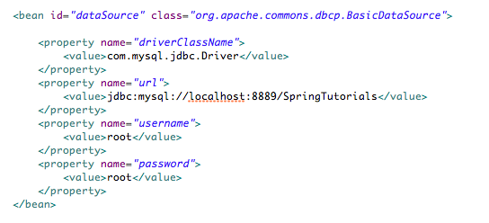

**Code Segment 6.3: Configuring Data Source Objects in Spring Framework**

1. **Configuring the jdbcTemplate**: By including the jdbcTemplate in the application actually enables the JDBC component in the application to handle data accessing operations. The jdbcTemplate also takes care of the basic fixed steps in data accessing, leaving the application to focus only on the variable steps. To configure the jdbcTemplate, you have to declare it as a bean and inject the data source object into the bean by autowiring as shown in Code Segment 6.4.



**Code Segment 6.4: Configuring jdbcTemplate in Spring Framework**

1. **Implementing the** main() **method**: Here, you actually write the application method main() which performs the data access operations. This is shown in Code Segment 6.5.

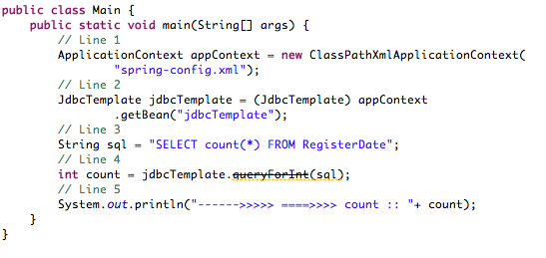

**Code Segment 6.5: Main Method Implementation**

In Code Segment 6.5:

* **Line1:**  Retrieves the instance of ApplicationContext within the spring-config.xml which includes the definition of datasource and jdbcTemplate
* **Line2:** Gets the bean of JdbcTemplate
* **Line3:** Defines a SQL query. Here the application is trying to get a count of the number of records in a database called RegisterDate
* **Line4:** Uses queryForInt() method of JdbcTemplate to execute the query and return an int value as output
* **Line 5:** Prints the output value.

Figure 6.5 shows the output of Code 6.5, where the application executes queries to JDBC for counting the number of rows held in the database table.

****

**Figure 6.5: Example Output**

With this example, you have now seen how to implement a simple data access application that reads from a database and displays a result based on the SQL query written in the access method. You have implemented this using the Spring Framework jdbcTemplate.

You are now familiar with the basic implementation of the Spring Framework’s data access component through JDBC framework. Let us now move on to understand the advanced concepts and capabilities of Spring JDBC that help developers use JDBC more efficiently for handling data access operations in a Spring Framework based application.

## Lesson 2: Advanced Spring JDBC

The Spring Framework’s JDBC data access component performs all communications to a database needed to use necessary data in a Java application. You can use some advanced data accessing components such as the jdbcTemplate to make the data accessing simpler and extensive. Just by using a few invocations and defining simple properties, the Spring Framework can be used to handle all data access operations keeping the main application focused on business logic.

After looking at basic data accessing concepts in the Spring Framework, let’s now learn more about the data accessing operations available with the jdbcTemplate and also see how database related exceptions are handled in the Spring Framework.

### Topic 1: Spring jdbcTemplate

As you know, that the jdbcTemplate is a feature of the Spring Framework that enables an application to perform data accessing operations. Table 6.2 lists the operations available when using the jdbcTemplate class in a Java application.

|  |  |  |
| --- | --- | --- |
| **Method** | **Description** | **Syntax Example** |
| query() | Used to query and populate any number of domain objects from a database | this.jdbcTemplate.query(  "select first\_name, surname from t\_actor",  new RowMapper() |
| queryForInt() | Used to query the number of rows in a relational database table | this.jdbcTemplate.queryForInt("select count(0) from t\_accrual"); |
| queryForObject() | Used to query for a string data in the database tables | (String) this.jdbcTemplate  .queryForObject |
| update(“insert into SQL statement”) | Used to insert a new row of data into the database tables | this.jdbcTemplate.update("insert into"); |
| update(“update,  SQL statement”) | Used to update the database table once the data has been modified | this.jdbcTemplate.update("update t\_actor set weapon = ? where id = ?", new Object[] {"Banjo", new Long(5276)}) |
| Update(“delete from orders”) | Used to delete a row of data from the database table | this.jdbcTemplate.update("delete from orders"); // :) |
| execute() | Used to invoke table operations such as create table, drop table, update table | this.jdbcTemplate.execute("create table mytable (id integer, name varchar(100))"); |

**Table 6.2: Methods of jdbcTemplate Class**

Now let us look at a few code examples of using the jdbcTemplate. To use the jdbcTemplate for data access, you have to configure the SpringJDBCDAO class and pass the jdbcTemplate as a property. This configuration enables the application to use jdbcTemplate as shown in Code Segment 6.6.

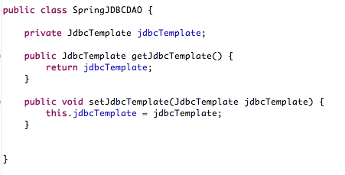

**Code Segment 6.6: Basic Configuration of SpringJDBCDAO Class**

Since you are using DAO interface to support data access operations, the next step is to configure the DAO class along with the DataSource and jdbcTemplate in XML-based configuration files in the Spring Framework. In other words, the jdbcTemplate object is declared as a bean and using this bean to perform data access operations. This is shown in Code Segment 6.7.

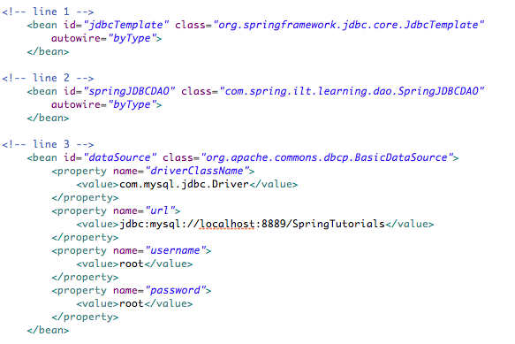

**Code Segment 6.7: Configuring DAO Class, DataSource and jdbcTemplate**

Now that the configurations are done, JDBC can be implemented in the Spring Framework based application, being developed in this example.

**Implementing the jdbcTemplate**

Now let us look at executing different methods and interfaces of the jdbcTemplate class to implement data accessing operation in an application. These methods of the jdbcTemplate class are are as follows:

* **queryForList()** **method:** This method is used to retrieve a list value from the database being queried. In the example using the RegisterDate table, the execution of queryForList() method is done by first defining the method and then calling the method in the main application. Code Segment 6.8 shows how to define a queryForList() method.

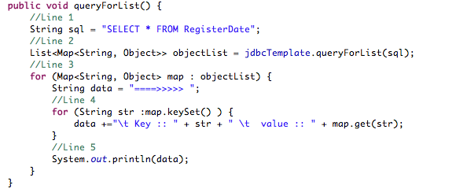

**Code Segment 6.8: Defining queryForList() Method**

Code Segment 6.9 shows how to call the queryForList() in the main application, once it has been defined.

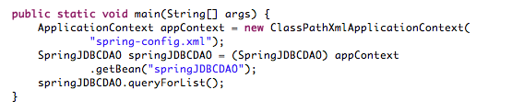

**Code Segment 6.9: Calling queryForList () from Main Application**

Figure 6.5 shows the output generated when the queryForList() method is executed.



**Figure 6.5: Output for queryForList() method**

* **RowMapper interface**: The RowMapper interface is used by the jdbcTemplate to map a ResultSet row to a ResultSet object. The RowMapper interface can be used instead of the ResultSet interface to map data directly to a class using the data. To implement the RowMapper interface, perform the following steps:

1. **Create RowMapper class**: Create a class for RowMapper interface which implements the RowMapper(t) method as shown in Code Segment 6.10.

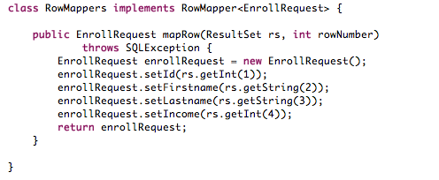

**Code Segment 6.10: Creating RowMapper Class**

The mapRow method (mapRow is a method called in the RowMapper interface) in Code Segment 6.10 accepts an object of the ResultSet interface and the row number as input to perform the necessary mapping. For every query requested by the application, the mapRow method is called-back.

1. **Define a query**: Now that the RowMapper has been created, you can pass it as an argument to the jdbcTemplate method query() to map a specific row of data from the RegisterDate table to an object of the use class, EnrollRequest as shown in Code Segment 6.11.

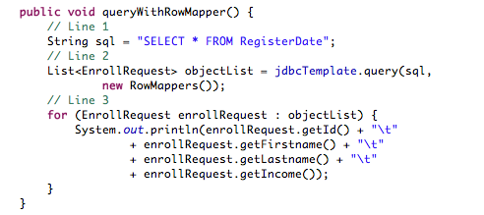

**Code Segment 6.11: Defining a RowMapper Query**

1. **Run the main application**: Once the method to implement the query is defined, this method can be called from the main application, as shown in Code Segment 6.12 to execute the application.

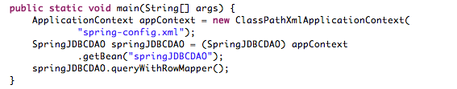

**Code Segment 6.12: Calling the RowMapper Query from Main Application**

Once the application is executed, the result generated is displayed, as shown in Figure 6.6.

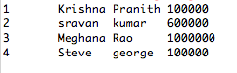

**Figure 6.6: Result for RowMapper Query**

* **QueryWithWhere clause method**: While searching for specific data in a database, you can set conditions using SQL query to define the target data object. This is done using the ‘where’ clause of SQL statements in JDBC. Code Segment 6.13 displays the code for querying the database for an object whose id number is one.

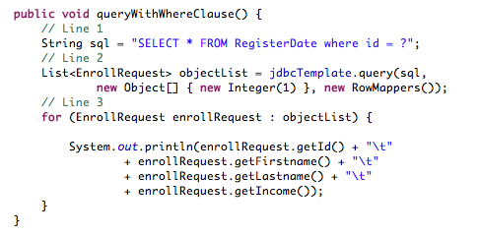

**Code Segment 6.13: Defining a queryWithWhere Method using ‘where’ SQL Clause**

Once the query method has been defined as seen in Code Segment 6.13, the queryWithWhere method can be called from the main application, as shown in Code Segment 6.14.

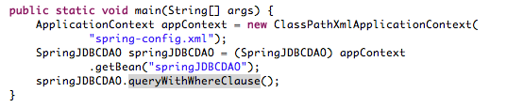

**Code Segment 6.14: Calling QueryWithWhere from Main Application**

When the above application is executed, the result generated as shown in Figure 6.7.



**Figure 6.7: Output for QueryWithWhere**

* **Updating data (INSERT/UPDATE/DELETE) with jdbcTemplate**: To insert new data, update existing data, or delete unwanted data, you can use the Update API of the jdbcTemplate. The Update API supports variable arguments and can take any number of parameters as needed. The arguments should be passed sequentially in the same order as the data object parameters. Code Segment 6.15 shows the implementation of the Update API to insert a new row of data to the RegisterDate database table.

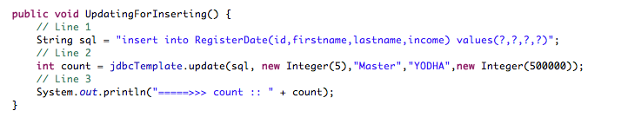

**Code Segment 6.15: Implementing Update API to Insert a New Data Row**

In Code Segment 6.15, you have done the following:

* **Line 1**: Defines the insert query and added four variable parameters to this query.
* **Line2**: Uses the Update API to accept the SQL as first parameter followed by data objects such as first name, last name and salary.
* **Line3**: Prints the count of the number of rows in table after insertion.

Once the Update API method has been defined, the Update API method can be called from the main application as seen in Code Segment 6.16.

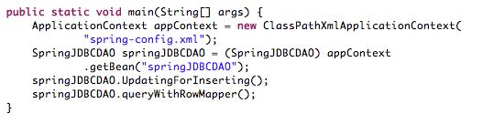

**Code Segment 6.16: Calling Update API Method from Main Application**

When the Update API method is executed from the main application, the result generated is shown in Figure 6.8.

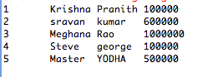

**Figure 6.8: Output for Update API Method**

Now that you have added a new row of data to the database table, the database can be queried to return the new value to the question of, ‘How many rows are there in the table RegisterDate’. This can be done as shown in Code Segment 6.17, where the Update API is used to update the database.

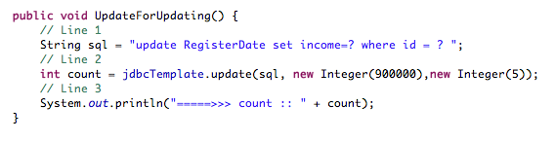

**Code Segment 6.17: Implementing Update API to Update a Database**

When you run the UpdateForUpdating method described in Code Segment 6.17 from the main application, the result generated is shown in Figure 6.9.

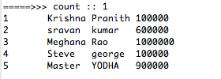

**Figure 6.9: Output for Update API‘s Update Method**

This result indicates that the number of new rows added to the RegisterDate table is one. The Update API can also be used to delete a row of data as shown in Code Segment 6.18.

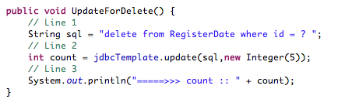

**Code Segment 6.18: Deleting Data using Update API**

Now you have seen how to use the jdbcTemplate methods to perform various data access operations in a Spring Framework application. Let us look at an example of using the NamedParameterjdbcTemplate interface to perform data access operations. To use the NamedParameterjdbcTemplate interface, perform the following steps:

1. **Create NamedParameterjdbcTemplate class:** To implement the NamedParameterjdbcTemplate, create a class for it and write setter and getter methods for this class, as shown in Code Segment 6.19.

**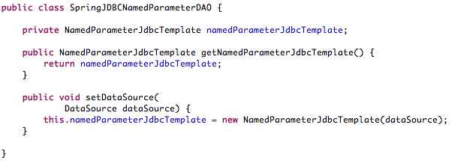**

**Code Segment 6.19: Class for NamedParameterjdbcTemplate**

1. **Configure using the Spring Framework’s XML-based configuration files**: To configure the NamedParameterjdbcTemplate class in the Spring Framework, it is defined as a bean. The NamedParameterjdbcTemplate bean is then injected with a DataSource object using the setDataSource method. This is done to create a connection between the application and the database. This is shown in Code Segment 6.20.

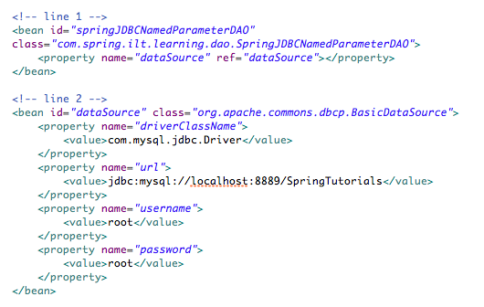

**Code Segment 6.20: Configuring NamedParameterjdbcTemplate in Spring Framework**

1. **Write methods to map objects to the database table**: By using named parameters assigned to the SQL variable in the method definition, you can specify the data objects that are being mapped by their id or string value. This is shown in Code Segment 6.21.

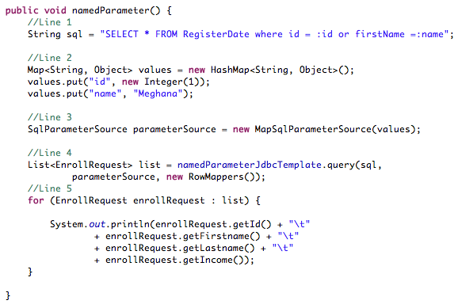

**Code Segment 6.21: Writing Mapping Methods**

You can write the same method implementation with NamedParameterjdbcTemplate using the SqlParameterSource interface. This interface serves as source for the values of named parameters passed to the NamedParameterjdbcTemplate. This is shown in Code Segment 6.22.

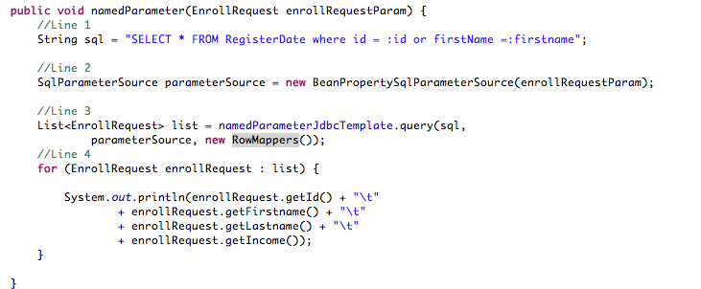

**Code Segment 6.22: Implementing NamedParameterjdbcTemplate Using SqlParameterSource Interface**

1. **Create bean instances for mapping data:** To map a named parameter of the SQL query, parameter value has to be set in a bean instance. For example, here you are trying to map the firstName parameter in the database to the bean definition, as shown in Code Segment 6.23.

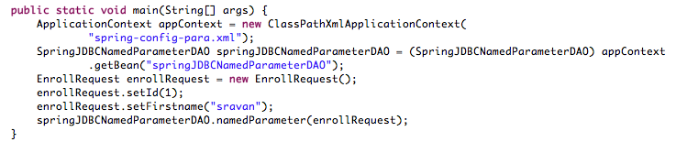

**Code Segment 6.23: Defining Beans for Mapping Named Parameters**

When the application written using the NamedParameterjdbcTemplate is executed, the result generated is shown in Figure 6.9.

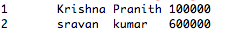

**Figure 6.9: Output for using NamedParameterjdbcTemplate Interface**

**Advantage of the jdbcTemplate**

The jdbcTemplate has the following advantages when compared to directly using JDBC for data access operations:

* Using jdbcTemplate enables easy clean-up of resources allotted for a database transaction.
* The jdbcTemplate converts JDBC SQLExceptions to RuntimeExceptions which allows the application to react to errors quickly and easily.
* The jdbcTemplate offers many ways to query the database for integers, string, hash maps and domain object data.
* The jdbcTemplate also can translate SQL query results directly into an object that is accepted by the Java application by using the ResultSetExtractor interface.

Now you have seen how to implement JDBC in the Spring Framework using different approaches. When an application is executed, the system may throw some exceptions which are handled by the Spring Framework exception handlers. Let us understand what stored procedure exception handlers are.

**Explicitly Declaring Parameters for SimpleJdbcCall**

Parameters passed to data access classes and methods are deduced based on the database metadata. These parameters, which specify the data objects to be mapped from the database tables, can also be declared explicitly so that an application does not have to rely on the metadata at all.

Parameters for a SimpleJdbcCall can be passed explicitly. To do so:

1. Create and configure the SimpleJdbcCall class using declareParameter method.
2. Decide whether you would like to declare one, some, or all of the parameters explicitly. If for any reason you do not use explicit declaration, the application refers to the metadata by default.
3. Call the withoutProcedureColumnMetaDataAccess method to bypass all metadata processing.
4. If an application’s database function already contains parameters names, use the useInParameterNames to refer to the list of parameters in the function call.

Code Segment 6.24 shows how to explicitly declare parameters for a SimpleJdbcCall class in the RegiterDate example.

**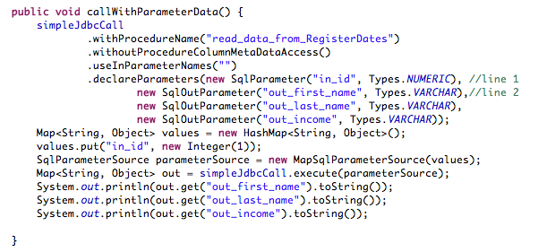**

**Code Segment 6.24: Explicitly Declaring Parameters for SimpleJdbcCall Class**

The output for using explicit declaration is the same as the output generated for calling the SimpleJdbCall class methods using metadata for mapping data objects. This topic dealt with the implementation of the templates available in JDBC component of the Spring Framework. The next topic will introduce the concepts of stored procedures and their uses in the Spring Framework implementation.

### Topic 2: Stored Procedure Exception Handling

A segment or portion of SQL statements stored within the database catalogue is referred to as stored procedures. These procedures perform data access operations that can be invoked using declarative SQL statements, or applications such as Java, C#, and so on. The reason for using stored procedures is that they can consolidate the data access logic and can be called from the database catalogue without being rewritten in the application’s main code.

To implement a stored procedure supported by a Database Management System (DMBS), you have to first create the stored procedure in the database. Let us look at an example where a stored procedure named fetchRecords is created and executed in the SQL console of a system as shown on Code Segment 6.25.

**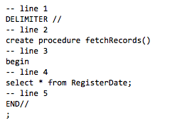**

**Code Segment 6.25: Stored Procedure Creation**

In the procedure created in Code Segment 6.25, you are fetching all the records held in database table RegisterDate which has been used in previous example in the same module. Once the procedure is created, the procedure can be called from SQL as shown in Code Segment 6.26.



**Code Segment 6.26: Calling Stored Procedure**

Once this procedure is executed the output generated is shown in Figure 6.10.



**Figure 6.10: Output Generated After Executing Stored Procedure**

Stored procedures can be created and used in an application using the Spring Framework’s JDBC component. As stored procedures are vendor-specific, they can only be used when an application does not need to be portable. Let us now look at how stored procedures are used in Spring JDBC.

**Stored Procedures in Spring JDBC**

In the Spring Framework, the SimpleJdbcInsert and SimpleJdbCall classes are used to simplify configuration of stored procedures by taking advantage of metadata in the database. This metadata can be retrieved using the JDBC driver. Let us look at an example application where the fetchRecords procedure defined in Code Segment 6.25, is called in the Spring Framework JDBC. Code Segment 6.27 shows how to define the SimpleJdbcCall class with the SimpleJdbcCall instance that invokes the stored procedure fetchRecords.

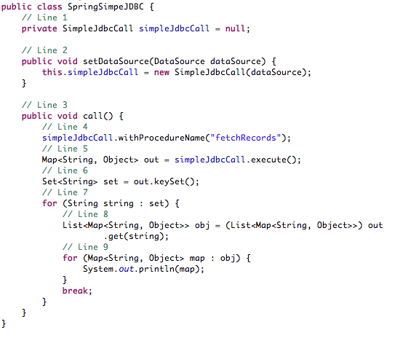

**Code Segment 6.27: Using SimpleJdbCall Class to Execute a Stored Procedure**

In Code Segment 6.27,:

* **Line 1**: Defines the SimpleJdbCall class.
* **Line 2**: initializes the SimpleJdbcCall and injecting the datasource object using a setter method.
* **Line 3**: Uses the ProcedureName API to specify which procedure has to be called.
* **Line 4**: Uses the Execute API to call the stored procedure and fetch the result in the map.

When the SimpleJdbcCall method is called in the main application and executed, the result generated is shown in Figure 6.11.

**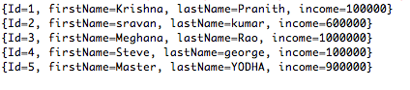**

**Figure 6.11: Output for Stored Procedure Called using SimpleJdbcCall Class**

### Topic 3: Implementing Caching Using Annotations

Abstracting caching to Java methods can reduce the number of executions that are based on the information available in the cache. In other words, every time a method is executed, the cache abstraction performs a behavior check to see if the method has already been executed for a given set of arguments. If the method has been executed, then the result for the method is returned from the cache without executing the method, thus saving on application runtime.

On the other hand, if the method execution is its first instance in the entire application, the execution is completed, results cached, and returned to the user. Thus, an application executes methods just once for a given set of arguments and the result is reused for subsequent executions. To use the cache abstraction, you have to make sure of the following specifications:

* Caching declaration: The methods that need to be cached have to be identified.
* Cache Configuration: The application back-up cache which holds all the data is to be configured to the application.

The caching service is an abstraction in the Spring Framework and requires the use of an actual, physical storage to hold the cache data. This way the caching abstraction removes the need for developers to write caching logic without providing the actual stores. There are two integrations available out of the box, for Java Development Kit (JDK):

* java.util.concurrent.ConcurrentMap
* Ehcache

To implement caching in any Java application developed using the Spring Framework, you have to first declare the cache configuration in the XML-based configuration files. This is shown in Code Segment 6.28.

**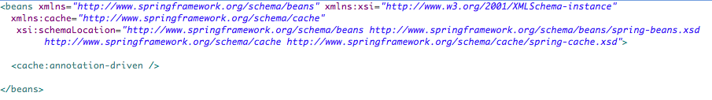**

**Code Segment 6.28: Configuring Cache in Spring Framework Application**

**Annotation Based Caching**

In the Spring Framework, there are two declarative annotations to perform caching operations. These annotations are:

* @Cacheable: Triggers methods to populate a cache
* @CacheEvict: Triggers methods to evict a cache from its storage

**@Cacheable**

The @Cacheable annotation is used to identify cacheable methods. In other words, the @Cacheable annotation declares that for a specified method, the results obtained after execution are to be stored in a cache. Code Segment 6.29 shows the implementation of the @Cacheable annotation.

**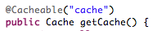**

**Code Segment 6.29: @Cacheable Annotation**

It is also possible to provide multiple cache names when there are multiple caches declared in an application. This is shown in Code Segment 6.30.

**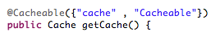**

**Code Segment 6.29: @Cacheable Annotation for Multiple Caches**

When multiple caches are declared for a method, the results obtained after the method is executed for the first time is stored in all cache storage. When the same method is called again, any one of the cache can return the result value. This is useful when one of the cache does not work properly, another cache can handle the storage and retrieval operations for method results.

### @CacheEvict

The @CacheEvict annotation is used to delete unused or stale data from the cache. This annotation is used to declare that specified methods have to perform cache eviction. Methods annotated by the @CacheEvict become triggers for removing data from the cache. Code Segment 6.30 shows the use of @CacheEvict annotation.

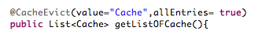

**Code Segment 6.30: @CacheEvict annotation**

The @CacheEvict annotation requires you to specify one (or multiple) caches that are affected by the action and it allows a key or a condition to be specified for cache eviction operation. The @CacheEvict annotation also features an extra parameter allEntries that is used to indicate whether a cache-wide eviction needs to be performed rather than just one entry is to be evicted from the cache.

### Using Default key

In the Spring Framework, the arguments of cached methods are the source of key generation. The key is essentially a specification that defines the extent of caching or extent of evicting a cache. To provide a default key generator, you have to implement the org.springframework.cache.KeyGenerator interface. Once this interface is configured within the Spring Framework application, the generator is used for each method that does not specify its own key.

### Understand Conditional Caching

The Spring Framework supports conditional caching, which allows caching of certain methods based on conditions specified in the cache method definition. Code Segment 6.31 is an example of setting conditions to perform caching using the @Cacheable annotation. Here, the application specifies that the method should cache only those results whose ID is greater than one hundred.

**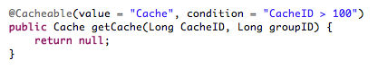**

**Code Segment 6.31: Conditional Caching**

With this, you have seen how to use the @Cacheable annotation for performing cache related operations. Cache generation is an important aspect of any application that depends on databases and has to handle the results generated by multiple method invocations. This is particularly important for enterprise applications as they are large and complicated. Externalizing cache operations will keep the application running smoothly and remain free of caching responsibilities.

**Module Summary**

You have seen that enterprise applications that handle a lot of data depend on external databases and tools that help applications to manage communication with databases. The Spring Framework uses its data access implementation through JDBC to oversee all data access operations. In this module, you have been introduced to the concepts of JDBC and database communications done through JDBC. You have also learnt the advantages of implementing JDBC through the Spring Framework. In addition, you covered the necessity of caching data and the process of caching through the use of annotations.

### References

* Web references:
* <http://docs.spring.io/spring/docs/2.0.8/reference/jdbc.html> (Accessed 9 May 2014)
* <http://www.tutorialspoint.com/spring/spring_jdbc_example.htm> (Accessed 9 May 2014)
* <http://www.dzone.com/tutorials/java/spring/spring-jdbc-tutorial-1.html> (Accessed 9 May 2014)
* Book references:
* Ho, Clarence. (2012). *Pro Spring 3.* In: Apress Publishing. sd
* Walls, Craig. (2011). *Spring in Action-3rd edition.* Manning Publication Company.

# Module 7: ORM Integration

**Module Overview:**

Object-Relational Mapping, or ORM, is a method used to support incompatible data types in object-oriented programming (OOP). This support is needed between a data storage service such as Relational Database Management Systems (RDBMS) and your Java-based enterprise application developed using Spring Framework.

An RDBMS or any data storage service often contains persistent data, that is, data that needs to retain its original structure and content. Using an ORM tool such as Hibernate helps to persist application objects (or keeps them unchanged in the data storage service) and retrieves them when required. Thus, an ORM tool helps to keep your application independent of data management tasks, allowing you to focus on the business requirements of your application. Combining Spring Framework, a Dependency Injection (DI) framework that supports Inversion of Control (IoC), and Hibernate, a powerful data persisting tool, helps you to introduce ORM in a Java application developed using Spring Framework. ORM manages the task of mapping data between your application and an external database.

This module explains the concepts of ORM and Hibernate and their functionalities and application. With the use of ORM, developers can access and manipulate data objects without having to consider how these objects are related in their data sources. You will also learn how Hibernate integrates with Spring Framework and provides seamless application layering. As a developer, you can take advantage of this integration and optimize code function and reusability.

**Module Objectives:**

By the end of this module, you will be able to:

* Explain the Spring ORM module.
* Explain Hibernate and object mapping.
* Describe the Spring Hibernate module.
* Integrate Spring Framework with Hibernate.

## Lesson 1: Introduction to ORM and Hibernate

ORM is a method of mapping data (held in the tables of a database) with application classes. Using ORM makes your application objected-oriented as you can work with objects and save them to a database automatically. ORM simplifies the database create-read-update-delete (CRUD) operations and lets your application focus on the business logic it needs to satisfy.

Hibernate is an ORM tool that maps Java classes to database tables. It significantly reduces development time by reducing the time spent in manual data handling by your application. In this lesson, you will be introduced to the concepts of ORM and the use of Hibernate as an ORM tool for Java applications.

### Topic 1: Introduction to ORM

ORM uses a mapping technique to bind an object to data stored in a database. Mapping is the definition of the relationship between an object, its properties, and behavior to the respective fields in a database table that holds the values for these objects, properties, and behaviors. For instance, an address book database contains a list of contacts, where the names of people are considered objects that have attributes or fields containing details such as street addresses and phone numbers. When your application needs to access any information, it calls on the name object. Using this object as a key, the ORM tool maps all the other details such as street addresses and phone numbers to the corresponding arguments in your application.

The ORM manages the interactions of your application with a database by generating the SQL for the relational database to insert, update, and delete data in response to the changes that the application makes to the data objects. Therefore, you do not need to write any data access code within your application, which helps to keep it simple and manageable.

### Features of ORM

ORM works by making your application object-oriented, so that its code is easier to maintain and modify and creation of new objects does not affect the existing ones. An ORM tool has the following key features:

* ORM uses Object-Oriented Based Query Language to map objects to a database. With this query language, the SQL provided by the database management system (DBMS) is translated automatically into a pattern recognizable by your application.
* The ORM query is global, which helps in situations requiring migration to another database. Suppose you are using MySQL in a product but decide to migrate to the Oracle database. In such a case, you will not need to change the entire query as the ORM query is compatible with the Oracle database.
* An ORM tool uses the metadata of the database and application objects. This means that the database cannot access objects in the application and the application objects are not affected by the working of the database.
* Using ORM in your data application helps in clear separation of concerns. Therefore, the database and the application can work with data in their native forms.

### The Working of ORM

Let us find out how ORM works, using an example. A bank has several branch offices and each branch office holds multiple accounts. Each account includes details such as the account holder’s name, the account ID number, and the name of the branch office where the account is held. Each branch office may include details such as the branch ID and the branch name. In the database, the branch office and account details are held in two separate tables that are related to each other. Figure 7.1 shows the one-to-many relationship between the two tables, as maintained by ORM.

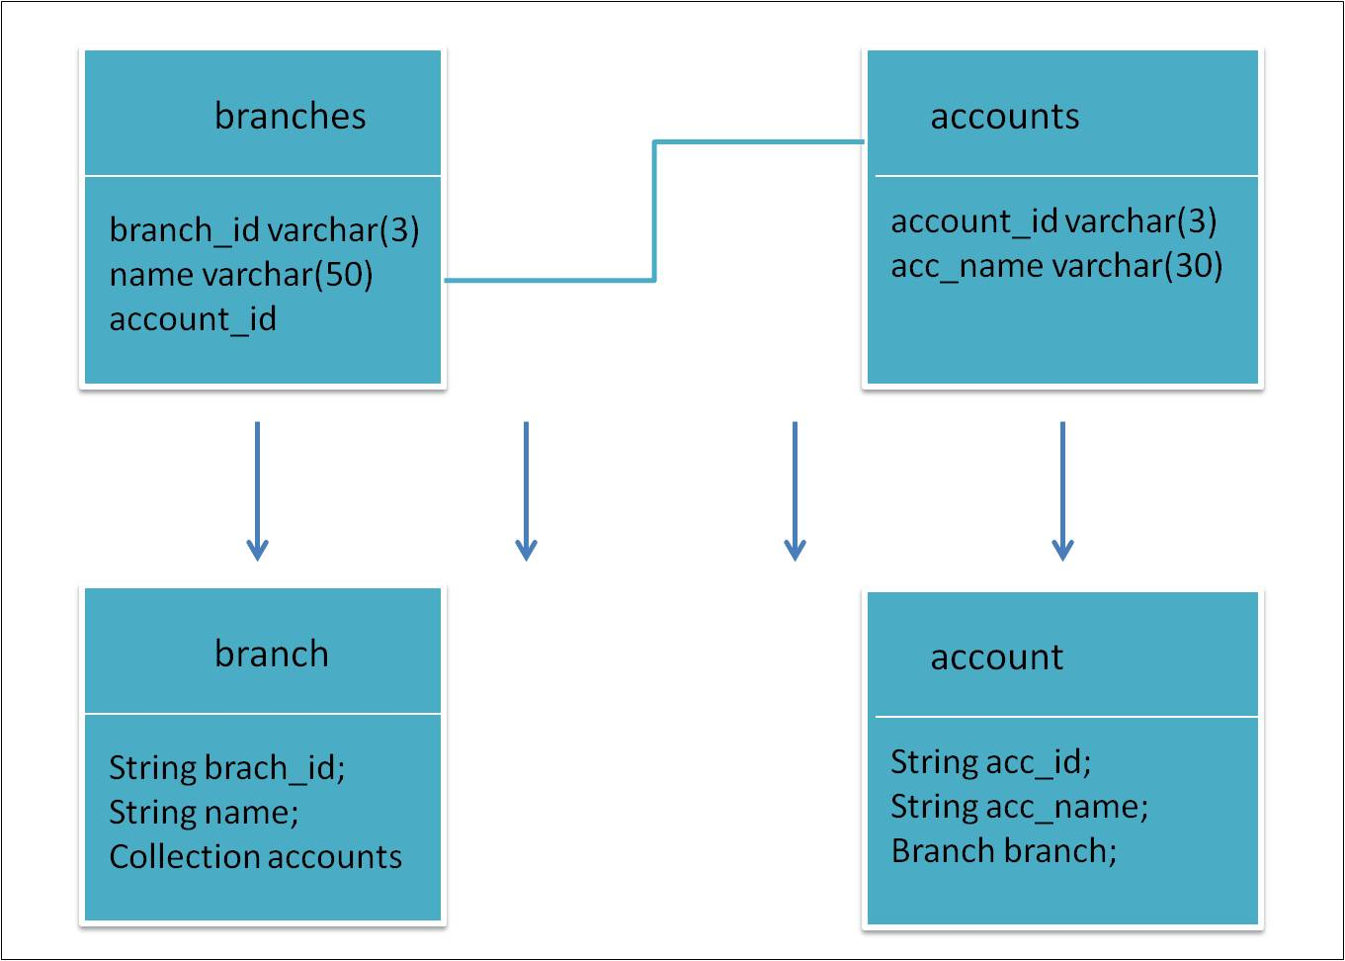

Figure 7.1: One-to-Many Relationship of Branches in ORM

Suppose a banking application accesses this database with methods that change account details. The database holds tables of data for each account with fields representing the account ID, account name, and the branch that holds a particular account. The branch information can be in a secondary table, which is accessed by an object of the first table that holds account details. ORM converts the data tables into classes to be mapped with the application’s objects. When the ORM query converts the two tables into two classes, you will notice that:

* The account object has a branch object. Unlike the traditional way, the ORM query stores the entire branch object. Therefore, the benefit appears in the query. For example, if Acc01 is an account and Bran001 is a branch, in the traditional query, the data is stored in the format shown in Code Segment 7.1.

acc\_id=1

acc\_name = Acc001

branch\_id = 12 (assuming 12 is the ID Bran001)

Code Segment 7.: Sample of Code Stored in a Traditional Query

* The branch class is a collection of account classes with generic data about each account. The branch class stores all the objects related to the account. For example, if you have three accounts in Branch 1 and two accounts in Branch 2, all the three accounts will be stored in a collection with the department name as Branch 1.

### Benefits of Using ORM

The use of ORM provides several benefits; the key among these are listed:

* **Ease of implementing the Domain Model pattern**: ORM tools allow you to map between the logical business model and the physical storage model. Because of this feature, you can use the Domain Model pattern and model entities based on real business concepts rather than those based on the database structure.
* **Reduction in code**: ORM tools provide an array of services that allow you to focus on the business logic rather than the CRUD logic, thereby reducing the amount of coding needed.
* **Ease of handling change**: With ORM, you need not replicate the business model changes (using the SQL Update, Delete, and Insert statements) through various layers such as the business layer or the data access layer of the application. This means that an object is defined in one layer, but it can be used in multiple layers. After the object passes through methods written for it, its definition changes. After you update the object definition, ORM automatically uses the revised structure for updates and retrievals.
* **Efficient query capabilities**: ORM tools support an object-oriented query language that allows you to concentrate on the object model and not be concerned about the database structure or the SQL semantics. In this way, the ORM tool handles the translation activity by translating the query language into the relevant syntax for the database so that your application can use any database without needing any specific configuration. This keeps your application platform independent.
* **Ease of navigation**: In ORM, navigating to object relationships is easy. The related objects are loaded automatically. You are not required to perform any manual data loading.
* **Ease of data load management**: ORM can be configured to load data appropriately for each situation. For example, you can specify a parent object to load with its corresponding child or line objects in one scenario, but without the child or line objects in another scenario.
* **Support for concurrency**: ORM provisions for multiple users updating identical data at the same time. This allows multiple teams to work simultaneously on the same data without corrupting the original data.
* **Improved cache management**: In ORM, all entities are cached in memory, thereby reducing the load on the database. This prevents bottlenecks during data flow, thus increasing performance of the database and the system accessing it.
* **Transaction management**: With ORM, an entire transaction can be committed or rolled back with no extra coding or configuration required in the application, thus reducing the time and money spent on writing code.
* **Improved productivity**: ORM offers a high-level object-oriented Application Programming Interface (API), which means that you have less Java code to write and no SQL to manage.

### Topic 2: Introduction to Hibernate

Hibernate is an open source persistent ORM framework that enables you to map Plain Old Java Objects (POJO) to relational database tables. Hibernate is available for free download at [http://www.Hibernate.org/](http://www.hibernate.org/). Using Hibernate, you can develop persistent classes that have the following behaviors:

* **Association**: Involves defining relationships between objects such as one-to-one, one-to-many, and many-to-many.
* **Inheritance**: Is used for building hierarchies of classes based on the object type.
* **Polymorphism**: Is a feature that allows child classes to have unique features as well as inherit behaviors from their parent classes.
* **Composition**: Involves using object references to compose a class.
* **Java collections framework**: Is a collection of elements such as interfaces, implementations, operations, and algorithms.

Hibernate also provides data query and retrieval features that can considerably reduce the development time by eliminating the need for the developer to write code to perform data query and retrieval tasks. Hibernate internally converts all Hibernate queries to SWL queries, so the developer need not write SQL queries.

#### Features of Hibernate

The primary goal of Hibernate is to reduce your time and effort spent on common data persistent-related programming activities. Key features of Hibernate ORM and the advantages of each feature are listed:

* **Transparent persistence**: Hibernate provides transparent persistence for POJOs. It is an extensible type system that:
  + Persists JavaBeans style properties
  + Avoids build-time source or byte code processing
  + Supports an extensive subset of Java collections API
  + Supports collection instance management
  + Constraints transparency
  + Performs automatic dirty checking
  + Provides detached object support
* **Object-oriented query language**: Hibernate supports easy-to-use and powerful object-oriented query language. It can support polymorphic, new criteria, and native SQL types of queries.
* **Object/Relational mapping**: Hibernate provides several types of ORM mapping strategies; for example, it supports:
  + Multiple-objects to single-row mapping
  + Polymorphic and bidirectional associations
  + Association filtering
  + Collection of basic types and indexed collections
  + Composite collection elements
  + Life cycle objects
* **Object/Relational mapping definition**: Hibernate supports XML mapping of documents in human-readable format. It supports the creation of documentation through XDoclet, a generic Java tool that helps to create custom application-related Java documents by providing document template engines.
* **Automatic primary key generation**: Hibernate supports multiple synthetic key generation strategies, as well as application-assigned identifiers and composite keys.
* **Hibernate Dual-Layer Cache Architecture**: Hibernate performs caching at the Session level as well as at the process level, which is why its architecture is called dual-layer cache architecture. Hibernate’s dual-layer cache ensures thread safeness by:
  + Providing nonblocking data access
  + Supporting session-level cache, optional second-level cache, and optional query cache
  + Integrating well with other ORM systems (such as Spring ORM)
* **High performance**: Hibernate ensures high performance by:
  + Supporting lazy initialization
  + Supporting outer join fetching and batch fetching
  + Supporting optimistic locking with versioning and time stamping
  + Providing highly scalable architecture
  + Not having any special database tables
  + Having SQL generated at system initialization time
  + Providing internal connection pooling and prepared statement caching

#### Understanding Hibernate Architecture

Before moving on to working with Hibernate, it is essential to get an overview of the architecture of Hibernate. Hibernate uses POJO along with XML mapping documents to persist objects to the database layer in your application. Figure 7.2 shows the high-level architecture of Hibernate.

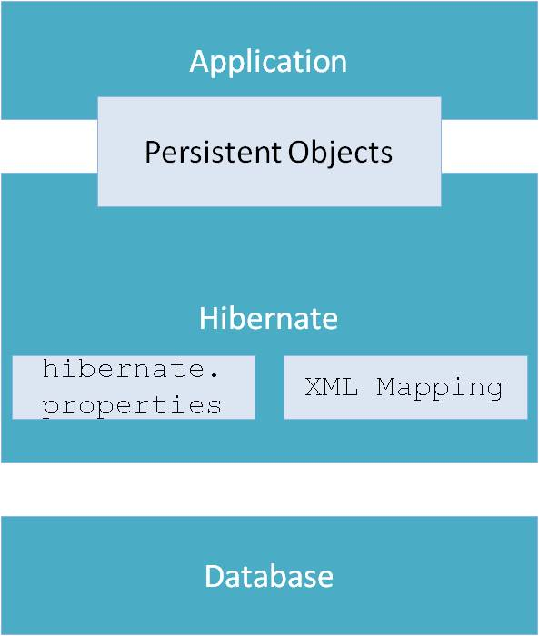

Figure 7.2: Hibernate Architecture Representation

Hibernate uses run-time reflection (self-evaluation) to determine the persistent properties of a class. The objects to be persisted are defined in mapping documents, which describe the persistent fields, associations, and subclasses or proxies of the object, if any. These mapping documents are compiled at the application startup time and provide the framework with the necessary information for creating a class. In addition, the mapping documents are used to generate the database schema or create stub Java source files.

Code Segment 7.2 shows an example of Hibernate code used to map an object to a database.

sessionFactory = new Configuration().configure().buildSessionFactory();

Session session = sessionFactory.openSession();

Transaction tx = session.beginTransaction();

Customer newCustomer = new Customer();

newCustomer.setName("Harles");

newCustomer.setAddress("California");

newCustomer.setEmailId("Harles.123@gmail.com");

session.save(newCustomer);

tx.commit;

session.close();

Code Segment 7.2: Example of Hibernate Code

Hibernate ORM works by performing the following steps:

1. In any Hibernate application, the first step is to retrieve the Hibernate session, which is the primary interface between a Java application and Hibernate.
2. SessionFactory allows the applications to create a Hibernate session by reading the Hibernate configuration file, Hibernate.cfg.xml.
3. After specifying the transaction boundaries, the application can use Hibernate sessions to persistent Java objects to the databases.

#### Mapping Objects Using Hibernate

To understand the working of Hibernate, let us consider a simple Java example that authenticates users based on their credentials. The following steps are performed when you use Hibernate as an ORM tool to check user ID for authentication:

1. Preparing the database
2. Creating persistent Java objects
3. Mapping POJO with persistence layer using the Hibernate mapping document
4. Creating the Hibernate configuration file
5. Performing mapping declaration

Let us look at these steps in detail:

1. **Preparing the database:** The first step in using Hibernate is to prepare a database with the data needed for your application. Code Segment 7.3 shows how to create a simple database schema with a single table as ACCOUNTINFO.

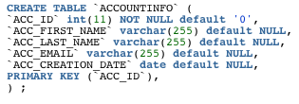

Code Segment 7.3: Database Schema with a Single Table as ACCOUNTINFO

1. **Creating persistent Java objects:** After creating the table, create a persistent Java object. Code Segment 7.4 shows the representation of a Java object structure of the ACCOUNTINFO table in a class named AccountInfo. Typically, domain objects such as the AccountInfo class contain only getters and setters methods.

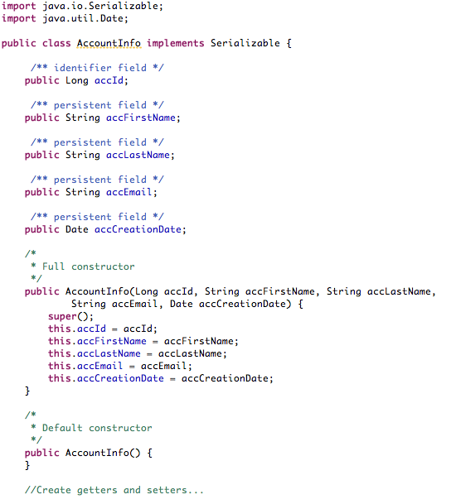

Code Segment 7.4: Java Object Structure Representing the ACCOUNTINFO Table

1. **Mapping POJO with the persistence layer using the Hibernate mapping document:** After creating a persistent Java object, you must map every persistent class with its configuration file. Code Segment 7.5 represents the Hibernate mapping file for the AccountInfo class.

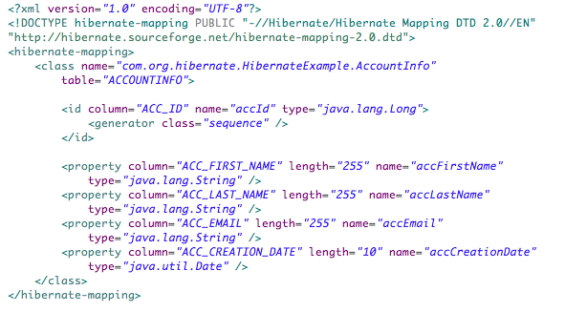

Code Segment 7.5: Hibernate Mapping File for the AccountInfo Class

In Code Segment 7.5:

* The <class> element maps a table with the corresponding class.
* The <id> element indicates the primary key column and its related attribute in the domain object.
* The <property> element specifies all other attributes available in the domain object.

Now, you can generate the Hibernate mapping document using the Hibernate extension toolset.

1. **Creating the Hibernate configuration file:** After mapping POJO with the persistence layer using the Hibernate mapping document, you need to connect the Hibernate configuration file information to the persistent layer and the linked mapping documents. In the file, specify the data source name or JDBC details required for Hibernate to make JDBC connection to the database. Code Segment 7.6 shows the configuration file for the AccountInfo class.

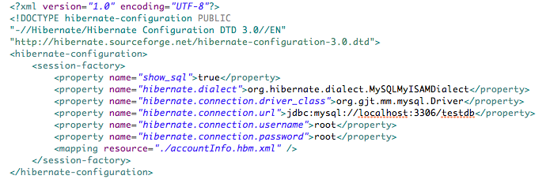

Code Segment 7.6: Hibernate Configuration File for the AccountInfo Class

In the code sample, the element <mapping-resources> refers to the document that contains mapping for the domain object and the Hibernate resource.

You can configure Hibernate in two ways:

* **Programmatically**: In this method, the details such as the JDBC connection and resource mapping are supplied in the program using the configuration API.
* **Configuration file method**: A highly popular method today because the objects do not need to be mapped to the data in a database until execution time, which keeps the application lightweight and efficient. In this method, Hibernate.cfg.xml is placed in the CLASSPATH.

Code Segments 7.7 is an example of Hibernate code using the configuration file approach.

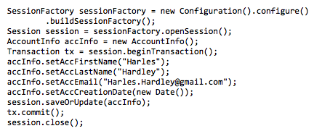

Code Segment 7.7: Hibernate Code in the Configuration File Method for Inserting a New Record

1. **Performing mapping declaration:** After creating the Hibernate configuration file, provide a mapping declaration. There are several tools available to automatically create mapping documents. Usually, the ORM mappings are defined in an XML document. The mapping language used is Java-centric as defining data tables in Java is easier than in XML. The mappings are defined around persistent class declaration, not around table declaration. This is because an ORM converts Java objects to persisted object, not the other way round. Code Segment 7.8 is an example of a class mapping document that maps a database table type.

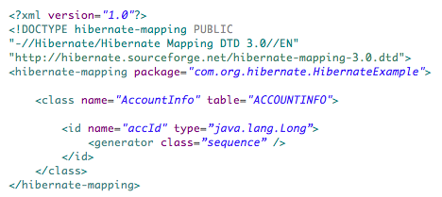

**Code Segment 7.8: AccountInfo Mapping Document**

Now you know how to implement Hibernate to persist objects in your Java-based application. Let us now look at the Hibernate elements that help with mapping elements and their attributes and their uses in Hibernate mapping.

#### Hibernate Configurations for Different Relationships

When objects are mapped from an application to a database, their mapping relationship is defined by the elements used in the code. This section explains the various mapping elements, their attributes, and their functions used in a Hibernate mapping document.

###### **<hibernate-mapping> Element**

The <hibernate-mapping> element is the root element of the Hibernate mapping document. Code Segment 7.9 provides a sample of a <hibernate-mapping> element.

<hibernate-mapping

schema="schemaName"

catalog="catalogName"

default-cascade="cascade\_style"

default-

access="field|property|ClassName"

default-lazy="true|false"

auto-import="true|false"

package="package.name"

/>

**Code Segment 7.9: Code Sample of the <hibernate-mapping> Element**

The <hibernate-mappings> element supports numerous attributes and values. These are listed in Table 7.1.

|  |  |
| --- | --- |
| **Attributes** | **Description** |
| schema | Refers to the name of a database schema. It is an optional value. |
| catalog | Refers to the default cascade style. The default value is None. |
| default-access | Refers to the strategy Hibernate implements for accessing all properties. It can be a custom implementation of PropertyAccessor. The default value is Property. |
| default-lazy | Refers to the default value for unspecified lazy attributes of class and collection mappings. The default value is True. |
| auto-import | Specifies whether you can use unqualified class names in the query language. |
| Package | Specifies a package prefix for assuming unqualified class names in the mapping document. |

Table 7.1: Attributes of the <hibernate-mapping> Element

###### **The <class> Element**

The <class> element maps the domain object with its corresponding entity in the database. The <hibernate-mapping> element can nest multiple persistent <class> mappings. Still, it is recommended that only a single, persistent mapping be mapped in one mapping file to avoid confusion or unnecessary repetition of mapping tasks. Code Segment 7.10 provides a sample of the <class> element.

<class

name="ClassName"

table="tableName"

discriminator-value="discriminator\_value"

mutable="true|false"

schema="owner"

catalog="catalog"

proxy="ProxyInterface"

dynamic-update="true|false"

dynamic-insert="true|false"

select-before-update="true|false"

polymorphism="implicit|explicit"

where="arbitrary sql where condition"

persister="PersisterClass"

batch-size="N"

optimistic-lock="none|version|dirty|all"

lazy="true|false"

entity-name="EntityName"

catalog="catalog"

check="arbitrary sql check condition"

rowid="rowid"

subselect="SQL expression"

abstract="true|false"

**Code Segment 7.10: Code Sample of the <class> Element**

Table 7.2 lists the various attributes and their values that you can use in the <class> element.

|  |  |
| --- | --- |
| **Attributes** | **Description** |
| Name | Is the fully qualified Java name of the persistent class or interface. If this attribute is missing, you can assume that the mapping is for a non-POJO entity. |
| table | Is the name of the database table. The default value is the unqualified class name. |
| discriminator-value | Is the value that distinguishes individual subclasses. It is used for polymorphic behavior. Acceptable values include null and not null. The default value is the class name. |
| Mutable | Specifies whether the instances of the class are not mutable. The default value is True. |
| schema | Overrides the schema name specified by the root <hibernate-mapping> element. |
| Catalog | Overrides the catalog name specified by the root <hibernate-mapping> element. |
| proxy | Specifies an interface to use for lazy initializing proxies. You can use the name of the class itself. |
| dynamic-update | Specifies that you must generate UPDATE SQL at run time and it should contain only the columns with changed. |
| dynamic-insert | Specifies that INSERT SQL should be generated at run time and contains only the columns with values not null. |
| select-before-update | Specifies that Hibernate should never perform an SQL UPDATE until it is definite that an object is modified. In situations where only a transient object is associated with a new session using update, Hibernate will execute an extra SQL SELECT to conclude whether an UPDATE is actually required. |
| polymorphism | Helps to determine whether implicit or explicit query polymorphism is used. The default value is Implicit. |
| where | Specifies that an arbitrary SQL WHERE condition should be used when reclaiming objects of this class. |
| persister | Specifies a custom ClassPersister. |
| batch-size | Specifies a "batch size" for procuring instances of this class by identifier. The default value is 1. |
| optimistic-lock | Determines the optimistic locking strategy. The default value is Version. |
| lazy | Deactivates the Lazy fetching by setting lazy="false". |
| entity-name | Represents entity mappings for classes that are mapped multiple times by referring to the entity by an explicit and unique name. = |
| catalog | Is a name of a database catalog used for this class and its table. |
| check | Is an SQL expression used when a multirow check constraint must be generated for automatic schema generation. |
| rowid | Indicates the physical location of a stored tuple. Hibernate uses rowid with databases that support row IDs such as Oracle. If you have set this option, Hibernate uses the ROWID column for fast updates. |
| subselect | Used to map an immutable and read-only entity to database sub-select. It is useful if you want to create a view for the UI, which is an entity that cannot be changed by the UI user. |
| abstract | Used to mark abstract superclasses in <union-subclass> hierarchies. |

Table 7.2: Attributes of the <class> Element

###### **The <id> Element**

The <id> element is used to define the mapping from a specified property to an appropriate primary key column and can support the optional attributes listed in Table 7.2. Mapped classes should declare the primary key column of the database table as the primary key is the data identifier in a database table. Largely classes will also include a JavaBeans-style property consisting of the unique identifier of an instance so that your application can identify the class when it is called. Code Segment 7.11 shows the use of the <id> element.

<id

name="propertyName"

type="typename"

column="column\_name"

unsaved-value="null|any|none|undefined|id\_value"

access="field|property|ClassName">

<generator class="generatorClass"/>

**Code Segment 7.11: Code Sample of the <id> Element**

Table 7.3 lists the various attributes and their values that you can use in the <id> element.

|  |  |
| --- | --- |
| **Attributes** | **Description** |
| name | The name of the identifier property |
| type | A name that indicates the Hibernate type:   |  |  | | --- | --- | | **Java Class Attribute Type** | **Hibernate Type** | | Integer, int, long short, char | integer, long, short, character | | [java.math.BigDecimal](http://docs.oracle.com/javase/7/docs/api/java/math/BigDecimal.html" \t "_new" \o "Java API) | big\_decimal | | float, double | float, double | | [java.lang.Boolean](http://docs.oracle.com/javase/7/docs/api/java/lang/Boolean.html" \t "_new" \o "Java API), boolean | boolean, yes\_no, true\_false | | [java.lang.String](http://docs.oracle.com/javase/7/docs/api/java/lang/String.html" \t "_new" \o "Java API) | string | | Very long strings | text | | [java.util.Date](http://docs.oracle.com/javase/7/docs/api/java/util/Date.html" \t "_new" \o "Java API) | date, time, timestamp | | [java.util.Calendar](http://docs.oracle.com/javase/7/docs/api/java/util/Calendar.html" \t "_new" \o "Java API) | calendar, calendar\_date | | [java.util.Locale](http://docs.oracle.com/javase/7/docs/api/java/util/Locale.html" \t "_new" \o "Java API) | locale | | [java.util.TimeZone](http://docs.oracle.com/javase/7/docs/api/java/util/TimeZone.html" \t "_new" \o "Java API) | timezone | | java.util Currency | Currency | | [java.sql.Clob](http://docs.oracle.com/javase/7/docs/api/java/sql/Clob.html" \t "_new" \o "Java API) | Clob | | [java.sql.Blob](http://docs.oracle.com/javase/7/docs/api/java/sql/Blob.html" \t "_new" \o "Java API) | blob | | Java object | serializable | | byte array | binary | | [java.lang.Class](http://docs.oracle.com/javase/7/docs/api/java/lang/Class.html" \t "_new" \o "Java API) |  | |
| column | The name of the primary key column  The default value is the property name. |
| unsaved-value | An identifier property value that specifies if an instance is newly instantiated and unsaved. It also differentiates an instance from detached instances that were saved or loaded in a previous session and the default value here is the sensible value. |
| access | The strategy Hibernate must use for accessing the property value  The default value is property. |

Table7.3: Attributes of the <id> Element

###### **<generator> child element**

The elective <generator> child element labels a Java class used for generating unique identifiers for instances of the persistent class. If any parameters are required to configure or initialize the generator instance, they are passed using the <param> element. Code Segment 7.12 is a sample of the <generator > element.

<id name="id" type="long" column="cat\_id">

<generator class="org.hibernate.id.TableHiLoGenerator">

</generator>

</id>

**Code Segment 7.12: The <generator> Child Element and Attributes**

Table 7.4 explains the various attributes and their values that you can use with the <generator > element.

|  |  |
| --- | --- |
| **Attributes** | **Description** |
| increment | This is used to generate identifiers of the type long, short, or integer, these unique identifiers are generated only when no data is being inserted into the table by other processes. |
| identity | This is used to identify columns in DB2, MySQL, MS SQL Server, Sybase, and HypersonicSQL. The returned identifier can be of the type long, short, or int. |
| hilo | This is used to generate identifiers for objects using a hi/lo algorithm that are unique for a particular database. The source of hi/lo values are a table and column, which is by default Hibernate\_unique\_key and next\_hi, respectively. |
| seqhilo | This is used to generate type identifiers for a named database sequence using a hi/lo algorithm. |
| uuid | This is used to generate type identifiers within a network using a 128-bit Universally Unique Identifier (UUID) algorithm. The UUID is encoded as a string of hexadecimal digits of length 32. |
| guid | This uses a database-generated Globally Unique Identifier (GUID) string on Microsoft SQL Server and MySQL. |
| native | This is used to pick the identity, sequence, or hi/lo of an object based on the underlying database. |
| assigned | This is used to to assign an identifier to the object before the object is saved. This is the default strategy if no <generator> element is specified. |
| select | This is used to retrieve a primary key assigned by a database trigger to an object’s table, by selecting the row using a unique key and retrieving the primary key value. |
| foreign | This is used to reference an object using the identifier of another associated object through a <one-to-one> primary key association. |

Table 7.4: Attributes of the <generator> Element

All generators implement the interface org.hibernate.id.IdentifierGenerator. Hibernate provides a wide range of built-in generators.

Generators are used to create a unique key in a sequence. These keys are used to index the objects being mapped. While defining a <generator> element, the object types you can use are:

* The name of a Hibernate basic type such as integer, string, binary, serializable, character, date, timestamp, float, , object, or blob
* The name of a Java class with a default basic type such as Integer, Float, java.util.Date, java.lang.Integer, char, java.lang.String, or java.sql.Clob)
* The name of a serializable Java class
* The class name of a custom type such as com.illflow.type.MyCustomType

###### **The <property> Element**

Derived properties are a powerful feature of Hibernate. Derived properties are defined as read-only properties and are computed during load time. When you declare the computation as a SQL expression, it translates into the subquery clause of SELECT. Code Segment 7.13 is a sample of the <property> element.

<property name="totalPrice"

formula="( SELECT SUM (li.quantity\*p.price) FROM LineItem li, Product p

WHERE li.productId = p.productId

AND li.customerId = customerId

AND li.orderNumber = orderNumber )"/>

**Code Segment 7.13: Code Sample of <property> Element**

###### **The <many-to-one> Element**

###### A **<many-to-one>** element is used to define the rule that will establish a many-to-one relationship between entities. Code Segment 7.14 provides a sample of the <many-to-one> element.

<many-to-one

name="propertyName"

column="column\_name"

class="ClassName"

cascade="cascade\_style"

fetch="join|select"

update="true|false"

insert="true|false"

property-ref="propertyNameFromAssociatedClass"

access="field|property|ClassName"

unique="true|false"

not-null="true|false"

optimistic-lock="true|false"

lazy="true|false"

entity-name="EntityName"

/>

**Code Segment 13: <many-to-one> element and attributes**

**Code Segment 7.14: Code Sample of the <many-to-one>Element**

A typical many-to-one declaration looks like this:

**<many-to-one name="product" class="Product" column="PRODUCT\_ID"/>**

You can use attributes to specify the type of objects being mapped in the many-to-one declaration. Table 7.5 explains the various attributes of the <many-to-one> element available in Hibernate.

|  |  |
| --- | --- |
| **Attributes** | **Description** |
| name | Refers to the name of the property. Here, the initial letter is in lowercase to differentiate it from a class name. |
| column | Refers to the table column being mapped from a database. This can also be specified through nested <column> element(s). |
| class | Refers to the class associated with a particular property where the default property type is determined by reflection. |
| cascade | Refers to the operations that need to be cascaded from the parent object to the associated object. |
| fetch | Is used to select between outer-join fetching or sequential select fetching. |
| update, insert | Is used to to specify the mapped columns to be included in SQL UPDATE and/or INSERT statements. |
| property-ref | Refers to the name of a property of the associated class that is joined to this foreign key. |
| access | Refers to the access for the property value. |
| unique | Is used to generate a unique constraint for the foreign key. |
| not-null | Is used to enable the Data Definition Language (DDL) to generate a null constraint for the columns. |
| optimistic-lock | Is used to specify that a property needs optimistic lock (to resolve change conflict) during updates. |
| lazy | Is used to specify that a property is to be fetched lazily when the instance variable is first accessed. |

Table 7.5: Attributes of the <many-to-one> Element

###### **The <one-to-one> Element**

By using the **<one-to-one>** element, you can declare one-to-one association to another persistent class. Code Segment 7.15 provides a sample of the <one-to-one> element.

<one-to-one

name="propertyName"

class="ClassName"

cascade="cascade\_style"

constrained="true|false"

fetch="join|select"

property-ref="propertyNameFromAssociatedClass"

access="field|property|ClassName"

formula="any SQL expression"

entity-name="EntityName

/>

**Code Segment 7.15: Code Sample of the <one-to-one> Element**

You can use attributes to specify the type of objects being mapped in the one-to-one declaration, which are same as the arguments described in Table 7.5.

#### Hibernate Query Language

Hibernate ORM uses Hibernate Query Language (HQL) to map objects to their properties in an ORM application. HQL is similar to SQL in the syntaxes that are used the difference between them is that while SQL works with tables and columns, HQL works with persisted objects and their properties. Using Hibernate with HQL is more feasible than using SQL. This is because SQL is not platform independent like HQL. When a query reaches the database from Hibernate, it gets converted from HQL to the native SQL compatible with the database. This keeps your application independent of the database it is accessing.

Hibernate queries are simple to write. Except for Java names and properties, the other elements of the query are case-sensitive. Table 7.6 lists all the Hibernate query clauses available for persisting objects.

| **Query clause** | **Description** | **Example** |
| --- | --- | --- |
| from AccountInfo | This returns all instances of the class com.org.hibernate.hibernate.Examples.AccountInfo. |  |
| from AcountInfo as info | This assigns the alias info to objects or classes so that you can use the alias later in the query. | from AccountInfo,Branch  from AccountInfo info,Branch branch |
| The select clause | This is used to determine the objects and properties to be returned in the query result set. | Select info.accFirstName from AccountInfo info where info.accFirstName like 'Harles%' |
| The where clause | This is used to determine the order of a list returned by a query. It could be ordered by any property of a returned class or components. | from AccountInfor info where info.accFirstName = 'Harles'  Returns instances of AccountInfo named 'Harles' |
| The order by clause | This is used to indicate that the list returned by a query that may be ordered by any property of a returned class. | from User user order by user.name asc, user.creationDate desc, user.email |
| The group by clause | This is used to indicate the return aggregate value that may be grouped by any property of a returned class. | select sum(document) from Document document group by document.category  select sum(document) from Document document group by document.category  having document.category in (Category.HIBERNATE, Category.STRUTS) |

Table 7.6: Options of Hibernate Query

**Lesson 2: Spring ORM**

When using an ORM tool such as Hibernate, Spring Framework does not depend on low-level JDBC details such as connection management, statement evaluation, and result retrieval to manage its data access tasks. The data source being accessed by your application can be easily configured using XML files. Spring-based applications that use Hibernate depend on Hibernate APIs such as Configuration, SessionFactory, and Session to perform data transactions between the application and a database.

However, as Spring Framework can externalize an object’s state and keep it separate from the main application using the IoC container, you can use Hibernate objects as Spring Beans and treat them as any other regular bean. This is the main advantage of integrating Spring Framework with Hibernate. In this lesson, you will learn how to integrate Spring Framework with Hibernate and use Hibernate to develop an application within Spring Framework.

### Topic 1: Introduction to Spring ORM

Spring Framework provides APIs to facilitate its easy integration with ORM frameworks such as Hibernate, Java Persistence API (JPA), Java Data Objects (JDO), Oracle TopLink, and iBATIS. In a typical Hibernate framework, you provide all the database information in hibernate.cfg.xml file. You need not do this if you are integrating a Hibernate application with Spring Framework. All the information can be provided in the application Context.xml file itself. Let us look at how Spring ORM functions by using the HibernateTemplate to support integration with Hibernate ORM.

#### HibernateTemplate

The HibernateTemplate is a helper class that you can use to simplify data access code. It automatically converts HibernateExceptions (a checked exception) into DataAccessExceptions (an unchecked exception). You can use the HibernateTemplate to implement data access or business logic services. The primary method of HibernateTemplate is execute (). It supports the Hibernate code that implements the HibernateCallback interface.

Benefits of using HibernateTemplate include the following:

* It simplifies interactions with Hibernate Session.
* It simplifies common functions to single method calls.
* It closes sessions automatically.
* It detects exceptions automatically and converts those to runtime exceptions.

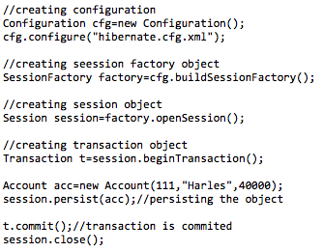

Code Segment 7.16: Code with Hibernate

When you use Hibernate code to perform persistence-related tasks, you may need to write several lines of code and follow multiple steps such as createConfiguration, BuildSessionFactory, Session, and beginning and committing transaction as shown in Code Segment 7.16.

On the other hand, if you use the HibernateTemplate class of Spring Framework, you can achieve persistence in just a few steps. An example of code written using HibernateTemplate is shown in Code Segment 7.17.

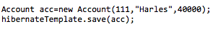

Code Segment 7.17: Code written Using the HibernateTemplate class of Spring Framework

Similarly, you can enable several Hibernate properties such as creating a table by using hbm2ddl.auto in the applicationContext.xml file. This is shown in Code Segment 7.18.

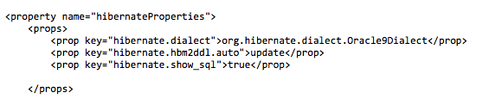

Code Segment 7.18: Code Sample to Create a Table Using the hbm2ddl.auto Option

The table is created automatically. You do not need to encode it.

This topic introduced the concepts involved in using an ORM tool such as Hibernate. In the next topic, you shall be introduced to the ORM feature of Spring Framework and how to integrate Hibernate and Spring Framework.

### Topic 2: Integration of Spring and Hibernate

In the previous topic, you learned about Spring ORM and how its integration with ORM frameworks such as Hibernate, JPA, JDO, Oracle TopLink, and iBATIS. In this topic, you will find out how Spring Framework integrates with Hibernate.

### Spring Framework and Hibernate Integration

By using Hibernate, Spring Framework applications can access data from any database and still remain independent of Hibernate. Therefore, your application need not depend on any low-level JDBC details such as managing connections, dealing with statements, and sets. You can configure the details required to access an external data source in your application’s XML-configuration files. Hibernate ORM works well with both J2SE and J2EE applications.

Before learning how Spring Framework and Hibernate integrate, it is essential to understand the need for this integration. When you integrate Hibernate with Spring Framework, your application need not depend on Hibernate APIs such as Configuration, SessionFactory, and Session. When you integrate Hibernate and Spring Framework, you can configure the Hibernate objects with the help of IOC Container, so that they can be handled as Spring beans by your application.

Consider an example that explains the integration of Spring Framework with Hibernate ORM. Continuing with our ReachoutWorld application explained in Module 4, let us extend the application to include ORM functionalities. In this application, you are enabling a customer to submit an enrollment form online and the data from these forms is persisted to a database. An administrator will be able to access this database through the application and view details submitted by customers.

Let us assume that all the forms that are submitted are converted into data tables and persisted to an external database. Next, you need to implement Spring ORM to retrieve, store, and update data in the database through your application.

**Integrating Hibernate and Spring Framework**

The following steps are involved in integrating Hibernate with Spring Framework for the ReachoutWorld application to include ORM in it:

1. Create tables in database
2. Define Spring Framework and Hibernate dependencies in pom.xml
3. Configuration tasks:
   1. Define data sources
   2. Define the SessionFactory
   3. Define Hibernate Template
   4. Define DAO class
4. Create enrollment form class
5. Create DAO interface and class
6. Write controller classes
7. Create JSP files for the UI

Let us follow the above steps in ReachoutWorld application in order to implement data access and persistence in the application.

1. **Create two tables in database:** Let us start by creating two tables in a database. One of these tables contains customer related information such as name, email address, occupation, and income. The second table contains only address related details for each customer. Once these tables are created you also have to create classes that handle this table in the application.
2. Create the first table: Code Segment 7.19 shows the first table.

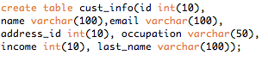

**Code Segment 7.19: Code to Create Table One**

Code Segment 7.20 creates an empty table. Let us now create a class called ‘CustInfo’ to handle the first table , as shown by Code Segment 7.20.

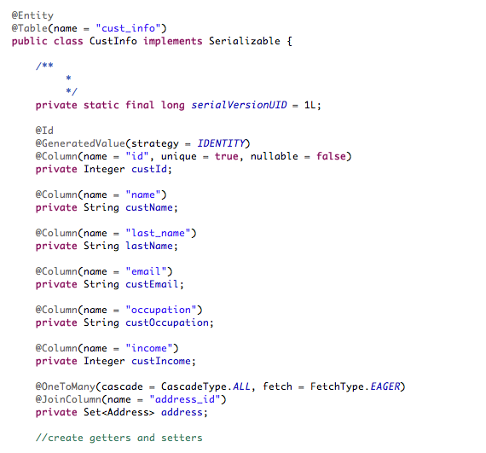

**Code Segment 7.20: Table One Represented in the Application with Class**

1. Create Table Two containing address details. Code Segment 7.21 shows Table Two.

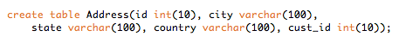

**Code Segment 7.21: Code to Create Table Two**

Code Segment 7.21 creates another empty table. Let us now create a class called ‘ADDRESS’ to add data to Table Two, as shown in Code Segment 7.22.

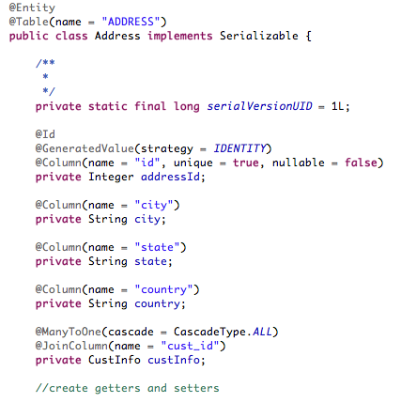

**Code Segment 7.22: Table Two Represented in the Application with the Class**

1. **Define Spring Framework and Hibernate dependencies in pom.xml:** Once you have created tables in the database and written classes that handle these tables, you have to configure Hibernate within your Spring Framework application. To do this, you first define Spring Framework and Hibernate dependencies in the application’s pom.xml. Code Segment 7.23 shows how to define Spring and Hibernate dependencies in the pom.xml file.

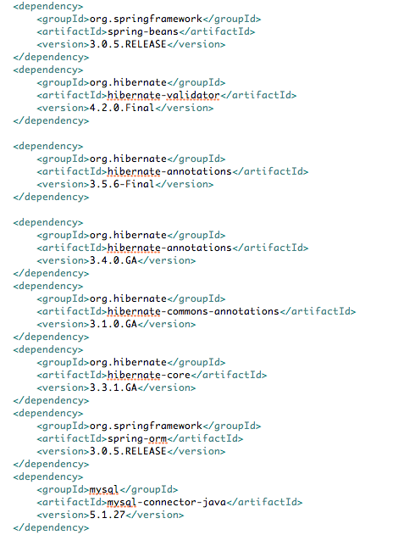

**Code Segment 7.23: pox.xml File Defining Spring and Hibernate Dependencies**

Now that you have added the necessary dependencies to the pom.xml file, let us look at configuring the necessary beans needed to run your application. As noted earlier, in Spring Framework, all business objects are configured in an XML file. The configured business objects are known as Spring Beans and are maintained by the IOC. When requested, the IOC delivers the Spring Beans to the Client application.

1. **Configure data source, SessionFactory, and HibernateTemplate Spring Beans:** In the ReachoutWorld example, let us now define the following Spring Beans.
2. Data source
3. SessionFactory
4. HibernateTemplate
5. Data Access Object class
6. **Define Data source:** Let us define a data source and name it ReachOutWorld-servlet.xml. This is shown in Code Segment 7.24.

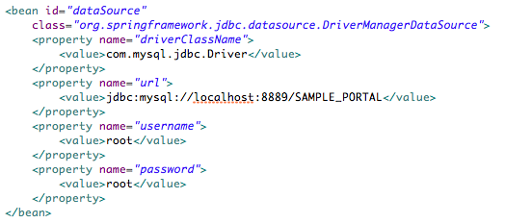

**Code Segment 7.24:** ReachOutWorld-servlet.xml **Data Source File**

dataSource Spring Bean defines a data source of the type org.apache.commons.dbcp.BasicDataSource. It defines the various connection properties required to access the database to refer the data stored in the database tables. MySQL database driver is required to access the MySQL database. Table 7.7 lists the properties and values in the ReachOutWorld-servlet.xmldata source file.

|  |  |
| --- | --- |
| **Property** | **Value** |
| driverClassName | Refers to the MySQL database driver class. |
| url | Refers to the URL string required to connect to the MySQL database. |
| Username | Refers to the user name required to access the database. |
| Password | Refers to the password required to access the database. |

**Table 7.7: Properties and values of the** ReachOutWorld-servlet.xml **file**

1. **Define SessionFactory:** After defining the data source Spring Bean, let us now define the SessionFactoryBean. In Hibernate, SessionFactoryBean creates Session objects through which Transaction and Data access is performed. Code Segment 7.25 shows how SessionFactoryBean is configured in Spring Framework.

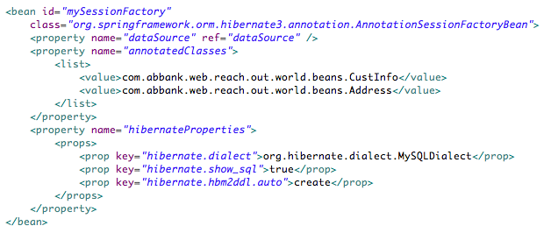

**Code Segment 7.25: Code of** SessionFactoryBean **Configured in Spring Framework**

To ensure that the SessionFactoryBean is configured correctly, provide the following information:

* Data source information: You have provided the data source information in <property name= dataSource” ref=”dataSource”>.
* List of mapping files: The Mapping files contain the mapping information between the database tables and the Java class name. You have provided this information under the list tag.

<list>

<value> com.abbank.web.reach.out.world.beans.CustInfo</value>

<value> com.abbank.web.reach.out.world.beans.Address</value>

</list>

1. **Define HibernateTemplate:** After configuring the data source and SessionFactoryBean, you now have to configure the HibernateTemplate. The HibernateTemplate contains the methods for inserting, deleting, updating, and finding data in the database. It provides a wrapper to access and manipulate low-level data. Only the SessionFactoryBean object argument required to configure the HibernateTemplate. Code Segment 7.26 shows how to configure a HibernateTemplate.

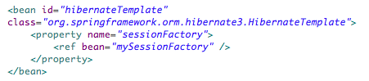

**Code Segment 7.26: Code to Configure HibernateTemplate**

1. **Define Data Access Object** (DAO) **class:** The DAO class is the client facing class. In the Code Segment 7.27, the request object is set to CustInfo.class. Later, saveFormDetails(EnrollRequest enrollRequest) is used to call the save method in DAO.

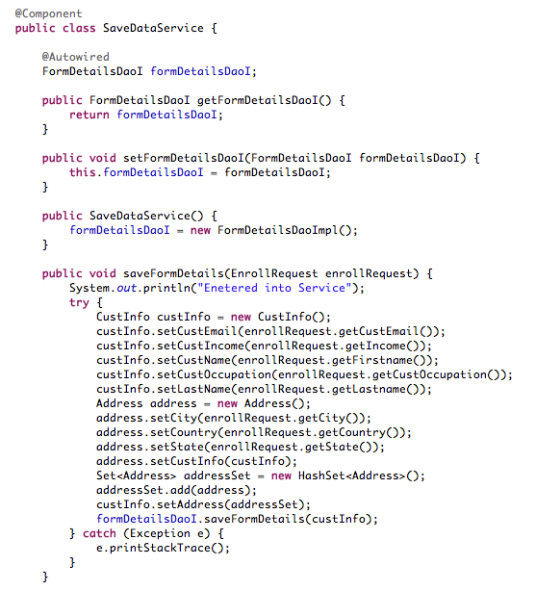

**Code Segment 7.27: Code Calling the Save Method in DAO Class**

Code Segment 7.28 shows how the method fetchFormDetails (Integer custId) is used to fetch the form details from the DAO class.

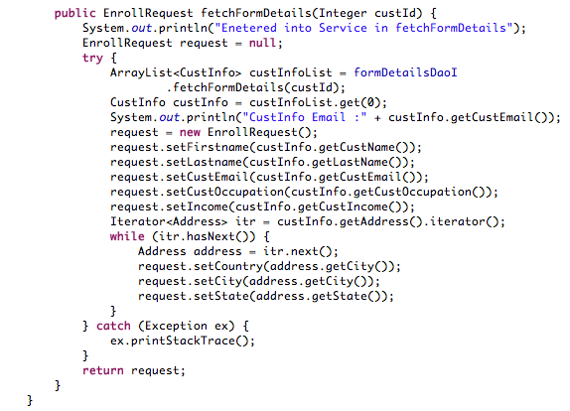

**Code Segment 7.28: Code Fetching Form Details from the DAO Class**

1. **Create the enrollment form:** Now that you have created the database tables, configured Hibernate and Spring Dependencies, and created a submission form that accepts data from customer, the next step is to use the application’s web component to accept form submission. This is done by writing a class named EnrollRequest.java, as shown in Code Segment 7.29.

**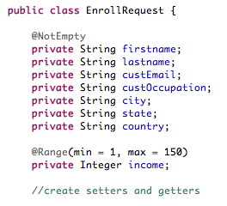**

**Code Segment 7.29: EnrollRequest.java**

1. **Create DAO interface and methods:** Create a DAO interface as shown in Code Segment 7.30 and write classes in this interface that calls on the database to retrieve or save customer information. This class is called FormDetailsDaoI and is written using the Hibernate Template, as shown in Code Segment 7.31.

**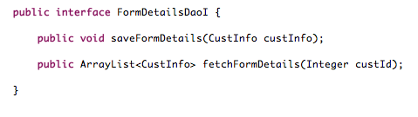**

**Code Segment 7.30: Create DAO Interface**

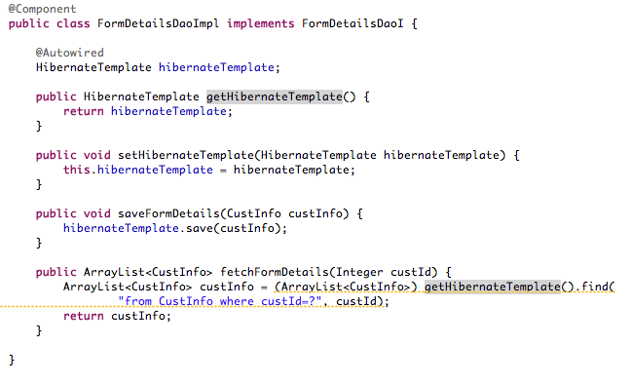

**Code Segment 7.31: Create Class FormDetailsDaoI**

Write class FormDetailSessionFactoryDaoImpl that calls the update/save/fetch from or into database using session factory. This is shown in Code Segment 7.32.

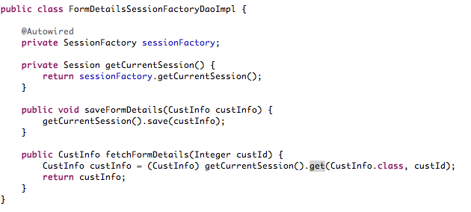

**Code Segment 7.32: Class FormDetailSessionFactoryDaoImpl**

1. **Write Controller classes**: The controller classes hold all the retrieval and create operations for the form submission being performed. It is the Spring Model Controller View (MVC) framework’s responsibility to handle the web layer of the application. The two main controller classes for your applications are SubmitEnrollerdRequest.Java and FetchEnrollerdRequest.java. These two classes are shown in Code Segments 7.33 and 7.34.

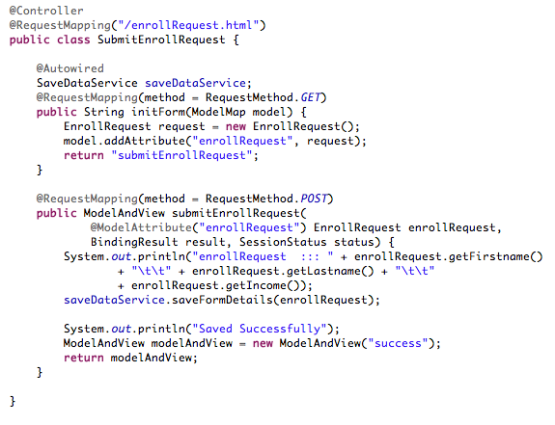

**Code Segment 7.33: SubmitEnrolledRequest Class**

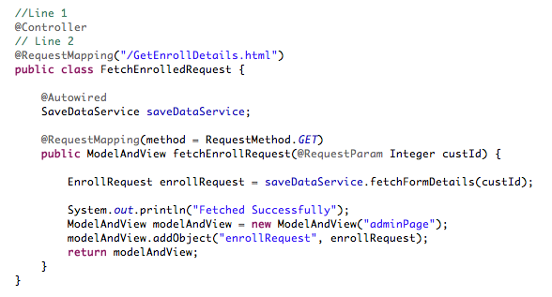

**Code Segment 7.34: FetchEnrolledRequest Class**

1. **Create JSP files**: As the ReachoutWorld is a web based application, you have to define JSP files to define the view for the application that is displayed on the UI. Write the JSP files needed to display the form to the customer in the UI. These are shown in Code Segment 7.35.

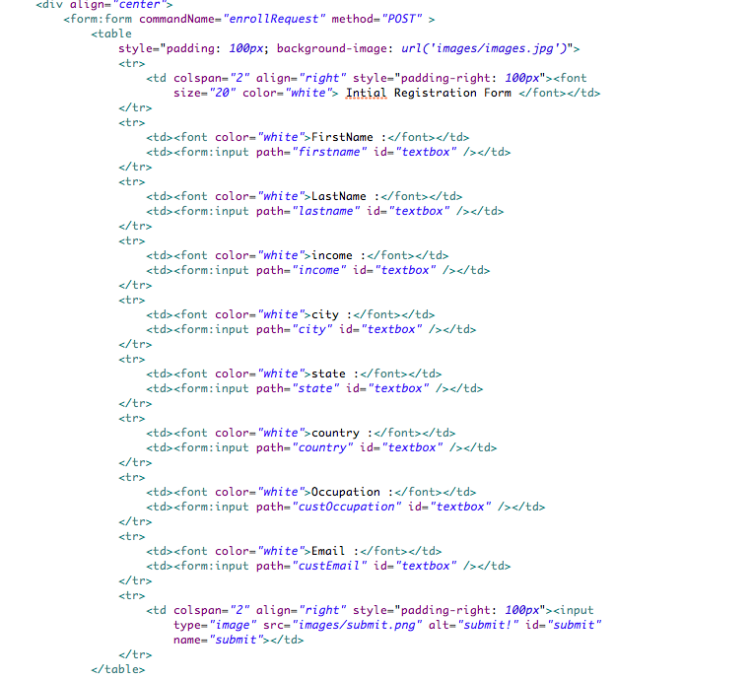

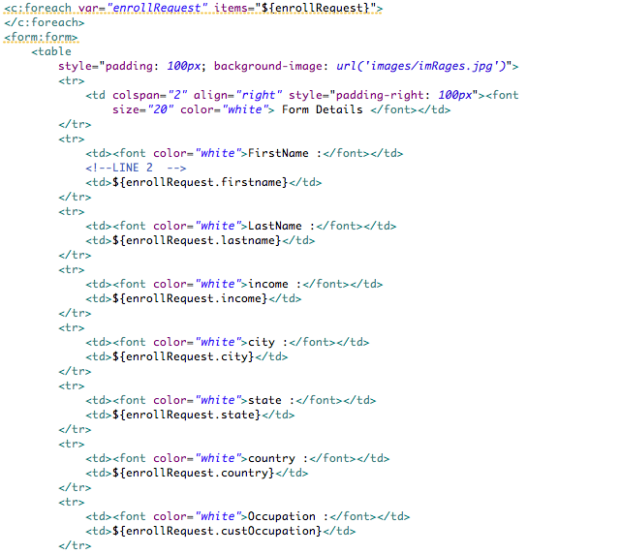

**Code Segment 7.35: JSP Files for the ReachoutWorld Application**

With this step, you created a web application using Spring Framework. You implemented Spring MVC to handle the web layer of the application and Hibernate to perform data access tasks and persisting.

With this, you have learned the purpose for ORM in a Spring Framework application and the methods needed to integrate Hibernate into Spring Framework to develop a Java-based web application that uses the services of an external database.

**Module Summary**

In this module, you learned that ORM is another important feature of Spring Framework that helps you to create an efficient application by keeping the data persistence layer separate from the main application code.

You have learned about the features and benefits of the ORM tool called Hibernate and how its integration with Spring Framework is useful to developers who need to access external databases.

### References

Web references:

* http://docs.spring.io/spring/docs/3.0.x/spring-framework-reference/html/orm.html (Last accessed 24Apr 2014)
* http://www.packtpub.com/article/integrating-spring-framework-with-Hibernate-orm-framework-1 (Last accessed 24 Apr 2014)
* http://docs.spring.io/spring/docs/2.0.x/reference/orm.html (Last accessed 24 Apr 2014)

Book references:

* Seddhigi, Ahmed. (2012). *Spring Persistence with Hibernate.* PAKT Publishing.
* Lui, Mark; Gray, Mario; Chan, Andy H; Long, Josh. (). *Pro Spring Integration.* Apress Publishing

# Module 8: Transaction Management

**Module Overview:**

For applications that interact with databases, such as a Relational Database Management System (RDBMS), a transaction is a unit of work performed against a database in a logical order. A transaction can be performed manually or automatically where multiple operations occur in sequence. A transaction consists of one or more queries that either read a value from the database or write a value to the database. Each transaction propagates one or more changes to the database. The collective propagation of transactions to modify the database is known as transaction management. The code component in an application that handles database transactions is called the transaction manager.

While interacting with databases, the RDBMS-oriented enterprise applications need to ensure that the data in the database is consistent, the integrity of the data is maintained, and database communication does not corrupt the database in any way. Spring Framework enables transaction management by providing the transaction management component that is consistently abstract. This means that the transaction management component is kept open in order to support integration with external Application Programming Interfaces (APIs).

The API’s support programmatic methods of transaction management and this capability of Spring Framework, helps you to focus on the business logic rather than on the integrity of data during application development. So by using Spring Framework to manage all database transactions, you don’t have to write any code specifically related to transaction management which, in turn, reduces the volume of code that is compiled in an application.

In this module, you will learn how Spring Framework leverages the capabilities of transaction management.

**Module Objectives:**

By the end of this module, you will be able to:

* Define transaction management.
* Integrate Spring Framework with transaction managers.
* Identify the uses of transaction management.

## Lesson 1: Introduction to Transaction Management

Any application that relies on an external database to handle its data requirements transacts with the database for data storage or retrieval of data. This external database has to ensure the integrity of the data that is being transacted, by controlling the transaction properties.

In this lesson, you will learn about the properties of transactions and setting these properties to achieve different levels of system performance, such as inter-application and intra-application communications. You will also learn about transaction management, how it is performed, and the risks associated with it.

### Topic 1: Understanding Transactions

### A transaction groups a set of tasks into a single execution unit. Each transaction starts with a specific task and concludes when all the tasks in the group are successfully completed. The transaction fails if any of the tasks fails. Therefore, a transaction has only two possible results, success or failure.

**Defining a Transaction Process**

You can define a transaction process and enclose every transaction within a transaction boundary. By doing this, you ensure that a transaction is either completed successfully, or the system is in a consistent state even if the transaction fails. To ensure that a system is in a consistent state means that the application makes sure any transaction failure does not affect the state of the database.

Let us understand the transaction process with the help of an example of a double-entry accounting system where every debit must have an associated credit transaction.

Assume that Jonathan Sawyer writes a check for $100 to buy a phone. In a transactional double-entry accounting system, this single transaction must have the following two transactions:

* Debit $100 from the bank account of Jonathan
* Credit $100 to mobile store account

It is not possible to have a debit transaction recorded, but an associated credit transaction missing, or vice versa. A transactional system manages both the entries as either success or failure and ensures that the integrity of the database or the application performing the transaction is not affected.

**Transaction Control**

The ability to manage several transactions occurring within a DBMS is known as transaction control. Knowledge of transaction control helps you to ensure that transaction is completed as a logical unit and the data in the DBMS remains consistent.

Table 8.1 provides a list of transaction control commands that are used for modifying transactions.

|  |  |  |
| --- | --- | --- |
| **Transaction Control Command** | **Description** | **Syntax** |
| COMMIT | Used to save the changes implemented by a transaction to the database. It saves all transactions that occur since the last COMMIT or ROLLBACK command to the database | COMMIT [work]; |
| ROLLBACK | Used to undo transactions which are not yet saved to the database | ROLLBACK [work]; |
| SAVEPOINT | Used to roll back the transaction to a certain point without rolling back the entire transaction and to create a SAVEPOINT among transactional statements | SAVEPOINT TO SAVEPOINT\_NAME; |
| ROLLBACK TO SAVEPOINT\_NAME | Used to undo a group of transactions | ROLLBACK TO SAVEPOINT\_NAME; |
| SET TRANSACTION | Used to place a name on a transaction | SET TRANSACTION [name] |

Table 8.1: Transaction Control Commands

**Properties of a Transaction**

Every transaction has certain properties that can be defined in the transaction code. Properties of a transaction help in defining transactions with desirable properties and ensure that the transactions are reliable and safe for the database.

When a read and/or write action is being performed in a transaction, the DBMS ensures that the transaction is reliable by guaranteeing the Atomicity, Consistency, Isolation, and Durability (ACID) properties of a transaction. ACID properties are described as follows:

* **Atomicity**: Atomicity refers to the ability to ensure that all the operations in the transaction are either successful or unsuccessful. A transaction is said to be atomic when an entire transaction fails because of failure of one subtransaction. For example, in a banking application, transaction atomicity ensures that when a successful debit transaction is made from one account, a corresponding credit transaction is made into another account.
* **Consistency:** The consistency property of a transaction ensures that the data is maintained in consistent state from the beginning to the end of a transaction and that no defined DBMS integrity constraints are violated. For example, if a database holds customer details in a specified order and format, any transaction that occurs within this database must follow the same order and format. Transaction consistency can be defined as:
  + - **Strong:** A strong transaction consistency ensures that a consistent state of data is observed throughout the system. For example, the database in a retail store must provide a strong consistency so that when there a reduction in stock, a parallel increase in buying can be observed.
  + **Weak:** A weak or eventual consistency indicates that the data in the DBMS may now be in an inconsistent state and will reach a consistent state eventually. For example, an application where funds are moved between accounts, the consistency property ensures the value of funds changed in both the accounts, is same at both the start and end of the transaction. In other words, if an amount is debited from one account, the exact same amount should be credited to the other.
* **Isolation:** This refers to the need that a transaction is independent of other concurrent transactions executed in the DBMS. This ensures that data being manipulated by other concurrent transactions is not accessed by the first transaction. For example, when two concurrent transactions are taking place to update the database holding the account information, the isolation property decides whether the updates performed by one transaction can be available to the other.
* **Durability:** This ensures that changes made to the data in the DBMS by the transaction are permanent. This means even if the system fails, the changes made will be available to the application when the system restarts. However, these changes are not reflected in the permanent state of the database. Another transaction can overwrite changes made by the concurrent transaction without hampering the durability. For example, in a banking application where funds are transferred from one account to another, the durability property ensures changes made to the accounts are not reversed.

Transaction properties in a DBMS can be controlled using transaction rules. Let’s find out more about these rules.

**Transaction Isolation, Propagation, and Roll back Rules**

Transaction rules and conditions define how a transaction is to occur and under what conditions a transaction is invoked. By setting transaction rules and conditions, you can control transactions that impact:

* Transaction isolation property
* Method of transaction propagation
* Reasons for roll backs (a process that returns the database to a previous state)

**Transaction Isolation**

As you know, isolation is one of the key properties of a transaction. The rules for transaction isolation can be user defined, while the rules for atomicity, consistency, and durability are handled during the implementation of a transaction.

Concurrent transactions are those that take place at the same time such as, debit and credit of an amount from a bank account. When concurrent transactions are being executed on a DBMS, transaction isolation controls the visibility of changes to the data made by the transactions. Transaction isolation decides whether queries from one transaction can view the changes made by another transaction. In an RDBMS, each transaction is completely isolated from other concurrent transactions in the system. This means that the transaction can see only the changes made to the data by transactions that were executed prior to its initiation.

Such complete isolation can, however, impact application performance in the real world where several applications are running simultaneously. For example, complete isolation could mean that one transaction cannot insert data into a table that is being queried by another transaction. To resolve this issue, the ANSI/ISO SQL standard (SQL92) defines four levels of transaction isolation, with each level offering a different degree of impact on system performance. Table 8.2 lists the levels of transaction isolation.

|  |  |
| --- | --- |
| **Transaction Isolation Level Type** | **Description** |
| Read Uncommitted | The Read Uncommitted level provides the lowest level of isolation that specifies that a transaction can query the changes made by another transaction even if the changes are not yet committed. The Read Uncommitted transaction isolation can be of the following types:   * + **Dirty read**: Dirty read indicates that a transaction can read rows changed by transactions in other uncommitted sessions.   + **Non-repeatable read**: Non-repeatable read indicates that a transaction can read the changes in a row after another transaction has modified (DELETE or UPDATE) the row and committed the changes.   + **Phantom read**: Phantom read indicates that when two identical queries are executed at different times in the same session, the second query returns a different collection of rows than the first query. |
| Read Committed | The Read Committed level specifies that a query returns only those rows that were committed when the query was initiated. If the data was modified by another transaction after the query was initiated, the modifications will not be read by the query. |
| Repeatable Read | The Repeatable Read level specifies that a query returns only those rows that were committed when the transaction to which the query belongs was initiated. If the data is modified by a later transaction after the first transaction was initiated, the modifications will not be read by the query. |
| Serializable | The Serializable level provides the highest level of isolation where a transaction will retrieve exactly the same data every time it performs a read operation. As the name suggests, at this level of isolation, all the transactions in the application execute sequentially. |

Table 8.2: Isolation Levels

**Transaction Propagation**

Managing the propagation of a transaction implies checking the status of the transaction being performed. The status of a transaction can be any one of the following:

* New transaction
* Read-only transaction
* Roll back transaction

The types of propagation used to check the status of a transaction are listed in Table 8.3.

|  |  |
| --- | --- |
| **Propagation type** | **Description** |
| REQUIRED | Starts a new transaction |
| MANDATORY | Specifies that a method must run within a transaction, else throws an exception |
| REQUIRES\_NEW | Specifies that an active transaction be stopped and a new one is to be started |
| NOT\_SUPPORTED | Specifies that an active transaction is to be suspended |
| NEVER | Specifies that if a transaction exists then a remote exception is to be thrown |

**Table 8.3: Transaction Propagation types**

**Roll back**

In transaction management, roll back is a process that returns the database to a previous state. Roll backs help to maintain data integrity as they can restore a clean data copy even after an erroneous operation. They also help databases in recovering after server crashes by reverting the database to the state it in was before the crash. When a transaction is rolled back, the following events take place:

1. All changes made by the SQL statements in the transactions are reversed.
2. The transactions access to data is removed.
3. The transaction is terminated.

Roll backs can occur under various conditions and all types of roll backs follow the same sequence of events. You can roll back a transaction under specific conditions, which are:

* **Statement-level roll back** **Roll back to a save point**
* **Roll back due to a user request**
* **Roll back due to abnormal process termination**
* **Incomplete transaction roll back during recovery**

**A Sample Transaction Process**

To understand the transaction process, let consider a situation where a banking application allows transferring funds between two accounts. A customer, Irene wants to transfer an amount of 500 units from her savings account to his checking account.

The code that describes this transaction is shown in Code Segment 8.1, where:

1. The BEGIN TRAN statement notifies the SQL server to consider all of the actions as a single transaction.
2. The UPDATE statement requests an update of 500 units to the checking account balance.
3. If there were no errors at this state, all changes are committed to the database as the SQL server processes the BEGIN TRAN statement and the stored procedure is complete.
4. In this case there is an error as denoted by the PROBLEM statement, the SQL server displays the error to the user and rolls back any changes that occurred during the process.

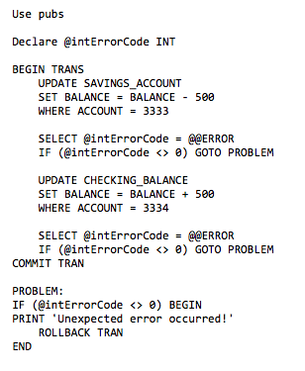

Code Segment 8.1: Transaction Session

Code Segment 8.1 shows how to define a transaction between the banking application and the account database. In this example, you can bundle multiple Transact-SQL statements into a single transaction statement using the following syntax:

* Begin Transaction: Starts a transaction
* Rollback Transaction: Reverses a transaction in case of errors
* Commit Transaction: Records all changes in the database, if all the statements are correct

**Topic 2: Purpose of Transaction Management**

Transaction management is a sequence of actions performed to manage and complete one database operation. Transaction management in an RDBMS-oriented application is done to:

* Ensure that the data held in the database is always consistent
* Ensure that there is no violation of the integrity of the database during transaction
* Provide a specific procedure for execution of transactions
* Resolve conflicts that may occur during concurrent transactions
* Restore the database to the state it was in, in the event of a database server failure

In other words, the purpose of a transaction management system is to ensure that a transaction life cycle runs smoothly without disrupting database integrity. The task of managing transactions starts when the first executable SQL command is initialized or when a transaction commences. For a transaction to be completed and database changes to be made permanent, the transaction must be executed completely by the transaction management system.

For example, an application handles delivery of catalog merchandise ordered by customers via telephone through a salesperson. The transaction management system is required to:

1. Create an order transaction that involves checking an inventory database for the available products.
2. If the product ordered by the customer is available, then place the order.
3. Confirm the order placed and provide an expected time of shipment to the customer.

Figure 8.1 shows the tasks performed by the transaction management system to run an inventory based ordering application.

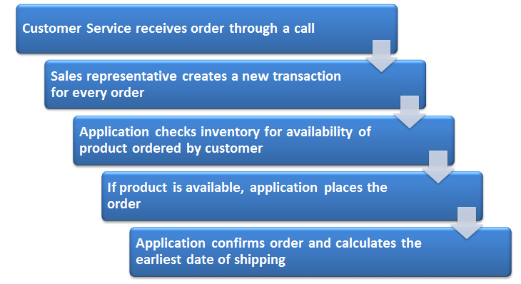

**Figure 8.1: Sequence of Events in an Inventory Based application**

This entire process is viewed as a single transaction between a salesperson and a customer. All the mentioned steps must be completed and the database must reflect the new order before you can say that the transaction is successful. When one transaction ends, the next executable SQL statement starts automatically.

Transaction management is also useful when you want to perform multiple database operations as one transaction. Consider a situation where you want to insert data into master and child tables in an SQL Server and after you have inserted one row into the master table, the transaction fails to insert the data into child tables correctly. Now, that the child table data is not inserted correctly, you also need to roll back the master table data to avoid inconsistencies in data. Here, both the master table insertion and the child table insertion must be considered as a single execution unit or a transaction. Transaction management ensures that insertions into parent and child tables are consistent to the parent-child relationship between the tables.

You need to take care of several aspects to manage the risks associated with transaction management.

**Risks in Transaction Management**

There are many risks associated with implementing transaction management for an application that depends on an external database. If the risks are ignored, the entire transaction system fails and corrupts the database. Some of the key risks are as follows:

* **System failures:** The following types of system failures may occur during transaction management:
  + Transaction failure because of logical error: This type of failure can occur when the data entered in the database is corrupt or if no data has been entered.
  + Transaction failure because of system error: This type of failure can occur when the database is erroneous or in deadlock mode. A deadlock is a situation where two or more transactions are waiting for the others to be completed.
* **Disk failure:** This risk occurs when data is lost from the database during a transaction or when the database is empty.
* **Data cache failure**: Every object in a database has a session cache that keeps the object is a persistent state. If the session is open for a long time or a lot of data is uploaded during transactions, the cache grows endlessly and becomes difficult to manage till you get an OutOfMemoryException.
* **Exception errors:** This type of failure can occur due to an exception during a transaction. When an exception occurs, you can roll back the transaction and close the session. This will stop the application to be bound to the transaction, which means the database state and business objects will fall out of sync, to assist in start over of the transaction.
* **Session use**: This type of failure can occur when a session is not thread safe or multiple transactions are executed in a single session. Therefore, if two concurrently running threads use the same session, it will cause the transactions to compete with each other when trying to commit themselves and consequently, affect the database.

## Lesson 2: Spring Transaction Management

A component of Spring Framework is its transaction management capability, which brings abstraction mechanism to the application being developed. Abstraction mechanism is a way to separate implementation from the interface in Java programming. The transaction management component of Spring Framework allows you to work with transactions on almost all Java platforms. Apart from the abstraction mechanism, Spring Framework’s transaction management module supports both programmatic and annotation-based transaction management. This transactional system does not depend on the Java Transaction API or Enterprise JavaBeans. As a result, Spring Framework’s transaction management module makes an application portable, manageable, and platform independent.

In this lesson, you will be introduced to transaction managers and transaction management in Spring Framework using programmatic and declarative methods and using annotations. You will also look at integrating Spring Framework with external transaction managers such as Hibernate. This allows users to keep their application flexible.

### Topic 1: Integration of Different Transaction Managers

Spring Framework is flexible and supports integration to ORM frameworks, MVC frameworks, and even transaction managers.

**Introduction to Transaction Managers**

The part of the application that handles the coordination of transactions between multiple resources is called a transaction manager. The transaction manager is responsible for the creation and maintenance of transaction objects and the tracking of all the resources that are part of a transaction.

Committing a transaction makes the changes implemented in a transaction permanent. When you call on a transaction manager to commit a transaction, the transaction manager commences the two-phase commit protocol as follows:

1. **Phase 1**: The transaction manager prepares all the enlisted resources before committing a transaction.
2. **Phase 2**: The transaction manager notifies the resource managers involved if the transaction was aborted or committed.

The tasks performed by a transaction manager are as follows:

* **Maintaining logs:** The transaction manager records events when the application is executed. It maintains a log of every transaction that takes place in the application in storage. This log is a sequential file that records transaction events that have occurred. This log is used by transaction managers to record:
  + When a transaction starts
  + When a transaction is committed When a transaction related decision is made
  + When a transaction enlists resources
  + When a transaction succeeds or fails

If a transaction fails, the transaction managers record the log as soon as the transaction restarts and try to restore the database to the latest state.

* **Demarcation**: The transaction manager starts and finishes a transaction using Begin, Commit, and Roll back methods.
* **Controlling transaction context**: All the necessary information needed to monitor a transaction is held in the transaction contexts. These transaction contexts are built and connected to the existing thread by the transaction manager.
* **Managing multiple resources**: The transaction manager in an enterprise application usually has to handle multiple resources at the same time. A resource is a single running instance of the application that is involved in transaction.
* **Failure recovery**: The transaction manager ensures that the enlisted resources are kept in a consistent state in case of a system or application failure occurs to ensure integrity of the database.

Transaction managers can be categorized based on the kind of transactions they handle. The different types of transaction managers are as follows:

* **Local transaction managers**: A transaction manager that handles transactions over a single resource and is embedded within the resource is called a local transaction manager... An application may have multiple local transaction managers that work independently without any dependence on each other.
* **Global transaction managers:** A transaction manager that handles transactions which span across multiple resources is called a global transaction manager. In this case, a Transaction Processing (TP) monitor is required in an application to coordinate the transaction because an embedded transaction manager specific to a single resource cannot be used. .
* **Distributed transaction managers**: Servers are usually connected directly to the resources that are involved in a transaction. However, if the resources are distributed among different physical locations, the connection becomes difficult. Therefore, a distributed transaction manager is used to indirectly connect multiple resources through a web service.

**Transaction Management in Spring Framework**

The Spring Framework’s transaction management module is capable of supporting:

* Global and local transactions
* Nested transactions
* Save points
* All Java based environments
* PlatformTransactionManager that can support:
  + Transaction managed on JDBC connection
  + ORM related transaction management
  + JTA managed transactions
* Programmatic transaction management using TransactionTemplate
* Declarative transaction management using XML metadata and annotations

Spring Framework allows consistent abstraction for transaction management which has the following benefits for transaction management:

* It provides a programming model that is compatible with various transaction APIs, such as Java Transaction API (JTA), Java Database Connectivity (JDBC), Hibernate, Java Persistence API (JPA), and Java Data Objects (JDO).
* It supports declarative transaction management that helps in separating transaction code from the business logic code. Annotations or XML-based configurations can be used to manage transactions.
* It allows application to be independent of the framework because due to the declarative transaction management you have to write little to no code related to transaction management. This keeps the application portable and secure.
* It is very simple and easy to use by developers.
* It allows the use of a consistent programming model in any environment. This means that code is portable and if written once can be used in different environments. .

**Transaction Manager Interfaces**

Spring Framework’s transaction abstraction is governed by a transaction strategy that is defined by the org.springframework.transaction.PlatformTransactionManager interface. Code Segment 8.2 shows an example of implementing this interface.

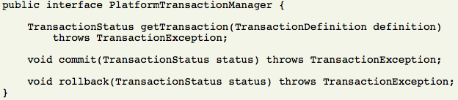

**Code Segment 8.2: org.springframework.transactionPlatformTransactionManager interface**

The PlatformTransactionManager is an interface. Therefore, it can be mocked or stubbed. It is not bound to any look up strategy such as JNDI. The PlatformTransactionManager implementations can be defined like any other bean in your Spring Framework’s Inversion of Control (IoC) container. Table 8.4 lists the methods available in the org.springframework.transaction.PlatformTransactionManager interface.

|  |  |
| --- | --- |
| **Method** | **Description** |
| void commit (TransactionStatus status) | Used to commit a transaction based on its status, which can be:   * **New,** which means tocommit the new transaction and move on to the next * **Not new**, which means torejecting to commit to complete the transaction * **Roll back**, which means to perform roll back and not commit |
| getTransactionStatus( TransactionDefinition definition) | Used to return an active transaction or a new transaction based on the specified behaviour |
| void rollback(TransactionStatus status) | Used to perform a roll back on the specified transaction |

**Table 8.4: Methods of PlatformTransactionManager**

The TransactionDefinition interface is another important interface, which defines the transaction properties in Spring Framework. The properties of a transaction that can be defined are listed in Table 8.5.

|  |  |
| --- | --- |
| **Transaction Property** | **Description** |
| ISOLATION | If the isolation property is set to:   * \_DEFAULT, the application uses the default isolation level of the database * \_READ\_COMMITTEDdirty reads are not possible, only non-repeatable and phantom reads are possible * \_SERIALIZATION, dirty, non-repeatable and phantom reads are not possible |
| PROPAGATION | If the propagation property is set to:   * \_MANDATORY, it supports the current transaction * \_NESTED, it executes a nested transaction if the parent transaction is current * \_NEVER, it does not support the current transaction * \_REQUIRED, it supports the current transaction or creates a new transaction |
| TIMEOUT\_DEFAULT | Uses the default time out of the transaction management system to limit transaction time |
| READONLY | Does not change any data but is sued for optimization |

**Table 8.5: Transaction Properties**

To control a transaction execution and query the transaction’s status, you use the TransactionStatus interface. Code Segment 8.3 shows an example of implementing the TransactionStatus interface.

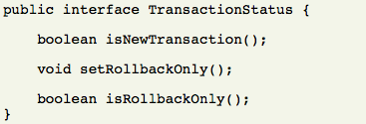

**Code Segment 8.3: Implementing TransactionStatus interface**

**Resource Synchronization with a Transaction**

Synchronizing resources to a transaction means that resources involved in a transaction can be accessed by one transaction thread at a time. For example, a DataSourceTransactionManager is an interface that has to be synchronized with the corresponding JDBC data source, which is a resource used in the transaction. The application code uses a persistence API, such as Hibernate, Java Data Object (JDO), etc. to ensure that the resource objects are being created, used, and cleaned up properly via a PlatformTransactionManager. The different approaches to resource synchronization are as follows:

* **High-level approach**: This approach uses Spring Framework’s highest level persistence APIs that do not replace native APIs. High-level persistence APIs handles resource creation, reuse, and cleanup internally. They can also handle transaction synchronization of resource and exception mapping. This allows your application’s data access code to focus only on high level persistence without implementing synchronization code.
* **Low-level approach**: This approach uses native persistence APIs when the synchronization of resources has to happen at low level exit classes, such as the DataSourceUtils for JDBC and the SessionFactoryUtil for Hibernate. The application code directly deals with the native APIs to ensure that proper Spring Container managed objects are created and transactions are synchronized.
* TransactionAwareDataSourceProxy: This is the lowest level approach in synchronizing resources. This creates a proxy for the target data source and adds connection to the transaction by wrapping the target data source. Generally, it is used only when existing code must be called and passed as a standard JDBC DataSource implementation.

Resource synchronization can be performed in the following two ways:

* Call the getconnection() method on the resource
* Use Spring Framework’s org.springframework.jdbc.datasource.DataSourceUtils class as follows:

Connection conn = DataSourceUtils.getConnection(dataSource);

If a transaction already exists and has a resource synchronized to it, the connection instance will be returned. Else the method call will create a new connection that will be synchronized to the existing transaction and can be used immediately in the same transaction.

### 

### Topic 2: Declarative and Programmatic Transaction Management

Spring Framework’s transaction management module supports the following two ways of managing transactions, based on the approach needed for transaction management:

* **Declarative transaction management,** by declaring AOP proxy and using this proxy to define transactions
* **Programmatic transaction management,** by defining transactions directly in the application code

Let us look at these two methods of transaction management in detail.

**Declarative Transaction Management**

Declarative transaction management is possible because of the Spring AOP Framework that is used to Advice transactions. The transaction Advice used by a declarative transaction is derived from transactional metadata, which, along with the AOP framework, creates an AOP proxy that uses the TransactionInterceptor interface along with PaltformTransactionManager interface to execute transactions around a method’s invocation. The benefits of using Spring Framework’s declarative transaction management are:

* It works in any environment, such as JDBC, JDO, or Hibernate.
* It can be applied to any class, not just special EJB classes.
* It allows roll back to be controlled declaratively using roll back rules, not just programmatically. These rules allow you to specify which exceptions in your application transaction code should trigger a roll back. This specification is done in the XML-based configuration files. When roll back rules are used, the business objects are kept independent of the transactional infrastructure, keeping them secure and reusable throughout the business code.
* It allows customization of transaction behavior using AOP. For example, aspects can be inserted aspects when an error triggers a roll back of the transaction.

**Implementing Declarative Transaction Management**

As mentioned earlier, in Spring Framework, the AOP framework and the transactional metadata create an AOP proxy to execute a declarative transaction around a method’s execution. Figure 8.2 shows how a method can be called on a transactional AOP proxy.

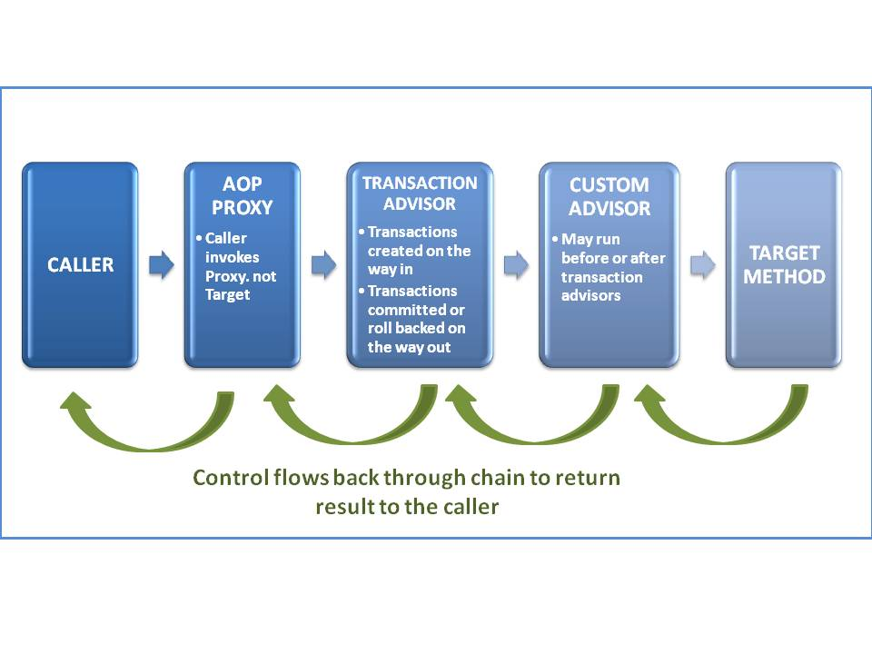

**Figure 8.2: Calling a Method Using AOP Proxy**

**Programmatic Transaction Management**

Programmatically, managing a transaction means you are writing the code for every step for managing and executing a transaction. Spring Framework supports two means of programmatic transaction management as follows:

* Using the TransactionTemplate
* Using PlatformTransactionManager implementation

Let us look at these two methods in detail.

**Using the TransactionTemplate**

The TransactionTemplate uses a callback approach to help you to write transaction code that is intention driven, where the intention is to perform a transaction. The callback approach keeps the application code focused on the transaction and prepares the resources for the upcoming transaction. The following steps are performed to use the TransactionTemplate:

1. Write a TransactionCallback implementation as an inner class.
2. In the inner class, write the code that needs to execute in the Transactioncontext.
3. Pass an instance of TransactionCallback class to the execute() method of the TransactionTemplate to:

* Return value from your transaction, you can use the TransactionCallbackWithoutResult class
* Perform a roll back you can call the setRollbackOnly() method on an object from TransactionStatus class
* Set transaction properties, such as propagation method, isolation level, and so forth on the TransactionTemplate while configuring the application using XML-based configuration

Let’s look at an example that implements programmatic transaction management using the TransactionTemplate. To implement the TransactionTemplate, you first need to pass an instance of the TransactionCallback to the execute() method as seen in Code Segment 8.4.

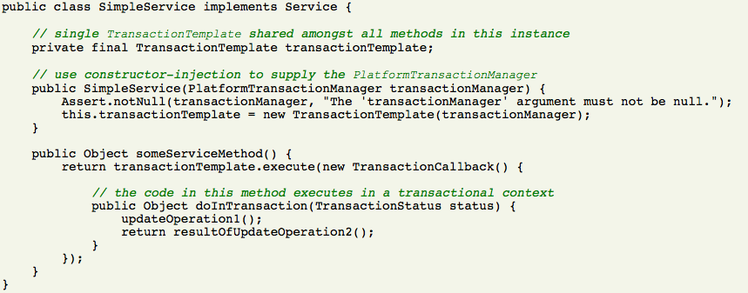

**Code Segment 8.4: Declaring an Instance of TransactionCallback interface**

If you are not expecting a return value, you can use the TransactionCallBackWithoutResult implementation as shown in Code Segment 8.5, to callback a transaction.

**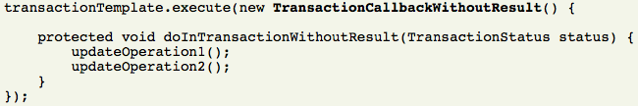**

**Code Segment 8.5: Implementing TransactionCallBackWithoutResult**

You can also set transaction properties when using the TransactionTemplate interface by defining the properties programmatically or in the configuration file. Code Segment 8.6 shows how to set transaction properties using TransactionTemplate.

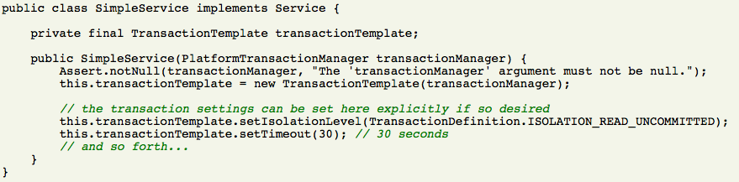

**Code Segment 8.6: Setting Transaction Properties Using TransactionTemplate**

**Using PlatformTransactionManager**

The org.springframework.transaction.PlatformTransactionManager can be used to directly manage a transaction. The implementation of the PlatformTransactionManager is passed to your target bean through a bean reference. Then, TransactionDefinition and TransactionStatus objects are used to initiate transactions, roll back, and commit. Code Segment 8.7 shows an example of using the PlatformTransactionManager.



**Code Segment 8.7 Using PlatformTransactionManager**

Using programmatic transaction management is helpful only when you have a small number of transaction operations to be performed. For example, in a web application, you have transactions that are needed to update only certain information. Here, you may not want to set up AOP proxies as that would be too much effort for very few operations. You can use the TransactionTemplate method to explicitly set the transaction name and execute a simple transaction.

On the other hand, declarative transaction management is useful when you have a large number of transactions taking place in your application. For example in a banking application, on a given day, numerous transactions take place between accounts in the same branch and also between accounts in different branches. By using declarative transaction management, you can separate transaction management from the business logic. Declarative transaction management is also simple to configure as it significantly reduces the cost of transaction management in larger, enterprise applications.

**Topic 3: Transaction Management with Annotations**

Annotations can be used to configure transactions in your application. Spring Framework supports the @Transactional annotation to perform transaction management. Let us understand the use of the @Transactional annotation with the help of an example of the ReachoutWorld application developed in previous modules. It is a simple Java-based web application that is being developed using Spring Framework. It accepts online forms submitted by users and returns a form submission message which can be either success or failure depending on the result of form submission. Consider the class shown in Code Segment 8.8.

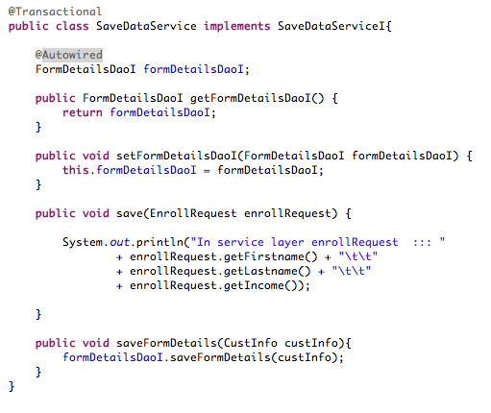

**Code Segment 8.8: Using @Transactional Annotation**

In Code Segment 8.8, the SaveDataService class is defined as a bean in the IoC container. To make the SaveDataService bean transactional, you have to add just one line XML configuration as shown in Code Segment 8.9.

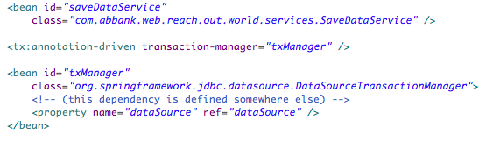

**Code Segment 8.9: XML-based Configuration to Make a Bean Instance Transactional**

Thus, you have implemented transaction management using the @Transactional annotation and then called the bean definition in the configuration to make it transactional. The @Transactional annotation can be used to annotate:

* Interface definition
* Method on an interface
* Class definition or a *public* method on a class

The @Transactional annotation is just the metadata that can be recognized by a transactional AOP proxy and then the same proxy uses the metadata to configure the appropriate beans with transactional behavior such as committing or roll back. It is easier to annotate classes rather than interfaces with the @Transactional annotation. This is because annotations do not inherit properties. So, if you annotate an interface, the classes contained within the interface may not inherit the transactional definitions contained within the interface.

Like any other annotation, you can define the optional attributes to the class you are annotating with the @Transactional annotation. The optional attributes are listed in Table 8.6.

|  |  |
| --- | --- |
| **Attribute** | **Description** |
| Transaction-manager | Used to specify the name of transaction manager to be used when the name of the transaction manger is user defined (not by default) |
| proxy-target-class | Used to control the type of transactional proxies created for implementing transactions as follows:   * When the proxy-target-class attribute is set to "true," Spring creates class-based proxies * When proxy-target-class is set to "false", the standard JDK interface-based proxies are created |
| order | Used to define the order of the transaction advice that will be applied to beans |

**Table 8.6: @Transactional Annotation Optional Attributes**

**Using @Transactional Annotation to Set Transactional Properties**

While using the @Transactional annotation, you can set transactional properties, such as:

* Propagation method
* Isolation level
* Read only transaction or read and write transaction
* Transaction time out
* Roll back

The various properties of the @Transactional annotation are listed in Table 8.7.

|  |  |  |
| --- | --- | --- |
| **Property** | **Description** | **Default Values** |
| propagation | Sets propagation setting | PROPAGATION\_REQUIRED |
| isolation | Sets isolation level | ISOLATION\_DEFAULT |
| readOnly | Specifies if transaction is Read/write vs. read-only transaction | Read/write |
| timeout | Specifies transaction timeout | Default time out of the underlying database |
| rollbackFor | Specifies the array of exception classes which must cause roll back | Roll backs are triggered by only runtime exceptions. |

**Table 8.7: Properties of @Transactional Annotation**

Let us look at setting transactional properties using @Transactional with the example of the ReachoutWorld application. In this application, you annotated the class SaveDataService with @Transactional and the saveFormDetails(CustInfo) method. This is shown in Code Segment 8.10.

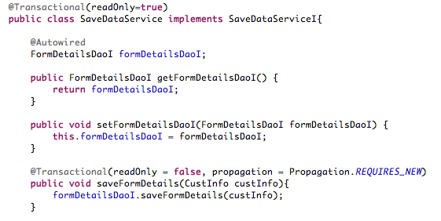

**Code Segment 8.10: Setting Properties to Transaction using @Transactional**

### 

### Topic 4: JNDI

An important feature of the Spring Framework transaction management module is that it supports different transaction APIs, such as JTA, JDBC, Hibernate, and JDO. For the purpose of transaction management, Spring Framework can be integrated with the following tool:

* **Java Naming and Directory Interface (JNDI)**: This is an API that helps Java applications to store and retrieve named java objects from a database. By configuring the JNDI API within the Spring Framework’s configuration files, you can support transaction management capabilities using JNDI elements such as list() and data binding methods.

Let us look at the roles played by JNDI in transaction management in a Spring Framework based application.

**JNDI**

JNDI is an API that provides naming and directory methods to Java-based applications. JNDI can store and retrieve Java objects of any type. JNDI can also implement methods for standard directory operations, such as connecting attributes with objects and locating data objects in a database using attributes.

With JNDI your applications can support a number of different naming and directory services. These include file systems, directory services, such as

* Lightweight Directory Access Protocol (LDAP)
* Novell Directory Services, and Network Information System (NIS)
* Distributed object systems such as Common Object Request Broker Architecture (CORBA)
* Java Remote Method Invocation (RMI)
* Enterprise JavaBeans (EJB) are supported

**JNDI Architecture**

The JNDI architecture is made up of an API and a Service Provider Interface (SPI). The SPI supports a variety of naming and directory services by plugging in these services transparently to the application. Figure 8.3 shows all of the services your application can access by using the JNDI API.

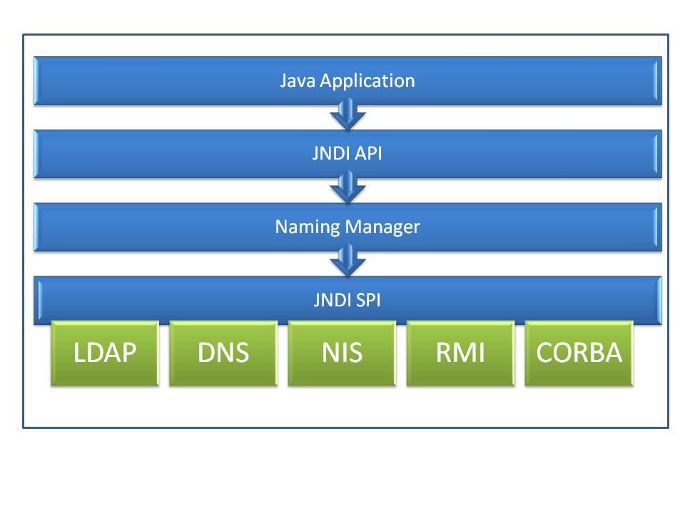

**Figure 8.3: JNDI Architecture**

Services available through the JNDI API are:

* **Lightweight Directory Access Protocol (LDAP)**: LDAP is an open source application protocol that allows applications to access and maintain distributed directory information services through intranet or internet network. Directory services are important in developing web applications as they allow data sharing between users, systems, networks, services, and applications.
* **Network Information Services (NIS)**: NIS is a network wide system database that can be used to store data related to an applications users, systems, and machines.
* **Novell Directory Services (NDS)**: NDS is a directory service software product that can be used to manage resources on multiple servers and machines within a given network system.
* **Remote Method Invocation (RMI)**: RMI service provider allows application to access remote objects registered within the RMI directory.
* Common Object Request Broker Architecture (**CORBA)**: CORBA is a standard designed to enable communication of systems that are deployed on diverse platforms. It enables applications developed using different frameworks, software, or even programming languages to communicate with each other for networking purposes.

JNDI elements that are available to be used to access data objects from a data source or repository are:

* **Naming Package**: The javax.naming package contains classes and interfaces that allow the application to access naming services.
* **Context interface**: The core interface for JNDI, allows the application to look up, bind/unbind, rename objects, and create and destroy sub contexts.
* **Initial context**: JNDI defines an InitialContext, which is necessary for naming and directory operations. With the initial context in place, other contexts and objects can be looked up.
* **Lookup**: As most commonly used operation, Lookup is used to look up the name of an object. It returns the object bound to a specified name.
* **Binding**: A binding holds the bound object’s name, class, and the object itself. It is implemented by the listBinding () method.
* **Lis**t: This returns a list of objects with a specific name and the name of the object's class. list() is useful for browser applications that search for context bound to a given object.
* **Name**: This is an interface that represents an object’s generic name and is used by Naming Systems to define an object’s name.
* **References**: A reference can be called a compact representation of an object or a summary of an object and its properties. The Reference class contains information on how to construct a copy of the object.
* **Exceptions**: JNDI defines a class hierarchy for exceptions that occur and also the naming and directory operations. The root of this class hierarchy is NamingException.

You need to implement JNDI by configuring it to the application. To do this, perform the following steps:

1. **Change the tomcat server.xml or context.xml configuration file**: The context.xml and the server.xml files are global resources that can be used multiple times within your application. To enable this you have to configure. This is shown in Code Segment 8.11.
   * The globalResource file in the context.xml root node Context
   * TheGlobalNamingResources file in the server.xml file

**Code Segment 8.11: Changing Tomcat server.xml or context.xml Configuration**

<Resource name = "jdbc */* testDB" / / *specify the JNDI name will be used for the configuration of the spring data source bean configuration and ResourceLink*  
type = "javax.sql.DataSource" */ / data source bed type, using the standard javax.sql.DataSource*  
driverClassName = "com.mysql.jdbc.Driver" */ / JDBC driver*  
url = "jdbc: mysql :/ */* localhost: 3306/test" / / *database URL address*  
username = "test" */ / database user name*  
password = "test" */ / database password*  
maxIdle = "40" */ / Maximum idle connections*  
maxWait = "4000" */ / When the pool of database connections have been occupied, the maximum waiting time*  
maxActive = "250" */ / connection pool among the largest database connection*  
removeAbandoned = "true"   
removeAbandonedTimeout = "180"   
logAbandoned = "true" */ / database connection is discarded whether records in order to track*  
**factory** = "org.apache.tomcat.dbcp.dbcp.BasicDataSourceFactory" />

The BasicDataSOurceFactory interface in Code Segment 8.11 is configured to use the Resource class to access data from a specified resource for transactions. With the Resource class, you can also create a javax.naming.spi.ObjectFactory interface to hold all the data objects needed in your application’s transaction management.

1. **Configuration of the Spring Framework data source:** Once you have configured the resources access files as seen in step 1, the next step is to configure the datasource in Spring Framework’s configuration files. These data sources are configured as regular Spring Framework beans by providing their bean definition in XML file configuration. This is shown in Code Segment 8.12.

*<Bean id = "testDataSource" class = "org.springframework.jndi.JndiObjectFactoryBean">  
<Property name = "jndiName">  
<Value> java: comp / env / jdbc / testDB </ value>  
</ Property>  
</ Bean>*

**Code Segment 8.12: Configuring Spring Data Source**

After configuring JNDI resources to your Spring Framework based application, you will be able to implement JNDI elements, such as the Context interface and also use JNDI methods like list(),listBinding(), and lookup()in your application. Therefore, JNDI can help your application in transaction management by providing resource management support.

**Module Summary**

In this module, you learned that it is important to protect the integrity of data stored in a database, such as the RDBMS. You also saw how to implement transaction management using Spring Framework in a Java-based enterprise application. Spring Framework supports transaction managers which are interfaces that provide methods to access a database, read data from or write data to a database, and store data in a database. Resources that are needed for a transaction needs to be synchronized so that they are aware of the changes made to the database.

You have also seen how to implement programmatic and declarative transaction management in a Java- application. In addition, you have learned how to use Spring Framework annotations to define transactions and their properties to enable data transfer from and to a database appropriately.

### References

* Web references:
* <http://www.javabeat.net/transaction-management-in-spring-framework/>(Accessed 27 April 2014)
* <http://www.tutorialspoint.com/sql/sql-transactions.htm/>(Accessed 27 April 2014)
* <http://www.itu.dk/people/pagh/DBSE06/Transactions.pdf>(Accessed 27 April 2014)
* Book references:
* Johnson, Rod; Hoeller, Juergen;Arendsen, Alef; Risberg, Thomas; Sampaleanu, Colin. (2005). *Professional Java Development with the Spring Framework.* In: Wiley Publishing, Inc.
* Ho, Clarence. (2012). *Pro Spring 3.*Apress publication.

# Module 9: Spring Security Framework

**Module Overview:**

In an enterprise, the applications that are used by various teams to execute their day to day work is an important resource that needs to be protected from security threats. Software security is implemented by an application that protects data and resources contained and controlled within the application. In today’s world, dependence on Information Technology (IT) industry makes software security a very important part of business continuity and security.

In this module, you will learn about providing security to J2EE-based applications using the Spring Security Framework, which performs authentication and authorization for enterprise applications. The Spring Security Framework was initiated in 2003 by Ben Alex and later released under the Apache License in March of 2004. Additionally, you will see how to implement the Spring Security Framework to protect your J2EE applications and also how to secure web request. You will also learn how to describe function-level and view-level securities using advanced security concepts of the Spring Security Framework.

**Module Objectives:**

By the end of this module, you will be able to:

* Implement Spring Security Framework.
* Secure web requests.
* Describe function-level security.
* Describe view-level security.

## Lesson 1: Spring Security Framework Support

Implementing security to an application involves ensuring that the application is designed to operate in such a way that, any potential harm that could result from misusing the application or the resources it controls is prevented. Harm to an application and the resources it controls can happen due to one or more of the following reasons:

* **Failure to satisfy business requirements**: Every application has a set of business requirements that has to be met. These requirements can go unsatisfied by a common coding error or by something complex such as input validation errors.
* **Mistakes in the application’s requirements**: A very serious security risk to any application is caused when the requirements for the application are not designed properly. For example, an application may work as designed under normal conditions, but one particular system state may not have been included in the design. When the application has to implement this particular system state, you may see unexpected and undesirable results and behavior.
* **Misuse of application and its resources**: There is a risk of great harm to an application due to loss of data, inaccuracy in code writing or code alterations, misuse of data and resources controlled by the application.

To protect an application from any of the above mentioned reasons; a security program has to ensure:

* Security evaluation needs to been done for the application
* Security requirements needs to be identified and finalized for application development, operation and maintenance processes
* Security evaluation needs to be performed every time the application is updated or modified
* The application has adequate physical security

Now that you are familiar with the general concepts of software security, let us look at the concepts involved in the development and implementation of the Spring Security Framework.

### Topic 1: Introduction to Spring Security Framework

The Spring Security Framework is a comprehensive security service for J2EE-based enterprise applications which is particularly good at supporting applications developed using the Spring Framework. Most developers are drawn to the Spring Security Framework as it supports protection of typical enterprise application scenarios, unlike the security features of J2EE’s Servlet specification or EJB Specifications.

An example of an enterprise application scenario is where, a user logs onto a web page using a legacy system, which, in turn, creates a request token. The legacy system then passes the token, username and user role to the Spring Framework web service, which performs verification operations on the user name and token. If the verification is passed, then the Spring Security Framework creates a new session and allows the user to access the web page. If verification does not pass, then the user is directed to an error page.

When you use the EJB specification or J2EE Servlet specifications you would have to do a lot of work in reconfiguring your application’s security in the new target environment. However using Spring Security Framework you can easily port the application to the new environment without any configuration hassles and also implement any of the customizable features you will be studying later in this module. Now, let us see the benefits of using Spring Security Framework in implementing authenticating and authorization in an access controlled application.

**Authentication and Authorization**

Authentication and authorization are two important areas of application security for implementing access control to an application that accesses external database, tools, or services. Spring Security Framework supports authentication and authorization in the following ways:

* **Authentication**: This is the process of establishing the identity of a principal. A principal can be a user, a system, or a device that is trying to access another system, device, or service. Spring Security Framework supports a variety of authentication models that are usually provided by third parties, or developed by standard bodies such as the Internet Engineering Task Force. Apart from this, the Spring Security framework also provides its own set of authentication features by supporting integration with the technologies and methods as listed in Table 9.1.

|  |  |
| --- | --- |
| **Technology** | **Brief Description** |
| HTTP BASIC authentication headers,  HTTP Digest authentication headers, and  HTTP X.509 client certificate exchange | The HTTP basic authentication headers implements methods that allow HTTP users to provide user name and passwords when making a web request.  The HTTP Digest authentication header performs methods used by web servers to negotiate credentials with a user’s web browser.  HTTP X.509 client certificate exchange is used to verify the identity of a server that uses Secure Socket Layer protocol for HTTP transactions. |
| Lightweight Directory Access Protocol (LDAP) | A common protocol that supports cross platform authentication needs in larger environments. |
| Form based Authentication | A method that is used to control access to a system or service log-in by using forms that have to be filled out by the user. |
| Open ID authentication | An open source method that allows web sites to perform authentication by using a third party service and eliminating the need for using webmasters in security requirements. |
| JA-SIG Central Authentication Service | An open source protocol which is a Java server component that manages web authentication with a ‘single sign on (SSO)’ feature. This allows users to access multiple web resources by providing their credentials just once. It is also referred to as Central Authorization Service. |
| Transparent authentication context propagation | An authentication method used to perform context based authentication for the Remote Method Invocation (RMI) component of the Spring Framework. |
| Java Authentication and Authorization Service (JAAS) | A Java implementation of the Pluggable Authentication Module of Java. This works by separating user authentication concerns from the main application code and also evaluates authentication by checking who runs a given code. |
| JEE container authentication | A method that is used to secure resources in your deployed project by performing administrative tasks such as adding or deleting user information from a repository. |

**Table 9.1: Authentication Technologies and Methods Supported by Spring Security Framework**

Spring Security Framework as an open source security platform, also allows you to create your own customized authentication systems and implement them using DI. Because of this feature, many Independent Software Vendors (ISV) use the Spring Security Framework to choose from a collection of flexible authentication models. Thus you can integrate new solutions without having to take on a whole lot of code refactoring or re-configuration.

Some applications need to differentiate security based on the interaction occurring between your application and the principal. Here,, authentication is not enough. For example, you may need your application to ensure that only HTTP- based requests are processed. To help achieve such goals, Spring Security Framework supports a fully automatic channel security which works along with JCaptcha to detect human principals. Now that you are aware of authentication capabilities of the Spring Security Framework, let us look at the implementation of authorization within the framework.

* **Authorization:** Authorization is the process by which your application decides whether to allow a user, service, or system to perform a particular action within the application. The identity of principal (user, service, or system) has already been established using authentication at this point, while authorization decides whether to allow the principal to perform a particular action or not. The three main areas where you can implement authorization using the Spring Security Framework are:
  + Authorizing web requests
  + Authorizing methods that can be invoked and
  + Authorizing principal access to single domain object instances.

Now that you have been introduced to the basics of the Spring Security Framework, let us look at a brief history of Spring Security Framework.

**History of Spring Security Framework**

In 2003, Spring Security Framework was started as the “Acegi Security System for Spring Framework” when the community of developers using Spring Framework was very small. By January 2004, as the community depending on Spring Framework based development grew, a Source Forge project was established to help Java-based application support security implementations. In early days, the Source Forge project did not contain authentication modules of its own and depended on Container Managed Security. As the number of people using Spring Framework grew, new features had to be added to handle large enterprise application security, and the limitations of container specific authentication had to be overcome.

In May 2006, Acegi Security was included as an official Spring Framework sub project for implementing security to applications after it underwent multiple additions and updates. In 2007, the Acegi Security was rebranded as Spring Security Framework and since then, it possesses a strong and active open source community till today. Now that we have seen how Spring Security Framework evolved, let us understand some of the concepts used while implementing the Spring Security Framework.

**Terminology used in Spring Security Framework**

Let us now learn about the terminology contained in the Spring Security Framework vocabulary. These are as follows:

* **Auto-Config**: A namespace element that allows you to automatically configure Spring Framework beans more precisely than regular bean configuration. It also allows you to define alternate configuration syntax for the bean which is similar to the application code and hides the underlying complexities from you.
* **AccessDecisionManager**: As a component of the Spring Security Framework, AccessDecisionManager is an interface which uses the objects of the GrantedAuthority interface to decide whether a user can access a requested resource or not. The GrantedAuthority objects are invoked by the AuthenticationManager interface.
* **AuthenticationManager**: This is an interface that processes authentication requests using sub classes which are called AuthenticationProviders. This interface accepts user name and password from the user and compares the input to the authentication tokens defined in a repository. If the authentication is passed, then it allows the user to access a resource via the AccessDecisionManager.
* **ProviderManager**: ProviderManager is an instance of the AuthenticationManager interface which processes authentication request through a list of authentication providers.
* **Delegating Filer Proxy**: You have to declare Servlet filters in the web.xml to allow your application to use them for authorization purposes. If not, these filters will be ignored by the Spring Container. The Servlet filter classes are defined as beans in the ApplicationContext and can use Dependency Injection (DI). The DelegatingFilterProxy is a connection between the ApplicationContext and the web.xml.
* **Principal**: A principal is a term used to refer to a user, system, or service that applies for an authentication and authorization to access a particular resource.
* **SecurityContext**: This is an authentication session initiated when a user requests authentication to access a particular resource. It is stored in a security context repository.
* **Session Authentication Strategy:** The strategy that is used while designing the security data needed to implement Spring Security Framework within your application. This tries to answer the following questions:
  + Should a user have a session
  + Should the application retrieve any existing sessions
  + Should a session be created automatically when a user logs in?
  + How many sessions can a user have?
  + What is the session timeout?
  + How to proceed with Session Handling?

**How Spring Security Framework Works**

Now that you are familiar with some of terms used in the Spring Security Framework, let us look at the basic steps performed by Spring Security Framework while protecting access to resources controlled by your application. The steps that describe the basic operations taking place in a Spring Security Framework implementation are:

1. A user requests access to a secured page through a web application.
2. The AuthenticationManager configured into the application checks the users credentials.
3. User provides necessary credentials such as a login ID and a password.
4. If the validation of the credential fails, access to the secured page is refused.
5. If the credentials are validated successfully, the AccessDecisionManager ensures that the user has the proper authority to access the secured page.
6. If the authorization fails, then access to the secured page is denied.
7. If authorization succeeds, the secured page is displayed to the user.

Now that you have seen the basic steps involved in implementing the Spring Security Framework, let us look at how filters help in processing user request.

**Introduction to Filter Chains**

Filters are components of the Java Servlet specification that translates user requests and responses, to a machine compatible form, so that the information contained in the user requests or response can be utilized by the application. Filters are also used in Spring Framework when an application is processing user request to access a given resource. In Spring Security Framework, the AuthenticationManager and AccessDecisionManager are the filters used, which are configured automatically when the auto-configuration is enabled in your application. When a user Request is initiated, filters are used to process the request by performing the following steps.

1. When a user submits a request through a web application, Spring Framework loads its SecurityContext.
2. If the user request is to log out of a particular URL, the user is logged out.
3. If the user requests an authentication form submission, then authentication is attempted and a default login page is displayed.
4. Filters check whether the request has an authorization header.
5. If yes, user name and password is extracted for authentication. If authentication is successful, it is registered in the SecurityContext.
6. The user request is then wrapped with the SecurityContext into a single object.
7. If authentication fails, then the object is flagged as anonymous.
8. If the user authentication is successful, session authentication strategy is applied.
9. If the user has not been authenticated successfully so far, it is flagged as anonymous.
10. Any AccessDeniedException and AuthenticationException thrown by any of the above are handled at this stage of processing requests using filters.
11. Authorization and access control decisions are delegated to an AccessDecisionManager interface.

Code Segment 9.1, is an example of setting filter configurations while implementing filters in a Spring Security Framework application.

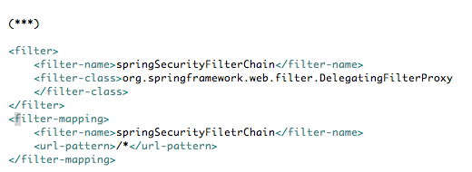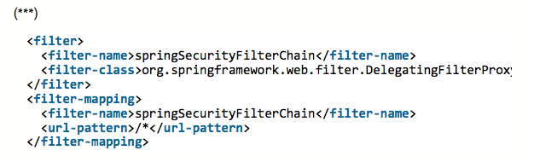

**Code Segment 9.1: Filter Configuration in Spring Security Framework Framework**

You have now seen how user requests are handled using filters in Spring Security Framework to process access requests to a particular resource. In the next topic, you will learn about implementing security to a web request using the Spring Security Framework.

### Topic 2: Securing Web Requests

When you have a web application that is accessed by numerous users and administrators every day, you have to protect the application and the data held in the application from being destroyed or illegally modified. You also have to ensure the security of the web application and that only those who are authorized to view, edit, or delete the data are granted access to the web application. This is done by assigning and using user names, user IDs, and passwords, and authenticating users based on these characteristics. Once your application has authenticated users, you can check their authority to implement any change or access data held in the secured web application. Spring Security Framework allows you to secure web applications by proving web based security features, which you will learn about in this topic.

**Web based Security**

When a user tries to access a web resource like a URL or web page, the user needs to be authorized to access the resource. The access request from the user is processed by the Spring Security Framework once it has been configured in the XML-based configuration file. Let us look at how Spring Security Framework configuration is defined to protect a web-based application built using the Spring Framework.

**Security Namespace Configuration**

Spring Security Framework configuration is defined in an XML document and has a namespace (a set of Tag elements that define it). The namespace allows you to access additional elements from XML Schema to traditional bean definitions in Spring Framework. In other words, the namespace element is used to define individual bean configuration with greater precision. You can also write the configuration code using domain objects and hide the underlying complexity from the user. The underlying complexity in configuration files may conceal multiple beans and steps being added to the ApplicationContext. Table 9.2 lists some of the namespace configuration Tag elements you can use to define Security namespace configuration in Spring Security Framework.

|  |  |
| --- | --- |
| **Namespace Configuration Tag Element** | **Description** |
| <html auto-config='true'> | This is the main element of web related configuration definition which contains the filter chain proxy bean SpringSecurityFilterChain and has auto-config attributes. |
| <access-denied-handler> | This element is used to define the default error page when a user’s access request has been denied. |
| <intercept-url pattern="/\*\*" access="ROLE\_USER"> | This element defines a relationship between URLs and the access authorization required to visit these URLs. |
| < requires-channel> | This element is used to invoke the use of HTTPs to access an URL. |
| <form-login> | This element is used to describe the login page URL for a web application. In other words, this is the URL for processing the login and target URL after the login has been passed or failed. |
| <remember-me> | This element is used to remember user information from cookies for URLs that are visited often by the user. |
| <session-management> and <concurrency-control> | These elements are used to apply session management strategies as defined in the SecurityContext code. |
| <logout> | This element is used to configure the default logout page for an URL. |
| <http-firewall> | This element is used to invoke a firewall filter that stops further access to the URL. |
| <authentication-manager> | This element is necessary to configure and create ProviderManager and AuthenticationProviders |
| <authentication-provider> | This element is used to create an in-memory authentication provider and its child elements <user-service> are used to define login and password combinations. |
| <password-encoder> | This element is configured to identify password encryption when the user’s login and password are stored in a database. |

**Table 9.2: Tag Elements of Security Namespace Configuration**

Now you have seen the Tag elements that are used to define the configuration settings of Spring Security Framework namespace, now you will learn how to secure web requests.

**Securing Web Requests**

To secure web requests, Spring Security Framework uses the Spring Expression Language (SpEL) which contains expressions that define the characteristics of the user such as roles and authentication status. Let us now learn how to use SpEL to authenticate and authorize web requests.

**Web Authentication**

Spring Security Framework authenticates web requests by evaluating an expression retrieved from the user against a context dependent root object. The root object, called the SecurityExpansionRoot, defines common security terms and predicates an available list of user based expressions for use in web security context. Some of the security terms used, when implementing security is listed in Table 9.3.

|  |  |
| --- | --- |
| **Term** | **Description** |
| authentication | The current user’s Authentication object, taken from SecurityContext |
| Principal | The current user’s principal object, taken from Authentication object |

**Table 9.3: Terms Used in Web Security**

Along with the terms listed above, SecurityExpressionRoot supports several predicates as well. Their semantics center on authentication status and user roles as listed in Table 9.4.

|  |  |
| --- | --- |
| **Predicate** | **Sets Predicate to True if and only if…** |
| permitAll | Always true |
| denyAll | Always false |
| isAnonymous() | User is anonymous |
| isAuthenticated() | User is not anonymous |
| isRememberMe() | User authenticated via remember-me |
| isFullyAuthenticated() | User is neither anonymous nor remember-me |
| hasRole(role) | User has a specified role |
| hasAnyRole(role1,role2,…..,role n) | User has at least one of the specified roles. |

**Table 9.4: Predicated supported by SecurityExpressionRoot**

Another important class in authenticating web requests is the WebSecurityExpressionRoot, which extends the SecurityExpressionRoot class. Table 9.5 lists the common user expressions that are supported by this class.

|  |  |
| --- | --- |
| **User Expression** | **Description** |
| hasRole(‘admin’) | Used to allow access to only administrators |
| hasAnyRole('instructor’,’admin’) | Used to allow access to only administrators or instructors |
| isFullyAuthenticated() and hasAnyRole('customer’,’admin’) | Used to allow access to any user who is fully authenticated or performs any role |
| hasIpAddress('127.0.0.1’) | Used to allow access to a specified loopback address |
| hasRole('admin’) and hasIpAddress(‘192.168.1.0/24’) | Used to allow access to administrators on the Local Area Network(LAN) |

**Table 9.5: Common User Expressions Supported by WebSecurityExpressionRoot**

With this, you have learned about the authentication of web requests and how to implement authentication using user expressions through SpEL. Now let us learn about authorization in web applications.

**Web Authorization**

Authorization of a resource decides, if a principal is allowed access to the resource. Spring Security Framework authorizes users through security expressions. These expressions allow you to write rules in terms of user characteristics such as the authentication status, user roles, and IP address. Two types of web authorization are supported in Spring Security Framework:

1. Web security expressions are used to describe how to control access to resources
2. Security expressions are used to show or hide JSP content using the Spring Security Framework Tag library. You will learn about the Tag library in Lesson 2 of this module.

Let us see how to use security expressions to authorize a web-based application which accepts user requests.

**Authorizing Web URLs**

Implement expression based web URL authorization by setting auto-config, as shown in Code Segment 9. 2.



**Code Segment 9.2: Auto-Config to Implement Expression Based Web URL Authorization**

You can also implement access rules for URLs by including the <intercept-url> element to the <http> element while configuring the expression. The <intercept-url> attributes that can be used are listed in, Table 9.6.

|  |  |
| --- | --- |
| **Attribute** | **Description** |
| Pattern | Defines which URL pattern to use for authentication |
| Method | Defines the HTTP method to be used to narrow the match |
| access | Defines the security expression to be applied, when expressions are activated |
| Filters | Defines the Spring Security Framework filter chain that the request is to bypass. The request will not have a SecurityContext. Generally, used for static resources like images, JavaScript, CSS and so forth. |
| Requires-channel | Defines which channels are needed, either “http” or “https” |

**Table 9.6: <intercept-url> Attributes**

Some examples of implementing access rules using the <intercept-url> attribute are:

* <intercept-url pattern=”/images/\*\*” filters=”none” />:

Excludes images from being intercepted

* <intercept-url pattern=”/home” method=”GET” access=”permitAll” />:

Allows all users to view the homepage of a web site

* <security:intercept-url pattern="/member/\*\*" access="ROLE\_USER" requires-channel="https"/>

Shows the passing of access attribute to specify which security expression is to be used

* <security:intercept-url pattern="/member/\*\*" access="ROLE\_USER" requires-channel="https"/>

Shows the passing of required channel argument to specify the need for http channel.

* <intercept-url pattern=”/users” method=”POST” access=”isAnonymous()” />:

Allows only authenticated users to register a new account in the web application

* <intercept-url pattern=”/lounges/student” method=”GET” access=”hasAnyRole(‘student’, ‘admin’)” />:

Allows only students or administrators to access the URL

You have seen how to authorize web URLs. Now, let us look at authorizing Java Server Pages content based on user characteristics.

**Authorizing JSP Content Based on User Characteristics**

To provide support to access secured information, Spring Security Framework has a set of Tag libraries that apply security to JSP content on a web application. To use expression based URL authorization in your application, you have to include the security Tag library in your JSP definition. This security Tag-lib is configured, as shown in Code Segment 9.3.



**Code Segment 9.3: Including Tag-Lib in JSP**

This Tag library provides three tags that define the security applied to the JSP content in your application. Table 9.7 lists these tags and their descriptions, and the attributes available to supplement each Tag.

|  |  |  |
| --- | --- | --- |
| **Tag Name** | **Description** | **Attributes** |
| <security:authentication> | Used to store the current Authentication object in the SecurityContext. It exposes the Authentication object to the JSP to create variables or to be displayed. | * property: Specifies a property in the Authentication object * variable: Stores the property value * scope: Is an optional variable used to store property |
| <security:authorize> | Used to decide if a JSP’s content is to be evaluated or not. This shows or hides the Tag body according to the current principal’s authentication | * access: Displays the Tag body if authorization is passed * url: Displays Tag body if user has access to a given URL * method: Used to specify method when performing URL authorization * ifNotGranted and ifAllGranted: Displays Tag body to user based on user roles defined |
| <security:accesscontrollist> | Used to display or hide Tag body based on access granted to current principal for a specified domain object. Permissions are passed to PermissionFactory interface set in ApplicationContext. | * hasPermission: Lists the numerical permission to be evaluated and display the Tag body even if one of the values matches * domainObject: Object against which the permission is to be evaluated |

**Table 9.7: Tags to Authorize JSP Content Based on User Characters**

Now that you seen the library of tags available to perform JSP content authorization in Spring Security Framework, let us look at some situational examples of using these tags and their attributes.

**<security: authentication> Example**

Let us assume, a user (principal) accesses a web page which requires login. The webpage greets the user by his username and obtains user information from the UserDetails interface. Now let us assume for some security reasons, the user’s account has been locked. The application has to send an appropriate response to the user. This is seen in Code Segment 9.4, using the <security: authentication> Tag.

**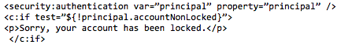**

**Code Segment 9.4: Using <security: authentication> Tag**

Now you have seen how to use the <security: authentication> Tag to send a message to the user. Let us see how to use <security:authentication> to access properties on a custom principal, to write a more user-friendly greeting. This is shown in Code Segment 9.5.



**Code Segment 9.5: Using <security: authentication> Tag to Create Greeting**

**<security: authorize> Examples**

In the same web page example, let us look at using the <security: authorize> Tag to display the login link to the principal, once the user is authenticated. Code Segment 9.6 shows, how to display a page to the user after authentication.

**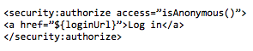**

**Code Segment 9.6: Using <security: authorize> Tag to Display Login Page**

Similarly, you can use the <security: authorize> Tag to determine whether to show a grade book link to the principal whose role has been authenticated as an instructor. Code Segment 9.7 shows, the use of <security: authorize> Tag to display contents to the principal based on their role authentication.

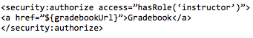

**Code Segment 9.7: Using <security: authorize> Tag to Display Contents**

Once the user has completed the work using a web page, the user would like to log out. Let us see how to use the <security: authorize> Tag to display the logout link if the user has been authenticated. Code Segment 9.8 shows, how to display the logout page to the user who is accessing a secure web application.

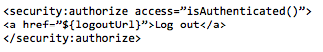

**Code Segment 9.8: Using <security: authorize> Tag to Display Logout Page**

Let us now look at an example of using the <security: accesscontrollist> Tag to display an edit link for a message. The permission value of 2 allows the user to write new content to the JSP and the permission value of 16 allows administrative tasks to be performed. This is seen in Code Segment 9.9, which uses the <security:accesscontrollist> Tag.

**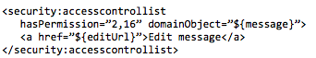**

**Code Segment 9.9: Using <security: accesscontrollist> Tag to Allow User to Edit a Web Page**

With this, you have seen how to use the Tag library to implement web security to JSP content in Spring Security Framework. The Tag library allows you to define the authorization conditions for a secured resource based on the characteristics of the principal accessing the web resource.

In this lesson, you have been introduced to the basic concepts of applying security to Java-based application using the Spring Security Framework. In the next lesson, you will learn about certain advanced security features available in Spring Security Framework and its implementation.

## Lesson 2: Advanced Spring Security

In the previous lesson, you were familiarized with the basic concepts of Spring Security Framework and how to implement security features in a Java-based web application. Some of the advanced features of the Spring Security Framework include view level security, implementing security tags and using filters to process user requests. They help you to control how access is granted to users who try to use resources or data controlled by the web application.

Like all other components of Spring Framework, such as Access Oriented Programming (AOP) module and Transaction Management component, Spring Security can also be invoked using annotations. Security annotations are used to implement method-based security in a web application to evaluate resource access requests. In this lesson, you will learn about using the Spring Framework Tag library for security purposes, view and method level security implementation, and customizing filter chains to suit application’s requirements.

### Topic 1: Using Spring Tag-Lib for Security

A web application that is developed using Spring Framework is based on Model View Controller (MVC) design pattern. The MVC design pattern uses secured login forms, user expressions, or method level security for protecting the application on its controller and model layers. To add security in the view layer of the web application, you need to define which of the contents of the web application are to be displayed to a principal based on his role. You can use the Spring Security Framework’s Tag library to implement the view-level security. These tags have been discussed in Lesson 1, under Authorizing JSP Content Based on User Characteristics. Let us now, look at the implementation of the security tags with an example.

**Implementation of Security Tags with an Example**

Let us take up an example application that provides web services to the user and also access a database to perform data transactions. To implement security features of Spring Security Framework in this application, you have to perform the following steps:

1. **Add necessary dependencies**: You are developing the application using Spring Framework and Maven development tool. To implement all the necessary Spring Framework components such as Java Database Connectivity (JDBC) component, MVC component, and Spring Security in your code, you have to import their dependencies. These dependencies are added in the pom.xml file of your application. Code Segment 9.10 shows, how to add dependencies to your pom.xml files.

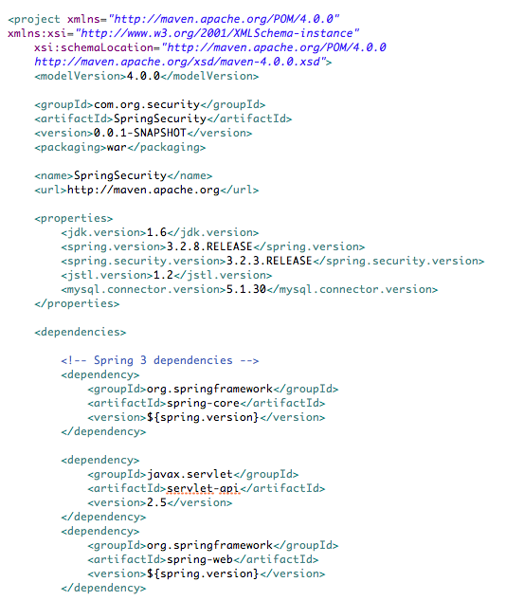

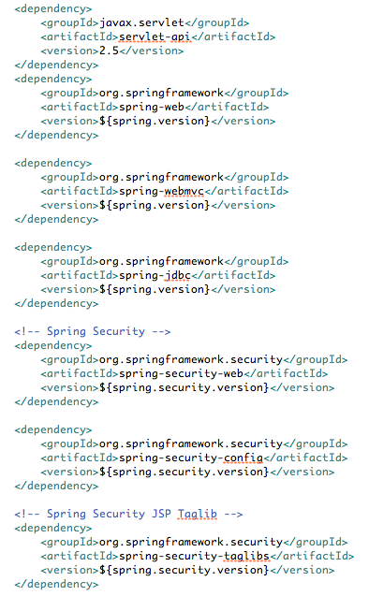

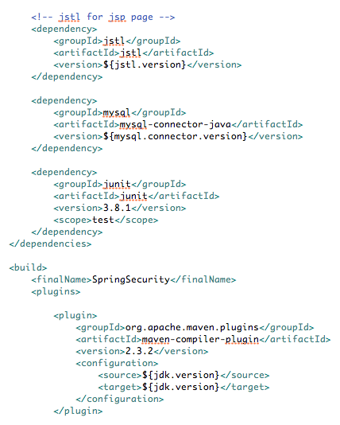

**Code Segment 9.10: Including Dependencies in pom.xml**

1. **Create database tables** **and enter values in them**: Once you have included all the dependencies you need in your application’s POM, you can invoke any component you need for executing your application. For authenticating databases, you have to first create the tables that store user details and user roles. These tables are accessed when the Spring Security Framework is performing authentication for a principal. Code Segment 9.11 shows, the creation of a database table called users.

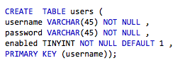

**Code Segment 9.11: Create users Table**

Code Segment 9.12 shows, how to create a database table called user\_roles.

**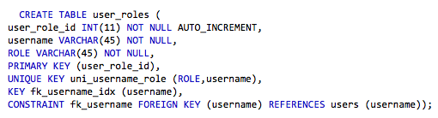**

**Code Segment 9.12: Create Table user\_roles**

Once the database tables are created, you have to insert some values into them. These values hold information such as, user names, passwords, and a Boolean value. The Boolean value shows if the particular user is to be granted access if set to ‘true’. These tables also hold user roles which can be either ‘user’ or ‘admin’. Code Segment 9.13 shows, values being added to database table fields.

**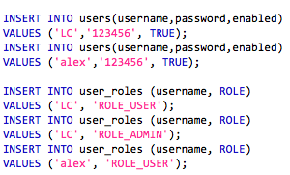**

**Code Segment 9.13: Insert Values to Database Tables**

1. **Spring Security Configuration**: Now that you have created database tables, let us configure Spring Security Framework before writing methods to implement security in your application. Here, you will see how to handle configuration using XML-based configuration files and annotation-based configuration method. To configure security, you have to perform the following steps:
   1. Create a DataSource object to connect to MySQL for implementing database transaction. Code Segment 9.14 shows, how to create DataSource objects in XML files using Java bean definitions.

**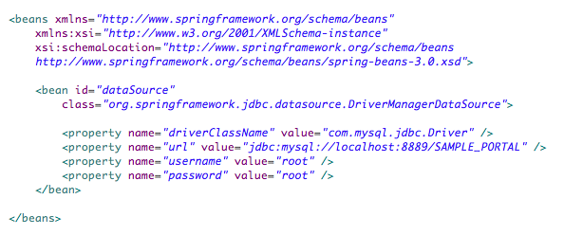**

**Code Segment 9.14: Create DataSource Object using XML Based Configuration**

Code Segment 9.15 shows, how to create a DataSource object using Spring Framework annotations.

**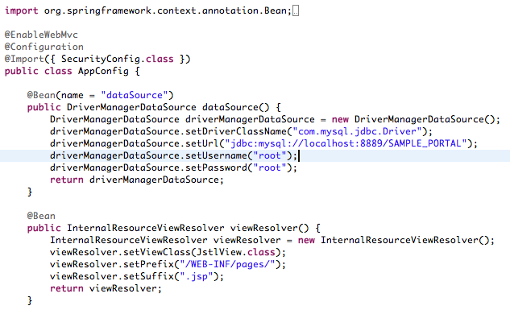**

**Code Segment 9.15: Create DataSource Objects using Annotations**

* 1. Define a query to perform database authentication using the jdbc-user-service interface. Code Segment 9.16 shows, how to define a query using XML files.

. **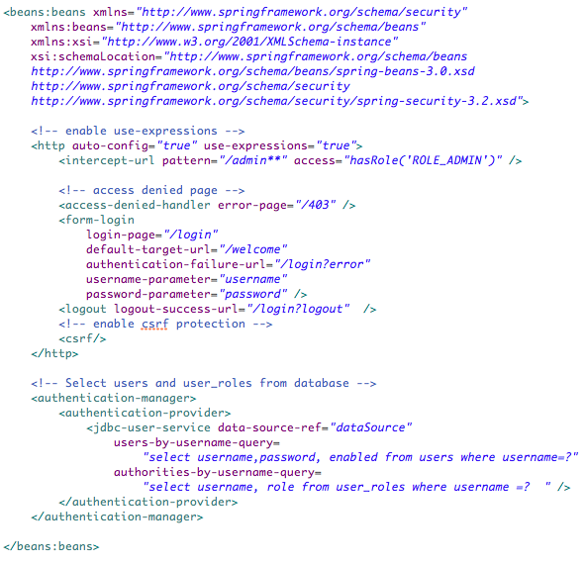**

**Code Segment 9.16: Defining Query using XML Files**

Code Segment 9.17 shows, how to define query using Spring Framework annotations.

**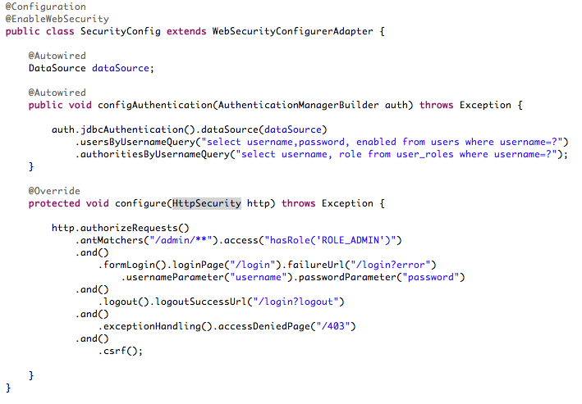**

**Code Segment 9.17: Defining Query using Annotations**

With this, you have configured the Spring Security Framework in your application. The next step is to create JSP pages for user interactions.

1. **Create JSP pages**: The JSP pages are used to define the UI for the web application. Here, you are creating:
   * Default page to be displayed to the user when they access the web application
   * Custom login page
   * Authentication message to be displayed when user name and password are accepted
   * Access denied page message when authentication fails because of invalid user name or password

The JSP pages are created using the Spring Security Framework Tag library. Perform the following steps to create JSP pages:

* 1. In this step, you will be creating the default page using the security:authorize tab. This page displays the body of the page to principals who have ‘user’ role authority. This is seen in Code Segment 9.18.

**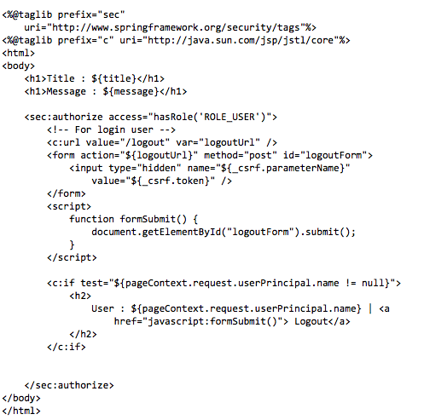**

**Code Segment 9.18: Create Default Page JSP**

* 1. In this step, you are creating a page to display the custom login form to accept username and password, as seen in Code Segment 9.19.

**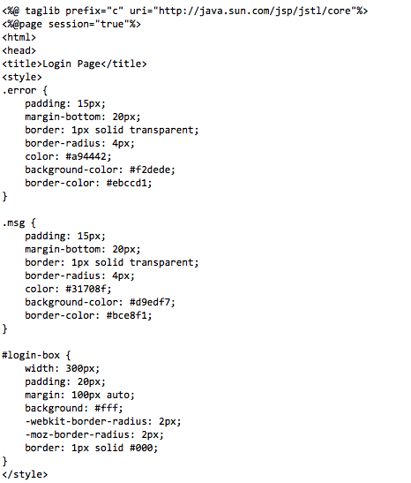**

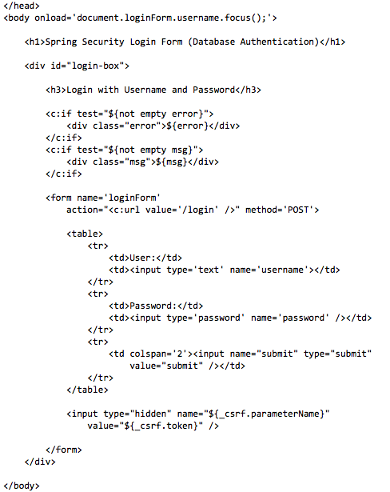

**Code Segment 9.19: Create Custom Login Page**

* 1. In this step, you are creating a password protected page that is displayed only when the username and password have been authenticated by Spring Security Framework, and the user credentials match admin role. This is shown in Code Segment 9.20.

**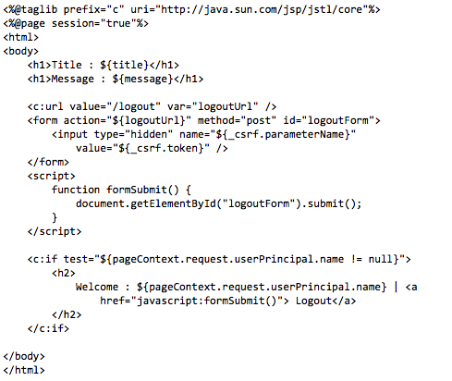**

**Code Segment 9.20: Page to be displayed to Authorized Users**

* 1. In this step, you are creating the JSP Page that is displayed when access is denied to a principal whose user name and password do not pass authentication, as shown in Code Segment 9.21.

**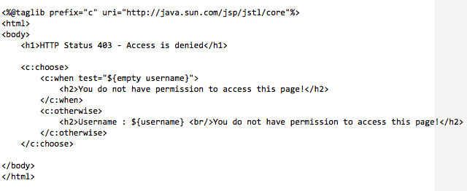**

**Code Segment 9.21: Access Denied JSP Page**

Now that you have created all the necessary JSP pages, you have to match incoming requests to the ones on the database.

1. **Create Spring MVC Framework controllers**: The Spring MVC framework allows you to define web based applications and their implementation using controllers. These controllers intercept incoming requests from the web site and redirect it to the appropriate request handlers who then pass the request on to the application to generate appropriate responses. Code Segment 9.22 shows, how to write a simple controller class for your application.

**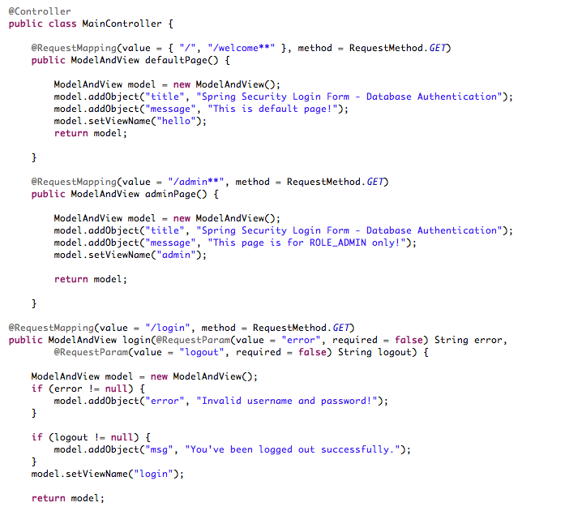**

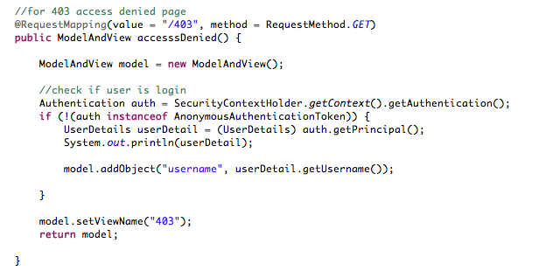

**Code Segment 9.22: Controller Class to Handle Incoming Requests**

With this, you have completed the example web application using the security tags provided by Spring Security Framework. In this application, you have:

* Created database tables with user name and password stored in their fields
* Used Spring Security Framework security tags to create JSP pages to be displayed to user when they try to access the web application
* Used Spring Framework’s MVC component to call the methods needed to implement the web application and to allow users to login and logout of the web page

Now that you have seen how to use the security Tag library, let us learn about implementing method level security using Spring Security Framework.

### Topic 2: Method Level Security

Method level security, as the name suggests, is implementing Spring Security Framework to protect an application from security threats, by limiting access to its methods. Only those principals who have been authenticated are allowed access to the methods in the application. The most important part of implementing method level security is the configuration element that is defined in your application’s Spring Configuration files. Once configuration is done, you can implement method level security in any one of the following ways:

* By annotating a method using the
  + @Secured annotation
  + @RolesAllowed annotation
  + Pre and post invocation annotations
* Match method using pointcuts in Spring AOP Framework

The following example shows how to implement method level security using annotations in Spring Security Framework using the methods listed above. Let us assume there is an application that accepts login from users and grants them access to controlled resources, based on their authentication and credentials. In this application, method level security implementation works by following the steps listed below.

1. User accesses a URL on a web application.
2. The web application refers to web.xml
3. The web.xml matches the URL pattern
4. The control is redirected to DispatcherServlet in Spring framework
5. Spring Framework ensures if all the URLs are secured. It also identifies if the custom login page is configured and forwards the request to the LoginController which is a Spring MVC Controller
6. The LoginController redirects to the Custom Login Page
7. The user enters his login name and password and submits the custom login form
8. Spring performs authentication and authorization of user's credentials against the entries in the Spring Configuration file and redirects to LoginController
9. LoginController displays the originally accessed URL upon successful authentication.
10. User accesses the 'Admin Page' link
11. LoginController ensures if the logged in user has 'ROLE\_ADMIN' authorization @Secured method level annotation and next displays the 'Admin Page'

To implement these steps in your application, you should write the following in your source code:

1. **Create the LoginController class**: The LoginController class, shown in Code Segment 9.23, is a Spring MVC Controller class .

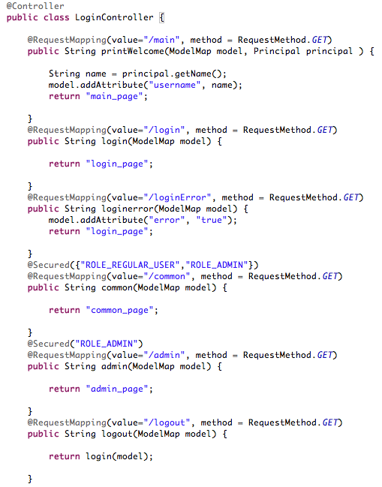

**Code Segment 9.23: Creating LoginController Class**

In Code Segment 9.23, you are:

* Mapping the main() method to display a welcome message to the user
* Mapping the login() method to accept user details and redirects to the login page named login\_page.jsp
* Setting a condition that, if there is a login error, using loginError() method to display error message and redirect the user to the login page
* Setting a condition that if login is successful, redirect the user to the web page using common() method

The @Secured annotation used in Code Segment 9.10 indicates the method level security implementation. The method annotated with @Secured, is applied for principal roles of USER and ADMIN to authenticate them to access the web application.

1. **Create login JSP**: Once the LoginController class is created, you have to create the login page that is controlled by the LoginController class. In the login JSP page:

* User name is stored in j\_username parameter
* Password is stored in j\_password parameter
* Login form is submitted to URL j\_spring\_security\_check
* Login error is identified by the error parameter

Code Segment 9.24 shows, the creation of the login JSP.

**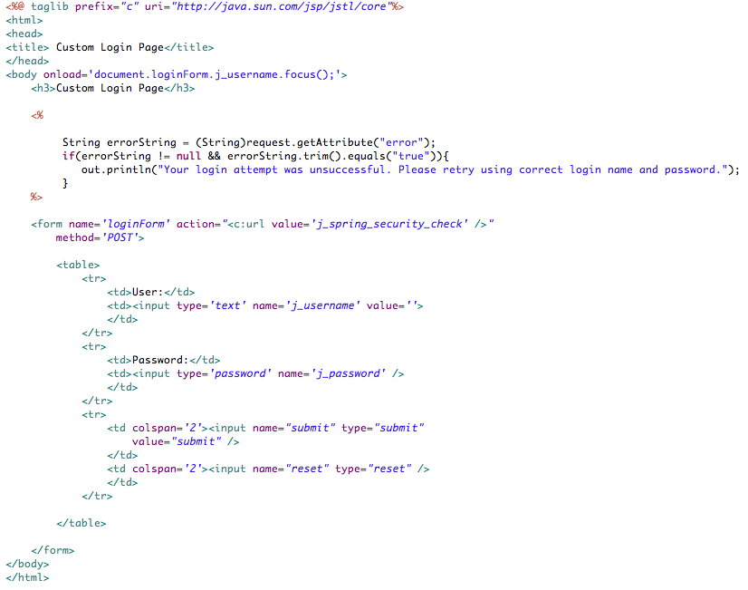**

**Code Segment 9.24: Creating Login JSP**

1. **Create main page JSP:** Just like the login page, your application needs a main page. So now you have to create a main page JSP called main\_page.jsp, which contains the following links:

* /admin: To access the admin page (accessible only for ROLE\_ADMIN)
* /common: To access the common page (accessible only for ROLE\_USER and ROLE\_ADMIN)

Code Segment 9.26 shows, the creation of main page JSP.

**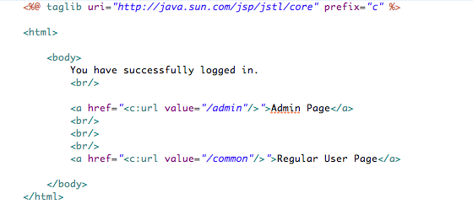**

**Code Segment 9.26: Create Main Page JSP**

1. **Create Admin Page**: Just like the main page and login page, your application needs an admin page. This page can be accessed only if the principal is an administrator and has been authorized using Spring Security Framework. Code Segment 9.27 shows, the creation of Admin Page called Admin\_page.jsp.

**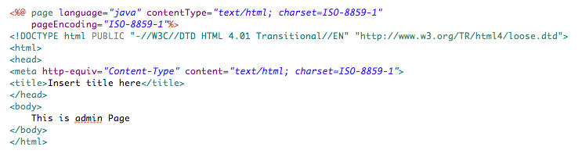**

**Code Segment 9.27: Create Admin Page JSP**

1. **Create the common page JSP:** Web applications data is held in common page JSP.Code Segment 9.28 shows, how to create the common page JSP.

**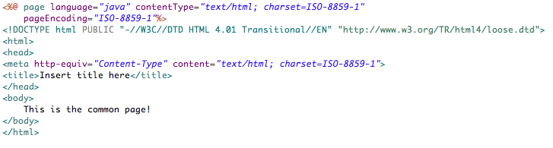**

**Code Segment 9.28: Create Common Page JSP**

1. **Write the Main method:** Once all the pages have been defined, you have to write and call the main method. In the main method, you are configuring the application to do the following:

* Use annotation-based Spring MVC Controller declaration.
* Enable method level security by using the security:global Tag.
* Enable Spring Security using the security:http Tag.
* Specify the authentication and authorization credentials for the application using <security:user> Tag.
* Specify that when a view is generated, the appropriate prefix of /view and suffix of .jsp is added to the view name.

Code Segment 9.29 shows, the main method which configures the application to perform security related operations.

**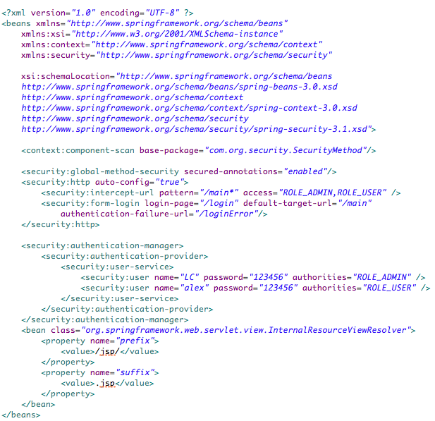**

**Code Segment 9.29: Main Method Invocation**

With this, you have seen how to implement method level security using Spring Security Framework. Next, let us look at the annotations available in Spring Security Framework to annotate methods and classes to perform authorization and authentication.

**Implementation using @Secured and @Roles Allowed**

Annotations are used to protect methods by attaching security expressions to classes and methods in your application. Spring Security Framework provides four expression-based @Pre and @Post annotations, along with the @Secured annotation. To enable your application to use annotations for implementing security, you must have the top level namespace element, as seen in Code Segment 9.30.

****

**Code Segment 9.30: Namespace Element needed to use Annotations in Spring Security Framework**

Let us now look at the annotations available in Spring Security Framework, as listed in Table 9.8.

|  |  |
| --- | --- |
| **Annotation** | **Description** |
| @PreAuthorize(expression) | Used to check if the expression that is passed as an argument is true before allowing access to the method being annotated. |
| @PreFilter(value=expression [,filterTarget=collection]) | Used to filter a collection of elements before passing it on to the annotated method. Each element is evaluated against the specified expression and is removed from the collection if the expression fails. |
| @PostAuthorize(expression) | Used to check if the expression passed is true before returning the result value of the annotated method. This is used when the method’s domain object parameters are user IDs. |
| @PostFilter(expression) | Used to filter a collection before returning the value of the annotated method. |

**Table 9.8: Annotations Available in Spring Security Framework**

Now that you have seen the annotations available in Spring Security Framework, let us look at some examples of implementing security using these annotations. Let us assume there is a web application that allows access to users to a web page, and then allow them to just read the content or edit the content based on their role.

Code Segment 9.31 shows, how to use the @PreAuthorize annotation to allow only those users with write or admin credentials to edit a message being displayed by the application.

**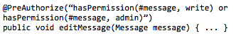**

**Code Segment 9.31: Use of @PreAuthorize Annotation**

Code Segment 9.32 shows, how to use the @PreAuthorize annotation to allow users with read credentials, to access a form in the web application.

****

**Code Segment 9.32: Using @PreAuthorize to Allow Form Access to Users**

In this way, you can use expressions to set permission to access or delete or update or just read the contents of a web page using the @PreAuthorize annotation. Let us now look at using @PostAuthorize annotation.

Until a message or a list of objects to be displayed has been loaded to the application, you cannot decide whether to display them or not. Code Segment 9.33 shows the use of @PostAuthorize annotation to give permission to a user with admin credentials to access a list of messages.

**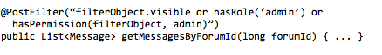**

**Code Segment 9.33: Using @PostAuthorize Annotation**

With this, you have seen how to implement annotations to use Spring Security Framework to protect your application. You have also seen how to implement method level security to your application using the Spring Security Framework Tag library and creating JSP pages. In the next topic, you will learn how to customize filters to intercept incoming user requests for web abased applications and how filters are useful.

### Topic 3: Customizing Filter Chain

You were introduced to filter chains in the previous lesson. You have seen that Spring Security Framework’s web component is based on Java Servlet Filters. Java Servlet Filters do not use any other web based frameworks such as Spring MVC Framework internally to implement security to web applications. Filters work by handling user requests through the HttpServletReuests and HtttpServletResponses interfaces, and are capable of handling request that come from:

* A web browser
* A web service client
* HTTPInvoker interface or
* An AJAX application

To simplify the request handling process, Spring Security Framework maintains a chain of filters, where each filter is given one specific task by defining methods in the filter’s code. Then these filters are arranged in the order in which their tasks are to be implemented which is important to maintain the dependencies between them. You can insert or remove filters from the configuration files depending on which of the tasks are needed for a given application. Some of the filters to handle user requests in a web application are:

* Implement the:
  + DelegatingFilterProxy interface
  + FilterChainProxy interface
* Bypass the filter chain
* Set filter ordering
* Use with other filter-based frameworks

**DelegatingFilterProxy Interface**

Before you use filters in your web application, you have to declare them in your application’s web.xml configuration files. In Spring Security Framework, filter classes are treated like beans defined in the ApplicationContext interface and so that the filters can benefit from DI and bean life cycle interfaces. To declare filters in the web.xml configuration files, you have to invoke the DelegatingFilterProxy interface. Code Segment 9.34 shows, how to include filters through the DelegatingFilterProxy interface.

**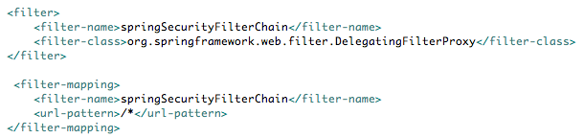**

**Code Segment 9.34: Declaring Filters using DelegatingFilterProxy Interface**

The DelegatingFilterProxy interface delegates the Filter class’s methods to a bean that is obtained from the ApplicationContext interface. The bean used should implement javax.servlet.Filter methods and must have the same name as the filter element name.

**FilterChainProxy Interface**

The FilterChainProxy interface allows you to declare filters by adding a single entry to the web.xml configuration files and implement security filters in your application. If you use the DelegatingFilterProxy interface, you need to write more code as first, the filter bean has to be declared and matched to the filter and then the filter order can be defined. The FilterChainProxy interface allows you to implement filters with much less coding on your part. The filter chain is declared in the ApplicationContext with the same name as the filter bean. Code Segment 9.35 shows an example of using the FilterChainProxy interface.

**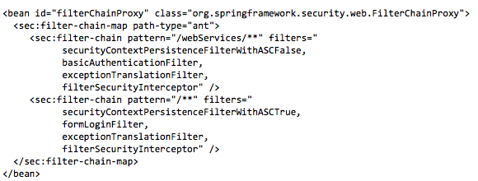**

**Code Segment 9.35: Using FilterChainProxy interface**

In code Segment 9.35, the namespace element filter-chain-map sets up the security filter chains in the application. This element is used to map URL patterns to a chain of filters defined using the bean name specified in the <filter> element. At runtime, the FilterChainProxy interface finds the URL pattern that complements the current web request and the list of filter beans will be applied to the request. The filters are invoked in the order that they are defined so that you can have complete control over the filter chain applied to a particular URL.

**Bypassing the Filter Chain**

If you wish to completely bypass the filter chain, you can set the attribute filter= to none instead of changing the filter bean list. Thus you can remove the request pattern from the security filter chain. This is useful when you do not want to have any authentication or authorization for a specific URL and keep it freely accessible to all users.

**Filter Ordering**

When you are using security filters to intercept and process user requests, it is very important to define the order in which they have to be invoked. Else, the sequence of events that are needed to process a request will not be followed resulting in errors and security breach of the application. Irrespective of the type filters you are using, the order should be as follows:

1. ChannelProcessingFilter: This is used to redirect the request to a different request handling protocol.
2. SecurityContextPersistenceFilter: This is used to set up SecurityContext in the SecurityContextHolder when a web request is intercepted. Any changes made to the SecurityContext can be transferred to the HttpSession when the web request is processed.
3. ConcurrentSessionFilter: This is used to reflect ongoing requests from the principal to the SessionRegistry.
4. Authentication processing filters: UsernamePasswordAuthenticationFilter, CasAuthenticationFilter, BasicAuthenticationFilter, are used to modify the SecurityContextHolder to contain a valid Authentication request token.
5. SecurityContextHolderAwareRequestFilter: This is used to install a Spring Security aware HttpServletRequestWrapper into your Servlet container.
6. RememberMeAuthenticationFilter: This is used to store authentication information on a cookie, so that the SecurityContextHolder can reuse this information when no earlier authentication processing mechanism has updated the SecurityContextHolder.
7. AnonymousAuthenticationFilter:This is used to implement an anonymous authentication object when there are no authentication processing mechanism updating the SecurityContextHolder.
8. ExceptionTranslationFilter: This is used to catch any Spring Security exceptions so that either an HTTP error response can be returned or an appropriate AuthenticationEntryPoint can be launched.
9. FilterSecurityInterceptor: This is used to protect web URIs and raise exceptions when access is denied.

You have seen the order in which security filters are to be defined. Now let us move on to learning how you can integrate Spring Framework with other filter-based frameworks.

**Use with other Filter-Based Frameworks**

When you use some other filter-based frameworks, such as SiteMesh and Wicket in your application, you have to ensure that the Spring Security filters are processed first, so that they are defined first in the filter order list. This allows the SecurityContextHolder to be used by other filters such as SiteMesh and Wicket.

Let us look at the types of filters classes and interfaces available in Spring Security Framework.

**Core Security Filter Interfaces**

Some key filters that are used in every web application use Spring Security Framework. These filters belong to classes and interfaces that are as follows:

* FilterSecurityIntercepter interface
* ExceptionTranslationFilter Interface
* AuthenticationEntryPoint Interface
* AccessDeniedHandler Interface
* SecurityContentPersistenceFilter Interface
* HTTPSessionSecurityContextRepository Interface
* UsernamePasswordAuthenticationFilter Interface

Let us now learn about these filter interfaces and their function in the Spring Security Framework.

* **FilterSecurityIntercepter interface:** This interface is used with the namespace element to handle the security of HTTP resources. It is usually configured along with the ExceptionTranslationFilter interface that converts other exceptions into the Spring Framework runtime exception. The FilterSecurityIntercepter interface needs a reference object belonging to the AuthenticationManager and AccessDecisionManager interfaces in order to handle HTTP resources. You can also supply configuration attributes in the application code that apply to different HTTP URL requests. Code Segment 9.36 shows, the configuration of the FilterSecurityIntercepter interface.

**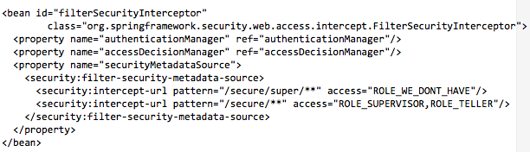**

**Code Segment 9.36: Configuring FilterSecurityIntercepter**

You can implement the setSecurityMetadataSource()method in FilterSecurityIntercepter to obtain the configuration attributes for a particular FilterInvocation object. The configuration attributes are obtained by matching the request URL against the pattern attributes stored in FilterSecurityMetadataSource. Code Segment 9.37 shows, how to write user expressions in the configuration of the FilterSecurityIntercepter interface.

**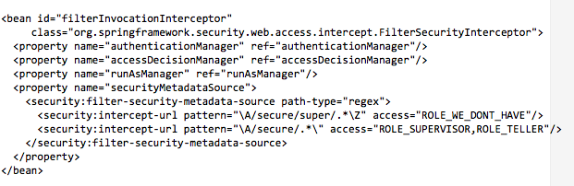**

**Code Segment 9.37: Configuration of FilterSecurityIntercepter using Expressions**

* **ExceptionTranslationFilter Interface:** When defining the filter order for your application, the ExceptionTranslationFilter interface comes directly before FilterSecurityIntercepter. The ExceptionTranslationFilter interface does not actually perform security enforcement but handles exceptions thrown by the security interceptors and generates the suitable HTTP responses for the exceptions. Code Segment 9.38 shows, how to configure the ExceptionTranslationFilter interface.

**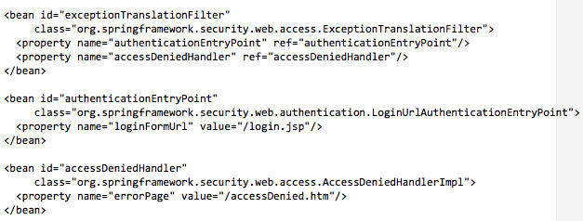**

**Code Segment 9.38: Configuring ExceptionTranslationFilter**

* **AuthenticationEntryPoint** **Interface:** This interface is called when a secure HTTP resource is being accessed through a user request, even though the user is not authenticated. In this case, an AuthenticationException or AccessDeniedException is thrown by the security interceptor which, in turn, triggers the commence method on the request entry point.
* **AccessDeniedHandler Interface:** Let us assume in a web application, a user has been authenticated and tries to access the admin page. The admin page is designed in such a way that it is hidden from users who do not have user role admin credentials. Your application must be protected from users who are trying to access the admin page without necessary credentials. The AccessDeniedException interface is thrown when a user tries to access content or performs unauthorized operations. The AccessDeniedHandler interface is then invoked, which sends a forbidden (403) response to the client.
* **SecurityContentPersistenceFilter Interface:** This filter interface has two important tasks. It handless storage of the SecurityContext interface content between two consecutive HTTP requests and for clearing out the SecurityContextHolder interface once the request is processed. Clearing the thread in which the context is stored is important to avoid the security context for a particular user to be reapplied in another thread. Code Segment 9.39 shows, the configuration of the SecurityContentPersistenceFilter interface as a bean declaration in the XML file of your application.

**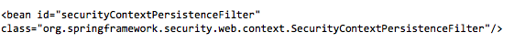**

**Code Segment 9.39: Configuring SecurityPersistenceFilter**

* **HTTPSessionSecurityContextRepository Interface:** This is a separate strategy interface that is responsible for loading and storing security context. HTTPSessionSecurityContextRepository is a container that holds incoming requests and the responses generated for them. The default implementation of this class is the HttpSession attribute used to implement the allowSessionCreation method. Code Segment 9.40 shows, how to configure the HTTPSessionSecurityContextRepository interface.

**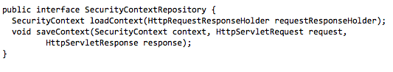**

**Code Segment 9.40: Configuring HTTPSessionSecurityContextRepository**

Code Segment 9.41 shows, the implementation of the allowSessionCreation property.

**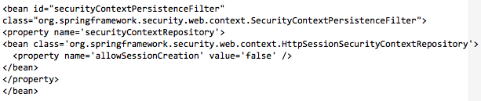**

**Code Segment 9.41: allowSessionCreation Implementation**

* **UsernamePasswordAuthenticationFilter Interface:** This interface is the actual authentication mechanism used in Spring Security Framework. The UsernamePasswordAuthenticationFilter interface implements the <form-login> element and can be configured by following these three steps:

* 1. Configure LoginUrlAuthenticationEntryPoint using the login page’s URL.
  2. Implement the login page using JSP or Spring MVC Controller class.
  3. Configure UsernamePasswordAuthenticationFilter in ApplicationContext and add the filter bean to the filter chain proxy.

Code Segment 9.42 shows, the basic filter configuration for the interface UsernamePasswordAuthenticationFilter.

**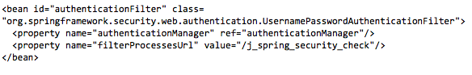**

**Code Segment 9.42: Configuring UsernamePasswordAuthenticationFilter**

With this, you have seen the commonly used filter interface in Spring Security Framework and their implementation in a web application. In this lesson, you were familiarized with the implementation of the Spring Security Tag library and the use of filters to process user requests.

**Module Summary**

In this module, you were introduced to the concept of securing data and resources controlled by your Java-based applications against Security threats. You learned about the Spring Security Framework which is a component of Spring Framework used to implement security to your applications. You also learned about authentication and authorization methods that can be implemented through user expressions and the security Tag library available in the Spring Security Framework. Lastly, you were introduced to filters that also perform security operations on incoming user requests and handle request based exceptions thrown by your application.

### References

* Web references:
* http://docs.spring.io/spring-security/site/docs/3.0.x/reference/springsecurity.html (Accessed 15 May 2014)
* http://projects.spring.io/spring-security/ (Accessed 15 May 2014)
* Book references:
* Winch, Robert; Mularien, Peter. (2010). *Spring Security 3.1.* In: Packt Publishing ltd.

Walls, Craig. (2011). *Spring in Action-3rd edition.* Manning Publication Company

### Glossary

|  |  |
| --- | --- |
| **Term** | **Definition** |
| Acegi | A Java-based security framework released in 2003 by Ben Alex. Released under the Apache licence, it handles authentication and authorization of Java applications. |
| Apache licence | A software licence written by the [Apache Software Foundation](http://en.wikipedia.org/wiki/Apache_Software_Foundation) (ASF) and that requires preservation of the [copyright](http://en.wikipedia.org/wiki/Copyright) notice and [disclaimer](http://en.wikipedia.org/wiki/Disclaimer). |
| Enterprise JavaBeans (EJB) | A managed, server-side component architecture used to develop enterprise applications in a modular fashion. |
| Immutable objects | Objects in object-oriented programming whose state cannot be modified after they are constructed. |
| Inversion of Control (IoC) | A process in which the dependency relationships are reversed in an application to provide a consistent method for configuring and managing Java objects. |
| iText | An open source library for creating and manipulating PDF files in Java. |
| Java API for XML based Remote Procedure Call (JAX-RBC) | A Java-based API that enables Java applications to invoke a Java-based web service using a description while being consistent to Web Service Description Language (WSDL). |
| Java Database Connectivity (JDBC) | A specification of a Java API that allows an application to access database management systems. |
| Java Data Objects (JDO) | A specification of Java objects persistence that persists services to the domain model. |
| Java Naming and Directory Interface (JNDI) | An API that allows Java clients to discover and look up data and objects using its name. |
| Jetty | A pure Java-based HTTP (Web) server and Java Servlet container. |
| Plain Old Java Objects (POJOs) | A term that specifies that a given object is an ordinary Java object, not a special object. |
| Remote Method Invocation (RMI) | A method where using Java programming language, you can write object-oriented programming in which objects on different systems can interact in a distributed network. |
| Representational State Transfer (REST) | An API that uses the four HTTP methods Get, Post, Put, and Delete to execute different operations. |
| Servlet API | A standard for implementing Java classes that respond to requests. |
| Spring Framework GA | A software product is said to be generally available if it has passed its beta test and is free of bugs or errors. GA is the abbreviated form of Generally Available. |
| Tomcat | An application server that executes Java Servlet and renders web pages that include Java Server Page coding. |
| TopLink | An ORM package for Java developers that provides a framework for storing Java objects in a relational database or for converting Java objects to XML documents. |
| Singleton | A Java design pattern that is categorized as a creational design pattern. |
| Velocity | A Java-based template engine that allows designers of web pages to reference methods defined in Java code. |
| Bean post processors | An interface that defines call back methods that you can implement to provide your own custom logic after the Spring container completes instantiating, configuring, and initializing a bean. |
| BeanFactory | The root interface for accessing a bean container in Spring Framework. |
| java.util.Properties | A class name where all the static properties (values) are defined in an application. |
| Simple Mail Transfer Protocol (SMTP) | This is an internet standard for transmitting electronic mail. |
| Mock Object | Simulated objects that mimic the behaviour of real objects during testing. |
| Stubs | Stand-in pieces of code for programs that are inserted at run time and act as a replacement to the real code. |
| Model View Controller (MVC) | A software design pattern providing architectural support to Web applications. |
| Model | A component of the MVC design pattern that implements the logic for application’s data domain. |
| View | A component of the MVC design pattern that displays the application’s user interface. |
| Controller | A component of the MVC design pattern that controls the interaction between the model and view. |
| Command objects | Java beans that are populated with the data from your web request forms. |
| Hibernate | An object-relational mapping tool used for Java applications, which provides a framework to map domain-oriented objects to those in a relational database. |
| Java Data Objects (JDO) | POJOs that do not need to extend a base class or implement a particular interface. They are specifications of Java object persistence. |
| Java Persistence API (JPA) | A Java interface that defines the management of relational data in Java-based applications. |
| JavaScript Object Notation (JSON) | A data translation format that keeps data in applications easy to read by humans and machines. |
| AspectJ | An Aspect Oriented Programming (AOP) framework that was created at Palo Alto Research Centre as an AOP extension for the Java programming language. AspectJ can be implemented in Eclipse Foundation open-source projects, as both a stand-alone project and integrated into Eclipse. AspectJ has become a widely used de facto standard for AOP because of its simplicity and usability for end users. |
| Code Generation Library (CGLIB) | An open source and powerful library that is used to extend Java classes and implementations at run time of an application. |
| Cross-cutting concerns | Code that perform secondary functions such as when classes in the OO model share common, secondary requirements with other classes. |
| Cache | Cache is defined as a collection of similar or related data that is stored in a hidden place. It is a specialized form of memory usage which holds copies of recently used or accessed data from an application. This is particularly important in enterprise applications which handle a large volume of data every day. |
| EhCache | It is an open source general purpose, distributed cache for Java based applications. It can support memory and disk storage, cache exception handling, listeners cache, and caching servlet filters. |
| Java Development Kit (JDK) | JDK is an implementation of J2EE platform that helps in java applications on Solar, Linux, Mac OS X, and Windows operating systems. |
| JDBC manager | This is a front end Java interface which helps applications to connect to a database through a JDBC driver. It allows applications to view, access, modify data and create, update, and delete tables and relations in a database. |
| Java.util,concurrent.ConcurrentMap | This is a map that supports concurrent access to it. It allows you to read or write data from it without locking the data. |
| Java Naming and Directory Interface (JNDI) | This is a Java API that supports directory services and allows developers to look up a data object using its name from a database. The JNDI is platform independent and provides developers with a pluggable service provider interface for integrating with the application being developed. |
| Controller classes | Classes that handle a user’s responses and inputs in a web-based application developed in the MVC design pattern. MVC requires these classes to have names ending with the term “Controller” for easy identification. |
| Domain Model pattern | A conceptual model that holds all the information related to a specific project that describes various elements, their attributes, relationships, and role. It also contains constraints and requirements that influence a given project. |
| Getter methods | A method used in any programming language to retrieve the value of a private variable. This is also called the accessor method and often accompanies the setter method. |
| iBATIS | A persistence framework that handles data mapping between SQL databases and Java-based applications. Here the mapping tasks are separated from the main application and packaging the SQL code in XML configuration files. |
| Immutable | The constant state of an object. This state is not changed under any circumstances. |
| Java DATA Object (JDO) | An object persistence specification in Java. JDO are regular POJO and they do not need to implement any specific interface or extend any base class. |
| Java Persistence API (JPA) | A Java programming interface that supports data management in an application. The API is included in the java.persistence package of an application. |
| Universally Unique Identifier (UUID) | A standard used to uniquely identify a data object or class without needing to refer to a central directory. |
| Hi/lo algorithms | In database table mapping, you have two numbers that make up the primary key that is used to relate tables to each other. The primary key has a high number and a low number. By setting the primary keys on the client side of the database application, you can easily create child-parent relationship between the database tables and have all the keys in one place before you insert any new data in the database tables. This definition of keys are performed using the hi/lo algorithms. |
| Oracle TopLink | A high-level object persistence and object transformation framework. This is used to provide development tools and run time support for Java applications. Using TopLink simplifies development and maintenance and increases the functionality of the enterprise application. |
| Executable SQL statement | An SQL statement that generates calls to an instance. It includes Data Manipulation Language (DML) and Data Definition Language (DDL) statements. |
| Enterprise JavaBean (EJB) transaction management | Transaction management in EJB specification is performed by EJB servers. EJB Servers are transaction servers that handle transactions, context propagation, and distributed transactions. Transactions can be managed by the container or by custom code handling in bean’s definition. |
| ANSI/ISO SQL standard | American National Standard Institute included Sequential Query Language (SQL) as a special purpose programming language used to manage data held in RDBMS. This was done in 1986. |
| Acegi security system | This is a powerful and flexible security implementation for Java-based enterprise applications developed with Spring framework. Spring-based DI makes Acegi easy to configure and implement in your application. |
| SourceForge project | This is a web based source code repository that is a centralized location for developers to use and manage open source tools for application development. |
| Container managed security | Applications need to provide security on data access to resources and page access control. It is easy to implement common security requirements at controller level in a Java based web application. This is used to implement authentication and authorization operations in your application. |
| Enterprise JavaBeans (EJB) specification | Enterprise JavaBeans (EJB) specification is a managed, server-side component architecture for modular construction of enterprise applications. |
| Java Completely Automated Public Test to tell Computers and Humans Apart  (JCaptcha) | This is an open source java framework for captcha definition and integration. Captcha stands for Completely Automated Public Test to tell Computers and Humans Apart |
| Java Server Pages (JSP) | JSP is a technology that helps developers to create dynamic web pages based on HTML, XML or other document types. |
| Java in Administration Special Interest Group (JA SIG) | This is an instruction community of university personnel who aim at creating open source applications to be used in higher education environments. |
| SiteMesh | This is an open source web layout and decoration framework that helps in creating large web sites with multiple pages. It helps in maintaining consistency throughout the web application in look and feel, navigation and page layout features. |
| Wicket | This is a lightweight component based web application framework that is used to handle incoming user requests by implementing listener delegation. |

### Additional Study: Differences between AOP and AspectJ

Spring AOP and AspectJ are complementary to each other. Those who use Spring AOP find it easy to configure and apply it to coarse-grained service-type objects such as UI implementations in the business layer. AspectJ can also perform Aspect insertions of proxy fine-grained domain objects. While the pointcut of AspectJ is more powerful than that of Spring AOP, it has a complicated syntax for implementation.

**Choosing an AOP Tool**

When choosing between Spring AOP and AspectJ, there are three main points you need to consider:

* **The aspect target**: In Spring AOP framework, you can target only the objects that have been created and managed by the Spring container. AspectJ can target any object to insert aspects.
* **The pointcut type needed by the aspect**: In AspectJ, there are no restrictions while using a pointcut, but in Spring AOP, you can only use the method execution pointcut.
* **How invasive can the solution be**: AspectJ is more difficult to manage in terms of weaving aspects into your main code and you have to depend on the AspectJ compiler for weaving. Spring AOP is simpler as weaving is independent of any compiler.

The Spring AOP and AspectJ differ from each other in the way they work and in the situations they are chosen for. The differences between the two AOP Frameworks are listed in Table 5.4.

|  |  |
| --- | --- |
| **AspectJ** | **Spring AOP Framework** |
| It is more powerful but also more complicated. | It is less complex and less powerful. |
| It supports method and type pointcuts | It is proxy-based AOP that supports only method introduction pointcuts. |
| It works on any object. | It works only on objects created and managed by the Spring container. |
| Volume of code needed is more as you need to build the process using AspectJ Compiler or set up load time weaving. | Using annotations, you can reduce the amount of coding needed. |
| There is no restriction in applying aspects to methods. | Aspects cannot be applied to more than one method from the same class. |
| It can apply cross-cutting concerns for static and final methods as it is not proxy-based. | It cannot apply cross-cutting concerns for static and final methods. |
| Weaving is done at compile time through AspectJ compilers if the source code is available or weaving is done postcompilation using compiled files. | Weaving is done at run time through proxy using the concept of dynamic proxy if an interface exists or the CGLIB library if direct implementation is provided. |

**Table 5.4: AspectJ Vs. Spring AOP Framework**

To conclude, Spring AOP and AspectJ are two opposite, but complementary solutions that can co-exist and interact without any problems.